**Testing Plan:**

|  |  |  |  |  |
| --- | --- | --- | --- | --- |
| Short Distance Test: | | | | |
|  | Pathfinding Algorithm | A*: | Best-FS: | Breadth-FS: |
| Operations Number: | Level 1(No Walls): | 47 | 47 | 843 |
| Level 2: | 94 | 62 | 847 |
| Level 3: | 188 | 119 | 1831 |
| Level 4: | 224 | 174 | 2289 |
| Level 5(Hardest): | 4266 | 866 | 4384 |

Level Design(Screenshot):

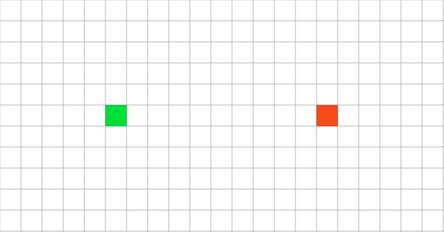Level 1 (No Walls)

Level 2  
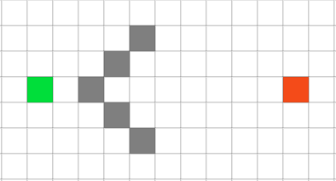

Level 3  
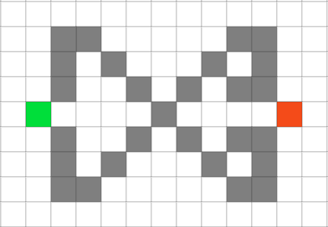

Level 4

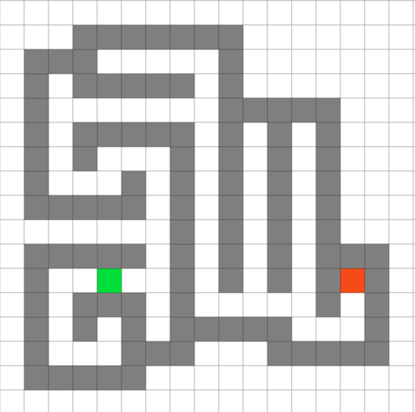

Level 5

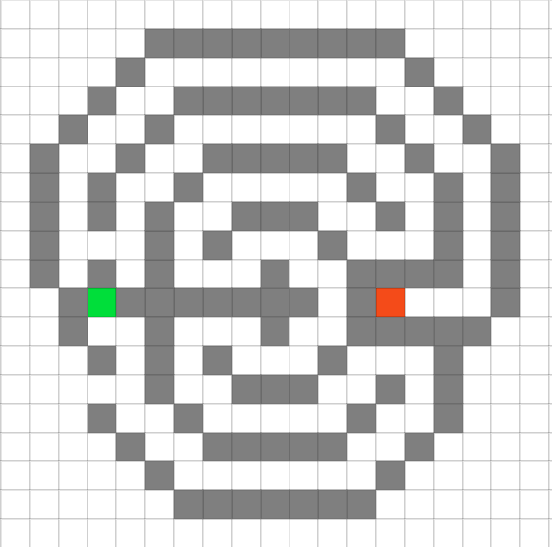

|  |  |  |  |  |
| --- | --- | --- | --- | --- |
| Medium Distance Test: | | | | |
|  | Pathfinding Algorithm | A*: | Best-FS: | Breadth-FS: |
| Operations Number: | Level 1(No Walls): | 151 | 151 | 3637 |
| Level 2: | 415 | 169 | 3615 |
| Level 3: | 588 | 197 | 3321 |
| Level 4: | 3318 | 878 | 4259 |
| Level 5(Hardest): | 3772 | 2101 | 3810 |

Level Design(Screenshot):

Level 1



Level 2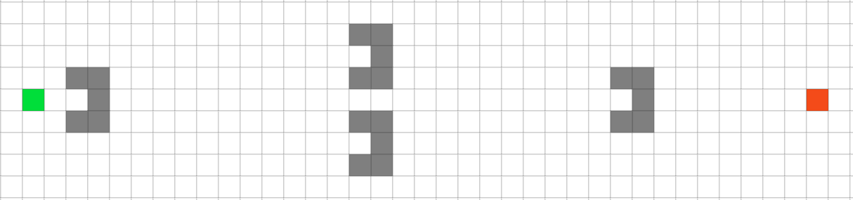

Level 3

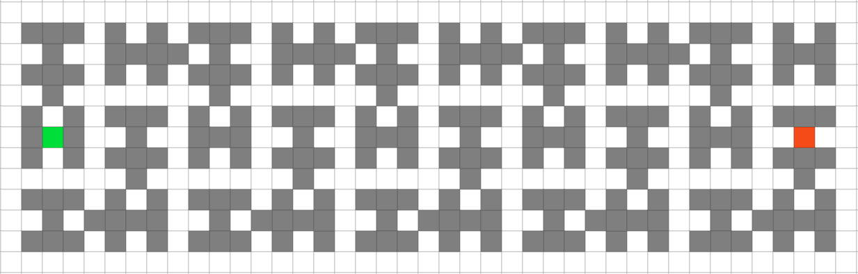

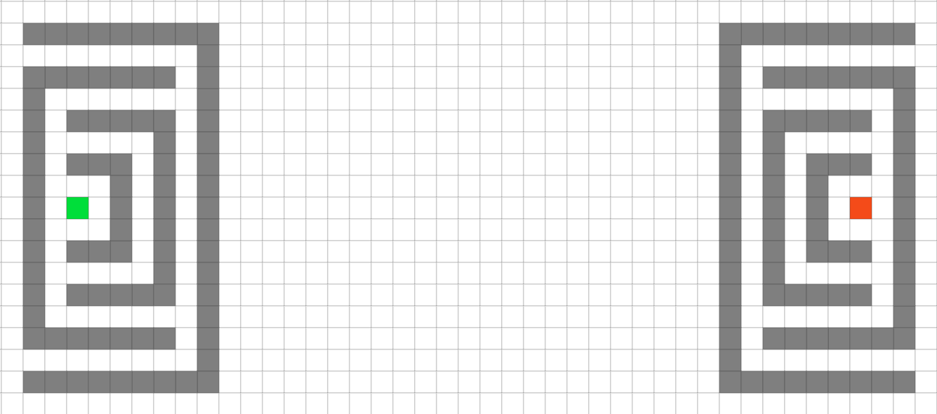Level 4

Level 5

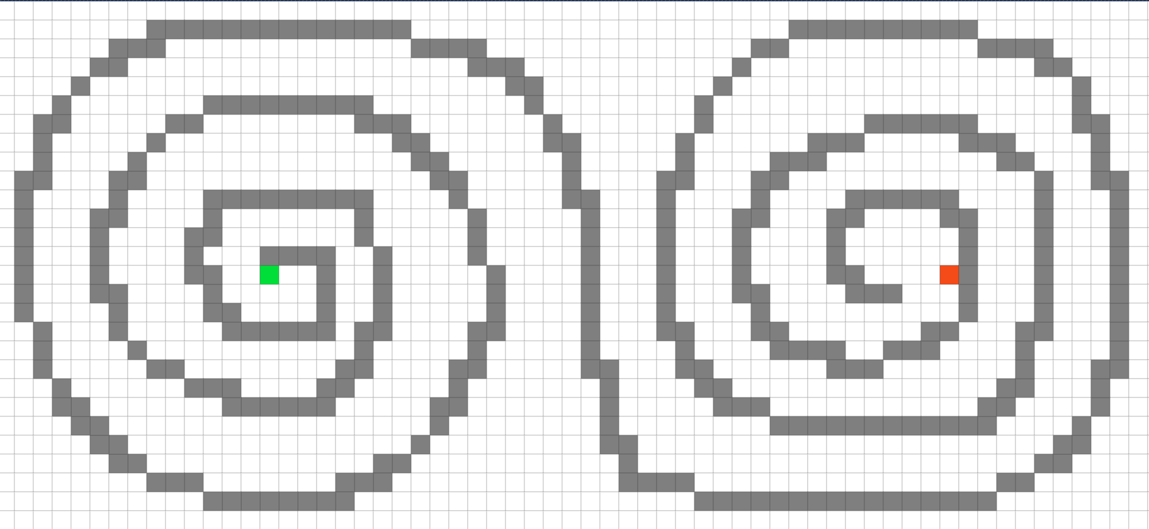

|  |  |  |  |  |
| --- | --- | --- | --- | --- |
| Long Distance Test: | | | | |
|  | Pathfinding Algorithm | A*: | Best-FS: | Breadth-FS: |
| Operations Number: | Level 1(No Walls): | 269 | 269 | 3842 |
| Level 2: | 379 | 345 | 3776 |
| Level 3: | 909 | 777 | 3331 |
| Level 4: | 1265 | 1147 | 3427 |
| Level 5(Hardest): | 1791 | 1927 | 3468 |

Level Design(Screenshot):

Level 1

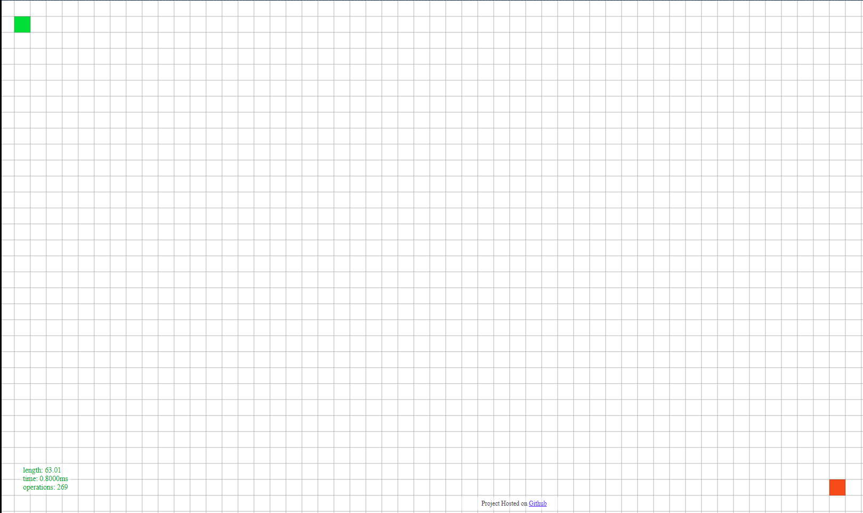

Level 2

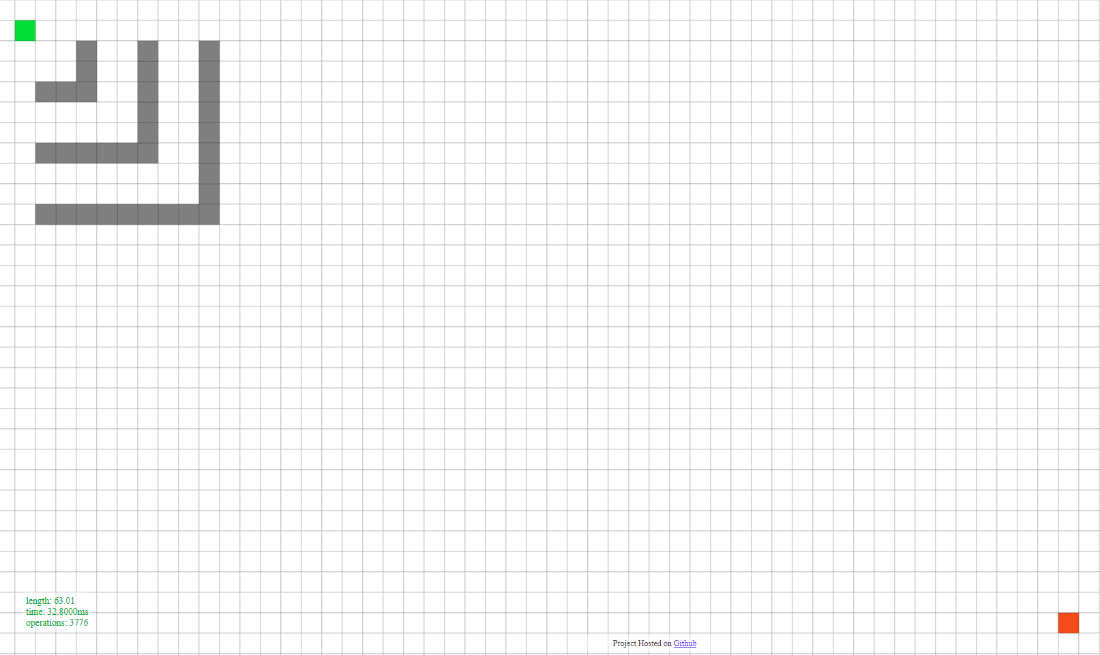

Level 3

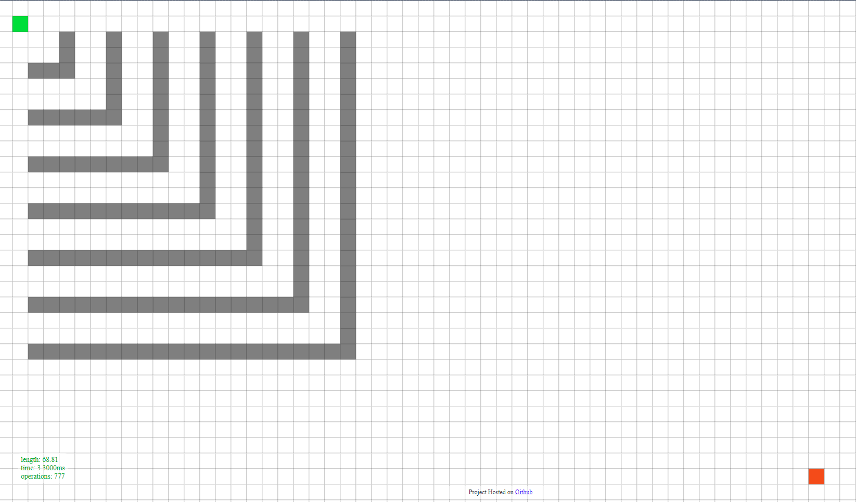

Level 4

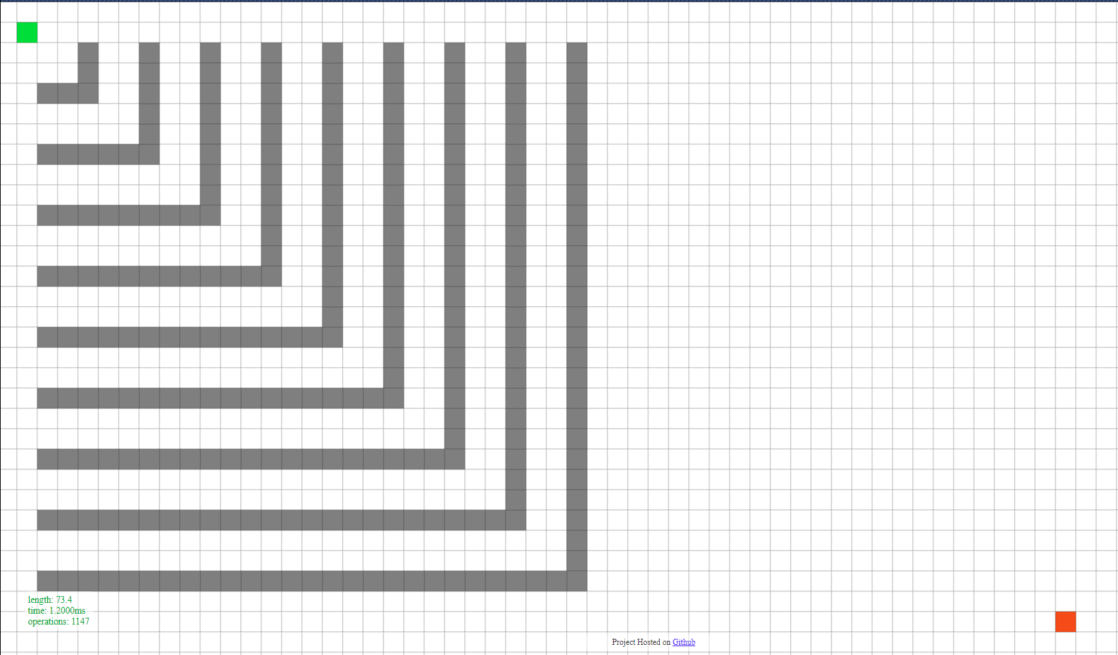

Level 5

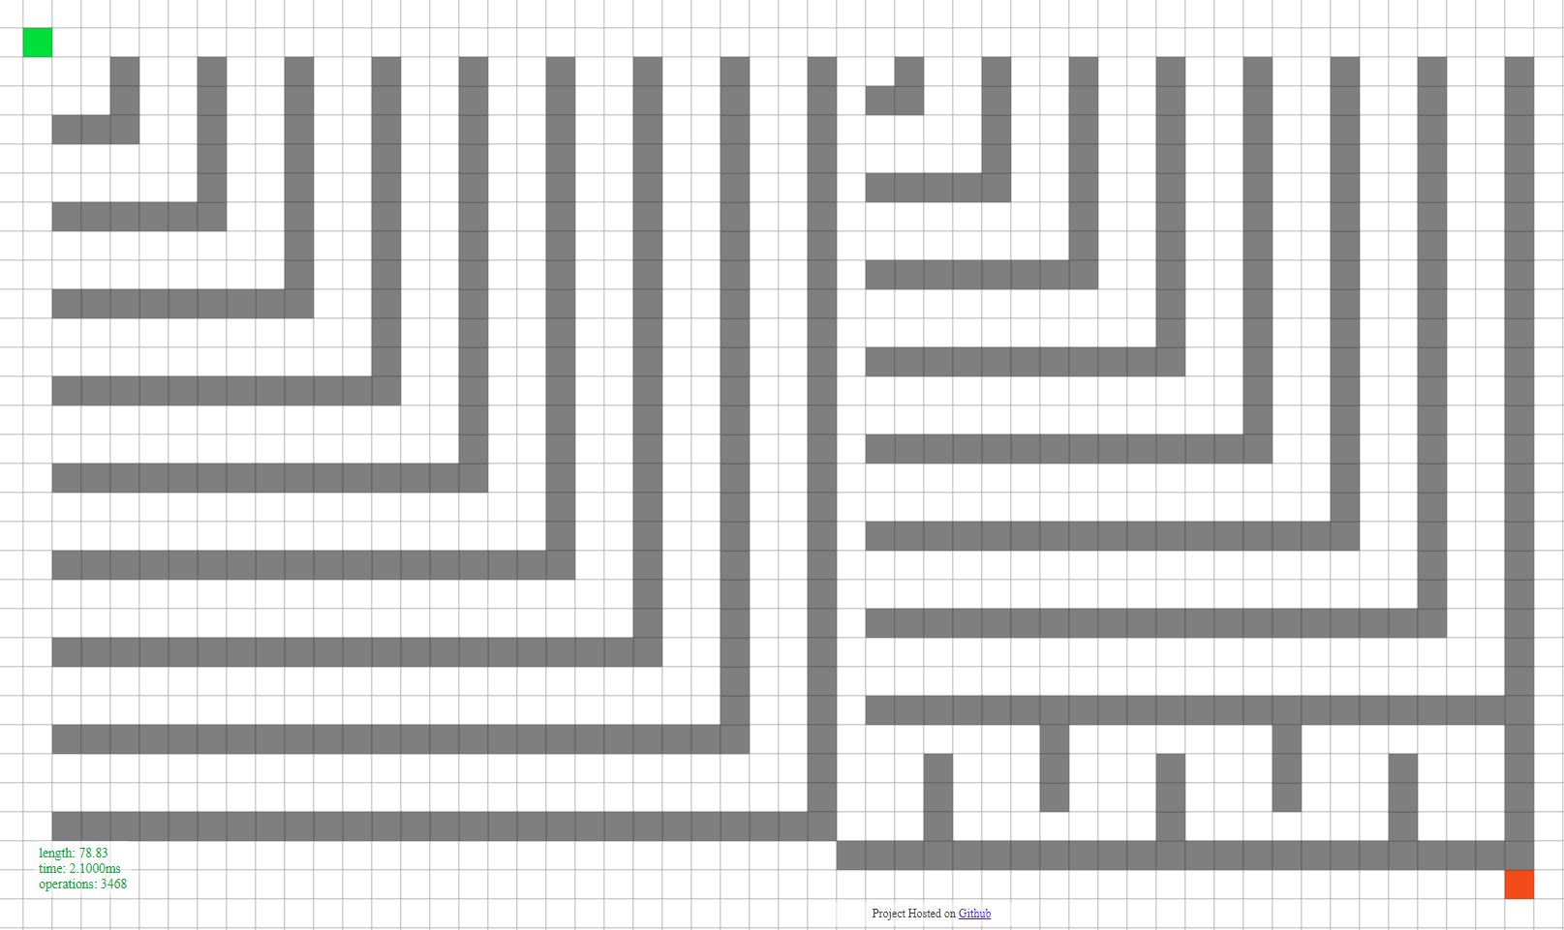

A* - Shorter length to target point, but performs more operations than Best-FS

Best-FS – Performs the least operations but result may not be the shortest way to target point.

Breadth-FS -Performs tons of operations but should give the shortest way to target point compare to the other two.