A digital platform for supporting long term retention in mental health research

# Background

Evidence suggests that participation in mental health services is not heterogenous with different groups experiencing different participation rates[1]. Retention in mental health research can be compounded by challenges in seeking access to services and adherence to treatments for mental ill health more generally, which is further exacerbated by demographic factors such as age, gender, and ethnicity[2].

Participation in research is burdensome. Naidoo et al[3] found the burden of participation was related to trial administration (exacerbated by high volume communications), inadequate communication formats, and a high variety of complex information. Interventions to improve retention in mental health services focus on engagement and have demonstrated some positive impact[4]. The systematic review by Woodall et al found that some research had reported outreach and engagement activities as beneficial to retention in studies[5].

Using routine social communication tools, such as text messaging and WhatsApp, to engage with participants of mental health research could:

* Increase engagement by utilising communication tools that participants use routinely, reducing the burden of communication in a more unfamiliar forum (e.g. a new app).
* Increase engagement by providing opportunities for two-way discourse outside of traditional phone and email communication, which isn’t always convenient to research participants.
* Provide opportunities to personalise ways in which research participants engage by allowing them to select their communication method preference.

# Prototype

What if we take the model of the Customer Relationship Management (CRM) system and make it a Participant Relationship Management (PRM) system? A traditional CRM system manages contact details, and logs interactions to allow for easy follow up and prioritisation – tasks which are equally key to the delivery of a research project. However, the core technology can be expanded on. In a world where interactions between human beings are increasingly digital, why can’t we leverage social communication technology to allow for interactions to be customised to the preferences of our participants without placing any extra pressure on the researcher?

In our prototype we have developed such a PRM system - a unified web portal by which researchers can:

1. Register their participants and add appropriate meta data.
2. Allow participants to define the method of communication that works for them.
3. Schedule and automate messaging to participants or groups.
4. Receive, review and apply ML methods to triage and escalate responses.
5. Audit and review their communication strategy to learn what does and doesn’t work.

The deep power of such a system comes from maturity. Once interactions have been recorded, the option presents itself to understand them. New participants can be compared to historical data to suggest optimal methods of communication, giving a step towards person centred, tailored research participation.

# Plans for Future Work:

## Vision

|  |  |
| --- | --- |
| Short term (end of 12 month project) | To co-design a digital product capable of enabling research participants in mental health studies to communicate with research teams in their preferred method and have this managed by a single source for researchers. |
| Medium term (follow-on study) | Determine efficacy of the digital tool in improving retention in mental health research studies. |
| Long term 5-10years) | Have a tool that has collected enough data that advanced analytics can be integrated to explore patterns of communication and risk factors for attrition and enable triaging of communication based on urgency of response. |

We are proposing a three-phase approach to co-developing our participant relationship manager: a partnership phase, a co-design phase and research design phase.

## The partnership phase (1-3 months)

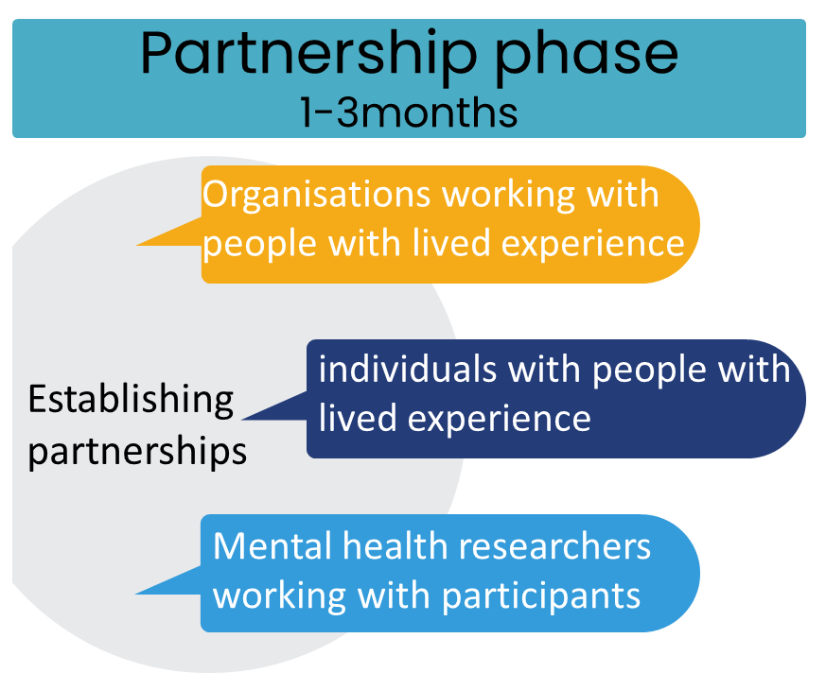We will work in partnership with people with lived experience of mental ill health and mental health researchers within an experience-based co-design (EBCD) approach[6]. This structured approach involves working with those who will experience the service or product that is being developed. We will work with three key groups:

1. **Existing organisations and charities which support mental health,** for example Mind. We will pro-actively make connections with organisations that amplify the voices of particular groups, e.g. Black Minds Matter. Different communities experience mental illness differently1, therefore we will collaborate with these organisations to seek their system-wide perspective, as well as to connect us with individuals with lived experience.
2. **Individuals with lived experience** of mental ill health and experience in research participation, including those who withdrew before the study completed.
3. **Mental health researchers** to understand the challenges they face when engaging research participants, and ensure that the digital tool supports their ‘work as done’ rather than ‘work as imagined’ (a human factors principle). Flexible partnership practices will allow us to respond to the needs of the individuals when engaging with them in the co-design process.

## The co-design phase (4-9 months)

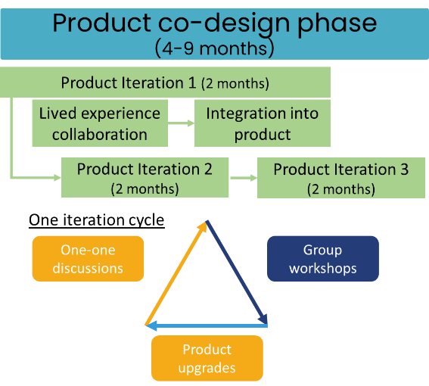Workshops tend to be the primary method for co-design. However, to ensure inclusivity we will offer additional opportunities to engage one-to-one in response to individual need (face to face or online). Whilst workshops remain our primary real-time co-design tool, this approach assures that individuals who experience barriers to workshopping may also contribute to the co-design process. Co-design will occur over three, two-month iteration cycles occurring one after another over a 6 month period. Each cycle consists of one-to-one discussions, which inform group workshops, which inform design/product upgrades. Upgrades are reviewed and refined in the next iteration cycle. At the end of the co-design phase, we will have collaboratively designed a tool to enhance relationships between mental health researchers and people with mental ill health in trials. We will have understood what was thought to be needed, how best to incorporate it into everyday practice and ensure it was user friendly.

As part of this process, we will aim to recruit 50 researchers in mental ill health to remotely test the tool and collect survey data on its usability. This will explore things such as overall experience, ease of use, intuitiveness, feature completeness, stretch goals (e.g. identification of new features) and more. Ten of these researchers will be invited to participate in a ‘walk and talk’ methodology whereby they are observed to use the tool for the first time and are asked to talk a project researcher through their thinking and use of the tool. We will invite up to 10 people who provided feedback on improvements to participate in a 20 minute interview to explore those challenges in further detail. Usability testing can only be done with researchers in mental ill health because they are the ones that will deploy the tool in the real world. People with lived experience of mental ill health will experience their engagement with a research team via their preferred and standard communication platform e.g. WhatsApp.

## Research design phase (10-12 months)

This phase addresses the need to empirically test whether the co-designed product improves retention in research trials. We will capitalise on established partner relationships to collaboratively design a research trial. Our early proposal is to design a multi-layered randomised controlled trial whereby we identify mental health studies where the research teams would be willing and able to overlay their trial with an embedded RCT of the participant relationship manager tool. We will continue to use face-to-face and workshopping to incorporate the views and experiences of people with lived experience of mental ill health and mental health researchers.

# Budget

|  |  |  |  |  |  |
| --- | --- | --- | --- | --- | --- |
| **Named researchers** | | | | | |
| Name | Personal attributes | Skills and expertise | Responsibilities | FTE | Cost (*) |
| Dr Robert Cook (PI) | Technical gremlin and data gubbins | Framework development, programming, implementation, analysis | Overall project responsibility, oversee the technical aspects of the product design. | 0.15 | (£10,085) |
| Dr Md Asaduzzaman (Co-I) | Disruptor and critical thinker | Statistician/machine learning modeller, validation, verification and quality assurance |  | 0.1 | (£3,905) |
| Dr Sarahjane Jones (Co-I) | Big picture thinker, jigsaw maker and cat herder | Research/data ethics, research governance, data and medical device legislation, partnerships and engagement | To ensure all relevant approvals are in place and study is conducted in line with ethical and legal frameworks. | 0.05 | (£4,960) |
| Charlotte Phillips (named researcher) | Critical mediator, zoomerouter and gentle speaker-upper | Co-design methodology, human factors, qualitative research | To oversee the co-design methodology and ensure partnership wellbeing. | 0.05 | (£7,139) |

*these costs are not being recovered and are being provided in-kind by the university in the delivery of the project.

|  |  |  |  |
| --- | --- | --- | --- |
| **Posts to recruit to** | | | |
| Role | Responsibilities | FTE | Cost |
| Full stack developer | To build both the front-end and the back-end of the web-based platform including backend development, API plug-in and server security. | 0.5 | £31,487 |
| Post-doctoral research fellow | To co-ordinate and deliver the co-design activity across the project lifecycle and project management | 0.5 | £25,562 |

|  |  |  |
| --- | --- | --- |
| **Expenditure** | **Description and justification** | **Cost** |
| Graphic design consultant | To support the design of the web-based platform to ensure it is aesthetically pleasing. 40 hours at £100 per hour | £6,000 |
| Partner Organisation | Nominal payment to support the administration and participation costs of partnering with the project team to deliver. The team will endeavour to ensure actual costs are within this and not ask too much of these organisations. We propose to engage two organisation providing funding of £5,000 including one organisation that works with people from an ethnic minority community. | £10,000 |
| Individual partner costs | Participation in up to 5 co-design events (three in product development, 2 in research co-design phase) for 10 people (5 researchers and 5 people with lived experience of mental ill health).  Based on NIHR costings we propose fees of £50 for up to a 2-hour discussion/workshop for an activity that requires little preparation (all activity including using the tool will be done in the session).  Additional £50 monthly payment to cover time costs relating to responding to emails and engaging with the project team. | £5,000  £2,500 |
| Technical costs | Hosted server time (e.g. AWS) Twillio accounts and usage fees and ngrok accounts | £5,000 |
| Travel and expenses | The use of this will depend on preferences for face to face and online activity so we have taken an average approach of £100 per person per event of which there are 5 plus 10 (assuming up to 3 people want to travel to do one-to-one discussions) | £6,000 |
| Dissemination costs | Conference or publication costs | £5,000 |

**Project Total Spend: £96,549**

1. Woodall, A., Morgan, C., Sloan, C., & Howard, L. (2010). Barriers to participation in mental health research: are there specific gender, ethnicity and age related barriers?. *BMC psychiatry*, *10*, 1-10.
2. Twomey, C. D., Baldwin, D. S., Hopfe, M., & Cieza, A. (2015). A systematic review of the predictors of health service utilisation by adults with mental disorders in the UK. BMJ open, 5(7), e007575.
3. Naidoo, N., Nguyen, V. T., Ravaud, P., Young, B., Amiel, P., Schanté, D., ... & Boutron, I. (2020). The research burden of randomized controlled trial participation: a systematic thematic synthesis of qualitative evidence. BMC medicine, 18(1), 1-11.
4. Greene, J. A., Bina, R., & Gum, A. M. (2016). Interventions to increase retention in mental health services: a systematic review. Psychiatric Services, 67(5), 485-495.
5. Woodall, A., Morgan, C., Sloan, C., & Howard, L. (2010). Barriers to participation in mental health research: are there specific gender, ethnicity and age related barriers?. BMC psychiatry, 10, 1-10.
6. Bate, P., & Robert, G. (2006). Experience-based design: from redesigning the system around the patient to co-designing services with the patient. *BMJ quality & safety*, *15*(5), 307-310.