Learning, Uncertainty Reduction and Optimizing the Location of Delimitation Wells in Hydrocarbon E&P

Wellington C. R. Nascimento^{a, b}, Marco A. C. Pachecoª, Marco A. G. Diasª,
Carlos L. Bastian-Pintoª, Luiz E. Brandão^{a, c}

ª Pontifical Catholic University of Rio de Janeiro, Brazil
^{b} Petróleo Brasileiro S.A., Brazil
^{c} University of Texas at Austin, USA

Keywords: Geostatistics, real options, value of information, delimitation campaign.

Abstract
The phases associated with the search for, and production of hydrocarbon reservoirs are known as Exploration and Production (E&P). The five main phases are: exploration, evaluation, development, production, and abandonment. As each step depends on the previous one, a combination of successful exploration, optimized assessment and commercial extraction is required to ensure a successful E&P cycle. Determining the number of appraisal wells is a problem widely discussed in the literature, however, studies are limited in determining the number and location of wells to obtain maximum profitability. There is no systematic approach. In this work we will use uncertainty reduction to optimize the location of wells. A quantity known as a learning measure will be used to measure the reduction of uncertainty in obtaining information. We use Geostatistics to obtain the spatial correlations of the delimitation wells. The study will complement the analysis of the value of information in the context of reducing uncertainty via evaluation wells. We will also analyze the value of flexibility quantified through real options theory which emphasizes the value of information. The use of real options will take place through the problem of delimiting the volume of oil, considering that there is already a discovery. This option is called a learning option because our objective is to resolve doubts in the delimitation stage and subsequently decide whether or not to develop the discovered field. This decision is strongly influenced by the economic context, known in the literature as market uncertainty.

Introduction
Delimiting a discovery is one of the most important and complex steps in planning the future development of an oil field. The ideal location and number of delineation wells are challenging dilemmas for the oil exploration and production industry. Delimitation activities revolve around the following questions (Haskett, 2003): 1) is the project worthy of development? 2) What is the appropriate size of the facility for the production potential? 3) What is the ideal development and production strategy needed to achieve maximum financial success?
In the delimitation stage there is no longer any exploratory risk, however, the uncertainty related to the volume discovered is high. An efficient delimitation campaign aims to maximize the value of information with minimum investment. Therefore, it is essential to know where to drill the wells and which sequence will contribute to the greatest expected reduction in variance. To do this, we will use a learning measure to evaluate investment in information. This measure called $η^{2}$ is defined as the expected percentage reduction in variance that constitutes a variance of the distribution of conditional expectations normalized by the a priori variance (Dias M. A., 2005).
In particular situations, the expected percentage reduction in variance is equal to the square of the correlation coefficient ($ρ$). This characteristic is fundamental for correlating exploratory wells, as it is a bivariate Bernoulli distribution (Dias M. A., 2005). We will use Geostatistics to obtain the spatial correlation of data, mainly between the locations of the delimitation wells. Geostatistical methods provide a set of techniques necessary to understand the apparent randomness of the data, however, what can be observed is a possible spatial structuring obtained by the spatial correlation function. This function represents the basis for estimating spatial variability in Geostatistics (Yamamoto & Landim, Geoestatística: conceitos e aplicações, 2013).
Geostatistics has been widely used in oil exploration to obtain a spatial probability distribution aiming at the optimal location of wells. The basic premise is related to the distance of the locations in relation to the discovery well. If the location is very close to the already drilled well, the chance of having a reservoir is high, however the reduction in uncertainty is low. For locations far from the already drilled well, if successful, there can be a good reduction in uncertainty, but, as the chance of success is low, the expected reduction in uncertainty tends to be reduced. Therefore, we have an optimal distance for the location of the appraisal wells in relation to the discovery well (Haskett, 2003). An interesting application was made to investigate a set of producing fields in the Texas-USA region. The region was divided into two areas: a training area, used to define the geostatistical parameters , and another test area analyzed from the perspective of data obtained in the training area, aiming to map the spatial distribution of chance factors (Willigers, Begg, & Bratvold, 2014). A more recent work (Morosov & Bratvold, 2021) proposes the use of Geostatistics to obtain geological probabilities in a more objective way, mainly during the exploratory phase. The proposed workflow takes as input conceptual models that describe geology and uses Geostatistics to generate spatial variability of geological properties in the vicinity of potential drilling prospects.
Once the spatial dependence model is obtained, the next step is to decide which drilling sequence adds the most value to the development plan. As projects can benefit from geological information obtained from boundary wells, it is possible to make good decisions to maximize the value of projects, as value erosion occurs in both overvaluation and undervaluation of projects. Selection of the delineation campaign can be made based on the value that spatial geological data adds to the development plan (Morosov & Bratvold, 2022). The drilling sequence in the delimitation stage will be in the decreasing direction of the values $η^{2}$ for each well, that is, the first well in the sequence will be the largest $η^{2}$ and the last well in the sequence will be the smallest $η^{2}$. This way, we will be able to maximize the expected reduction in variance. The results obtained $η^{2}$ will be compared using a series of simple decision trees, (Cunningham & Begg, 2008) allowing the consistency of the results to be verified.
Spatial dependence implies that data obtained at a certain position in space can inform and help the decision maker in relation to other locations, and this learning effect must be considered when analyzing and comparing information collection schemes. Therefore, it is possible to study the value of sequential information and quantify the effect of spatial dependence on decisions after information collection (Eidsvik, Martinelli, & Bhattacharjya, 2018). The value of information (VOI) can incorporate several aspects of decision-making in relation to subsurface exploration. We use VOI to determine the ideal sequence and location of appraisal wells. The optimal location and selection of exploratory wells changes when planning to drill wells in parallel, compared to planning to drill wells sequentially (Hall, et al., 2022).
Discounted Cash Flow (DCF) is one of the most common methods for valuing projects and the economics metric used is Net Present Value (NPV). However, the DCF does not consider the great uncertainties of the projects nor the flexibility of managers in decision making, considering the average values of the random variables in question, which in turn can distort the valuation. Therefore, the Real Options Theory (ROT) emerges, whose logical structure considers investment in a real asset as an option and not an obligation for the decision maker, given the uncertainty of the base asset conditioned on the value of the exercise price. The consolidated concepts of ROT can be consulted in one of the reference books on the subject (Dixit & Pindyck, 1994).
The problem addressed in this work consists of an area of interest where a company holds the rights to explore hydrocarbons. We will also consider that the option to drill the pioneer well has already been exercised and there has been a discovery. Therefore, we have a non-delimited field with high technical uncertainty in sizing the recoverable volume. The company's option in this case is to invest in the delimitation phase by drilling appraisal wells to obtain information about the volume of the reserve, reducing technical uncertainty and obtaining undeveloped, but delimited, reserves (Dias M. A., 2005). ROT provides us with the value of the opportunity to invest in the bounding wells (real option value) and the optimal decision rule (trigger to exercise the option). Market uncertainty, represented by the Brent oil price model, will be addressed via Brownian Geometric Motion (BGM) due to its mathematical simplicity and whose price properties are widely addressed in the literature.
The real options model adopted will be that of Paddock, Siegel and Smith (1988), which relates an American call option to the value of an undeveloped reserve in addition to considering a linear relationship between the value of the project and the price of the base asset. With the BGM representing the stochasticity of the oil price, we aim to calculate the monetary value of the option to invest after each delineation well. As a result, we will have the optimal number of delimitation wells since the value of additional information decreases with the number of wells.
The hydrocarbon field to be delimited can be seen as a derivative of the base asset, which is the price of a barrel of oil. As the base asset is stochastic, using the contingent asset method we arrive at a partial differential equation (PDE) of the value of a barrel of the undeveloped reserve. Since the PDE obtained is like to the Black-Scholes-Merton (BSM) equation whose analytical solution does not exist for the American option, we will use the finite difference method for the numerical solution. The numerical formulation adopted in this work is based on the one set out in (Dias M. A., 2015).

Methodology
The proposed methodology aims to improve the economic analysis of exploratory projects, incorporating the benefits of synergy between the following theories: Geostatistics, Learning Measurement, VOI, ROT and BSM. We will see how each theory can assertively contribute to quantifying the delimitation option. Figure 1 shows the dynamics of applying Real Options (RO) in the investment phases of oil Exploration and Production (E&P), starting with the acquisition of an exploration block, going through the development and production of the field, and ending with abandonment.
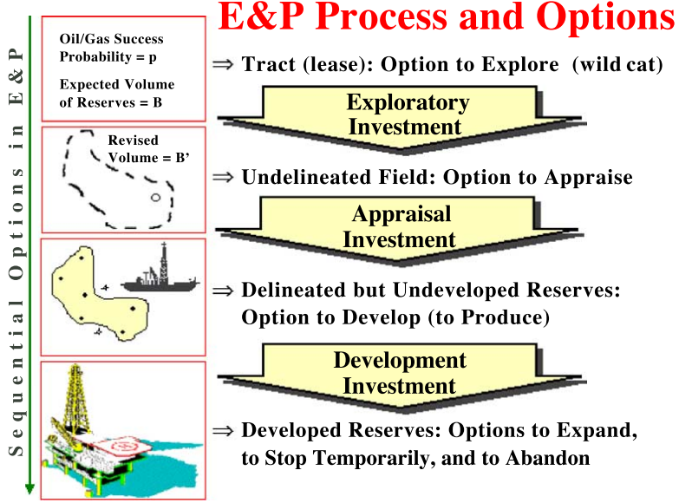
Figure 1: Real options in E&P. Source: (Dias M. A., 2014).
In Figure 1, the company exercising the RO to drill the pioneer well has a probability of discovering an oil field. As a result, the company then has the option of drilling delimitation wells. At this stage RO is a learning process to minimize uncertainties related to the volume and quality of the discovered reserve. By exercising the delimitation option, the company will invest in information (delimitation wells) until the VOI indicates the optimal number of wells. If the scenario revealed in relation to the volume and/or quality of the reserve is unfavorable, the company has the option of abandoning the field. Subsequently, once the company has exercised the option to delimit the field, it will have the development RO. By exercising the RO of developing the field, new options will emerge. For more details, the reader can consult Dias (2014). The focus of this work will be on the RO of field delimitation.

Geostatistical Analysis
Geostatistical analysis aims to determine the spatial correlation model of the data. Geostatistical estimation and stochastic simulation methods make use of the spatial correlation model, which is the variogram, which in turn is related to covariance.
Given the influence of the physical characteristics of the rock on the variation in the Factor of Chance (FC), it is plausible to suspect that there is a spatial relationship in the FC (Willigers, Begg, & Bratvold, 2014). To achieve this, our simplified reservoir model (a volume map) will be discretized into georeferenced cells where each cell has a specific volume value with a given FC, see Figure 2. Therefore, the volume at two different points may depend on the distances between these points, with volume being a random variable. Geostatistical analysis, through the experimental variogram, provides a formal approach to investigating this spatial dependence. To obtain fundamental information on geostatistical analysis, the reader is recommended to consult the works of Matheron (1971), Goovaerts (1997), Deutsch (2002) and Yamamoto (2013).
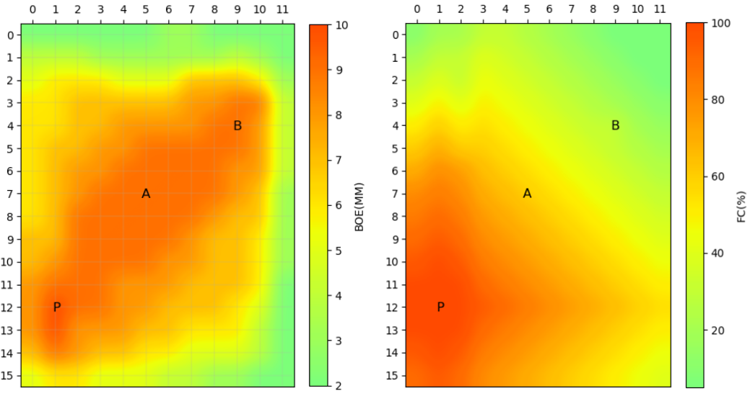
Figure 2: Volume map (left) and FC a priori (right).
The reservoir model presented in Figure 2 shows the location of the pioneer oil discovery well (P) located at coordinates $\left(x_{P}, y_{P}\right)=(1.0 km, 12.0 km)$ with ${FC}_{P}=100\%$. In didactic terms, for a better understanding of the methodology, we will assume only two delimitation wells (A and B). Their locations, as shown in Figure 2, are given by $\left(x_{A}, y_{A}\right)=(5.0 km, 7.0 km)$ and $\left(x_{B}, y_{B}\right)=(9.0 km, 4.0 km)$. The a priori factors of chance for these delimitation wells are ${FC}_{A}=60\%$ and ${FC}_{B}=30\%$. The input data is taken from Haskett (2003) and an example from a VOI course (Dias M. A., 2022), in which correlation was used as a learning measure to obtain the conditional probabilities. Here the model will be reviewed and reanalyzed using geostatistics techniques.
Our objective is to obtain the spatial correlation map that has a relationship with the expected percentage reduction in variance ( $η^{2}$). When it comes to correlating exploratory wells, in the case of Bernoulli's bivariate distribution, Dias (2005) showed that the correlation coefficient ($ρ$) is equal to the square root of $η^{2}$, that is, $ρ=\sqrt{η^{2}}$. However, to obtain the correlation we need the covariance, which in turn is related to the variogram through the equation:
$$\begin{aligned}Cov\left(h\right)=Cov\left(0\right)-γ(h) \#1\end{aligned}$$
where $Cov(h)$ is the covariance function that $h$represents a vector between any two points of the model, $Cov(0)$ is the covariance for zero distance and is the $γ(h)$ variogram function defined as the variance of the increment (Yamamoto & Landim, Geoestatística: conceitos e aplicações, 2013) given by:
$$\begin{aligned}γ\left(h\right)=\frac{1}{2}E\{{[Z\left(x+h\right)-Z(x)]}^{2}\} \#2\end{aligned}$$
variogram function is a measure of spatial variance and is the key to any Geostatistical estimation. In equation 2, the random $Z(x)$ function represents a realization for the set of random variables $\{Z\left(x_{i}\right), i=1,…,n\}$, known in Geostatistics as a regionalized variable.
The sample consists of a selection of values of the spatial random variable. To be representative, this sample needs to reproduce both the distribution and the spatial variability, both in terms of the number of data points and in relation to the distribution of these points in the study domain. However, it is important to highlight that any estimate based on sample points is subject to uncertainty. In this context, the geostatistical methodology stands out for providing a measure of the uncertainty associated with the estimate.
When we disregard the orientation of the samples, the variogram is commonly referred to as an omnidirectional variogram. In Figure 3 we have the omnidirectional experimental variogram for the sample values of the volume variable of the model presented in Figure 2.
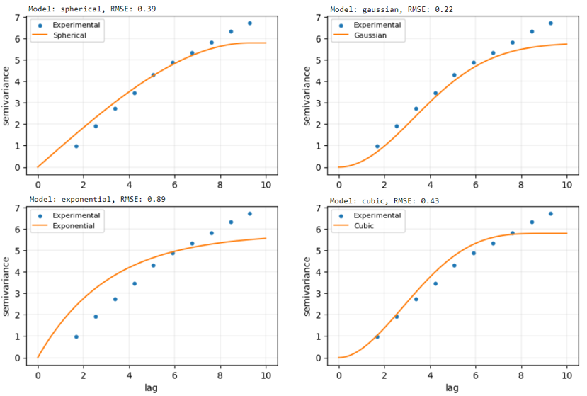
Figure 3: Experimental model and adjustment to four theoretical variogram models.

As we can see in Figure 3, the theoretical model with the lowest root mean squared error (RMSE) is the Gaussian model. You value at the ends of the experimental model can be neglected, since for $h=0$, the theoretical model has zero variance, and the upper limit is the variance of the sample data whose value is approximately $5,26 {BOE(MM)}^{2}$.
Let's take the direction into account when calculating the variogram. For the model (Figure 2) four directions will be considered:
0° - (East – West)
90° - (North – South)
53° - (Southeast – Northwest)
143° - (Southwest – Northeast)
The angles are in relation to the horizontal in a clockwise direction. The angle of 53° is approximately the direction perpendicular to the reservoir in the model in Figure 2 and 143° is the direction of the reservoir. According to Figure 4a, the orthogonal pair of variograms that presents the greatest difference is the 53°-143° pair, therefore, these are certainly the anisotropy directions.
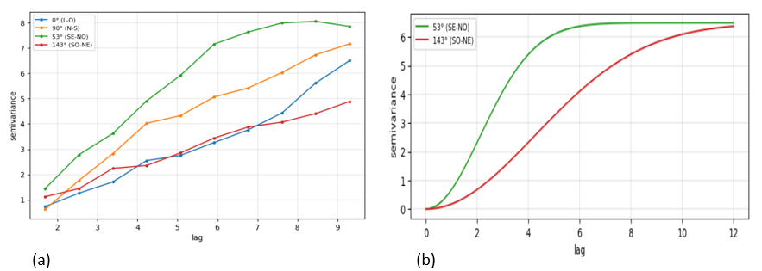
Figure 4: (a) Directional variograms, (b) Geometric anisotropy.
In Figure 4b we have an interesting characteristic for the variogram pair: different amplitudes in the anisotropy directions, but a single plateau. In this case, the anisotropy is said to be geometric. When the anisotropy directions have the same amplitude, but different levels, the model is known as zonal anisotropy. In the case of mixing the two models, we have mixed anisotropy (Yamamoto, 2020).
Our simplified reservoir model (a volume map) will be discretized into georeferenced cells where each cell has a specific volume value, Figure 5a. We can see that the sampling of our model is systematic and carried out on the nodes of a regular 12 x 16 mesh.
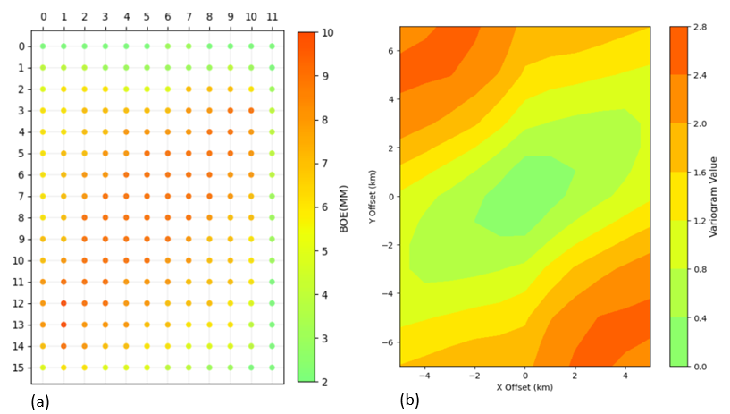
Figure 5: (a) Discretized model and (b) variogram map.

Variogram map (Figure 5b) is an extremely useful auxiliary tool in defining anisotropy directions. It involves calculating variograms in various directions, the results of which are presented on a map, hence the name variogram map (Chilès & Delfiner, 2012). The variogram map is obtained by calculating all variograms from 0° to 180°, in predefined angular intervals. The variogram function values are plotted according to the color scale. Distances are projected from the center. It is important to note that the variograms from 0° to 180° are reflected specularly to the range 180° to 360°, as shown in Figure 5b. For example, the variogram in the 5° direction is reflected to 185°, and so on. And, the existence of anisotropy can be clearly verified, with the direction of greatest continuity at 143°.
Variogram function, covariance and correlation are related, the latter being the normalized covariance. To obtain a spatial correlation model for the delimitation wells (A and B), we need to correct the geometric anisotropy in both directions. A method for combining the various directional models into a model consistent with all directions is equivalent to defining a transformation that reduces all directional variograms to a common standardized model with a unit threshold.
The correction of geometric anisotropy is performed through transformations. First, the angle between North and the major axis of the ellipse is measured, $θ$ which represents geometric anisotropy. Then, the axes are rotated according to the angle $θ$. Thus, given the distance vector $h=(h_{x},h_{y})$ between any two points, the new distance vector $h^{'}=(h_{x}^{'},h_{y}^{'})$ after rotation $θ$ is obtained by:
$$\begin{aligned}\left[\begin{matrix}h_{x}^{'} \\ h_{y}^{'}\end{matrix}\right]=\left[\begin{matrix}cos⁡(θ) & sen(θ) \\ -sen(θ) & cos⁡(θ)\end{matrix}\right]\left[\begin{matrix}h_{x} \\ h_{y}\end{matrix}\right] \#3\end{aligned}$$
After rotation, resizing is done, such that the ellipse will be represented by a circle with a radius equal to the minor axis:
$$\begin{aligned}\left[\begin{matrix}h_{x}^{''} \\ h_{y}^{''}\end{matrix}\right]=\left[\begin{matrix}1 & 0 \\ 0 & λ\end{matrix}\right]\left[\begin{matrix}h_{x}^{'} \\ h_{y}^{'}\end{matrix}\right] \#4\end{aligned}$$
This means that, after correcting geometric anisotropy, the variogram of the direction of least continuity will be used as the isotropic (Yamamoto & Landim, 2013) variogram. This is done necessary because in the isotropic variogram, the spatial correlation model has common parameters (nugget effect, spatial variance, and amplitude) in all directions.

Spatial correlation
Allow us to present our initial reservoir model together with the a priori variance to understand how the uncertainty in our model is distributed (Figure 6).
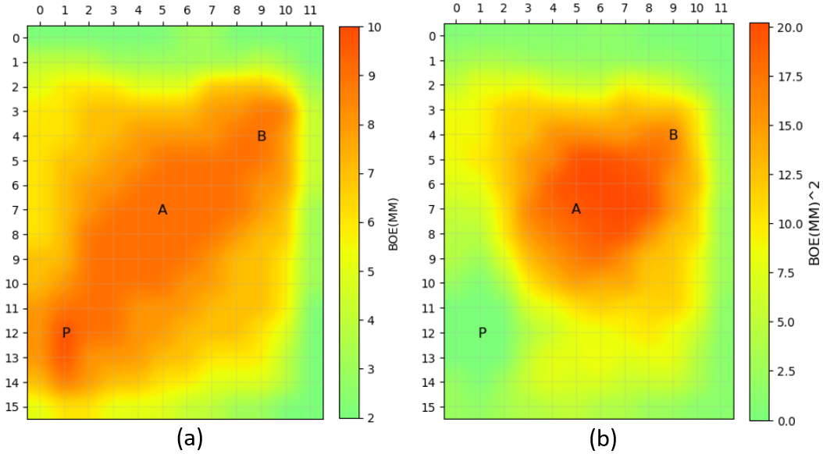
Figure 6: (a) volume map, (b) prior variance.
In Figure 6b we see that in the location of the discovering wildcat well (P) the variance is zero, that is, there are no uncertainties in this region since oil was discovered. The region of greatest variance is found between the locations of the delimitation wells (A and B). This is because the technical uncertainty resides precisely in the volume of the reservoir to be developed.
The spatial correlation in relation to location A, in the two anisotropy directions, is shown in Figure 7. We let your values highlighted for better analysis and comparison.
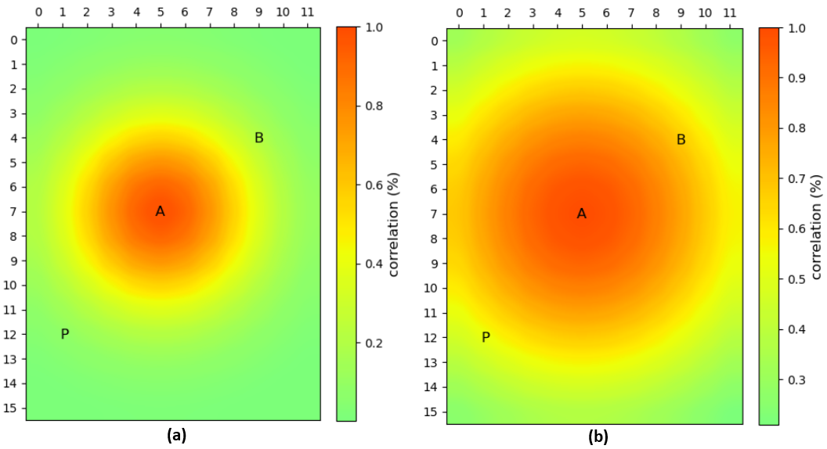
Figure 7: Correlation with location A in the direction (a) 53° and (b) 143°.
At location A, $\left(x_{A}, y_{A}\right)=(5.0 km, 7.0 km)$ the correlation is maximum, as it should be. As we move further away the correlation decreases radially. We noticed that the correlation decreases more quickly in the 53° direction (Figure 6a) when compared to the 143° direction (Figure 6b). This result is in complete agreement with the variogram in Figure 4b.
In Figure 8 we have the spatial correlations in relation to location B whose location is $\left(x_{B}, y_{B}\right)=(9.0 km, 4.0 km)$. Like location A, we notice that the correlation is maximum at the location of boundary well B and decreases as we move away.
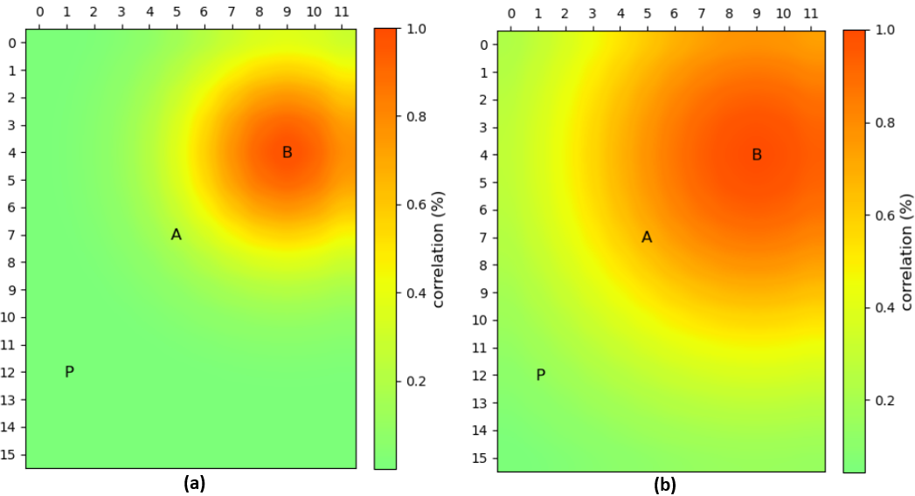

Figure 8: Correlation with location B in the direction (a) 53° and (b) 143°.
Having the correlation maps in both directions, we need to correct the geometric anisotropy using equations 3 and 4, for the two delimitation wells. The result is a spatial correlation map for each location (Figure 9).
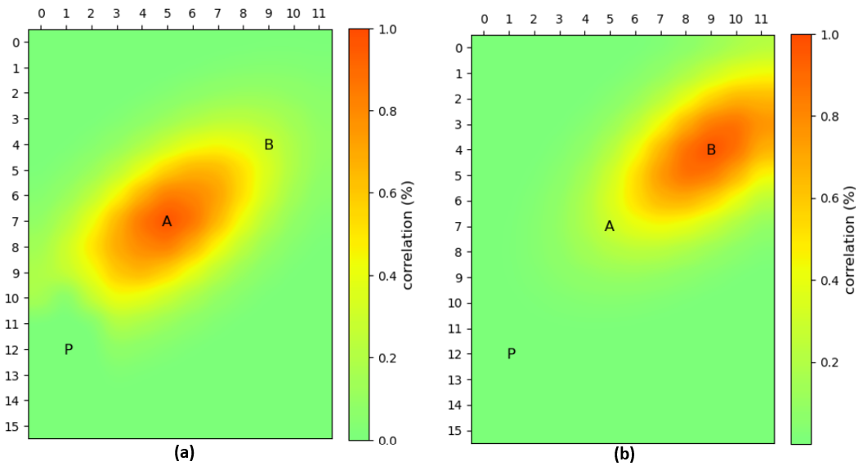
Figure 9: Correlation map in relation to locations (a) A and (b) B.

Having the spatial correlation of delimitation wells, A and B (Figure 9), we need to make one last correction. It is the application of the Fréchet-Hoeffding limits to the correlation coefficient. If the limits are not respected, the consequence may be a negative probability in one of the possible scenarios of the bivariate Bernoulli distribution or even values above 100%. The Fréchet-Hoeffding limits for the correlation coefficient are (Dias M. A., 2005):
$$\begin{aligned}Max\left\{-\sqrt{\frac{{FC}_{2}{FC}_{1}}{(1-{FC}_{2})(1-{FC}_{1})}}, -\sqrt{\frac{(1-{FC}_{2})(1-{FC}_{1})}{{FC}_{2}{FC}_{1}}}\right\} ≤ρ \#5\end{aligned}$$

$$\begin{aligned}ρ≤\sqrt{\frac{Min\{{FC}_{2},{FC}_{1}\}(1-Max\{{FC}_{2},{FC}_{1}\})}{Max\{{FC}_{2},{FC}_{1}\}(1-Min\{{FC}_{2},{FC}_{1}\})}} \#6\end{aligned}$$
where ${FC}_{1}$ and ${FC}_{2}$ are the success probabilities (odds factors) of the two correlated marginal Bernoulli distributions. Applying the limits given by equations 5 and 6 to the correlation maps in Figure 9, the result is presented in Figure 10.
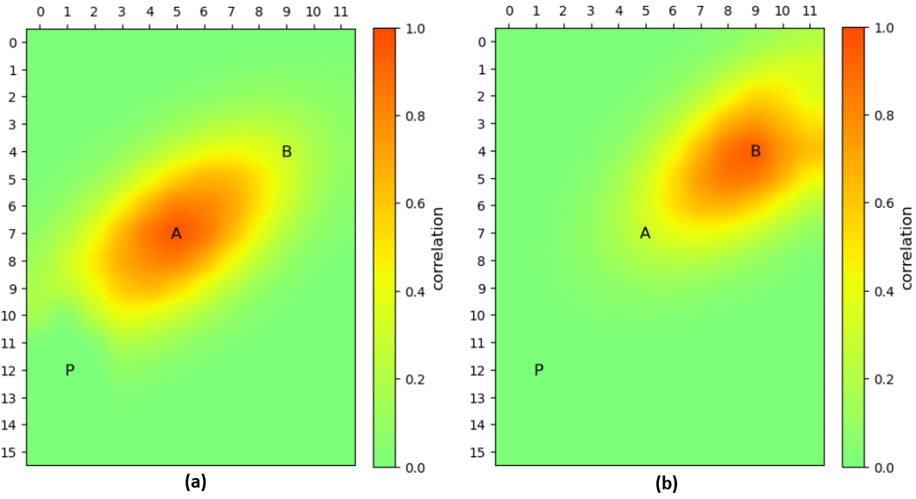
Figure 10: Correlation maps in relation to locations (a) A and (b) B after applying the Fréchet-Hoeffiding limits.
Correlation is a symmetric measurement, which can be seen in Figure 10. In Figure 10a in coordinates, $(x_{B},y_{B})=(9, 4)$ the correlation value is equal to the correlation value in Figure 10b in coordinates $(x_{A},y_{A})=(5, 7)$, i.e.:
$$\begin{aligned}Cor\left(A,B\right)=Cor\left(B,A\right)=0,30 \#7\end{aligned}$$
Figure 11 is the same as Figure 10, but showing the spatial correlation values.
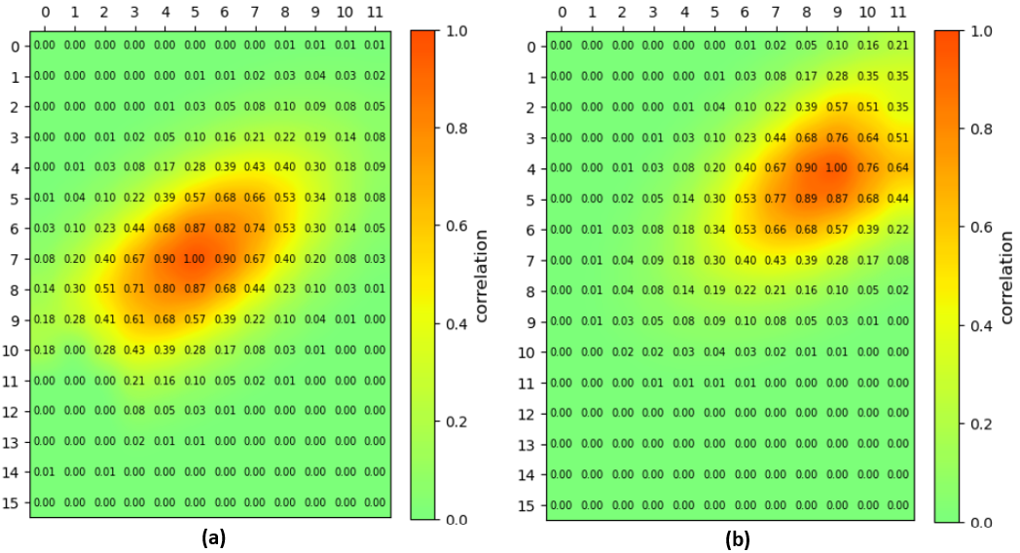
Figure 11: Correlation maps in relation to locations (a) A and (b) B.

Correlation is a symmetric measurement, which can be seen in Figure 11. In Figure 11a in coordinates, $(x_{B},y_{B})=(9, 4)$ the correlation value is equal to the correlation value in Figure 11b in coordinates $(x_{A},y_{A})=(5, 7)$, i.e.:
$$\begin{aligned}Cor\left(A,B\right)=Cor\left(B,A\right)=0,30 \#7\end{aligned}$$
Therefore, Figure 11 presents the final spatial correlation maps in relation to the delimitation wells A and B. These results are useful for calculating the learning measure that will provide the expected percentage reduction in variance. Let's now obtain the FCs in case of success and/or failure for each delimitation well, that is, the conditional FCs.

Conditional odds factor
The Bernoulli distribution is one of the most common and simplest probability distributions in statistics. It is a distribution that has only one parameter and two scenarios. One of the scenarios is likely $p$ to occur (1: success) and the other scenario is likely $(1-p)$ to occur (0: failure). The distribution will be adequate to model the most basic uncertainty inherent to oil exploration, namely, the uncertainty regarding the existence of oil when drilling a well. The variable that expresses such uncertainty is the FC, which reflects the probability of the existence of oil in each location. Like this,
$$\begin{aligned}FC\sim Be(p) \#8\end{aligned}$$
In situations where $p=0$ either $p=1$ the Bernoulli distribution is designated as degenerate. Therefore, we have full disclosure of the true distribution scenario, that is, if $p=0$ then with 100% probability $FC=0$, and if $p=1$ then $FC=1$ with 100% chance. In these cases, uncertainty is eliminated. In oil exploration this occurs when a specific well is drilled and then the result is either success or failure.
An important analysis in oil exploration is the modeling of how certain information acquired can revise the FC of correlated regions. This becomes important in the context of prioritization and optimized sequencing of a drilling campaign.
The information acquired and the drilling FC are random variables that follow the Bernoulli distribution. The dependence relationship between the two distributions is specified through the joint probability distribution, in this case the bivariate Bernoulli distribution. Being ${FC}_{0}$ the probability of success before the information coming from signal S (acquired information), the distribution of revelations has only two scenarios, ${FC}^{+}$ and ${FC}^{-}$ since $FC\sim Be(p)$, according to equation 8.
For non-negative correlation, since in the case of oil exploration there is generally no point in having $ρ<0$, the probabilities of success revealed by the sign S are given by:
$$\begin{aligned}{FC}^{+}={FC}_{0}+\sqrt{\frac{1-q}{q}}\sqrt{{FC}_{0}(1-{FC}_{0})} ρ \#9\end{aligned}$$
$$\begin{aligned}{FC}^{-}={FC}_{0}-\sqrt{\frac{q}{1-q}}\sqrt{{FC}_{0}(1-{FC}_{0})} ρ \#10\end{aligned}$$
Equations 9 and 10 are particularly important since the set of simultaneous revisions of FC possible at each step of the exploratory campaign will be considered.
Now see a sequence of results from the simulation to obtain FC maps in the case of success/failure for the delimitation wells (A and B). The results will be presented together with the a priori FC in order to better analyze the behavior of this parameter.
In Figure 12a we have the a priori FC map of our model given as Figure 2. At the same time, in Figure 11b, we have the FC conditional on the success of location A, that is, $FC\left(A^{+} | A=1\right)$.
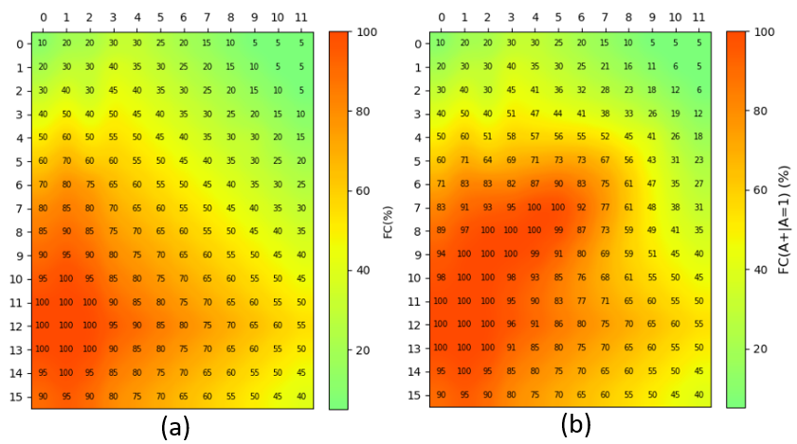
Figure 12: a) FC a priori. b) FC(A+|A=1).

Despite overloading the map, we leave the values for better analysis and comparison. When analyzing the maps in Figure 12, we see the coherence of the results. With the success of location A, the red part of the map (Figure 12a), indicating high FCs, spreads towards A (Figure 12b). The FC of location B, which was previously 30%, increased to 41%. In this way, the uncertainty that initially existed in relation to the initial volume model decreases, as we can see in the maps in Figure 13.
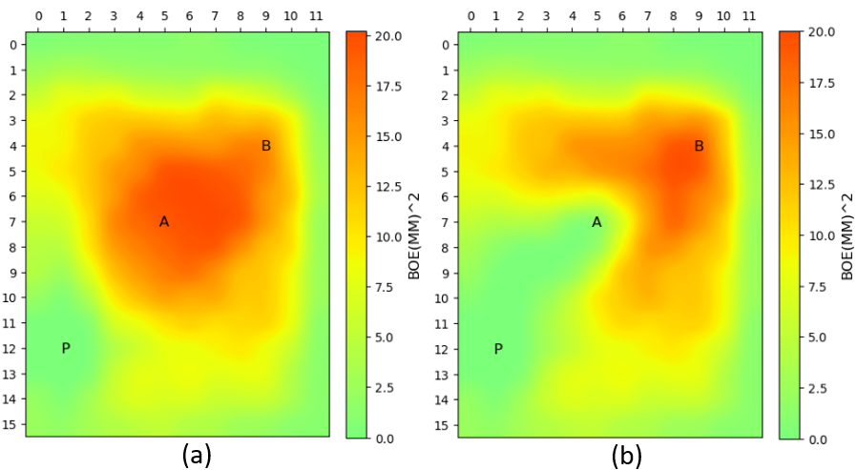
Figure 13: a) Prior variance. b) Variance conditional on the success of location A.

The uncertainty that previously extended throughout the region where locations A and B are located (Figure 13a) is now concentrated more intensely around location B (Figure 13b).
In the bad news situation, that is, location A indicating failure, the conditional FC indicated by $FC\left(A^{-} | A=0\right)$ is shown on the map in Figure 14b.
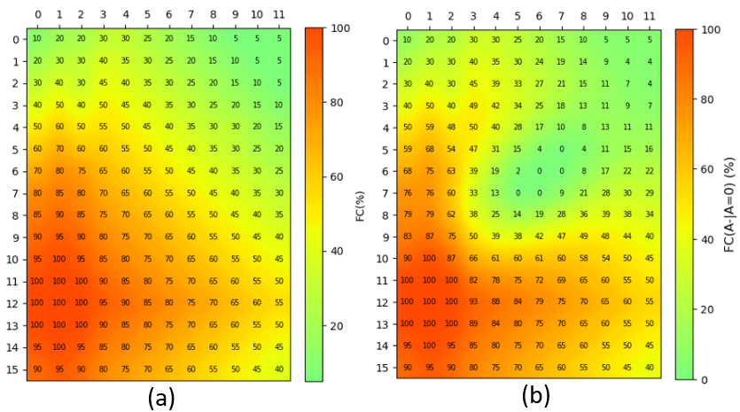
Figure 14: a) FC a priori. b) FC(A-|A=0).

Location A indicating failure, the FC of location B, which was previously 30%, dropped to around 13%. In this way, uncertainty will be more concentrated in the region between the discovery well and location A, as shown in the map in Figure 15b.
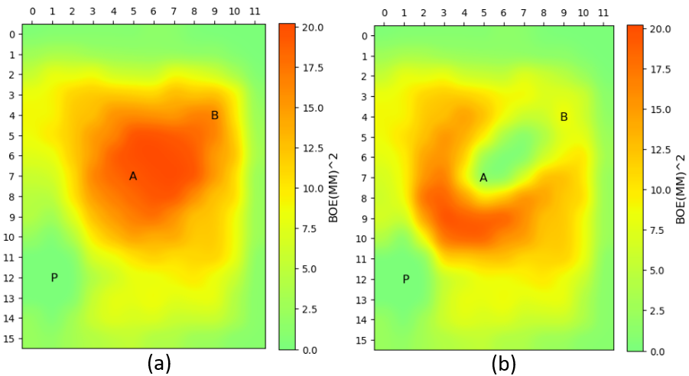
Figure 15: a) Prior variance. b) Variance conditional on the failure of location A.

Let us now look at the behavior of the FC maps in the face of the success or failure of location B. In Figure 16a we have the a priori FC map of the initial model and in Figure 16b the FC map conditional on the success of location B, that is, $FC\left(B^{+} | B=1\right)$.
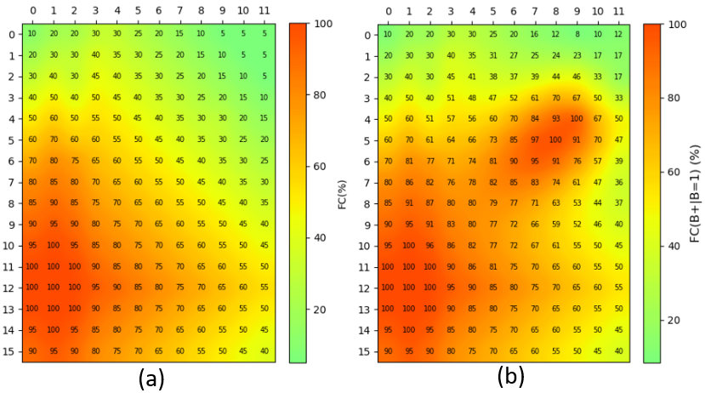
Figure 16: a) FC a priori. b) FC(B+|B=1).

In the situation of drilling location B and achieving success, the chance factor of location A, which was previously 60%, increases to around 82%. In fact, the FC improves in all cells located between locations A and B. As a result, the variance decreases in this region, as we can see in Figure 17b.
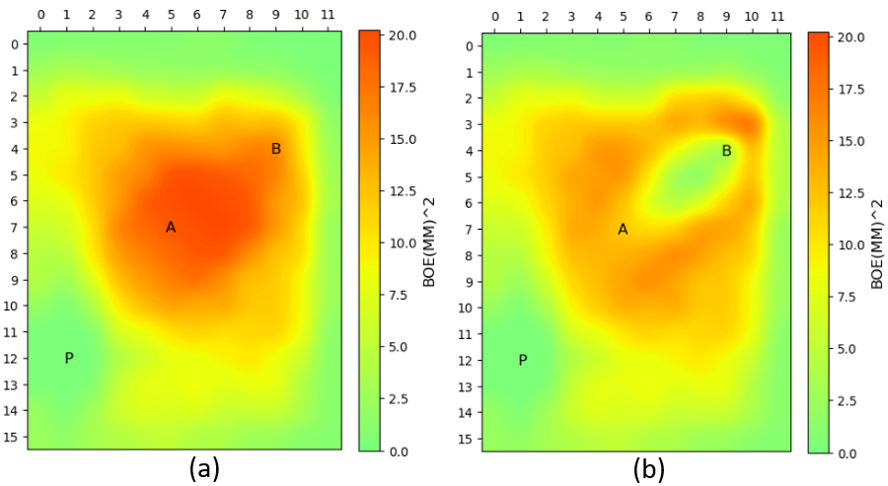
Figure 17: a) Prior variance. b) Variance conditional on the success of location B.

Location B indicating failure, the conditional FC indicated by $FC\left(B^{-} | B=0\right)$ is shown on the map in Figure 18b.
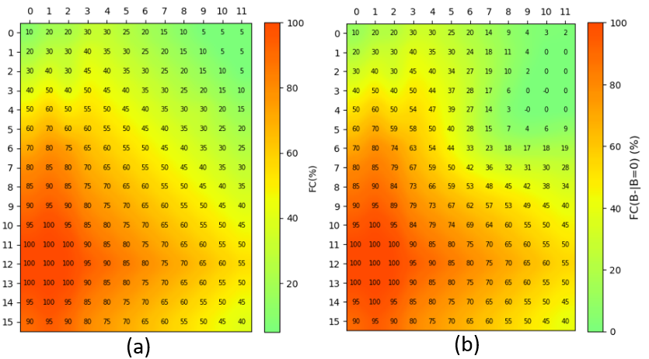
Figure 18: a) FC a priori. b) FC(B-|B=0).

Despite the failure in location B, the FC of location A is little affected, falling from 60% to 50% (Figure 18). The uncertainty that initially extended to the vicinity of location B, is now restricted to the surroundings of location A, maintaining the total coherence of the results (Figure 19).
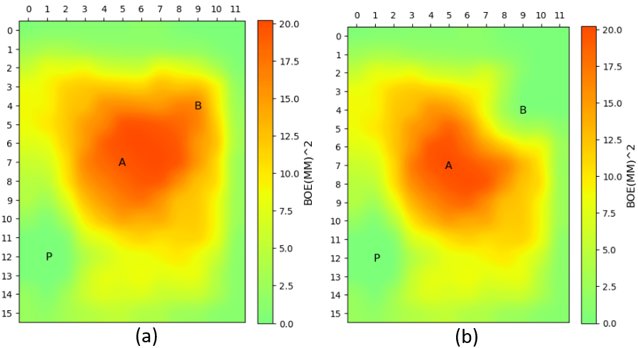
Figure 19: a) Prior variance. b) Variance conditional on the failure of lease B.

Learning Measure
The use of learning measures to evaluate investments in information was proposed by Dias (2005), including in the case of exploratory opportunities. The measurement parameter used is $η^{2}$ what provides the effectiveness of the information we wish to acquire to reduce uncertainty in the decision-making process (Pinto, Aguiar, & Moraes, 2011).
Let there be two variables random $X$ and $S$ with finite means and variances, defined in the same probability space $(Ω,Σ,Ρ)$. The expected percentage reduction in the variance of a given signal or information $S$ is defined $X$ as (Dias M. A., 2005):
$$\begin{aligned}η^{2}(X|S)=\frac{var\left(X\right)-E[var(X|S)]}{var(X)} \#11\end{aligned}$$
where $var(∙)$ represents the variance and $E[∙]$ the expected value. The numerator given in equation 11 provides the absolute reduction of variance, that is, the prior variance minus the average variance after (average of the variances of the posterior distributions) of the information. Dividing by the prior variance we have a percentage reduction in variance.
To better understand the concept of $η^{2}$, be it $X$ a technical variable with uncertainty, for example, the volume of oil in a region where there was a discovery: we know there is oil, we don't know the quantity. And let $S$ the new information be provided, in our case, by the delimitation wells. The parameter $η^{2}$ measures how much the estimates of $X$ are improved by obtaining new information ($S$) in relation to the initial estimates of $X$ (without new information). This learning reduces (or at least does not increase) the value of the average variance of the posterior distribution of the random variable under study.
It is important to highlight that the optimal moment for investing in information can be analyzed. In most cases there is a deadline for the exploratory activity, imposing a restriction in relation to the choice of the optimal moment, so the learning option has its moment great exercise.
The simplified volume model (Figure 2) shows two possible delimitation locations. Both locations have a learning objective that is to reduce the uncertainty related to the initial volume. Location A is a moderate distance from the discovery well, while location B, further away, is testing at roughly the extreme end of the volume distribution. Each location will contribute to reducing uncertainty. The well whose percentage variation in uncertainty is greater will be the first to be drilled.
Using equation 11, the value of $η^{2}$ for each well is given by:

Well A: $η^{2}\left(vol | A\right)=16\%$ and Well B: $η^{2}\left(vol | B\right)=11\%$.

Therefore, well A contributes more to reducing uncertainty than well B. Although the values of, apparently close $η^{2}$, the learning measure for well A is 45% better than the learning measure for well B. Therefore, considering our initial model, and the data presented, well A would be the first to be drilled.
The learning measure $η^{2}$ presents itself as an important tool for the optimal sequencing of delimitation wells. The sequence excellent it will be the one whose first wells will contribute to a greater reduction in uncertainty, that is, the learning potential has an optimal number of wells, since we will have a moment when the contribution to reducing uncertainty becomes irrelevant. Furthermore, the more wells drilled, the higher the cost of obtaining the information, again, leading us to conclude that there is an optimal number of wells whose contribution to the value of the information is maximum. We believe that a map will $η^{2}$ contribute greatly to this analysis.

Value of information
Information Value Analysis (VOI) aims to establish quantitative methods with the aim of valuing the acquisition of new information. The importance of VOI is evidenced by the fact that investment in information reduces technical uncertainty, which provides a more favorable situation for decision making. Furthermore, new scenarios are revealed: in favorable ones, the project can be developed and in unfavorable ones, abandoning the project, avoiding greater losses. And the fundamental question for any information investment process is whether the likely improvement in decision making is worth the cost of obtaining the information (Bratvold, Bickel, & Lohne, 2009).
The fundamental objective of VOI is to evaluate the benefit of collecting additional information to reduce or eliminate uncertainty in a specific decision-making context (Yokota & Thompson, 2004). A VOI analysis features the possible potential for loss arising from errors in decision-making due to uncertainties. At the same time, it makes clear the best strategy for obtaining information that will lead the decision maker on the path to maximizing the value of the project.
We also must consider the risks in the development phase that can be reduced if information is obtained to reduce or eliminate uncertainties. Basically, there are three types of risks at this stage : loss of opportunity (a prospect is considered uneconomical and abandoned, but is actually economically viable), non-commercial development (an uneconomical field is developed because it is mistakenly considered economical) and (Demirmen, 2001) suboptimal development (an developed field yields less than the maximum economic return that could be obtained if the correct reservoir model were considered).
But acquiring information is directly associated with costs. Therefore, before deciding to obtain information, we must analyze two aspects: whether it is worth obtaining additional information and whether there is information capable of improving the decision process (Ligero, Xavier, & Schiozer, 2005).
The VOI is obtained by:
$$\begin{aligned}VOI={EMV}_{2}-{EMV}_{1} \#12\end{aligned}$$
where ${EMV}_{2}$ is the expected monetary value of the project in optimal development scenarios (with evaluation) and ${EMV}_{1}$ is the expected monetary value of the project in the base case (without evaluation), or if you prefer:
$$\begin{aligned}VOI=\left[\begin{aligned}Expected value with \\ additional information\end{aligned}\right]-\left[\begin{aligned}Expected value without \\ additional information\end{aligned}\right] \#13\end{aligned}$$
The decision rule is (Demirmen, 2001):
$$\begin{aligned}Appraise if VOI>PV appraisal cost \#14\end{aligned}$$
The difference between $VOI$ and the cost of the assessment represents the expected net economic benefit of the assessment.
An interesting relationship between $VOI$ and the learning measure $η^{2}$ was given by Dias (2005) to obtain imperfect information. According to Dias (2005), VOI can be obtained as a function of the perfect information penalty factor ($η^{2}$, learning measure), in an approximately linear way, as we can see in Figure 20.
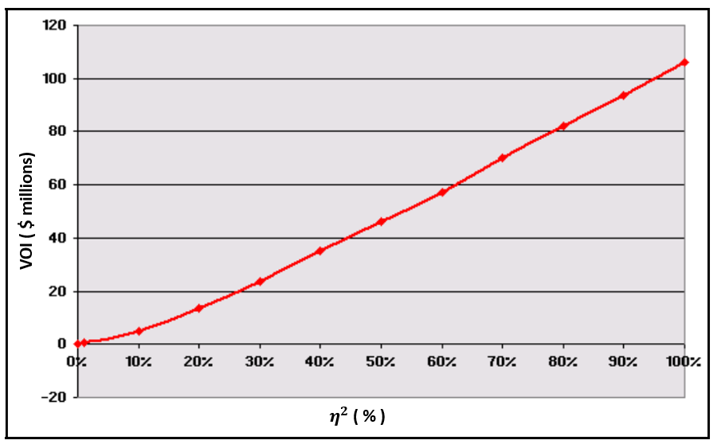
Figure 20: Value of Information as a function of $η^{2}$. Source: (Dias M. A., 2005).
Figure 20 shows that for $η^{2}$ equal to zero, the VOI is also equal to zero. That is, the information considered does not add additional value. For $η^{2}$ equal to 100%, the value of the information reaches its maximum value, a situation that constitutes perfect information. Also, according to Dias (2005), the gross VOI (before deducting the cost of information) is defined as the gross value of imperfect information, whose expression is given by:
$$\begin{aligned}VOI=VOII=VOIP∙η^{2} \#15\end{aligned}$$
where $VOII$ is the gross value of imperfect information and $VOIP$ the gross value of perfect information.
Perfect information is information that contains all the details, is accurate, complete, updated, and reliable. It allows you to make decisions accurately and efficiently, as all relevant variables are available and clear.
Imperfect information is information that contains gaps, uncertainties, or lack of details. It may be incomplete, outdated, inaccurate, or even false. Imperfect information makes decision-making difficult, as it can lead to erroneous interpretations, uncertainties, or risks.
Drilling exploration wells is investing in uncertain assets. The existence of hydrocarbons is uncertain and, even if the exploratory well leads to a discovery, it remains uncertain whether the volumes are commercially feasible. For such investment decisions, we need evaluation and decision models that consider all relevant aspects of uncertainty. The expected value of a well is a metric that serves as a decision for drilling.
The expected value of drilling a well is a function of many uncertain variables. The probability of “success” and the “probability distribution of volumes given that success” are important uncertainties. We consider several possible scenarios that are representative if we are successful. The net present value (NPV) of the cash flows in each scenario is a parameter widely used in determining the expected value to guide future actions: drilling the well, acquiring information or abandoning the well. Decision tree models are often used to represent uncertainties, decisions, and results.
The decision trees presented in Figures 21 and 22 show the results of the drilling sequences of wells A and B. As we can see, the sequence A→B is the one with the best chance of gains, confirming the sequence obtained with the learning measure $η^{2}$.
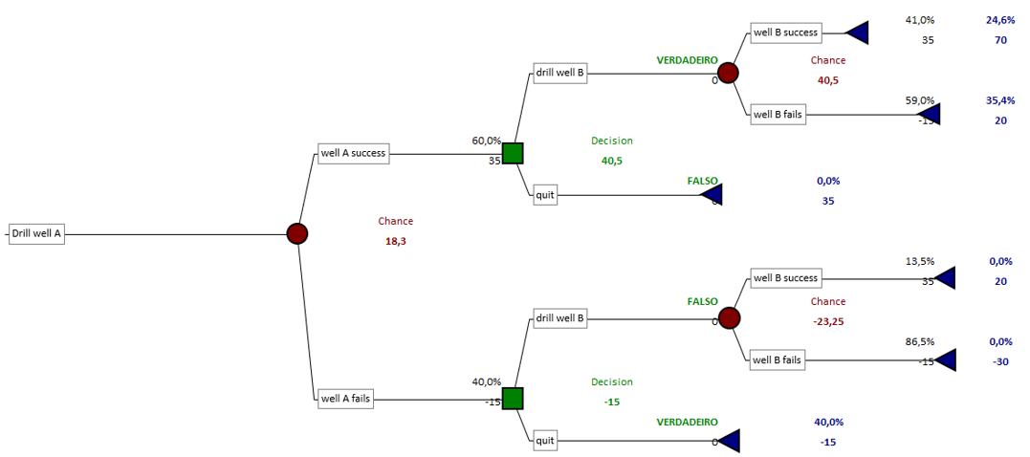
Figure 21: Drilling sequence A→B.

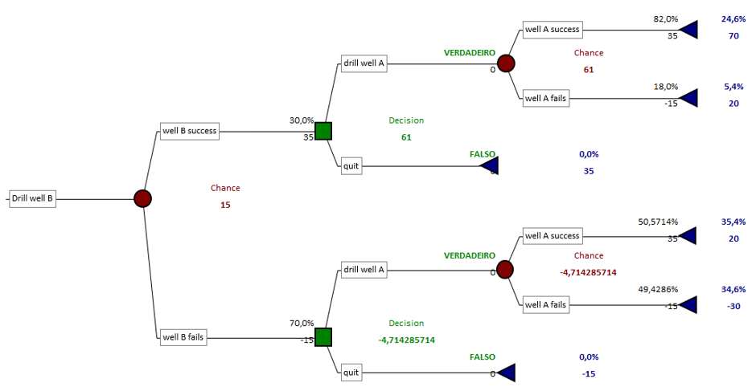
Figure 22: Drilling sequence B→A.

Real options in E&P
The main objective in the business environment is to maximize value when making decisions, even in the face of the various uncertainties inherent to the process. Bearing in mind that uncertainty is the rule, especially in the Oil Exploration and Production business environment, it is necessary to understand the qualitative and quantitative characteristics of uncertainty to help decision makers towards the best strategies, always with the objective of maximizing value.
Real Options Theory (ROT) is a methodology, although current, widely studied, however, little disseminated and used by the industry. However, cases of ROT applications in real problems show the main advantage of this theory compared to traditional project valuation techniques: the value of flexibility. A formal definition for real option is given by (Dias M. A., 2005):
Real option is the right, but not the obligation, that an agent has when making decisions about a real asset. An agent it can be a manager, a consumer, a regulator, or any decision maker. The real asset may be an opportunity to invest in a project or an existing asset such as a factory. The decision is whether to exercise one or more ROs. ROT seeks to quantify that right.
The definition above emphasizes that flexibility is freedom of choice in decision making and this flexibility has value in an uncertain environment, and one of the objectives of ROT is precisely to quantify this value. In the case particular to E&P, the main uncertainties are: technical uncertainties (e.g.: existence of oil, volume, and quality of an oil field) and market uncertainties (e.g.: oil price, exchange rate, inflation rate, product demand). The decision-making environment may also be faced with environmental, legal, ethical, managerial restrictions, etc., which influence the valuation of projects.
The first researcher to use the term “real options” for investment opportunities in real assets was Myers (1997), using as a reference the ideas related to financial options developed in the works of Black and Scholes (1973) and Merton (1973). ROT is nothing more than the value of the investment opportunity, the value of the right to invest. The value of the RO, in turn, is conditional on the optimal decision rule followed by the agent who owns the RO. A basic example is the RO of waiting for better market conditions when the net present value (NPV) of the immediate investment is less than the RO of waiting. Not following the optimal decision rule will result in lower gains than those reported by ROT.
Among the different types of RO (Dias M. A., 2005), we can mention the waiting option, expansion option, temporary stop option and the abandonment option. Our focus is learning RO, whose main objective is to obtain information to reduce uncertainties before proposing significant investments.
There are interesting types of RO that are sequential or compound RO. They are like this called because the exercise of an RO generates a new RO, being common in most industries, particularly in oil E&P. Figure 1 illustrates the typical case throughout the stages of acquisition, exploration, development, and abandonment of an oil field.
As we can see in Figure 1, when an oil company acquires an exploratory block, an RO is obtained to drill the wildcat well to determine whether there is oil. The well pioneer being successful, the volume and quality of the reserve are the uncertainties that arise. In this case we have the RO of delimiting the field, which is an RO of learning, aiming to resolve doubts at this stage. If the revealed scenario is unfavorable, the company may abandon the field, or, if the revealed scenario is favorable, we will have an RO to develop the field or abandon the project. Once the field is ready to be developed (put into production), other ROs arise: expansion, temporary stop, and abandonment. As already mentioned, our focus is on the OO of learning. Therefore, as discussed throughout this report, the delimitation RO will be the object of our research.
The Paddock, Siegel, and Smith (PSS) model is one of the most used when considering the RO of investing in the development of an oil field. The model makes an analogy between RO (Paddock, Siegel, & Smith, 1988) and financial options (Black & Scholes, 1973) and (Merton, 1973), as shown in Table 1.

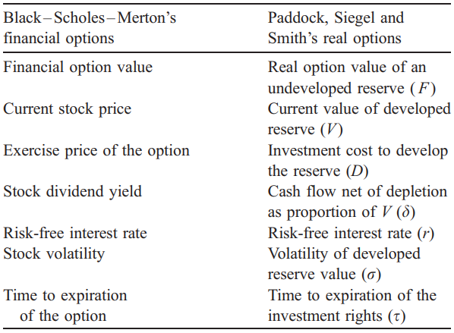
Table 1: Analogy between Financial Option and PSS RO. Source: (Dias M. A., 2005).

As illustrated in Table 1, the analogy is made between the Black-Scholes-Merton financial options and the RO value of an undeveloped oil reserve, where the latter is an oil deposit already discovered and delimited, but not yet developed. Having the company. The oil company drilled the pioneer well and was successful, it has until the end of the exploratory period to declare commerciality and commit to the development of the discovered field or return the area to the regulatory agency. The company exercising the RO acquires the right to produce the field during a certain period, with the aim of producing the discovered volume.
Let be $F(P,t)$ the value of the undeveloped reserve. Using the contingent assets method, we arrive at the following PDE for the value of $F(P,t)$ (Dias M. A., Opções Reais Híbridas com Aplicações em Petróleo, 2005):
$$\begin{aligned}\frac{1}{2}σ^{2}P^{2}\frac{∂^{2}F}{∂P^{2}}+\left(r-δ\right)P\frac{∂F}{∂P}-rF+\frac{∂F}{∂t}=0 \#16\end{aligned}$$
Equation 16 is the Black-Scholes-Merton PDE itself, which can be solved numerically. The parameters are:
$σ$: volatility of the value of the developed reserve.
$P$: oil price that follows a geometric Brownian movement.
$r$: risk-free rate.
$δ$: convenience fee.
The $NPV$ exercise of the development option is given by the business model (Dias, 2005):
$$\begin{aligned}NPV\left(P,t;I_{D}\right)=V\left(P\right)-I_{D}=qBP\left(t\right)-I_{D} \#17\end{aligned}$$
where:
$B$: is the number of recoverable barrels (reserve volume).
$q$: economic quality of the reserve, $q∈(0,1)$.
$I_{D}$: cost of investment in development.
The BSM PDE boundary conditions are given by:
Trivial: $if P=0⟹F\left(0,t\right)=0$.
Expiration: $if t=T⟹F\left(P,T\right)=Max\left[V(P)-I_{D},0\right]=Max[NPV,0]$.
Continuity: $if P\left(t\right)=P^{*}\left(t\right)⟹F\left(P^{*},t\right)=qBP^{*}-I_{D}$.
Soft contact: $if P\left(t\right)=P^{*}\left(t\right)⟹{\left.\frac{∂F\left(P,t\right)}{∂P}\right|}_{P=P^{*}}=qB$.
being $P^{*}(t)$ the threshold curve and $T$ the RO expiration time.
As previously mentioned, our focus is on the stage of delimiting the discovered field. The development RO will be exercised if the delimited volume is sufficient to justify an investment whose return is economically viable. We are currently in the analysis phase of equation 17, with the aim of applying it at this stage of exploration. That because Dias (2005) considers the following compound ROs in E&P:
$E(P,t)$: Exploratory RO whose exercise is the cost of the exploratory well.
$R(P,t)$: Development RO whose exercise is the cost to develop the reserve.
In other words, the delimitation step was not explicitly considered (for simplicity, the delimitation cost was included in I_{D}). We believe in the application of the BSM PDE in the delimitation stage with the objective of valuing the learning RO, since with each delimitation well drilled, the uncertainty in relation to the volume can be reduced. PDE's solution will be achieved by applying the finite difference method, with the price of oil being the stochastic variable.
Figure 23 presents a decision tree that is a modification of the E&P composite options decision tree from the book by Dias (2005).
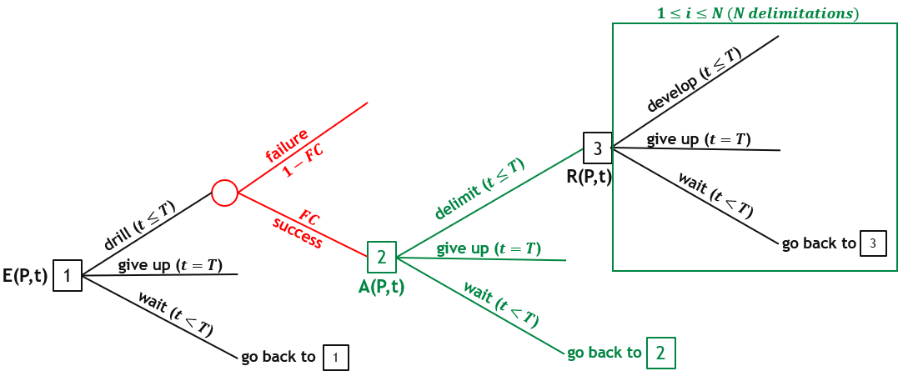
Figure 23: Decision tree showing the ROs in the E&P stage. Adapted from Dias (2005).
In Figure 23, the intermediate step in green is the field delimitation RO. Depending on the volume revealed, there is the option of abandoning or waiting for better market conditions to invest in the development stage. The number of delimitation wells is determined by analyzing the value of the information.

Results

By solving equation 16 numerically we obtain two linked answers, the real option value of the undeveloped reserve (F) and the decision rule (invest or wait for better conditions). Mathematical artifice is a normalization of the real options problem that allows a single normalized threshold curve to be the optimal solution for all parameters combinations. The project value (V) and the development investment ($I_{D} or D$) follow correlated geometric Brownian motions.

Figure 24 illustrates this method, showing two simulated sample-paths with jumps at $t_{R}$, one path with exercise at $t=1$ (the almost continuous line) and the other (dotted-line) reaching the expiration date without crossing the normalized threshold curve ${(V/D)}^{*}$.

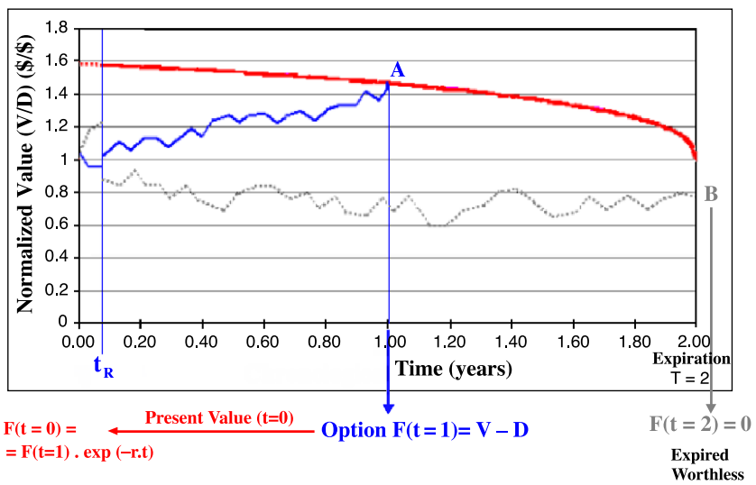
Figure 24: Normalized threshold and valuation of Real Options.

If $V/D≥{(V/D)}^{*}$ for the path i at any time t, we exercise the option (point A in Figure 24) and calculate the present value (using the risk-free interest rate) of this option, denoted by $F_{i}(t=0)$. In the opposite case, we wait and see. The paths that do not cross the normalized threshold curve ${(V/D)}^{*}$ along the two years of option are worthless. By summing up all the simulated real options present values $F_{i}(t=0)$ and dividing it by the total number of simulations, we get the real options value after the investment in information. Subtracting the cost of information (the learning cost), we obtain the real options value net of the learning cost for the alternative of investment in information under evaluation.

Conclusions

References
Black, F., & Scholes, M. (1973). The Pricing of Options and Corporate Liabilities. Journal of Political Economy, pp. 637-659.
Bratvold, R. B., Bickel, J. E., & Lohne, H. P. (2009). Value of Information in the Oil and Gas Industry: past, present and future. SPE Revervoir Eval. Eng., pp. 630-638.
Chilès, J. P., & Delfiner, P. (2012). Geostatistics: Modeling Spatial Uncertainty. Hoboken: John Wiley & Sons.
Cunningham, P., & Begg, S. (2008). Using the Value of Information to determine optimal well order in a sequential drilling program. AAPG Bulletin, pp. 1393-1402.
Demirmen, F. (2001). Subsurface Appraisal: The Road from Reservoir Uncertainty to Better Economics. SPE Hydrocarbon Economics and Evaluation Symposium, SPE-68603.
Deutsch, C. V. (2002). Geostatistic Reservoir Modelling. New York: Oxford University Press.
Dias, M. A. (2005). Opções Reais Híbridas com Aplicações em Petróleo. Rio de Janeiro: PUC-Rio: PhD thesis.
Dias, M. A. (2014). Análise de Investimentos com Opções Reais - Vol.1. Rio de Janeiro: Interciência.
Dias, M. A. (2015). Análise de Investimentos com Opções Reais - Vol.2. Rio de Janeiro: Interciência.
Dias, M. A. (2022, Out-Nov). Valor da Informação em Projetos do E&P. Curso para a Exploração - Petrobras.
Dixit, A. K., & Pindyck, R. S. (1994). Investment Under Uncertainty. Princeton University Press.
Eidsvik, J., Martinelli, G., & Bhattacharjya, D. (2018). Sequential Information Gathering Schemes for Spatial Risk and Decision Analysis Applications. Stoch Environ Res Risk Assess, pp. 1163-1177.
Goovaerts, P. (1997). Geostatistics for Natural Resources Modelling. New York: Oxford University Press.
Hall, T., Scheidt, C., Wang, L., Yin, Z., Mukerji, T., & Caers, J. (2022). Sequential Value of Information for Subsurface Exploration Drilling. Natural Resources Research, pp. 2413-2434.
Haskett, W. J. (2003). Optimal Appraisal Well Location Through Efficiente Uncertainty Reduction And Value of Information Techniques. SPE 84241 - Annual Technical Conference & Exhibition.
Ligero, E. L., Xavier, A. M., & Schiozer, D. J. (2005). Value of Information During Appraisal and Development of Petroleum Fields. 18th International Congress of Mechanical Engineering.
Matheron, G. (1971). The Theory of Regionalized Variables and Its Applications. Paris: Les Cahiers du Centre de Morphologie Mathématic.
Merton, R. C. (1973). Theory of Rational Option Pricing. Bell Journal of Economics and Management Science, pp. 141-183.
Morosov, A. L., & Bratvold, R. (2021). Probability Elicitation Using Geostatistics in Hydrocarbon Exploration. Computational Geosciences, pp. 2109-2130.
Morosov, A. L., & Bratvold, R. (2022). Appraisal Campaign Selection Based on the Maximum Value of Sequential Information. Journal of Petroleum Science and Engineering, p. 109473.
Paddock, J. L., Siegel, D. R., & Smith, J. (1988). Option valuation of claims on real assets: The case of offshore petroleum leases. The Quarterly Journal of Economics, pp. 479-508.
Pinto, J. R., Aguiar, J. C., & Moraes, F. S. (2011, May). The value of information from time-lapse seismic data. The Leading Edge, pp. 572-576.
Willigers, B. J., Begg, S., & Bratvold, R. B. (2014). Combining Geostatistics With Bayesian Updating To Continually Optimize Drilling Strategy in Shale-Gas Plays. SPE 164816 - EAGE Annual Conference & Exhibition.
Yamamoto, J. K. (2020). Estatística, Análise e Interpolação de Dados Geoespaciais. São Paulo: Gráfica Paulo's.
Yamamoto, J. K., & Landim, P. M. (2013). Geoestatística: conceitos e aplicações. São Paulo: Oficina de Textos.
Yokota, F., & Thompson, K. M. (2004). Value of Information Analysis in Environmental Health Risk Management Decisions: Past, Present, and Future. Risk Analysis, pp. 635-650.

Threshold P* is the value of the stochastic variable P at which the investor is indifferent between exercising an option or not.

