HRF_code_v1

jq Liao

2024-05-23

## R Markdown

This is an R Markdown document. Markdown is a simple formatting syntax for authoring HTML, PDF, and MS Word documents. For more details on using R Markdown see <http://rmarkdown.rstudio.com>.

load necessary packages

#### – 1. Price equation analysis –

In this part, we perform price equation analysis to calculate the impact of different community components (SIE.R,SIE.L,SRE.R,SRE.L,CDE).

# Load data (2017 as example):  
data<-read.csv("N2017.csv",stringsAsFactors = F)  
  
# Grouping data by key treatment/experimental columns:  
grouped.data<-data %>% group_by(trt,plot)  
  
# Run pairwise comparisons generating Price components:  
res1<- pairwise.price(grouped.data,species="spp",func="anpp")

## Warning: `group_by_()` was deprecated in dplyr 0.7.0.  
## ℹ Please use `group_by()` instead.  
## ℹ See vignette('programming') for more help  
## ℹ The deprecated feature was likely used in the priceTools package.  
## Please report the issue to the authors.  
## This warning is displayed once every 8 hours.  
## Call `lifecycle::last_lifecycle_warnings()` to see where this warning was  
## generated.

## Warning: `cols` is now required when using `unnest()`.  
## ℹ Please use `cols = c(tmp)`.

# Organize output:  
group.vars<-c('plot')  
treat.vars<-c('trt')  
  
# Save each year result  
# write.csv(res1,file = "2017res.csv")

## Vector plot of each N level   
pp1<-group.columns(res1,gps=c(group.vars,treat.vars),drop=F)  
datN0<-pp1[pp1$trt %in% c('N0 N2'),]  
datN2<-pp1[pp1$trt %in% c('N2 N4'),]  
datN4<-pp1[pp1$trt %in% c('N4 N8'),]  
datN8<-pp1[pp1$trt %in% c('N8 N16'),]  
datN16<-pp1[pp1$trt %in% c('N16 N32'),]  
  
windowsFonts(TNM = windowsFont("Times New Roman"))  
s1<-leap.zig(datN0,type='price',standardize=FALSE,  
 xlim=c(15,30),ylim=c(100,550),error.bars=F,  
 vectors=T,raw.points = F,legend=TRUE)+  
 annotate("text", x = mean(datN0$x.rich)+1, y = mean(datN0$x.func),   
 label = "N0",size=3)+  
 annotate("text", x = mean(datN0$x.rich), y = mean(datN0$x.func),   
 label = "*",size=5)  
  
s2<-leap.zig(datN2,type='price',standardize=FALSE,  
 xlim=c(15,30),ylim=c(100,550),error.bars=F,  
 vectors=T,raw.points = F,legend=TRUE,add=T,old.plot=s1)+  
 annotate("text", x = mean(datN2$x.rich)+1, y = mean(datN2$x.func),   
 label = "N2",size=3)+  
 annotate("text", x = mean(datN2$x.rich), y = mean(datN2$x.func),   
 label = "*",size=5)

## Scale for colour is already present.  
## Adding another scale for colour, which will replace the existing scale.  
## Coordinate system already present. Adding new coordinate system, which will  
## replace the existing one.  
## Scale for x is already present.  
## Adding another scale for x, which will replace the existing scale.  
## Scale for y is already present.  
## Adding another scale for y, which will replace the existing scale.

s3<-leap.zig(datN4,type='price',standardize=FALSE,  
 xlim=c(15,30),ylim=c(100,550),error.bars=F,  
 vectors=T,raw.points = F,legend=TRUE,add=T,old.plot=s2)+  
 annotate("text", x = mean(datN4$x.rich)+1, y = mean(datN4$x.func),   
 label = "N4",size=3)+  
 annotate("text", x = mean(datN4$x.rich), y = mean(datN4$x.func),   
 label = "*",size=5)

## Scale for colour is already present.  
## Adding another scale for colour, which will replace the existing scale.  
## Coordinate system already present. Adding new coordinate system, which will  
## replace the existing one.  
## Scale for x is already present.  
## Adding another scale for x, which will replace the existing scale.  
## Scale for y is already present.  
## Adding another scale for y, which will replace the existing scale.

s4<-leap.zig(datN8,type='price',standardize=FALSE,  
 xlim=c(15,30),ylim=c(100,550),error.bars=F,  
 vectors=T,raw.points = F,legend=TRUE,add=T,old.plot=s3)+  
 annotate("text", x = mean(datN8$x.rich)+1, y = mean(datN8$x.func),   
 label = "N8",size=3)+  
 annotate("text", x = mean(datN8$x.rich), y = mean(datN8$x.func),   
 label = "*",size=5)

## Scale for colour is already present.  
## Adding another scale for colour, which will replace the existing scale.  
## Coordinate system already present. Adding new coordinate system, which will  
## replace the existing one.  
## Scale for x is already present.  
## Adding another scale for x, which will replace the existing scale.  
## Scale for y is already present.  
## Adding another scale for y, which will replace the existing scale.

s5<-leap.zig(datN16,type='price',standardize=FALSE,  
 xlim=c(5,25),ylim=c(100,500),error.bars=F,  
 vectors=T,raw.points = F,legend=T,add=T,old.plot=s4)+  
 annotate("text", x = mean(datN16$x.rich)+1, y = mean(datN16$x.func),   
 label = "N16",size=3)+  
 annotate("text", x = mean(datN16$x.rich), y = mean(datN16$x.func),   
 label = "*",size=5)+  
 annotate("segment", x = mean(datN16$y.rich)-1, xend = mean(datN16$y.rich)+1,   
 y = mean(datN16$y.func), yend = mean(datN16$y.func),colour = "black")+  
 annotate("text", x = mean(datN16$y.rich)+1, y = mean(datN16$y.func),   
 label = "N32",size=3)+  
 theme_bw()+  
 theme(text= element_text(family = "TNM", face = "bold", size = 16))+  
 ggtitle("2017")

## Scale for colour is already present.  
## Adding another scale for colour, which will replace the existing scale.  
## Coordinate system already present. Adding new coordinate system, which will  
## replace the existing one.  
## Scale for x is already present.  
## Adding another scale for x, which will replace the existing scale.  
## Scale for y is already present.  
## Adding another scale for y, which will replace the existing scale.

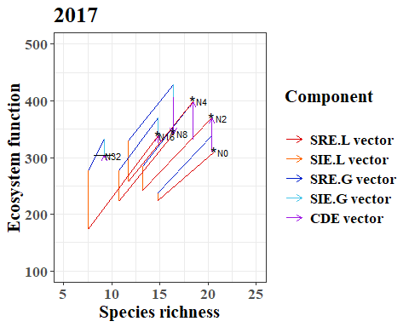

## Vector plot of total N effect  
data<-read.csv("N2017.csv",stringsAsFactors = F)  
  
# Grouping data by key treatment/experimental columns:  
grouped.data<-data %>% group_by(trt2,plot)  
  
# Run pairwise comparisons generating Price components:  
res1<- pairwise.price(grouped.data,species="spp",func="anpp")

## Warning: `cols` is now required when using `unnest()`.  
## ℹ Please use `cols = c(tmp)`.

# Organize output:  
group.vars<-c('plot')  
treat.vars<-c('trt2')  
  
pp1<-group.columns(res1,gps=c(group.vars,treat.vars),drop=F)  
pp1<-pp1[pp1$trt2 %in% c('N0 N0','N0 N+'),]  
  
# Separate out the comparisions isolating treatment effects  
dat1<-pp1[pp1$trt2 %in% c('N0 N+'),]  
  
s2017<-leap.zig(dat1,type='price',standardize=F,  
 xlim=c(10,25),ylim=c(100,500),error.bars=F,  
 vectors=T,raw.points = F,legend=F)+  
 scale_y_continuous(name = expression('ANPP g*m'^'-2'))+  
 annotate("text", x = mean(dat1$x.rich), y = mean(dat1$x.func),   
 label = "*",size=8)+  
 annotate("segment", x = mean(dat1$y.rich)-1, xend = mean(dat1$y.rich)+1,   
 y = mean(dat1$y.func), yend = mean(dat1$y.func),colour = "black")+  
 theme_bw()+   
 theme(text= element_text(family = "TNM", face = "bold", size = 16))+  
 ggtitle("2017")

## Scale for y is already present.  
## Adding another scale for y, which will replace the existing scale.

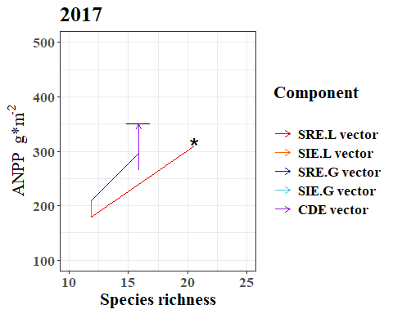

#### –2. ANOVA analysis –

data2 <- read.csv("HRF_data2014-2017.csv")

#2.1 ANPP

fit_ANPP <- aov(ANPP~N*Year+(1|Block),data=data2)  
summary(fit_ANPP)

## Df Sum Sq Mean Sq F value Pr(>F)   
## N 1 46612 46612 5.528 0.02041 *   
## Year 1 69847 69847 8.283 0.00477 **   
## N:Year 1 167495 167495 19.863 1.93e-05 ***  
## Residuals 116 978187 8433   
## ---  
## Signif. codes: 0 '***' 0.001 '**' 0.01 '*' 0.05 '.' 0.1 ' ' 1

interaction2wt(ANPP~N*Year,data = data2)

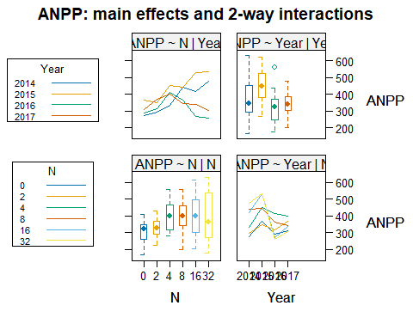

dcbj_ANPP<- LSD.test(fit_ANPP,'N',p.adj='none')  
plot(dcbj_ANPP)

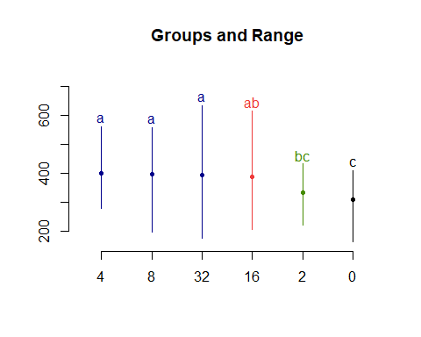

dcbj_ANPP$groups

## ANPP groups  
## 4 398.9554 a  
## 8 397.5118 a  
## 32 393.0773 a  
## 16 388.8403 ab  
## 2 331.8986 bc  
## 0 309.8377 c

lm_ANPP <- lmer(ANPP ~ N*Year + (1|Block),data = data2)

## Warning: Some predictor variables are on very different scales: consider  
## rescaling

## boundary (singular) fit: see help('isSingular')

## Warning: Some predictor variables are on very different scales: consider  
## rescaling

summary(lm_ANPP)

## Linear mixed model fit by REML. t-tests use Satterthwaite's method [  
## lmerModLmerTest]  
## Formula: ANPP ~ N * Year + (1 | Block)  
## Data: data2  
##   
## REML criterion at convergence: 1407  
##   
## Scaled residuals:   
## Min 1Q Median 3Q Max   
## -2.22925 -0.70120 0.03835 0.71144 2.34109   
##   
## Random effects:  
## Groups Name Variance Std.Dev.  
## Block (Intercept) 0 0.00   
## Residual 8433 91.83   
## Number of obs: 120, groups: Block, 5  
##   
## Fixed effects:  
## Estimate Std. Error df t value Pr(>|t|)   
## (Intercept) -1.954e+04 2.075e+04 1.160e+02 -0.942 0.348   
## N 6.136e+03 1.376e+03 1.160e+02 4.458 1.92e-05 ***  
## Year 9.870e+00 1.030e+01 1.160e+02 0.959 0.340   
## N:Year -3.043e+00 6.829e-01 1.160e+02 -4.457 1.93e-05 ***  
## ---  
## Signif. codes: 0 '***' 0.001 '**' 0.01 '*' 0.05 '.' 0.1 ' ' 1  
##   
## Correlation of Fixed Effects:  
## (Intr) N Year   
## N -0.685   
## Year -1.000 0.685   
## N:Year 0.685 -1.000 -0.685  
## fit warnings:  
## Some predictor variables are on very different scales: consider rescaling  
## optimizer (nloptwrap) convergence code: 0 (OK)  
## boundary (singular) fit: see help('isSingular')

anova(lm_ANPP)

## Type III Analysis of Variance Table with Satterthwaite's method  
## Sum Sq Mean Sq NumDF DenDF F value Pr(>F)   
## N 230972 230972 1 116 27.3902 7.486e-07 ***  
## Year 48433 48433 1 116 5.7435 0.01815 *   
## N:Year 230671 230671 1 116 27.3545 7.599e-07 ***  
## ---  
## Signif. codes: 0 '***' 0.001 '**' 0.01 '*' 0.05 '.' 0.1 ' ' 1

#2.2 height

fit_Hsp <- aov(Height~N*Year+(1|Block),data=data2)  
summary(fit_Hsp)

## Df Sum Sq Mean Sq F value Pr(>F)   
## N 1 229.5 229.51 20.679 1.35e-05 ***  
## Year 1 57.0 57.00 5.136 0.0253 *   
## N:Year 1 20.5 20.51 1.848 0.1767   
## Residuals 115 1276.4 11.10   
## ---  
## Signif. codes: 0 '***' 0.001 '**' 0.01 '*' 0.05 '.' 0.1 ' ' 1  
## 因为不存在，1个观察量被删除了

interaction2wt(Height~N*Year,data = data2)

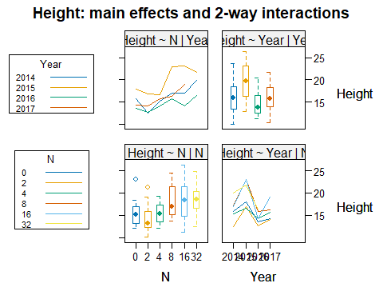

dcbj_Hsp<- LSD.test(fit_Hsp,'N',p.adj='none')  
plot(dcbj_Hsp)

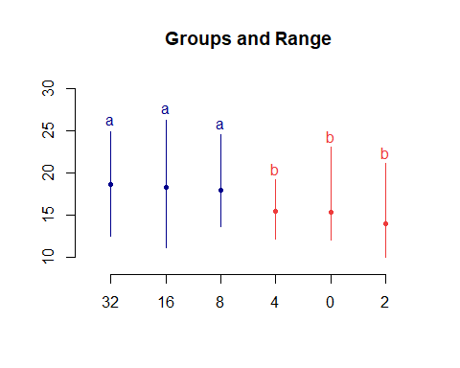

dcbj_Hsp$groups

## Height groups  
## 32 18.64888 a  
## 16 18.33516 a  
## 8 18.04005 a  
## 4 15.44557 b  
## 0 15.41589 b  
## 2 14.03534 b

lm_Hsp <- lmer(Height ~ N*Year + (1|Block),data = data2)

## Warning: Some predictor variables are on very different scales: consider  
## rescaling  
## Warning: Some predictor variables are on very different scales: consider  
## rescaling

summary(lm_Hsp)

## Linear mixed model fit by REML. t-tests use Satterthwaite's method [  
## lmerModLmerTest]  
## Formula: Height ~ N * Year + (1 | Block)  
## Data: data2  
##   
## REML criterion at convergence: 631.7  
##   
## Scaled residuals:   
## Min 1Q Median 3Q Max   
## -1.78180 -0.73881 -0.06084 0.49644 2.69073   
##   
## Random effects:  
## Groups Name Variance Std.Dev.  
## Block (Intercept) 0.2948 0.543   
## Residual 10.8570 3.295   
## Number of obs: 119, groups: Block, 5  
##   
## Fixed effects:  
## Estimate Std. Error df t value Pr(>|t|)  
## (Intercept) 578.47440 747.10059 110.97865 0.774 0.440  
## N 67.92572 51.01017 111.27141 1.332 0.186  
## Year -0.27940 0.37068 110.97862 -0.754 0.453  
## N:Year -0.03364 0.02531 111.27166 -1.329 0.187  
##   
## Correlation of Fixed Effects:  
## (Intr) N Year   
## N -0.682   
## Year -1.000 0.682   
## N:Year 0.682 -1.000 -0.682  
## fit warnings:  
## Some predictor variables are on very different scales: consider rescaling

anova(lm_Hsp)

## Type III Analysis of Variance Table with Satterthwaite's method  
## Sum Sq Mean Sq NumDF DenDF F value Pr(>F)   
## N 70.22 70.22 1 111.27 6.4675 0.01236 *   
## Year 403.62 403.62 1 114.40 37.1754 1.5e-08 ***  
## N:Year 70.04 70.04 1 111.27 6.4511 0.01247 *   
## ---  
## Signif. codes: 0 '***' 0.001 '**' 0.01 '*' 0.05 '.' 0.1 ' ' 1

#2.3 coverage

fit_Cover <- aov(Cover~N*Year+(1|Block),data=data2)  
summary(fit_Cover)

## Df Sum Sq Mean Sq F value Pr(>F)   
## N 1 1.08 1.08 1.645 0.202   
## Year 1 86.21 86.21 131.373 <2e-16 ***  
## N:Year 1 0.01 0.01 0.010 0.922   
## Residuals 115 75.46 0.66   
## ---  
## Signif. codes: 0 '***' 0.001 '**' 0.01 '*' 0.05 '.' 0.1 ' ' 1  
## 因为不存在，1个观察量被删除了

interaction2wt(Cover~N*Year,data = data2)

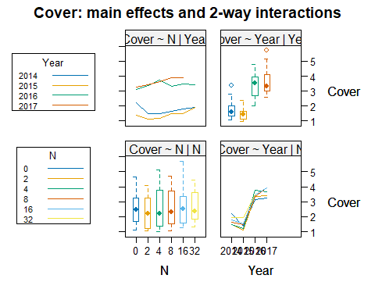

dcbj_Cover<- LSD.test(fit_Cover,'N',p.adj='none')  
plot(dcbj_Cover)

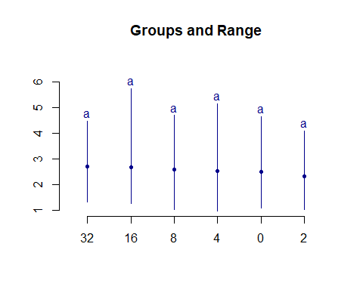

dcbj_Cover$groups

## Cover groups  
## 32 2.699929 a  
## 16 2.666133 a  
## 8 2.597371 a  
## 4 2.527475 a  
## 0 2.491503 a  
## 2 2.338533 a

lm_Cover <- lmer(Cover ~ N*Year + (1|Block),data = data2)

## Warning: Some predictor variables are on very different scales: consider  
## rescaling

## boundary (singular) fit: see help('isSingular')

## Warning: Some predictor variables are on very different scales: consider  
## rescaling

summary(lm_Cover)

## Linear mixed model fit by REML. t-tests use Satterthwaite's method [  
## lmerModLmerTest]  
## Formula: Cover ~ N * Year + (1 | Block)  
## Data: data2  
##   
## REML criterion at convergence: 307  
##   
## Scaled residuals:   
## Min 1Q Median 3Q Max   
## -1.61073 -0.85695 -0.08314 0.61316 2.53051   
##   
## Random effects:  
## Groups Name Variance Std.Dev.   
## Block (Intercept) 1.397e-12 1.182e-06  
## Residual 6.562e-01 8.101e-01  
## Number of obs: 119, groups: Block, 5  
##   
## Fixed effects:  
## Estimate Std. Error df t value Pr(>|t|)   
## (Intercept) -1.525e+03 1.837e+02 1.150e+02 -8.304 2.22e-13 ***  
## N -1.227e+00 1.253e+01 1.150e+02 -0.098 0.922   
## Year 7.580e-01 9.112e-02 1.150e+02 8.318 2.07e-13 ***  
## N:Year 6.140e-04 6.219e-03 1.150e+02 0.099 0.922   
## ---  
## Signif. codes: 0 '***' 0.001 '**' 0.01 '*' 0.05 '.' 0.1 ' ' 1  
##   
## Correlation of Fixed Effects:  
## (Intr) N Year   
## N -0.682   
## Year -1.000 0.682   
## N:Year 0.682 -1.000 -0.682  
## fit warnings:  
## Some predictor variables are on very different scales: consider rescaling  
## optimizer (nloptwrap) convergence code: 0 (OK)  
## boundary (singular) fit: see help('isSingular')

anova(lm_Cover)

## Type III Analysis of Variance Table with Satterthwaite's method  
## Sum Sq Mean Sq NumDF DenDF F value Pr(>F)   
## N 40.872 40.872 1 115 62.287 1.916e-12 ***  
## Year 113.546 113.546 1 115 173.038 < 2.2e-16 ***  
## N:Year 40.908 40.908 1 115 62.341 1.882e-12 ***  
## ---  
## Signif. codes: 0 '***' 0.001 '**' 0.01 '*' 0.05 '.' 0.1 ' ' 1

#2.4 C:N

fit_CNratio <- aov(CNratio~N*Year+(1|Block),data=data2)   
summary(fit_CNratio)

## Df Sum Sq Mean Sq F value Pr(>F)   
## N 1 2239.6 2239.6 186.591 < 2e-16 ***  
## Year 1 655.4 655.4 54.609 2.46e-11 ***  
## N:Year 1 13.1 13.1 1.088 0.299   
## Residuals 116 1392.3 12.0   
## ---  
## Signif. codes: 0 '***' 0.001 '**' 0.01 '*' 0.05 '.' 0.1 ' ' 1

interaction2wt(CNratio~N*Year,data = data2)

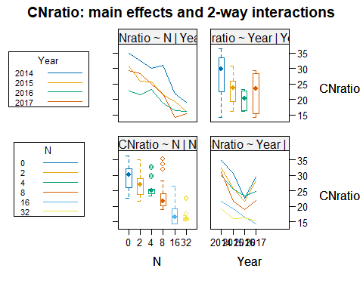

dcbj_CNratio <- LSD.test(fit_CNratio,'N',p.adj='none')  
plot(dcbj_CNratio)

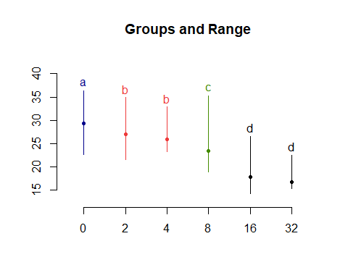

dcbj_CNratio$groups

## CNratio groups  
## 0 29.38604 a  
## 2 27.07147 b  
## 4 25.93724 b  
## 8 23.35853 c  
## 16 17.90646 d  
## 32 16.70546 d

lm_CNratio <- lmer(CNratio ~ N*Year + (1|Block),data = data2)

## Warning: Some predictor variables are on very different scales: consider  
## rescaling

## boundary (singular) fit: see help('isSingular')

## Warning: Some predictor variables are on very different scales: consider  
## rescaling

summary(lm_CNratio)

## Linear mixed model fit by REML. t-tests use Satterthwaite's method [  
## lmerModLmerTest]  
## Formula: CNratio ~ N * Year + (1 | Block)  
## Data: data2  
##   
## REML criterion at convergence: 646.6  
##   
## Scaled residuals:   
## Min 1Q Median 3Q Max   
## -2.84024 -1.05237 0.09972 0.69942 2.21810   
##   
## Random effects:  
## Groups Name Variance Std.Dev.   
## Block (Intercept) 4.244e-13 6.515e-07  
## Residual 1.200e+01 3.464e+00  
## Number of obs: 120, groups: Block, 5  
##   
## Fixed effects:  
## Estimate Std. Error df t value Pr(>|t|)   
## (Intercept) 4800.26154 782.91259 116.00000 6.131 1.24e-08 ***  
## N -54.55346 51.92562 116.00000 -1.051 0.296   
## Year -2.36805 0.38845 116.00000 -6.096 1.46e-08 ***  
## N:Year 0.02687 0.02576 116.00000 1.043 0.299   
## ---  
## Signif. codes: 0 '***' 0.001 '**' 0.01 '*' 0.05 '.' 0.1 ' ' 1  
##   
## Correlation of Fixed Effects:  
## (Intr) N Year   
## N -0.685   
## Year -1.000 0.685   
## N:Year 0.685 -1.000 -0.685  
## fit warnings:  
## Some predictor variables are on very different scales: consider rescaling  
## optimizer (nloptwrap) convergence code: 0 (OK)  
## boundary (singular) fit: see help('isSingular')

anova(lm_CNratio)

## Type III Analysis of Variance Table with Satterthwaite's method  
## Sum Sq Mean Sq NumDF DenDF F value Pr(>F)   
## N 226.19 226.19 1 116 18.845 3.048e-05 ***  
## Year 1474.12 1474.12 1 116 122.817 < 2.2e-16 ***  
## N:Year 228.36 228.36 1 116 19.026 2.810e-05 ***  
## ---  
## Signif. codes: 0 '***' 0.001 '**' 0.01 '*' 0.05 '.' 0.1 ' ' 1

#### – 3. SEM analysis –

# fit model use psem  
SEM <- data2[,3:11]  
SEM <- scale(SEM,center=T,scale=T)  
SEM <- data.frame(SEM)  
SEM <- na.omit(SEM)

## 3.1 initial sem model

model2 <- psem(CNratio %~~% Cover,Height %~~% Cover,Height %~~% CNratio,  
 lm(Height ~ N,data = SEM),  
 lm(Cover ~ N,data = SEM),  
 lm(CNratio ~ N,data = SEM),  
 lm(PCA ~ Height + Cover + CNratio + N, data = SEM),  
 lm(Rorder ~ Height + Cover + CNratio + N + PCA, data = SEM),  
 lm(ST ~ Height + Cover + CNratio + N + Rorder + PCA, data = SEM),  
 lm(ANPP ~ PCA + Rorder + ST + N + Height + Cover + CNratio,data = SEM),  
 data = SEM)  
summary(model2)

##   
## Structural Equation Model of model2   
##   
## Call:  
## CNratio ~~ Cover  
## Height ~~ Cover  
## Height ~~ CNratio  
## Height ~ N  
## Cover ~ N  
## CNratio ~ N  
## PCA ~ Height + Cover + CNratio + N  
## Rorder ~ Height + Cover + CNratio + N + PCA  
## ST ~ Height + Cover + CNratio + N + Rorder + PCA  
## ANPP ~ PCA + Rorder + ST + N + Height + Cover + CNratio  
##   
## AIC  
## -866.446  
##   
## ---  
## Tests of directed separation:  
##   
## No independence claims present. Tests of directed separation not possible.  
##   
## --  
## Global goodness-of-fit:  
##   
## Chi-Squared = 0 with P-value = 1 and on 0 degrees of freedom  
## Fisher's C = NA with P-value = NA and on 0 degrees of freedom  
##   
## ---  
## Coefficients:  
##   
## Response Predictor Estimate Std.Error DF Crit.Value P.Value  
## ~~CNratio ~~Cover -0.4238 - 119 -5.0392 0.0000  
## ~~Height ~~Cover -0.2770 - 119 -3.1051 0.0012  
## ~~Height ~~CNratio -0.0326 - 119 -0.3511 0.3631  
## Height N 0.3855 0.0866 117 4.4536 0.0000  
## Cover N 0.0825 0.0933 117 0.8839 0.3786  
## CNratio N -0.7231 0.0651 117 -11.1137 0.0000  
## PCA Height 0.7293 0 114 2411685.3043 0.0000  
## PCA Cover -0.5184 0 114 -1674572.9677 0.0000  
## PCA CNratio -0.1445 0 114 -338652.9031 0.0000  
## PCA N 0.0000 0 114 0.4737 0.6366  
## Rorder Height -20912.8973 15546.2279 113 -1.3452 0.1813  
## Rorder Cover 14866.2167 11051.0547 113 1.3452 0.1812  
## Rorder CNratio 4144.3183 3080.5925 113 1.3453 0.1812  
## Rorder N 0.3401 0.0922 113 3.6901 0.0003  
## Rorder PCA 28676.4087 21316.8659 113 1.3452 0.1812  
## ST Height -8790.5542 23355.9939 112 -0.3764 0.7074  
## ST Cover 6248.5461 16602.6408 112 0.3764 0.7074  
## ST CNratio 1741.6263 4628.1565 112 0.3763 0.7074  
## ST N -0.0652 0.1454 112 -0.4480 0.6550  
## ST Rorder -0.1190 0.1402 112 -0.8484 0.3980  
## ST PCA 12053.6701 32025.5702 112 0.3764 0.7073  
## ANPP PCA 28172.0755 29088.5287 111 0.9685 0.3349  
## ANPP Rorder -0.0314 0.1277 111 -0.2460 0.8061  
## ANPP ST -0.0337 0.0858 111 -0.3926 0.6953  
## ANPP N 0.0848 0.1321 111 0.6418 0.5223  
## ANPP Height -20545.2273 21214.0326 111 -0.9685 0.3349  
## ANPP Cover 14604.7734 15080.0239 111 0.9685 0.3349  
## ANPP CNratio 4071.2948 4203.7108 111 0.9685 0.3349  
## Std.Estimate   
## -0.4238 ***  
## -0.2770 **  
## -0.0326   
## 0.3807 ***  
## 0.0814   
## -0.7166 ***  
## 0.7293 ***  
## -0.5184 ***  
## -0.1440 ***  
## 0.0000   
## -20912.8973   
## 14866.2167   
## 4130.4616   
## 0.3359 ***  
## 28676.4087   
## -8785.2760   
## 6244.7942   
## 1734.7609   
## -0.0643   
## -0.1189   
## 12046.4325   
## 28171.8477   
## -0.0314   
## -0.0337   
## 0.0838   
## -20545.0611   
## 14604.6552   
## 4057.6494   
##   
## Signif. codes: 0 '***' 0.001 '**' 0.01 '*' 0.05  
##   
## ---  
## Individual R-squared:  
##   
## Response method R.squared  
## Height none 0.14  
## Cover none 0.01  
## CNratio none 0.51  
## PCA none 1.00  
## Rorder none 0.59  
## ST none 0.10  
## ANPP none 0.26

## 3.2 final optimal model

model1 <- psem(CNratio %~~% Cover,Height %~~% Cover,Height %~~% CNratio,  
 lm(Height ~ N,data = SEM),  
 lm(Cover ~ N,data = SEM),  
 lm(CNratio ~ N,data = SEM),  
 lm(PCA ~ Height + Cover + CNratio + N, data = SEM),  
 lm(Rorder ~ Height + Cover + CNratio + N, data = SEM),  
 lm(ST ~ Height + Cover + CNratio + N , data = SEM),  
 lm(ANPP ~ PCA + Rorder + ST + N,data = SEM),  
 data = SEM)  
  
dSep(model1,conditioning = T)

## | | | 0% | |============ | 17% | |======================= | 33% | |=================================== | 50% | |=============================================== | 67% | |========================================================== | 83% | |======================================================================| 100%

## Independ.Claim Test.Type DF Crit.Value  
## 1 ANPP ~ Height + N + PCA + Rorder + ST coef 113 1.1391885  
## 2 ANPP ~ Cover + N + PCA + Rorder + ST coef 113 0.9668506  
## 3 ANPP ~ CNratio + N + PCA + Rorder + ST coef 113 0.1444444  
## 4 Rorder ~ PCA + N + Height + Cover + CNratio coef 113 1.3452451  
## 5 ST ~ PCA + N + Height + Cover + CNratio coef 113 0.2723502  
## 6 ST ~ Rorder + N + Height + Cover + CNratio coef 113 -0.8106282  
## P.Value   
## 1 0.2570337   
## 2 0.3356835   
## 3 0.8854068   
## 4 0.1812396   
## 5 0.7858498   
## 6 0.4192832

fisherC(model1)

## Fisher.C df P.Value  
## 1 10.78 12 0.548

summary(model1)

## | | | 0% | |============ | 17% | |======================= | 33% | |=================================== | 50% | |=============================================== | 67% | |========================================================== | 83% | |======================================================================| 100%

##   
## Structural Equation Model of model1   
##   
## Call:  
## CNratio ~~ Cover  
## Height ~~ Cover  
## Height ~~ CNratio  
## Height ~ N  
## Cover ~ N  
## CNratio ~ N  
## PCA ~ Height + Cover + CNratio + N  
## Rorder ~ Height + Cover + CNratio + N  
## ST ~ Height + Cover + CNratio + N  
## ANPP ~ PCA + Rorder + ST + N  
##   
## AIC  
## -873.074  
##   
## ---  
## Tests of directed separation:  
##   
## Independ.Claim Test.Type DF Crit.Value P.Value   
## ANPP ~ Height + ... coef 113 1.1392 0.2570   
## ANPP ~ Cover + ... coef 113 0.9669 0.3357   
## ANPP ~ CNratio + ... coef 113 0.1444 0.8854   
## Rorder ~ PCA + ... coef 113 1.3452 0.1812   
## ST ~ PCA + ... coef 113 0.2724 0.7858   
## ST ~ Rorder + ... coef 113 -0.8106 0.4193   
##   
## --  
## Global goodness-of-fit:  
##   
## Chi-Squared = 5.373 with P-value = 0.497 and on 6 degrees of freedom  
## Fisher's C = 10.78 with P-value = 0.548 and on 12 degrees of freedom  
##   
## ---  
## Coefficients:  
##   
## Response Predictor Estimate Std.Error DF Crit.Value P.Value Std.Estimate  
## ~~CNratio ~~Cover -0.4238 - 119 -5.0392 0.0000 -0.4238  
## ~~Height ~~Cover -0.2770 - 119 -3.1051 0.0012 -0.2770  
## ~~Height ~~CNratio -0.0326 - 119 -0.3511 0.3631 -0.0326  
## Height N 0.3855 0.0866 117 4.4536 0.0000 0.3807  
## Cover N 0.0825 0.0933 117 0.8839 0.3786 0.0814  
## CNratio N -0.7231 0.0651 117 -11.1137 0.0000 -0.7166  
## PCA Height 0.7293 0 114 2411685.3043 0.0000 0.7293  
## PCA Cover -0.5184 0 114 -1674572.9677 0.0000 -0.5184  
## PCA CNratio -0.1445 0 114 -338652.9031 0.0000 -0.1440  
## PCA N 0.0000 0 114 0.4737 0.6366 0.0000  
## Rorder Height 0.5891 0.0691 114 8.5290 0.0000 0.5891  
## Rorder Cover -0.1601 0.0707 114 -2.2648 0.0254 -0.1601  
## Rorder CNratio 0.1665 0.0975 114 1.7087 0.0902 0.1660  
## Rorder N 0.3456 0.0924 114 3.7402 0.0003 0.3414  
## ST Height 0.0254 0.102 114 0.2493 0.8036 0.0254  
## ST Cover -0.2787 0.1045 114 -2.6681 0.0087 -0.2786  
## ST CNratio -0.3215 0.144 114 -2.2325 0.0275 -0.3202  
## ST N -0.1040 0.1365 114 -0.7615 0.4479 -0.1026  
## ANPP PCA 0.4688 0.1189 114 3.9425 0.0001 0.4688  
## ANPP Rorder 0.0223 0.1219 114 0.1826 0.8554 0.0223  
## ANPP ST -0.0474 0.0841 114 -0.5635 0.5742 -0.0474  
## ANPP N 0.0508 0.0918 114 0.5532 0.5812 0.0501  
##   
## ***  
## **  
##   
## ***  
##   
## ***  
## ***  
## ***  
## ***  
##   
## ***  
## *  
##   
## ***  
##   
## **  
## *  
##   
## ***  
##   
##   
##   
##   
## Signif. codes: 0 '***' 0.001 '**' 0.01 '*' 0.05  
##   
## ---  
## Individual R-squared:  
##   
## Response method R.squared  
## Height none 0.14  
## Cover none 0.01  
## CNratio none 0.51  
## PCA none 1.00  
## Rorder none 0.58  
## ST none 0.09  
## ANPP none 0.25