# 1、环境

192.168.0.12

192.168.0.13

部署模式：2M-2S-SYNC(两主两从同步写)

相关安装包存储路径：/root/svr/rocketmq

## 架构图

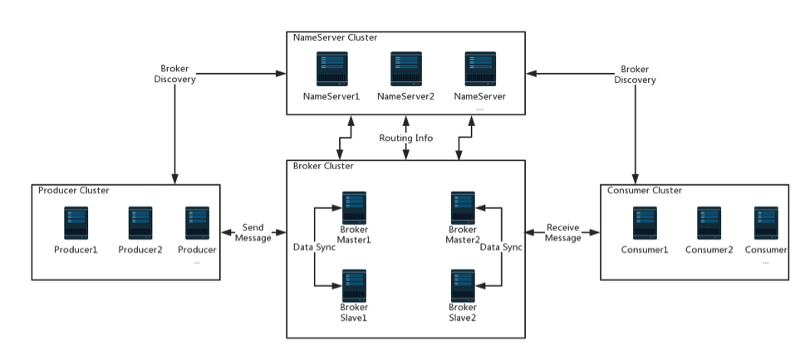

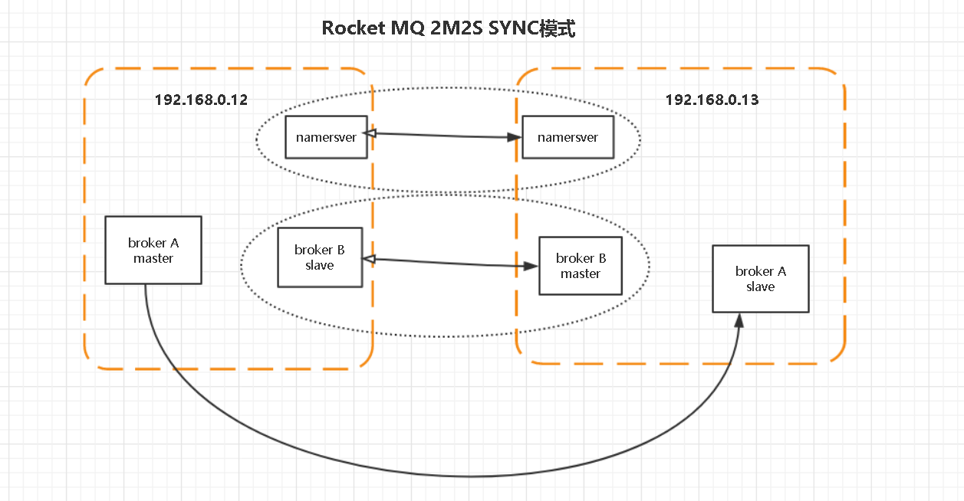

# 2、部署

## 2.1下载

Apache:

<https://www.apache.org/dyn/closer.cgi?path=rocketmq/4.2.0/rocketmq-all-4.2.0-bin-release.zip>

Alibba:

<https://github.com/alibaba/RocketMQ/releases>

## 2.2解压：

unzip rocketmq-all-4.2.0-bin-release.zip -d /root/svr/rocketmq

## 2.3配置host(给nameServer用)：

命令：vim /etc/hosts

|  |
| --- |
| 192.168.0.12 rocketmq1  192.168.0.13 rocketmq2 |

配置环境变量：vim /etc/profile

|  |
| --- |
| export ROCKETMQ_HOME=/root/svr/rocketmq  export PATH=$PATH::$ROCKETMQ_HOME/bin |

执行：source /etc/profile

2.4配置集群参数：

命令（master）：vim /root/svr/rocketmq/conf/2m-2s-sync/broker-a.properties

|  |
| --- |
| brokerClusterName=tl-rocketmq-cluster  brokerName=broker-a  brokerId=0  namesrvAddr=rocketmq1:9876;rocketmq2:9876  defaultTopicQueueNums=4  autoCreateTopicEnable=true  autoCreateSubscriptionGroup=true  listenPort=10911  deleteWhen=04  fileReservedTime=120  mapedFileSizeCommitLog=1073741824  mapedFileSizeConsumeQueue=300000  destroyMapedFileIntervalForcibly=120000  redeleteHangedFileInterval=120000  diskMaxUsedSpaceRatio=88  storePathRootDir=/root/svr/rocketmq/data/store  storePathCommitLog=/root/svr/rocketmq/data/store/commitlog  maxMessageSize=65536  flushCommitLogLeastPages=4  flushConsumeQueueLeastPages=2  flushCommitLogThoroughInterval=10000  flushConsumeQueueThoroughInterval=60000  checkTransactionMessageEnable=false  sendMessageThreadPoolNums=128  pullMessageThreadPoolNums=128  #Broker 的角色  #- ASYNC_MASTER 异步复制Master  #- SYNC_MASTER 同步双写Master  #- SLAVE  brokerRole=SYNC_MASTER  #- ASYNC_FLUSH 异步刷盘  #- SYNC_FLUSH 同步刷盘  flushDiskType=SYNC_FLUSH |

命令（slave）：vim /root/svr/rocketmq/conf/2m-2s-sync/broker-b-s.properties

|  |
| --- |
| brokerClusterName=tl-rocketmq-cluster  brokerName=broker-a  #0 表示 Master，>0 表示 Slave  brokerId=1  namesrvAddr=rocketmq1:9876;rocketmq2:9876  defaultTopicQueueNums=4  autoCreateTopicEnable=true  autoCreateSubscriptionGroup=true  listenPort=10911  deleteWhen=04  fileReservedTime=120  mapedFileSizeCommitLog=1073741824  mapedFileSizeConsumeQueue=300000  destroyMapedFileIntervalForcibly=120000  redeleteHangedFileInterval=120000  diskMaxUsedSpaceRatio=88  storePathRootDir=/root/svr/rocketmq/data/store  storePathCommitLog=/root/svr/rocketmq/data/store/commitlog  maxMessageSize=65536  flushCommitLogLeastPages=4  flushConsumeQueueLeastPages=2  flushCommitLogThoroughInterval=10000  flushConsumeQueueThoroughInterval=60000  checkTransactionMessageEnable=false  sendMessageThreadPoolNums=128  pullMessageThreadPoolNums=128  #角色  brokerRole=SLAVE  flushDiskType=SYNC_FLUSH |

|  |
| --- |
|  |

## 2.5创建存储&日志文件

|  |
| --- |
| mkdir /root/svr/rocketmq/data (也要创建store文件夹)  mkdir /root/svr/rocketmq/data/store/commitlog  mkdir /root/svr/rocketmq/data/store/consumequeue  mkdir /root/svr/rocketmq/data/store/index |

注意：如果一台虚拟机部署多个需要用文件进行区分

## 2.6修改日志配置文件

|  |
| --- |
| mkdir -p /root/svr/rocketmq/logs  cd /root/svr/rocketmq/conf && sed -i 's#${user.home}#/root/svr/rocketmq#g'  *.xml |

注意logback.*.xml配置文件中${user.home}需要替换自己指定的目录

## 2.7改参数

runbroker.sh,runserver.sh启动参数默认对jvm的堆内存设置比较大(不改启动不起来)，如果是虚拟机非线上环境需要改下参数

|  |
| --- |
| 默认大小  -Xms8g -Xmx8g -Xmn4g  改为：    JAVA_OPT="${JAVA_OPT} -server -Xms1g -Xmx1g -Xmn512m" |

## 2.8复制

**scp其他服务器**

scp -r rocketmq/ root@192.168.0.13:/root/svr/

## 3、启动服务

## 3.1启动Nameserver服务

在cd /root/svr/rocketmq/bin目录下执行命令：

|  |
| --- |
| nohup sh mqnamesrv & |

## 3.2启动BrokerServer

在cd /root/svr/rocketmq/bin目录下执行命令：

|  |
| --- |
| nohup sh mqbroker -c /root/svr/rocketmq/conf/2m-2s-sync/broker-a.properties& |

## 3.3是否启动成功

输入命令jps或者查看rocketmq/logs下日志是否输出正常。

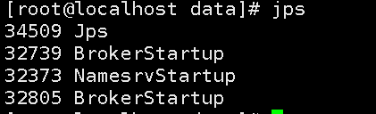

安装成功。

查看集群监控状态：

sh mqadmin clusterlist -n 192.168.0.12:9876

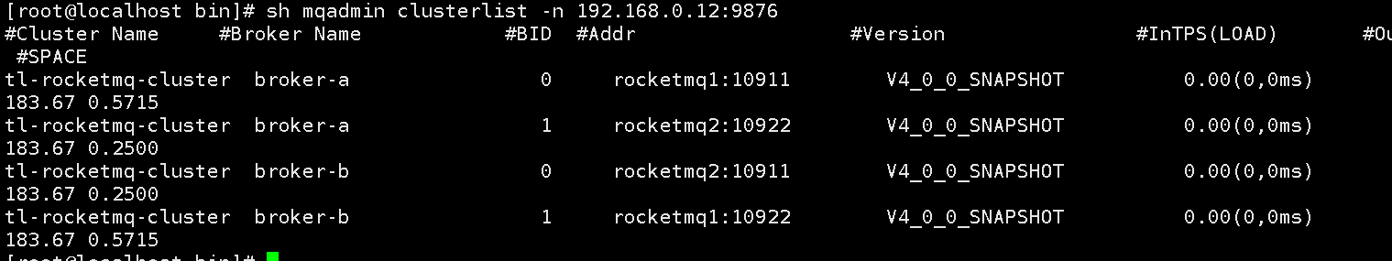

## 

## 测试：

|  |
| --- |
| export NAMESRV_ADDR=‘rocketmq1:9876;rocketmq2:9876’  测试发送端  > sh bin/tools.sh org.apache.rocketmq.example.quickstart.Producer  测试消费端  > sh bin/tools.sh org.apache.rocketmq.example.quickstart.Consumer |

## 服务停止：

在cd /root/svr/rocketmq/bin目录下执行命令或者jps查看进程号 kill -9 pid

|  |
| --- |
| sh mqshutdown broker  sh mqshutdown namesrv |

### 常见错误

Jvm参数没有配置启动错误：

# There is insufficient memory for the Java Runtime Environment to continue.

# Native memory allocation (malloc) failed to allocate 8589934592 bytes for committing reserved memory.

# An error report file with more information is saved as:

# /root/svr/rocketmq/bin/hs_err_pid30288.log

[root@localhost bin]# ll

启动日志报:Please set the JAVA_HOME variable in your environment, We need java(x64)! !!

需要设置vim /etc/profile环境变量

export JAVA_HOME=/root/svr/jdk

source /etc/profile