Andrew Wells

CPE301 – SPRING 2016

Design Assignment 0

**DO NOT REMOVE THIS PAGE DURING SUBMISSION:**

The student understands that all required components should be submitted in complete for grading of this assignment.

|  |  |  |  |
| --- | --- | --- | --- |
| **NO** | **SUBMISSION ITEM** | **COMPLETED (Y/N)** | **MARKS**  **(/MAX)** |
| 0. | COMPONENTS LIST AND CONNECTION BLOCK DIAGRAM w/ PINS |  |  |
| 1. | INITIAL CODE OF TASK 1/A |  |  |
| 2. | INCREMENTAL / DIFFERENTIAL CODE OF TASK 2/B |  |  |
| 3. | INCREMENTAL / DIFFERENTIAL CODE OF TASK 3/C |  |  |
| 4. | INCREMENTAL / DIFFERENTIAL CODE OF TASK 4/D |  |  |
| 5. | INCREMENTAL / DIFFERENTIAL CODE OF TASK 5/E |  |  |
| 6. | SCHEMATICS |  |  |
| 7. | SCREENSHOTS OF EACH TASK OUTPUT |  |  |
| 8. | SCREENSHOT OF EACH DEMO |  |  |
| 9. | VIDEO LINKS OF EACH DEMO |  |  |
| 10. | GOOGLECODE LINK OF THE DA |  |  |
|  |  |  |  |
|  |  |  |  |

|  |  |  |  |
| --- | --- | --- | --- |
| 0. | COMPONENTS LIST AND CONNECTION BLOCK DIAGRAM w/ PINS |  |  |

|  |  |  |  |
| --- | --- | --- | --- |
| 1. | INITIAL CODE OF TASK 1/A |  |  |

; Andrew Wells CPE 301, Design Assignment 0

; DA0_T1.asm

;

; Created: 2/13/2016 1:01:54 PM

; Author : sirfe

;

ldi R21, 0x04 // Load 0x04 into R21 = 00000100

out DDRB, R21 // Set bit 2 of PORTB as an Output port

start:

out PORTB, R0 // Sets all the pins of PORTB to LOW

ldi R16, 31 // Load 31 into R16

ldi R17, 53 // Load 53 into R17

ldi R18, 47 // Load 47 into R18

ldi R19, 35 // Load 35 into R19

ldi R20, 59 // Load 59 into R20

add R16, R17 // R16 = R16 + R17

add R16, R18 // R16 = R16 + R18

add R16, R19 // R16 = R16 + R19

add R16, R20 // R16 = R16 + R20

brcs overflo // Checks Carry bit to see if the sum produced an overflow, if yes branch to overflo. If not go to next instruction.

out PORTB, R0 // Sets all bits of PORTB to LOW

rjmp start // Unconditional Jump back to start

overflo: // Label for Branch instruction

out PORTB, R21 // Sets PORTB.2 pin to HIGH

rjmp start // Unconditional Jump back to start

|  |  |  |  |
| --- | --- | --- | --- |
| 6. | SCHEMATICS |  |  |

|  |  |  |  |
| --- | --- | --- | --- |
| 7. | SCREENSHOTS OF EACH TASK OUTPUT |  |  |

TASK 1/A:

Add five random numbers >30 and < 60. IF the sum produces an overflow set PORTB.2 pin = HIGH else PORTB.2 pin = LOW/

1. Sum Producing overflow, checking carry bit only after last addition:

Execution time: 1.75 µs and 14 Cycles

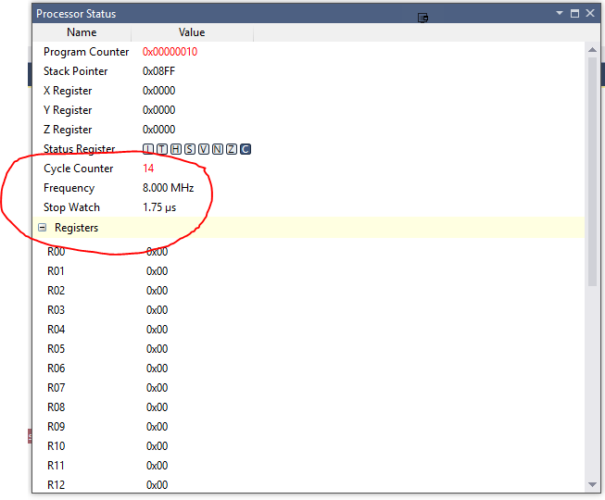

1. Sum Not Producing overflow, checking carry bit only after last addition:

Execution time: 1.63 µs and 13 Cycles

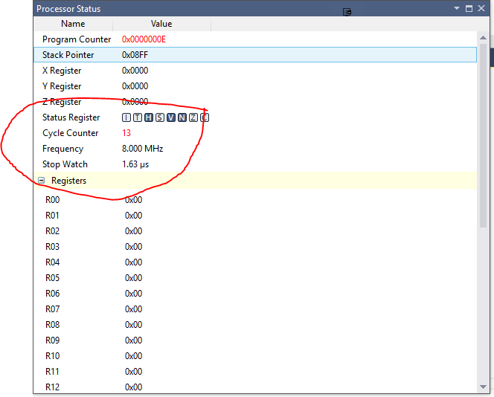

1. Sum Producing overflow, checking carry bit after every addition:

Execution Time: 2.13 µs and 17 cycles

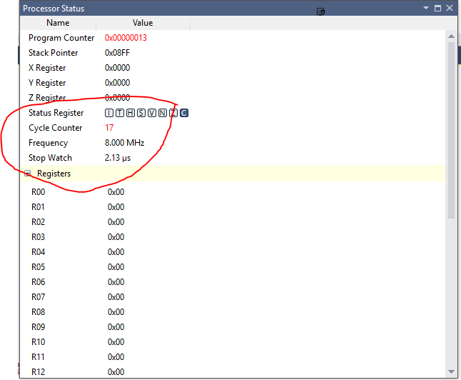

4) Sum Not producing overflow, checking carry bit after every addition:

Execution time: 2.00 µs and 16 Cycles

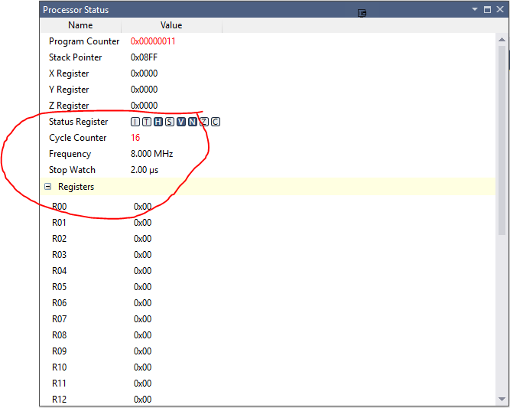

|  |  |  |  |
| --- | --- | --- | --- |
| 8. | SCREENSHOT OF EACH DEMO |  |  |

TASK 1/A:

Add five random numbers >30 and < 60. IF the sum produces an overflow set PORTB.2 pin = HIGH else PORTB.2 pin = LOW.

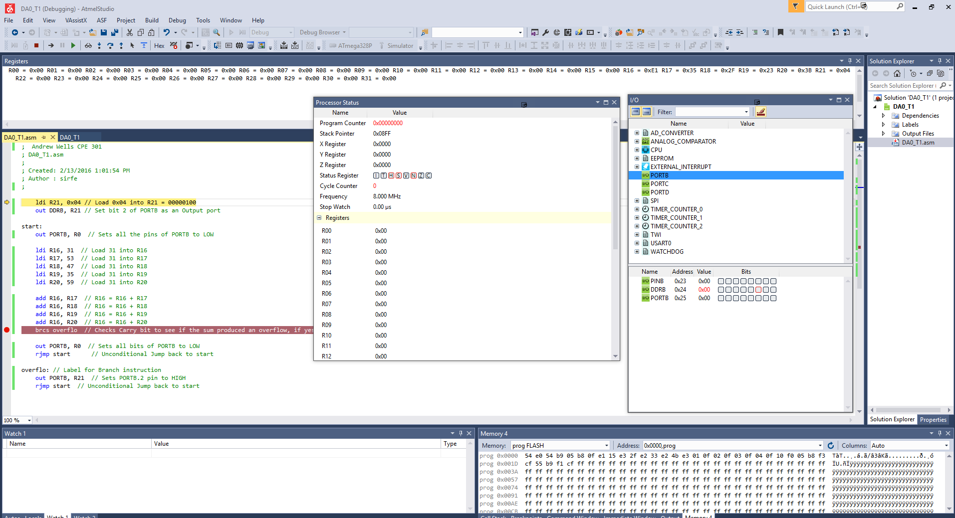

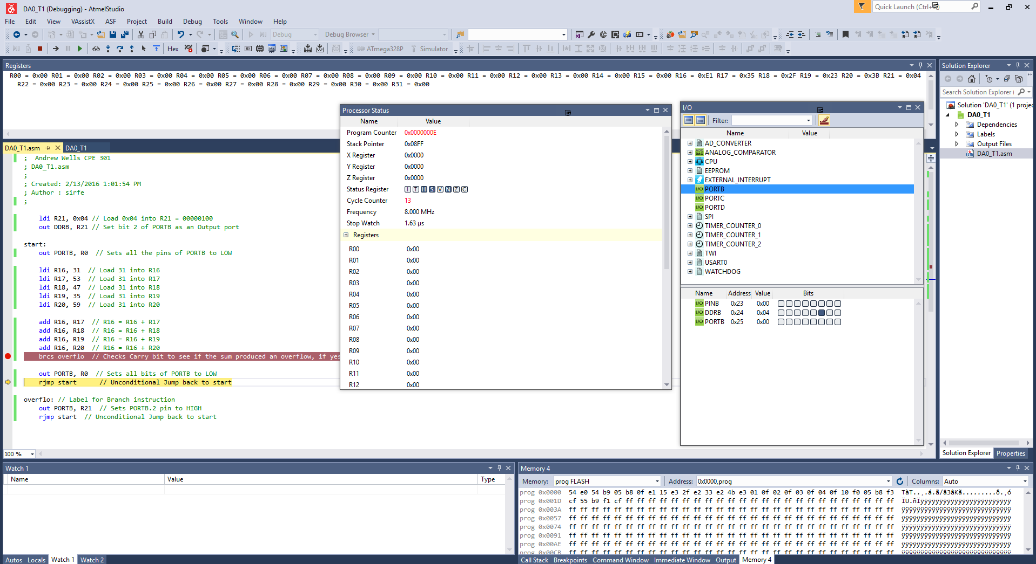

|  |  |  |  |
| --- | --- | --- | --- |
| 9. | VIDEO LINKS OF EACH DEMO |  |  |
| https://youtu.be/p2vZvDATRTQ | | | |
| 10. | GOOGLECODE LINK OF THE DA |  |  |
| https://github.com/Wellsa15/wellsa_unlv | | | |

**Student Academic Misconduct Policy**

<http://studentconduct.unlv.edu/misconduct/policy.html>

“This assignment submission is my own, original work”.

NAME OF THE STUDENT