Andrew Wells

TITLE: MPU-6050 Acceleration and Gyroscopic Data to Cloud

GOAL:

* Connect ESP8266 to a cloud IOT service
* Successfully connect ATmega328P to ESP8266 with UART
* Send commands from ATmega328P to ESP8266 using AT format
* Receive values from MPU-6050 6DOF sensor
* Transmit values from MPU-6050 to cloud

DELIVERABLES:

The project is intended to deliver sensor data to the cloud. With minor adjustments to some specific variables the code should be portable to any sensor attached to the ATmega326P.

LITERATURE SURVEY:

Used I2C to communicate between the Xplained mini and the MPU-6050. Using UART on the Xplained mini to transmit from data received from the sensor to the ESP-8266. Used AT commands to direct the ESP-8266 to pass the data to the cloud. The cloud service that was chosen to transmit the data to was Thingspeak.com. This cloud service is able to receive data at a rate of once every 15 seconds.

COMPONENTS:

Using the Xplained Mini with the ATmega328P chip I was able to connect the MPU-6050 and ESP8266. Using Atmel Studio, I programmed the ATmega328P using C. For this project there were no limitations while using the chip, only my ability to properly program using C. The MPU-6050 was connected using I2C. Using the header files at <https://github.com/YifanJiangPolyU/MPU6050>, I was able to interface and receive acceleration data from the sensor. The primary limitation of this device is the speed at which data can be received and processed by the micro controller. The ESP8266 was needed to connect to the Wifi and transmit the sensor data to the cloud. Commands were transmitted using UART over a serial connection using AT commands. A limit of the AT firmware is there is not a command to connect using https. Also there is not a way to connect to a Wifi signal that requires a username and password, can only connect to a SSID that requires a simple password. The biggest limitation to this project is the upload speed available using a free IOT service. Using Thinkspeak.com to receive the data limits uploads to every 15 seconds.

SCHEMATICS: (exception - include image)

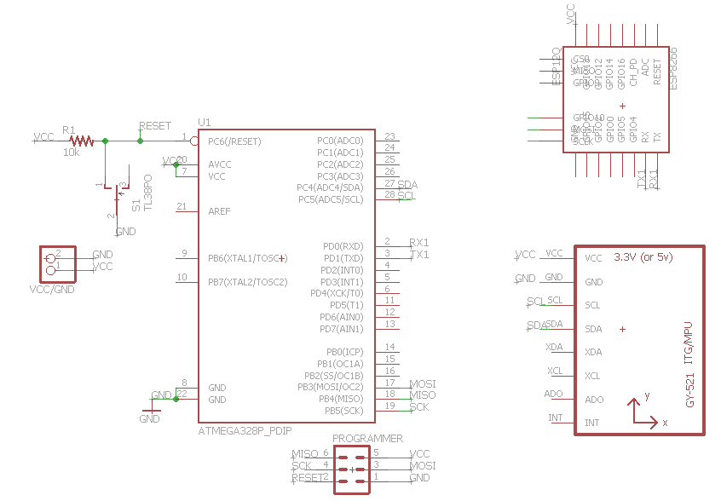

INITIAL PCB\*: (exception - include image)

IMPLEMENTATION:

* Flashed AT command firmware onto ESP-8266
* Read raw data from MPU-6050 using I2C
* Calculate true acceleration value
* Calculate true gyroscopic value
* Transmit data over UART from Xplained mini to ESP-8266
* Used the command AT+CIPSTART to connect to Thingspeak.com
* Used the command AT+CIPSEND to transmit with upload string

SNAPSHOTS/SCREENSHOTS\*: (only links - do not embed images or videos in the document)

Show snapshots/video of component implementation.

Show snapshots/video of demo (IOT/BLE/VISUALIZATION).

CODE: (with comments) [\*final code]

REFERENCE:

PS: \* - can be omitted in the Pre-Final Report.