Name: Andrew Wells
L#:
Project Title: 6 DOF Transmission to Cloud

Problem Statement:

Transmission of sensor data for analysis into the cloud using wifi. Using IO.Adafruit.com to analyze the received values.

Objectives:

Program an ATmega328P to accept sensor data from a MPU-6050 sensor and send that data through an ESP-8266 wifi module to io.adafruit.com for graphing.

Design Steps:

- Connect and receive value from MPU-6050
- Transmit Value over serial port to PC
- Program ESP-8266 to connect and transmit over wifi
- Connect ESP-8266 to Xplained mini board
- Transmit value from MPU-6050 to ESP-8266
- Transmit value from ESP-8266 to Cloud

Timeline:

April 23 – Able to receive value from MPU-6050 and transmit to PC
April 30 – ESP-8266 connected to wifi and receiving value from MPU-6050
May 7 – ESP-8266 successfully transmitting sensor value to Cloud

Hardware Components:

Atmega328P Xplained mini board
MPU-6050 6DOF sensor
ESP8266 Wifi module

Cloud service: io.adafruit.com

Initial Schematics:
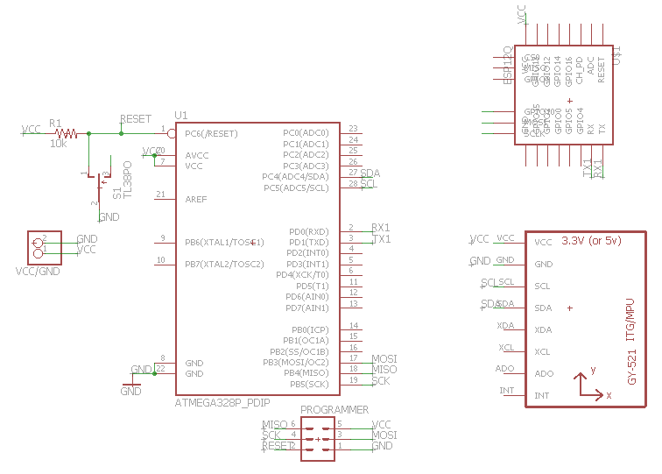

Reference:

ATmega328P datasheet
MPU-6050 Datasheet
Class Slides

