Lines added to .bashrc:
- source /opt/ros/noetic/setup.bash
- source /home/valhalla/catkin_ws/devel/setup.bash

In terminal to check if the path is correct:
IN: echo $ROS_PACKAGE_PATH
Expected OUT: /home/valhalla/catkin_ws/src:/opt/ros/noetic/share

Creating a ROS package (using catkin):
- It is recommended to build catkin packages using a catkin workspace.
- You can also build standalone packages (not sure how).
- cd ~/catkin_ws/src
- catkin_create_pkg beginner_tutorials std_msgs rospy roscpp
- This creates a package called beginner_tutorials which depends on std_msgs, roscpp, and rospy and contains a package.xml and a CmakeLists.txt.
- Build Package:
  - This will build any catkin projects found in the src folder.
  - cd ~/catkin_ws
  - catkin_make
  - catkin_make install # optional
- Check first-order dependencies – stored in package.xml:
  - IN: rospack depends1 beginner_tutorials
OUT: roscpp
rospy
std_msgs
- Check indirect dependencies – Nested dependencies (e.g rospy has dependencies of it’s own):
  - IN: rospack depends beginner_tutorials
  - OUT: cpp_common
rostime
roscpp_traits
roscpp_serialization
catkin
genmsg
genpy
message_runtime
gencpp
geneus
gennodejs
genlisp
message_generation
rosbuild
rosconsole
std_msgs
rosgraph_msgs
xmlrpcpp
roscpp
rosgraph
ros_environment
rospack
roslib
rospy
- Open package:
  - roscd beginner_tutorials
- Customising your package (package.xml):
  - update description tab – describes package
  - update maintainer tab – who to contact about package
  - update license tab - you should choose a license and fill it in here. Some common open source licenses are BSD, MIT, Boost Software License, GPLv2, GPLv3, LGPLv2.1, and LGPLv3 (https://opensource.org/licenses/alphabetical)
  - update dependecy tab - The dependencies are split into build_depend, buildtool_depend, exec_depend, test_depend (http://wiki.ros.org/catkin/package.xml#Build.2C_Run.2C_and_Test_Dependencies)
General Overview:
- Nodes - An executable that uses ROS to communicate with other nodes
- Messages – ROS data type used when subscribing/publishing to a topic
- Topics – Nodes can publish to a topic (send info) or subscribe to a topic to receive messages
- Master – Name service for ROS to help nodes find each other
- rosout – ROS equivalent of stdout/stderr
- roscore – Master + rosout + parameter service
ROS Nodes:
- Tutorial – sudo apt-get install ros-noetic-ros-tutorials
- An executable file in a ROS packages.
- Can publish or subscribe to a Topic.
- Can provide or use a Service.
- Python client library -> rospy
- C++ client library -> roscpp
- roscore -> the first thing you should run when using ROS
- rosnode list -> shows active nodes (/rosout if roscore is running)
- rosnode info /rosout -> gives information about node (subscriptions / publications etc.)
- rosnode ping turtlesim_node -> ping node to test that it is up
- To run node:
  - rosrun turtlesim turtlesim_node (package_name node_name)
  - rosrun turtlesim turtlesim_node __name:=my_turtle (package_name node_name:=node_alias -> change node name essentially)
ROS Topic:
- Install rqt to help visualise nodes and topics
- sudo apt-get install ros-noetic-rqt
- sudo apt-get install ros-noetic-rqt-common-plugins
- How to use rqt_graph -> rosrun rqt_graph rqt_graph


- Now run another node: rosrun turtlesim turtle_teleop_key
- rqt_graph
- Get info about Topic/Message:
  - rostopic -h -> help
  - rostopic echo turtle1/cmd_vel -> echo information on topic
  - rostopic list -v -> list of active topice (verbose list)
  - IN: rostopic type turtle1/cmd_vel -> shows type of topic (message)
OUT: geometry_msgs/Twist
  - IN: rosmsg show geometry_msgs/Twist -> shows message format
OUT: geometry_msgs/Vector3 linear
float64 x
float64 y
float64 z
geometry_msgs/Vector3 angular
float64 x
float64 y
float64 z
- Using rostopic pub:
  - rostopic pub -1 /turtle1/cmd_vel geometry_msgs/Twist -- '[2.0, 0.0, 0.0]' '[0.0, 0.0, 1.8]'
    - -1 -> causes rostopic to only publish one message and then exit
    - turtle1/cmd_vel -> name of topic being published to
    - geometry_msgs/Twist -> message type to use when publishing to topic
    - The rest is a hard-coded message in the required message format
  - rostopic pub /turtle1/cmd_vel geometry_msgs/Twist -r 1 -- '[2.0, 0.0, 0.0]' '[0.0, 0.0, -1.8]'
    - -r 1 -> command gets published onto to the topic every 1Hz
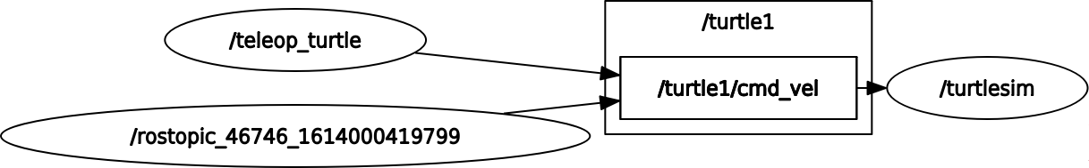
                - /teleop_turtle : teleop_key_node where you move turtle with keyboard keys (publisher node)
                - /rostopic_46746... : “node” that gets auto created when you use “pub” command to directly publish to topic
                - /turtlesim : subscriber node that listens to topic and executes to create and update GUI
                - turtle1/cmd_vel : ROS topic
  - rostopic echo turtle1/cmd_vel -> shows what is currently published on topic
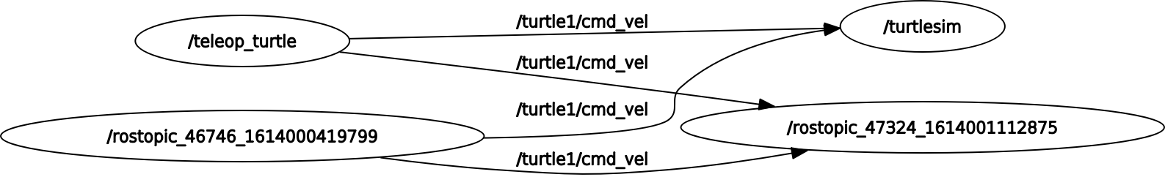
                - rostopic 47324... : “node” that gets created just to subscribe to a topic and print out what is currently published on it (like a listener)
  - rostopic echo /turtle1/pose -> data moves super fast, can’t see much
  - rostopic hz /turtle/pose -> shows you that data is being published at 60Hz (Also creates subscriber node)
  - Now use rosrun rqt_plot rqt_plot to variables changing over time
    - It is a bit finicky so the hz thing had to run to see “ turtle1/pose ” and to see cmd_vel I had to specify angular or linear in “ turtle1/cmd_vel/linear “

Services and Parameters:
- Allow a node to send a request and receive a response.
- Using rosservice:
  - rosservice list -> print active services
  - rosservice call -> call the service with the provider args
  - rosservice type -> print service type
  - rosservice find -> find services by service type
  - rosservice uri ->print service ROSRPC uri
- When turtlesim is running, rosservice list:
/clear
/kill
/reset
/rosout/get_loggers
/rosout/set_logger_level
/spawn
/teleop_turtle/get_loggers
/teleop_turtle/set_logger_level
/turtle1/set_pen
/turtle1/teleport_absolute
/turtle1/teleport_relative
/turtlesim/get_loggers
/turtlesim/set_logger_level
- rosservice type /spawn | rossrv show -> shows format for service inputs (args)
- Using rosparam:
  - rosparam set
  - rosparam get
  - rosparam load
  - rosparam dump
  - rosparam delete
  - rosparam list
- rosparam dump params.yaml -> dumps all parameters in a file named params.yaml
- rosparam set /turtlesim/background_r 150
- rosparam get /turtlesim/background_g
- rosparam get / -> shows contents of entire Parameter Server
- rosparam load params.yaml copy_turtle -> load to new namespace
- rosparam get /copy_turtle/turtlesim/background_b -> get params from that namespace again
RQT_console and RQT logger level:
- rosrun rqt_console rqt_console
- rosrun rqt_logger_level rqt_logger_level
- Need to try these out some more (can’t get console to show all the messages)

Roslaunch:
- Starts nodes as defined in launch file
- e.g
  - roscd beginner_tutorials
  - mkdir launch
  - cd launch
  - Note: roslaunch command automatically detects available launch files. However, putting them in one directory is good practice.
  - The launch file:
1 <launch>
2
3 <group ns="turtlesim1">
4 <node pkg="turtlesim" name="sim" type="turtlesim_node"/>
5 </group>
6
7 <group ns="turtlesim2">
8 <node pkg="turtlesim" name="sim" type="turtlesim_node"/>
9 </group>
10
11 <node pkg="turtlesim" name="mimic" type="mimic">
12 <remap from="input" to="turtlesim1/turtle1"/>
13 <remap from="output" to="turtlesim2/turtle1"/>
14 </node>
15
16 </launch>
  - ns => namespace
  - Two groups with namespace tag of turtlesim1 and turtlesim2
  - Start a mimic node with input => turtlesim1 and output=> turtlesim2
  - This causes turtlesim2 to mimic turtelsim1
  - roslaunch beginner_tutorials turtlemimic.launch
  - rostopic pub /turtlesim1/turtle1/cmd_vel geometry_msgs/Twist -r 1 -- '[2.0, 0.0, 0.0]' '[0.0, 0.0, -1.8]'
  - Note: The teleop key wouldn’t work here as is.
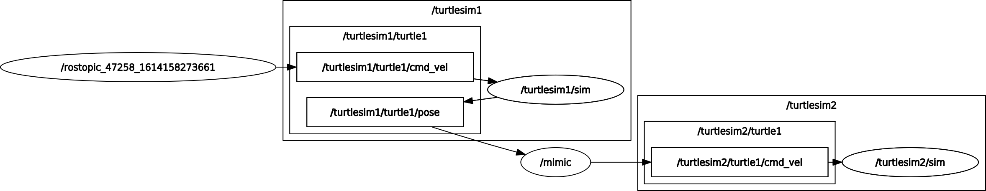

ROS text editor:
- rosed roscpp Logger.msg
- They check the default editor with echo $EDITOR and you can change it, but it isn’t working in my terminal

ROS msg and srv:
- msg:
  - text files used to generate code for messages in different languages
  - files stored in the msg directory of a package
  - simple text files with a field type and field name per line
  - field types
    - int8, int16, int32, int64 (plus uint*)
    - float32, float64
    - string
    - time, duration
    - other msg files
    - variable-length array[] and fixed-length array[C]
    - Special ROS type – Header header (contains time stamp and coordinate frame info commonly used in ROS)
  - e.g
1 Header header
2 string child_frame_id
3 geometry_msgs/PoseWithCovariance pose
4 geometry_msgs/TwistWithCovariance twist
- srv:
  - file that describes a service. It is composed of two parts, a request and a response.
  - Srv files are just like msg files except that they have two parts, a request and response separated by a ‘---’ line
  - e.g
1 int64 A
2 int64 B
3 ---
4 int64 Sum
  - A and B above are the request and Sum is the response
- Creating a msg:
  - roscd beginner_tutorials
  - mkdir msg
  - echo “int64 num” > msg/Num.msg
  - Need to make sure the msg files are turned into source code for C++, Python etc:
    - Open package.xml
    - Make sure this is included (uncommented):
<build_depend>message_generation</build_depend>
<exec_depend>message_runtime</exec_depend>
    - Note that at build time, we need "message_generation", while at runtime, we only need "message_runtime"
    - Now open CmakeLists.txt
    - Do the following:
      - find_package(catkin REQUIRED COMPONENTS
roscpp
rospy
std_msgs
# ADDING FOR MESSAGE GENERATION
message_generation
)

      - # UNCOMMENT THE FOLLOWING AND ADD YOUR MSG FILE
add_message_files(
FILES
Message1.msg
Message2.msg
Num.msg
)
      - # UNCOMMENT THE FOLLOWING
generate_messages(
DEPENDENCIES
std_msgs
)
      - catkin_package(
# INCLUDE_DIRS include
# LIBRARIES beginner_tutorials
## UNCOMMENTED THIS AND ADDED message_runtime
CATKIN_DEPENDS message_runtime roscpp rospy std_msgs
# DEPENDS system_lib
)
  - cd ~/catkin_ws
  - catkin_make
  - The Python script will be created in ~/catkin_ws/devel/lib/python3/dist-packages/beginner_tutorials/msg
  - The C++ message header file will be generated in ~/catkin_ws/devel/include/beginner_tutorials/
  - The lisp file appears in ~/catkin_ws/devel/share/common-lisp/ros/beginner_tutorials/msg/
- Using the msg:
  - Checking is ROS can see msg: rosmsg show beginner_tutorials/Num
  - OR: rosmsg show Num
- Creating a srv:
  - roscd beginner_tutorials
  - mkdir srv
  - Copy service from the rospy_tutorials package:
roscp rospy_tutorials AddTwoInts.srv srv/AddTwoInts.srv
  - Make sure the srf files are turned into source code for C++, Python etc.
    - Open package.xml and do same thing you would do for msg
    - Open CmakeLists.txt
      - Do same first step as with msg
      - # UNCOMMENT THE FOLLOWING LINES
add_service_files(
FILES
Service1.srv
Service2.srv
AddTwoInts.srv
)
  - cd ~/catkin_ws
  - catkin_make
- Using a srv:
- rossrv show beginner_tutorials/AddTwoInts
- OR: rossrv show AddTwoInts (It will just show the files from both the packages)

