**EXERCISE 1.3 - UMLET INSTALLATION**

Take a screenshot of UMLet running on your desktop.

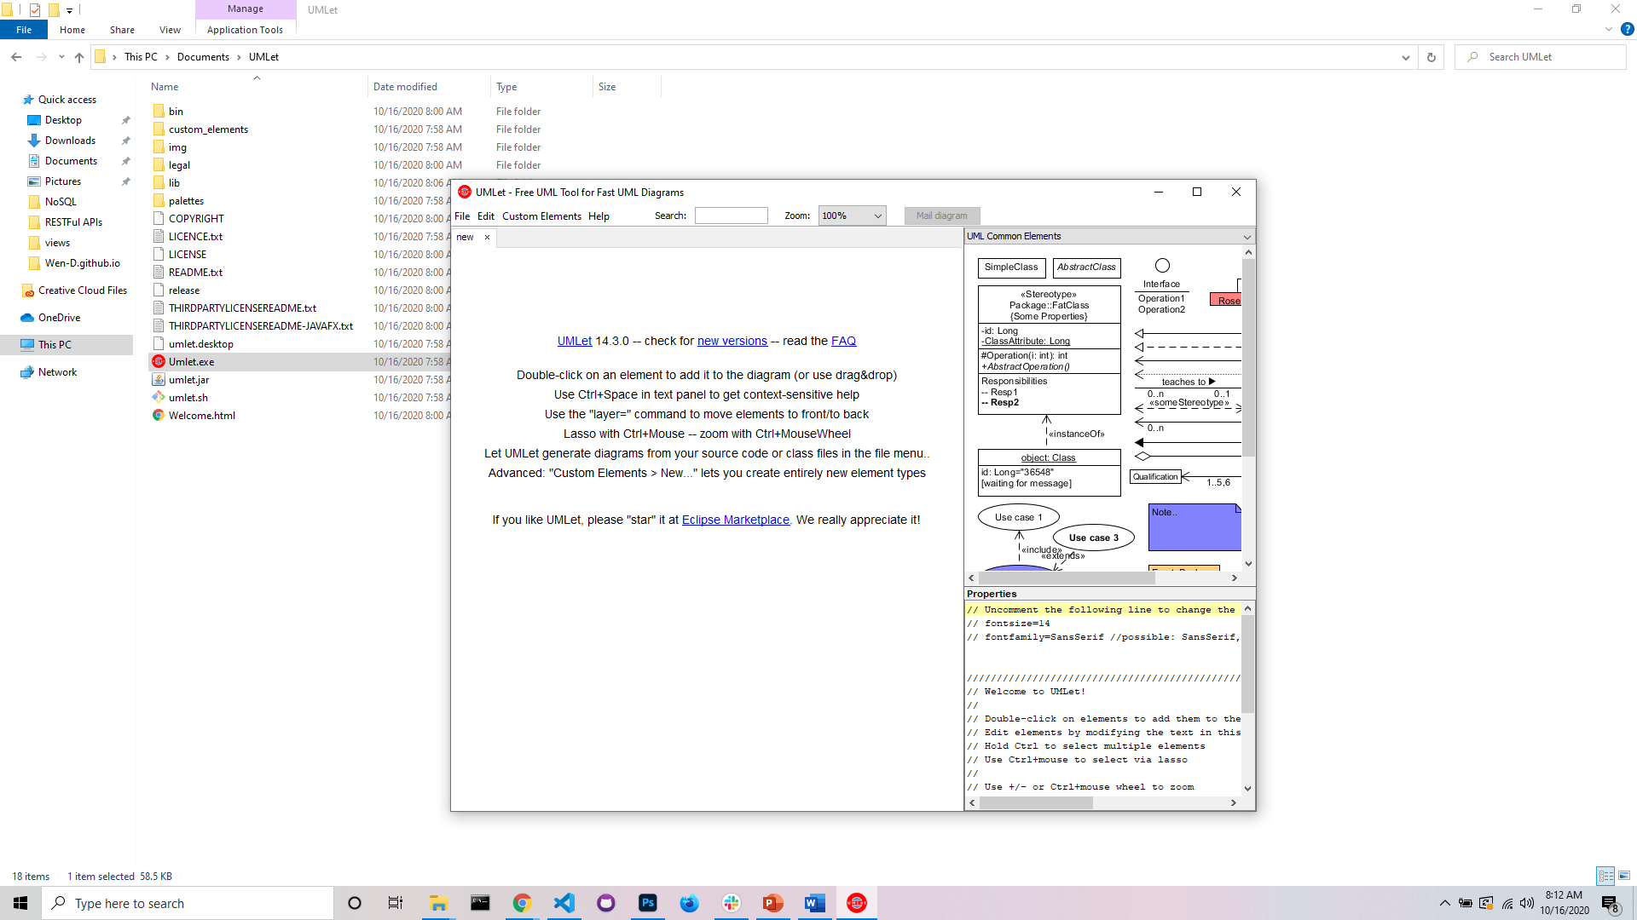

Take a screenshot of the directory where UMLet was installed.

