**Instruction for using GFN2NMR**

* 1. *The environment*

OS: Ubuntu 21 or higher, or other Linux releases.

Anaconda3 with Python 3.8, or higher <https://www.anaconda.com/>

xTB 6.4.1 or higher: <https://xtb-docs.readthedocs.io/en/latest/contents.html>

CREST 2.12 or higher: <https://crest-lab.github.io/crest-docs/>

Pytorch 1.11 or higher: <https://pytorch.org/>

Pytorch Geometric, a version corresponding to the versions of Python, Pytorch, and CUDA or CPU. <https://pytorch-geometric.readthedocs.io/en/latest/>. If some problem occurs, you can install the wheels (find your corresponding version on <https://data.pyg.org/whl/>) by “*pip*” first, and then run “*pip install torch_geometric*”.

RDkit 2022.09.1: <https://www.rdkit.org/docs/Install.html>. (you can simply run “*pip install rdkit*” in Terminal to install it)

The above-mentioned software suits are required for GFN2NMR. We did not check it with all combination of their existed versions, and we suggest you use the mentioned versions or higher, because **we will always update our codes to match the requirement of the latest environment.**

*1.2 Installation*

1.2.1 Unzip the required files in the same path

*gfn2nmr*: main program (command line), written by Python.

*gfn2nmr_gui*: main program (PyQT5 based UI), written by Python.

*gfn2nmr_core.py*: core functions of GFN2NMR, written by Python.

*best_params*: the weights for the model.

*xyz2mol.py*: the module for 2D-structure generation. It is a modified version of xyz2mol implemented by Jan H. Jensen.

1.2.2 Make it executable

In terminal, execute the command “chmod -R 750 /home/…/”. The highlighted part is the path of GFN2NMR.

1.2.3 Set the environment

Add “PATH=$PATH:/home/…/” to *.bashrc* file. The highlighted part is the path of GFN2NMR. Then you can execute *gfn2nmr* and *gfn2nmr_gui* in terminal directly.

*1.3 How to run*

A simple run with GUI: execute “gfn2nmr_gui” in a terminal window.

A simple run with command line: execute “gfn2nmr ***.xyz” in a terminal window. The highlighted part is the path and filename of your *xyz* file. To see all the arguments, please execute “gfn2nmr -h”. The calculated results will be output as an excel file.

Explanations of augments:

*-chrg <INT>* (command line) or *charge* (GUI): the number of net charges. Default: 0 ,

*-cs_method gfnff/gfn0/gfn1/gfn2* (command line) or *Method for conformer searching* (GUI): Method for crest conformational search, Default: gfnff,

*-energy_cutoff <Float>* (command line) or *Energy cut-off for conformers* (GUI): The energy window used to remove high energy conformers. Default: 3 Kcal/Mol.',

*-pre_opt* (command line) or *Pre-optimization* (GUI): Pre-optimize the initial coordinates with GFN-xTB, to avoid the errors caused by poor initial geometry.

*-nocs* (command line) or *No conformer searching* (GUI): Switch off conformational search.

*-d cuda/cpu/auto* (command line) or *Device for model loading* (GUI): choose the device to load model. Default: auto.

*-draw2d* (command line) or *Draw 2D structures to view results* (GUI): Output 2D structure with chemical shifts labeled. Default: False.

*-cmoff* (command line) or *Switch off continue mode* (GUI): gfn2nmr will clean the work directory.With default setting, GFN2NMR will automatically search the files for conformation search (crest_conformers.xyz or crest_ensemble.xyz) and continue the calculation process. It is useful when users want to continue an interrupted job or start calculation from a custom conformation ensemble. However, if the former calculation has error occurred, it is recommended to use *-cmoff* to clean the old files.

The users can use a .*txt* file (with the same name of *xyz* file) to set the experimental data, and gfn2nmr will add this data to the output excel file. The format is as:

Atom_num1 <space> value1

Atom_num2 <space> value2

If it was run with “-draw2d” argument, it will generate a 2D structure image file with carbons labelled by calculated chemical shifts, as shown below.

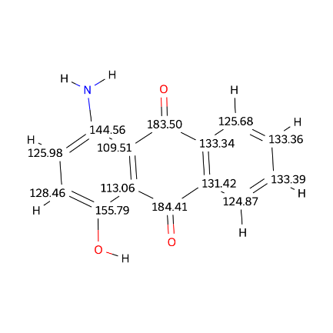

We have provided an example of acetic acid in the gfn2nmr package.

*1.4 Use a custom conformation ensemble*

With the default setting, GFN2NMR will search the existed files for conformation search. If users want to use the conformational search results by the software other than CREST, they can create a folder with the same name as *\*.xyz* file, place the file records custom ensemble of conformers (xyz format) to this folder, and name it as “*crest_conformers.xyz*”. Then, when the users execute “gfn2nmr *.xyz”, the program will start with the custom “*crest_conformers.xyz*”.