1.不管是web还是service这里都要有make

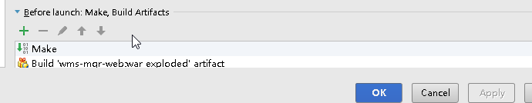

1. 新导入的工程需要配置maven
2. svn版本为1.8
3. 要选中import maven project auto
4. Idea报错duplicate,需要看File-project structure-Modules-找到具体项目-dependency
5. idea的注释模板
6. Class

|  |
| --- |
| /*  * @(#)${NAME} ${YEAR} ${TIME}  *  * Copyright (c) ${YEAR} - Business Intelligence Info. Tech.  *  * JiNan  * All rights reserved.  */ #if (${PACKAGE_NAME} && ${PACKAGE_NAME} != "")package ${PACKAGE_NAME};#end #parse("File Header.java") public class ${NAME} { } |

1. Interface

|  |
| --- |
| /*  * @(#)${NAME} ${YEAR} ${TIME}  *  * Copyright (c) ${YEAR} - Business Intelligence Info. Tech.  *  * JiNan  * All rights reserved.  */ #if (${PACKAGE_NAME} && ${PACKAGE_NAME} != "")package ${PACKAGE_NAME};#end #parse("File Header.java") public interface ${NAME} { } |

1. Enum

|  |
| --- |
| /*  * @(#)${NAME} ${YEAR} ${TIME}  *  * Copyright (c) ${YEAR} - Business Intelligence Info. Tech.  *  * JiNan  * All rights reserved.  */ #if (${PACKAGE_NAME} && ${PACKAGE_NAME} != "")package ${PACKAGE_NAME};#end #parse("File Header.java") public enum ${NAME} { } |

1. File Header

|  |
| --- |
| /**  * @Title ${NAME}  * @author ${USER}  * @date ${DATE}  * @Description ${todo}  */ |