## 节点的属性

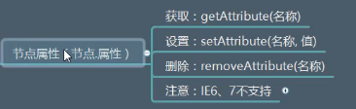

### 获取节点的属性

先获取到节点，然后使用节点.getAttribute(“属性名”)即可获取节点的属性

getAttribute(“属性名”)

|  |
| --- |
| <script>    var span1=document.getElementById("span1");  var attrSpan1=span1.getAttribute("id");  console.log(attrSpan1);  </script> |

### 2.设置属性

setAttribute(“属性名”,”属性值”)

|  |
| --- |
| <img id="imgTag">  <script>  //设置属性  var imgTag=document.getElementById("imgTag");  imgTag.setAttribute("src","1.png");  imgTag.setAttribute("alt","动态新增alt");  imgTag.setAttribute("aaa","aaaaaa");  </script> |

### 3.删除节点的属性

removeAttribute(“属性名”)

|  |
| --- |
| <script>  var imgTag=document.getElementById("imgTag");  //删除节点的属性  imgTag.removeAttribute("aaa");  </script> |