**PGE 383 – Stochastic Methods for Reservoir Modeling – 2/8/2019**

**Project Update #1** – Team 6: Leo Zeng, Kathleen Wilson, Wen Pan, Esmail Eltahan

**Executive Summary**

Our team acquired subsurface data from 209 wells in a data table with X and Y coordinates (meters). The data include: facies characterization (either 1 being sandstone or 0 being interbedded sand and mudstone); porosity (fraction); permeability (mD); and acoustic impedance (AI) in kg/m2s x 106. A two-dimensional acoustic impedance map complements well data and provides 10 x 10 m resolution over the 1 x 1 km area considered. This report provides an initial assessment of petrophysical properties and formulation of a preliminary geologic interpretation. Spatial patterns of facies and descriptive statistics of porosity, permeability and AI suggest the area of interest comprises a fluvial system including two sand-rich geobodies.

The work included:

* Visualization of data through spatial and statistical distributions, separating them by facies.
* Calculation of summary statistics.
* Comparison between well and seismic mapped AI.
* Identification of outliers.
* Initial interpretation of the depositional setting.

The at-well data covers the entire area of interest but demonstrates spatial bias of clustered wells. There appears to be pronounced spatial heterogeneity within reservoir properties controlled by facies distribution. Further investigation will complete a debiased well-based sample statistics.

# Description of Workflows and Methods

The following steps were completed in an annotated Python Jupyter Notebook:

1. Loading csv data files to Pandas DataFrame and gridded ndarray.
2. Checking summary statistics for invalid values, e.g. nulls and negatives.
3. Plotting of data distributions and spatial location maps (by-facies and combined).
4. Preliminary investigation of outliers.
5. Comparison of well and map-based AI data using histograms and cumulative-probability distribution.
6. Initial interpretation of reservoir depositional setting.

# Results and Discussions

# Location maps of facies, porosity, permeability and AI – show spatial biasing of well locations. There is clustering of well data within facies 1 which comprises over two-thirds of the overall dataset. Two zones (x: 0 –100, y: 600- 950; x: 700 – 800, y: 600 – 900) are lacking data, suggesting spatial interpolation may be necessary. There is pronounced spatial heterogeneity within porosity and permeability which may be controlled by facies.

# 

# *Figure 1 –location maps of porosity, permeability and acoustic impedance at all 209 wells.*

**Univariate histograms for combined and by-facies well data** – indicate a strong porosity, permeability and acoustic impedance dependence on facies. Facies 1 has a broad distribution of all three parameters. Porosity and permeability are directly related in both facies, AI is inversely related to the other two properties. Porosity for the sand facies appears to have a bi-modal distribution. This suggests the possibility of a dual-porosity system or natural fractures. Investigation in this matter shall follow. Summary statistics by facies indicate there are no null values, nor non-physical values. They also indicate an unusually large maximum permeability suggesting the well data may have poor quality, and further cleaning may be required.



*Figure 2 – histograms for porosity, permeability and acoustic impedance at all 209 wells.*

*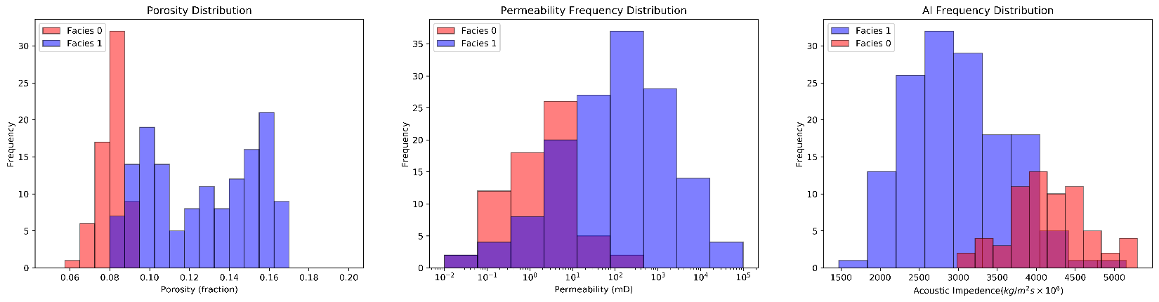Figure 3 – univariate binned histograms by-facies for porosity, permeability and acoustic impedance.*

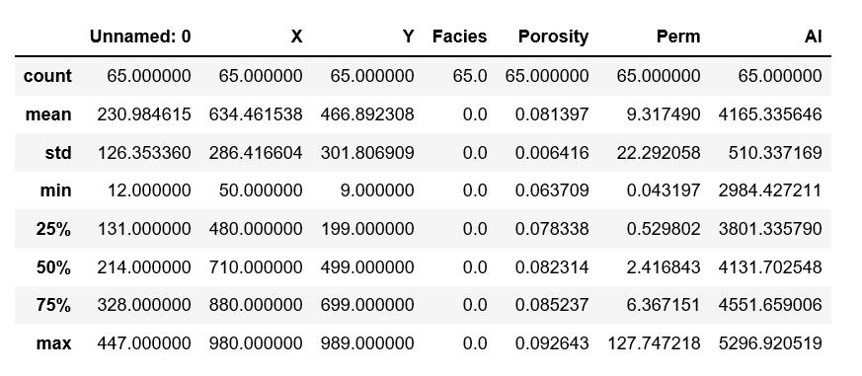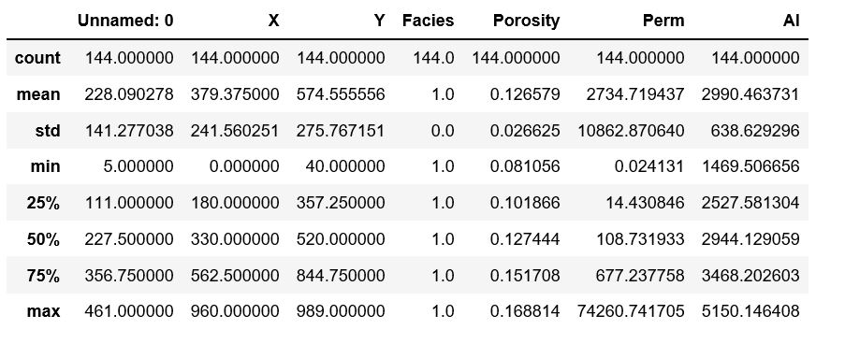

*Figure 4 – summary statistics of well data for interbedded shale and mudstone (facies 0; left) and sandstone (facies 1; right)*

**Outlier Detection** – We performed a preliminary outlier-detection for each data type using the Tukey 1.5 x the interquartile data method. We found reason not to dismiss the outliers, detected by this simple method, in upcoming analyses. As shown in Figure 2, outliers are not sparsely scattered on map, but appear to be grouped in spatially proximate clusters. In addition, logarithmic treatment of permeability data results in smaller number of outliers. Therefore, we point out the need for an outlier-detection method that considers multivariable and location effects.

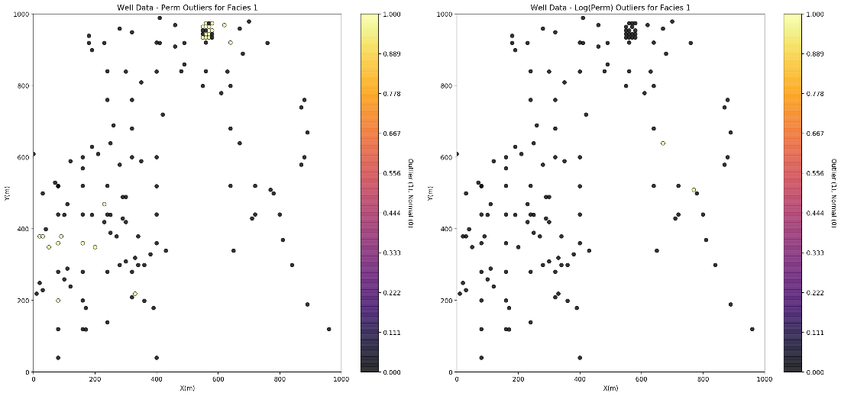

# *Figure 5 – location maps of outliers detected for permeability (left) and its logarithmic distribution (right) for facies 1.*

**Comparison of Acoustic Impedance over the Map and at Wells** – the acoustic impedance distributions were compared between the well based data and broader mapped area. AI histogram and CDF for the well data are shifted to lower values compared to the exhaustive AI map, further supporting results from the location maps that the well sites over-sample the low acoustic impedance, high porosity regions.

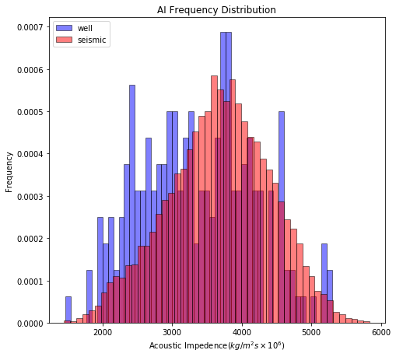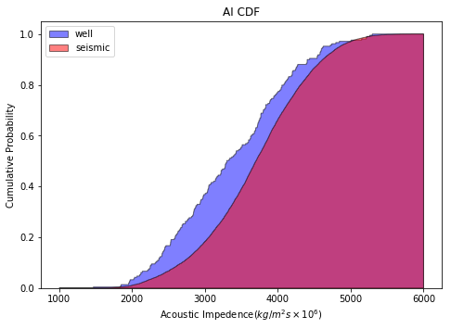

*Figure 6 – Histogram (left) and cumulative distribution of acoustic impedance (AI) from well data and seismic*

**Initial interpretation of depositional setting** – uncertainty is large as discussed earlier. From our preliminary data analysis, we hypothesize a fluvial depositional setting comprising of two rich sand geobodies (circled on figure below).

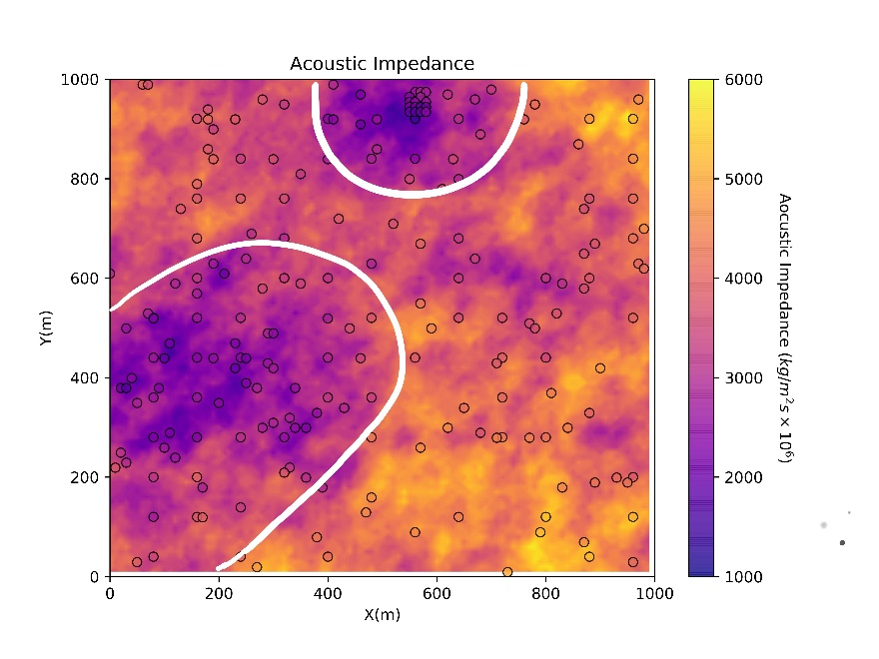

*Figure 7 – Plot of AI data retrieved from seismic mapping on our area of interest showing well locations as small circles. Areas enclosed by white curves are characterized by significantly smaller AI values.*

**Conclusions**

We conclude the following from our first evaluation of the received data:

* Data is clearly biased. Weight-based de-clustering must be performed.
* Porosity for facies 1 has a bi-modal distribution.
* Permeability has a large range of variation for each of the two facies type.
* The subsurface may embody two rich sand geobodies in a fluvial system.