**Wenbin Fei**

Department of Infrastructure Engineering

The University of Melbourne

Email: [wenbin.fei@unimelb.edu.au](mailto:wenbin.fei@unimelb.edu.au) M: 0416617811 Web: <https://wenbinfei.github.io>

**SUMMARY**

* Multiscale **numerical simulation** from 0.5mm particle packings (COMSOL) to 3km carbon dioxide storage site (ABAQUS + ECLIPSE).
* **Experiments:** Advanced hollow cylindrical tests on granular materials; Computed tomography analysis of granular materials; 2-years rock testing experience in a commercial lab.
* **Fieldwork:** More than 10 road projects including design of slope, subgrade, pavement, drains and special treatments of soft soil, expansive soil and poor-graded sandy soil. Leader of geotechnical engineering group for designing 6 roads in Hainan island (Sponge city and utility tunnel).
* **Data analysis** with machine learning and graph theory using python.

**EDUCATION**

**PhD.** Geotechnical Engineering, *The University of Melbourne JAN.2017-Current*

**M.S. C**ivil Engineering, *University of Chinese Academy of Sciences*, *SEP/2011-JUL/2014*

Outstanding Graduate, Merit Student of Chinese Academy of Sciences.

**B.S.** Geological Engineering, *Chang’an University, SEP/2007-JUL/2011*

Excellent Thesis of Chang'an University, Merit Student of Chang'an University.

**RESEARCH EXPERIENCE**

*JAN/2017-Current The University of Melbourne*

**Particle Scale Study on Fluid and Heat Flow in Granular Mixtures**

* Images from Computed Tomography Scanning and post-processed using ImageJ and Simpleware;
* Simulation of fluid flow and heat transfer using COMSOL and network models;
* In-house developed codes are used to calculate three-dimensional particle shape descriptors;
* Particle connectivity using complex network theory (graph theory);
* Machine learning is used to establish the relationship between the microscale structure and transport properties under loading and diagenesis.

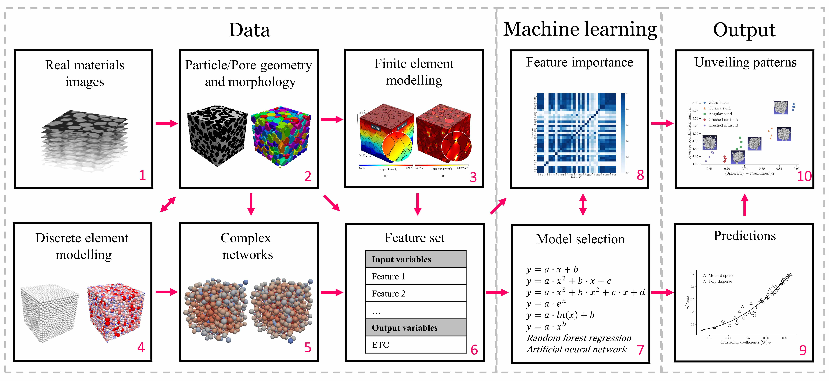

**Effect of Chemical Reaction on the Permeability of Fractures in Deep Geothermal Reservoir**

* Variation of precipitation and dissolution with the change of pore pressure and temperature;
* Fracture heterogeneity;
* In-house C++ software to conduct full coupling THC simulation.

*SEPT/2011.9-JUL/2014.7 Institute of Rock and Soil Mechanics, Chinese Academy of Sciences*

**Coupled Analysis of Carbon Dioxide Storage Combining with Overlying Coal Exploitation**

* A code (“AEEA Coupler”) by linking ABAQUS **(Mechanics software)** and ECLIPSE **(Reservoir software)** was developed to realize **THMC coupling analysis**;
* Applying sub modelling technique to well stability analysis;
* Geological modelling with **Petrel**;
* Controlling ABAQUS using **Python language**.

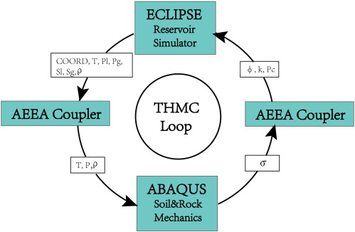

**Numerical simulation of hydraulic fracturing**

* The stress-damage model with different hydraulic and native fissures;
* Extended Finite Element Method (XFEM) in ABAQUS.

**Adopting different methods to simulate the mining process**

* Coal-rock visco-elasto-plasticity deformation;
* Cohesive element;
* Smoothed particle hydrodynamic (SPH) method.

**Survey and sampling in the Sichuan basin**

* One moth field trip to investigate the outcrops and to understand the geological systems;
* Investigating gas fields to study the injection-induced seismicity in oil/gas reservoirs;
* Sampling various rock for laboratory acoustic emission experiment to further understand the load-induced failure process.

**EMPLOYMENT**

*AUG/2014-NOV/2016 Geotechnical engineer at China Railway Siyuan Survey and Design Group Co., LTD*

**Road Bed Design**

* Design of high embankment and deep cutting in mountain highway;
* Design of CFG and pipe piles in soft soil;
* Special design about sponge city (permeable pavement and low impacted development drain) construction and unitality tunnel;
* Leader of geotechnical engineering group for designing 6 roads in Hainan island.

**Slope Design and Treatment**

* Slope stability analysis using GeoStudio Slope/w and ABAQUS;
* Research on expansive clay slope progressive deformation mechanism of instability based on FLAC2D (using **fish code** to add the expansion force) ;
* Design anchor frame beam, retaining wall or anti-slide pile to strengthening slope.

**Geotechnical Investigation Report**

* Field survey;
* Recommend soil and rock properties;
* Recommend methods to treat poor soil and avoid geological disasters.

**Experimental study of anisotropy and non-coaxiality of granular solids**

* Hollow cylindrical tests;
* Using particulate materials (glass beads and polymers).

*FEB/2018-Current Testing engineer at Bamford Rock Testing Services*

* Mechanical strength: Brazilian tensile, point load, uniaxial compressive and triaxial strength;
* Penetration resistance (Toughness): Goodrich drillability test and sievers J-value test
* Brittleness: Swedish brittleness number;
* Abrasiveness: CERCHAR abrasivity index.

*JUN/2018-Current Lab assistant at The University of Melbourne*

* Lab management; Induction for lab users; Lab inspection.

*May/2019- Current Senor Tutor at The University of Melbourne*

* Subject coordination, consultation, task arrangements for tutors.

*JUL/2017- May/2019 Tutor at The University of Melbourne*

* Seepage lab practical; Slope stability tutorial; Finite element simulation tutorial; Optimization tutorial; GeoStudio workshops.

**PUBLICATIONS**

* **[Fei W](https://www.sciencedirect.com/science/article/pii/S0032591019305868)**[, Narsilio G, Disfani M, Impact of three-dimensional sphericity and roundness on heat transfer in granular materials. Powder technology, 2019; 355:770-781](https://www.sciencedirect.com/science/article/pii/S0032591019305868)
* [**Fei W**, Narsilio G, van der linden J, Disfani M, Quantifying the impact of rigid interparticle structures on heat transfer in granular materials using networks. International Journal of Heat and Mass Transfer, 2019; 143, 118514](https://www.sciencedirect.com/science/article/abs/pii/S0017931019325207)
* **[Fei W](https://www.researchgate.net/publication/280093315_Interaction_Analysis_for_CO2_Geological_Storage_and_Underground_Coal_Mining_in_Ordos_Basin_China)**[, Li Q, Wei X, Song R, Jing M, Li X. Interaction analysis for CO2 geological storage and underground coal mining in Ordos Basin, China. Engineering Geology. 2015;196:194-209.](https://www.researchgate.net/publication/280093315_Interaction_Analysis_for_CO2_Geological_Storage_and_Underground_Coal_Mining_in_Ordos_Basin_China)

* [Yang Y, **Fei W**, Yu H-S, Ooi J, Rotter M. Experimental study of anisotropy and non-coaxiality of granular solids. Granular Matter. 2015;17:189-196.](https://www.researchgate.net/publication/273508107_Experimental_study_of_anisotropy_and_non-coaxiality_of_granular_solids)

* **[Fei W](https://www.researchgate.net/publication/266559777_Coupled_Analysis_for_Interaction_of_Coal_Mining_and_CO2_Geological_Storage_in_Ordos_Basin_China)**[, Li Q, Liu X, Wei X, Jing M, Song R, et al. Coupled Analysis for Interaction of Coal Mining and CO](https://www.researchgate.net/publication/266559777_Coupled_Analysis_for_Interaction_of_Coal_Mining_and_CO2_Geological_Storage_in_Ordos_Basin_China)[2](https://www.researchgate.net/publication/266559777_Coupled_Analysis_for_Interaction_of_Coal_Mining_and_CO2_Geological_Storage_in_Ordos_Basin_China) [Geological Storage in Ordos Basin, China. ARMS8-2014 ISRM International Symposium-8th Asian Rock Mechanics Symposium-Rock Mechanics for Global Issues-Natural Disasters, Environment and Energy. 2014. p. 2485-94.](https://www.researchgate.net/publication/266559777_Coupled_Analysis_for_Interaction_of_Coal_Mining_and_CO2_Geological_Storage_in_Ordos_Basin_China)

* [Li Q,](https://www.researchgate.net/publication/261058425_Challenging_combination_of_CO2_geological_storage_and_coal_mining_in_Ordos_basin_China) **[Fei W](https://www.researchgate.net/publication/261058425_Challenging_combination_of_CO2_geological_storage_and_coal_mining_in_Ordos_basin_China)**[, Liu X, Wei X, Jing M, Li X. Challenging combination of CO](https://www.researchgate.net/publication/261058425_Challenging_combination_of_CO2_geological_storage_and_coal_mining_in_Ordos_basin_China)[2](https://www.researchgate.net/publication/261058425_Challenging_combination_of_CO2_geological_storage_and_coal_mining_in_Ordos_basin_China) [geological storage and coal mining in the Ordos basin, China. Greenhouse Gases: Science and Technology. 2014;4:452-67.](https://www.researchgate.net/publication/261058425_Challenging_combination_of_CO2_geological_storage_and_coal_mining_in_Ordos_basin_China)

* **[Fei W](http://www.ccopyright.com.cn/cpcc/RRegisterAction.do?method=list&no=fck&sql_name=%B9%A4%D2%B5%BC%B6%CA%FD%D6%B5%C4%A3%C4%E2%C8%ED%BC%FE&sql_regnum=&sql_author=&curPage=1&count=&sortOrder=&sortLabel=)**[, Li Q. A Software to Analysis the Multi-physical THMC Promblems by Linking ABAQUS and ECLIPSE [AEEA Coupler], China Registration No. 2014R027901. 2013.](http://www.ccopyright.com.cn/cpcc/RRegisterAction.do?method=list&no=fck&sql_name=%B9%A4%D2%B5%BC%B6%CA%FD%D6%B5%C4%A3%C4%E2%C8%ED%BC%FE&sql_regnum=&sql_author=&curPage=1&count=&sortOrder=&sortLabel=)
* Li Q, Ma J, **Fei W**, et al, Coupling of ABAQUS and ECLIPSE for thermo-hydro-geomechanical modeling of fluid flow and rock deformation associated with carbon dioxide geological sequestration. 15th International Conference of the International Association for Computer Methods and Advances in Geomechanics (15th IACMAG).

* [Li Q, Wei Y-N, Liu G, Jing M, Zhang M,](https://www.researchgate.net/publication/273194086_Feasibility_of_the_Combination_of_CO2_Geological_storage_and_Saline_Water_Development_in_Sedimentary_Basins_of_China) **[Fei W](https://www.researchgate.net/publication/273194086_Feasibility_of_the_Combination_of_CO2_Geological_storage_and_Saline_Water_Development_in_Sedimentary_Basins_of_China)**[, et al. Feasibility of the combination of CO](https://www.researchgate.net/publication/273194086_Feasibility_of_the_Combination_of_CO2_Geological_storage_and_Saline_Water_Development_in_Sedimentary_Basins_of_China)[2](https://www.researchgate.net/publication/273194086_Feasibility_of_the_Combination_of_CO2_Geological_storage_and_Saline_Water_Development_in_Sedimentary_Basins_of_China) [geological storage and saline water development in sedimentary basins of China. Energy Procedia. 2013;37:4511-7.](https://www.researchgate.net/publication/273194086_Feasibility_of_the_Combination_of_CO2_Geological_storage_and_Saline_Water_Development_in_Sedimentary_Basins_of_China)

* [Zhang M, Yang Y, Li Q, Jiang M,](http://www.rockmech.org/EN/abstract/abstract28332.shtml) **[Fei W](http://www.rockmech.org/EN/abstract/abstract28332.shtml)**[. Influence of Stress Paths Including Principal Stress Rotation on Critical State of Dense Sand. Chinese Journal of Rock Mechanics and Engineering. 2013;32:2560-5.](http://www.rockmech.org/EN/abstract/abstract28332.shtml)

**SKILLS**

* **Programming:** Python (Data Science), C++, Git, GitHub;
* **Simulation:** ABAQUS, COMSOL, ECLIPSE, PETREL, GeoStudio Slope/w, PFC and FLAC;
* **Imaging:** Computed tomography (CT) scanning, ImageJ/Fiji, Simpleware.

**REFEREES**

**Referee 1:** A/Prof. Guillermo Narsilio, Supervisor of my PhD

Email: [narsilio@unimelb.edu.au](mailto:narsilio@unimelb.edu.au) Phone: 61 3 8344 4659

**Referee 2:** Prof. Qi Li, Supervisor of my Master

Email:[qli@whrsm.ac.cn](mailto:qli@whrsm.ac.cn) Mobile: 86 159 2712 3096

***To explore more:***[*https://wenbinfei.github.io*](https://wenbinfei.github.io)