Iowa State University

Ecology, Evolution, and Organismal Biology
of science and technology

Dear Dr. Gaut,

We would like to thank you and both reviewers for your recommendations on improving our manuscript titled “Comparative genomics of an unusual biogeographic disjunction in the cotton tribe (Gossypieae) yields insights into genomic downsizing”. We are pleased to know that both reviewers find the manuscript valuable and we feel that their comments have made the manuscript stronger. We have carefully considered each comment and provide responses below.

Referee 1

Figure 2
Tables 1 and 2, and Figure 2 seem to present the same information. Are both necessary?
The y-axis lacks a label.
Italicize species names.
Table 1 and Figure 2 are, indeed, different representations for the same data. Table 1 includes the Mean, Median, and Std Deviation for the rate of synonymous and nonsynonymous substitutions and Figure shows this visually. We have moved Table 1 to supplementary data to remove redundancy in the manuscript while preserving the information for those that may be interested in the numbers calculated. We place the most relevant information (i.e., median values) on the figure itself. We also note that original Table 2 (now Table 1) presents different data regarding gene copy number and should be preserved.

In addition, we have added a label to the y-axis of Figure 2 and italicized species names, as per the reviewer’s comments. Finally, we have added a few aesthetic (i.e., color and border) changes to improve the quality of the figure.

Figure 3
What are the error bars? How many individuals were used to calculate the means and variance?
The variable names need explaining.
Table 3 and Figure 3 seem to present the same information. Why are species names used in one and A1/A2 etc used in the other?
We apologize for the oversight in labeling the variable names on Figure 3, which we have fixed. We have also referenced the additional accessions used for the Gossypium transposable element amounts, although these are provided as a reference and are not central to the conclusions. Finally, we note in the figure legend that the error bars represent the standard error.

Figure 4
Are all 22 clusters necessary? They end up being so small that they are hard to read individually.
We understand the reviewer’s concern here. It was our intention to show the different patterns of gain/loss; however, to improve readability, we have selected exemplar clusters to show the patterns seen in the data. We believe that this was done without loss of information to the paper, and have edited the figure legend to correspond to the new figure. The original will remain on our Github repository, which is referenced in the manuscript.

Supp Figure 2
This figure lacks both x and y-axes.
In order to refrain from cluttering the visualized graphs, we describe the graphs (including the axes) in the figure legend.

Supp Table 5 is so large that I wonder if being part of a pdf is really the best idea.
The original file format (tab-delimited text) was rejected from the online submission system. We were only able to load the pdf; however, upon acceptance, we will work with the journal to make this table accessible in a reasonable format.

OTHER COMMENTS
Line numbers refer the 1-60 added to the page Page 3, line 9. Is evolutionary really the right word? How about historical?
We understand the reviewer’s hesitation regarding the word “evolutionary” versus an alternative such as “historical”. Here, however, we use the word to direct the reader toward the evolutionary relevance of long-distance dispersal and the potential evolutionary consequences of such. In switching to something like “historical”, we fear that the reader will be expecting a time-forward description of dispersal and/or population movement, which is not our intention. While “evolutionary” may not be the most precise, we believe it conveys the information adequately without becoming verbose.

Page 8, line 45. This is the first time the text G. raimondii is mentioned. For someone not familiar with the cotton relatives, there are a couple of times like this in the text where a new species is mentioned without explaining.
While we do mention in the introduction that the genus Gossypium is sister to the Kokia-Gossypioides clade, we have added reminders to this throughout, e.g., “Amino acid sequences from G. kirkii, K. drynarioides, and Gossypium raimondii (Paterson, et al. 2012; representative of the genus sister to Gossypioides + Kokia), were clustered using OrthoFinder v1.1.4 (Emms and Kelly 2015)…”

Page 8, lines 54-55. How many sequences were lost at this step?
We now specify the number of sequences lost as follows: “Orthologous groups containing only a single representative from all species were retained (12,281 orthogroups out of 21,415 total, discarding approximately 17,000 genes from both G. kirkii and K. drynarioides).”

Page 9, line 40. Clarify that the Malvaceae is the family of cotton
We now note Malvaceae is the cotton family: “divergence times for the Malvaceae, which includes cotton and chocolate…”

Page 10, line 5. At this point in the text it is not obvious why Theobroma is included. It only becomes clear later in the text.
We now note that chocolate is included because it is a member of the Malvaceae outside of Kokia-Gossypioides-Gossypium: “divergence times for the Malvaceae, which includes cotton and chocolate…”

Page 15, line 44. The dramatic gene loss is one of the striking results of the paper. Can you say anything about WHAT genes are being lost? For example, are they evenly distributed across the genome? Are certain functions overrepresented?
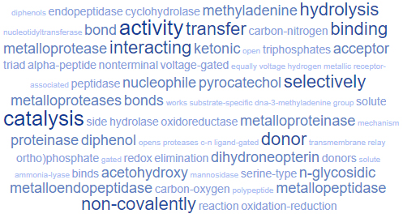
We thank the reviewer for this comment. We note that the distribution is already included in Figure 6, and they are indeed evenly distributed. We had previously conducted GO analyses to determine functional relevance of these genes, and found it generally unhelpful. I include the image here, and if it is desirable, we can include this in the supplementary materials.

Page 17, 37-38. I think the authors need to include an explanation of what ”A-genome” means.
We avoid this discussion by replacing “A-genome” with “subgenus Gossypium”, as these terms are interchangeable with the latter being more broadly accessible.

Page 18, line 30. Italicize gypsy
Thank you.

Page 23, line 21. This is a really exciting result. It would be interesting to hear the authors discuss their results more in the context of the quite rich literature on TE vs. indel-driven genome size evolution. In general, I would have liked to see more discussion of their results in the context of other plant species, beyond the cotton relatives.
We thank the reviewer for the comment and agree that a more generalized discussion has improved the manuscript. We have extended the discussion to include more patterns gleaned from the genome size literature and have revised it as such:

(Added text in the section Static genome size in the face of a changing repetitive element landscape)
We note that this result contrasts with the expectation based on small effective population size alone and stands in contrast to abundant literature that reports genome size differences among closely related species (Hawkins, et al. 2006; Kelly, et al. 2015; Macas, et al. 2015; Novak, et al. 2014; Piegu, et al. 2006; Tetreault and Ungerer 2016; Vu, et al. 2015) and even within species (Biemont 2008; Diez, et al. 2013; Duchoslav, et al. 2013; Smarda, et al. 2008). Furthermore, given the stresses associated with dispersal and colonization of new environments, it may be even more surprising that the genome size has remained the same; however, although biotic and abiotic stresses have been associated with TE release from suppression, this activation can be genotype dependent and repression under stress is also commonly observed (reviewed in Horvath, et al. 2017). Finally, research on plant invasiveness supports an association between small genome size and invasive potential, possibly due to the traits associated with invasive success (e.g., seedling growth rate, water/nutrient use, etc.; reviewed in Suda, et al., 2015). While these species are not invasive per se, colonization (such as that of the Hawaiian Islands and East Africa/Madagascar) may favor similar characteristics.
Notwithstanding the relative genomic stasis of the two genera, it is clear that the differences that do exist between the two species reflect both gain and loss of repetitive sequence. Most of the “younger” differentially abundant clusters that distinguish K. drynarioides and G. kirkii are over-represented in K. drynarioides, a result consistent with the observation that a reduction in population size and concomitant increase in the severity of genetic drift can lead to an increase in insertional mutations, possibly due to activation of TEs under stress conditions (Grandbastien 2004; Kalendar, et al. 2000; Liu and Wendel 2003; Parisod, et al. 2010). Ancestral state reconstructions of TE amounts (Figure 4) also suggest both gain and loss in K. drynarioides and G. kirkii of approximately the same magnitude, which accounts for the static genome size of these species in the face of a changing TE landscape and maybe indicative of nucleotypic or other phenotypic restrictions associated with genome size in these species.

(In the section Rates of indel formations compensate for biased TE proliferation)
The abundance of indels in these two small genomes may be a consequence of their presumably small effective population sizes during the course of evolution. An extension of the drift-barrier hypothesis to indel formation suggests that selection for DNA fidelity and repair is less efficient in small populations, leading to a higher rate of retained indel mutation events (Sung, et al. 2016). The predicted decline in DNA fidelity associated with decreasing population sizes has been broadly demonstrated across the tree of life (Sung, et al. 2016) and may explain the relative abundance of indels in these two lineages, including the increased propensity for indel formation in K. drynarioides which was likely subject to severe population size restrictions as it colonized the Hawaiian Islands. Differences in double-strand break repair have been invoked for genome size reduction in across the tree of life, including plant species (Hu, et al. 2011; Kirik, et al. 2000; Orel and Puchta 2003; Puchta 2005; Vu, et al. 2015).

Page 25, line 25. I don’t think ”equivocal” is what the authors meant here. Typo for ”equivalent”? Either way, I think something like ”similar” would be more accurate.
We thank the reviewer for catching this typo. We have replaced “equivocal” with “similar”, as suggested.

Referee 2

- page 7, line 13 and following: I’m not sure where the RNA comes from. It is not mentioned prior to this line. RNA shows up in the next section, but the species that were sampled for RNA are less than clear in the first paragraph. Was it both species? How / where were the plants grown?
We clarify in the methods that “RNA was extracted from three biological replicates of both K. drynarioides and G. kirkii for the purpose of annotation.” Because the only purpose here is annotation, we do not belabor details about the plants/growing conditions/etc, which would be pertinent to an expression-based analysis.

Then the annotation section describes data for the genome of G. kirkii, which is a bit weird given that K. drynarioides genome was already described. Generally, the Methods section needs some reorganization. I might suggest an RNA-seq section, a genomic data section, an annotation section, etc.
We understand the reviewer’s concern regarding the methods section. As the G. kirkii genome represents is a pre-release genome that we were given permission to publish on in this context, organizing the methods become tricky as the G. kirkii data was not generated by our group. This is why we note that it is a pre-release G. kirkii genome in several places. We understand the interest of some readers in having more information regarding the G. kirkii genome; therefore, we have asked the readers to refer to (https://github.com/Wendellab/KokiaKirkii) for more information on the G. kirkii genome. In doing this, we can have a brief set of methods explaining the annotation right now and then later link to the genome publication itself.

Otherwise, our organization is similar to what the reviewer suggests, although we do not divide the RNA-seq into its own section as it was only used for the purposes of facilitating more accurate annotations.

- Coverage is reported for Kokia. Was it given for Gossypiodes?
We now include coverage for Gossypioides kirkii. We will also include this information in the NCBI PRJNA that is reference in the manuscript.

- Page 9, lines 44 to 51. This is of course personal preference, but this bit strikes me as better put in the Results or the Discussion…
We thank the reviewer for this comment, and agree that moving these lines (from subsection Estimating Divergence Times) to the Results section is appropriate. We have pruned the paragraph describing how we generated the synonymous substitution rate to only include methods. The remaining sentences noting the derivation of historical substitution rate derivations was moved to the Results section (first paragraph under subsection Divergence Time within Malvaceae).

- The homemade CNV approach might be ok, but it might not. There are lots of CNV searching algorithms that have been published, and their performance has been characterized – i.e., LUMPY, delly, etc. This aspect of the paper would benefit from confirmation. Moreover, it is easier to identify deletions than gains, perhaps especially by this homemade method. This bias might explain the observation of more inferred deletions in the two non-Gossypium species…
We thank the reviewer for the recommendation of CNV algorithms. In addition to our current analysis and verification method, we now include independent verification of gene loss via delly2. While delly2 verifies slightly fewer losses in G. kirkii (40.8% versus 53.9%), it verifies an even greater number of K. drynarioides deletions (88.8% by delly2, versus 64.8%). We see advantages to both verification methods, where delly2 is a recognized structural variant, although, like most, it is best applied between closely related taxa and not necessarily across genera. Our method of explicitly searching for the “missing” genes using a divergence threshold borne out by our dS calculations, but excluding missense mutations, This method appears to do a better job of detecting large (e.g., whole gene deletions), as delly2 could detect an upper limit of 160nt deleted for the gene space. Nevertheless, because we have no other reason to suspect one method is “more correct” than the issue of divergence among species, we report an average between the two methods and temper our conclusions to suggest that there has likely been remarkable gene removal of about 2:1 (losses-to-gains) in the lineage leading to the two sister genera Kokia and Gossypioides. We also note that a refined estimate will become available in the future with the improvement of both genomes.

“Verification of deletions via delly2 led to a similar, but slightly lower overall validation rate for G. kirkii (40.8% of the original 2,957 inferred), but nearly complete validation of the original K. drynarioides deletion estimate (88.8%). The average number of deletions verified by the two independent methods suggests that the number of losses in both species exceeds the number of gains by about twofold since divergence (5.3 MYA) with a similar number of losses in both G. kirkii and K. drynarioides. Clearly this remarkable result will warrant further research, including using improved genomes and syntenic analyses to uncover the true extent and identity of gene deletions.”

- The Kokia assembly seems reasonable. I don’t understand, however, why the G. kirkii genome is considered “pre-release”. I’m assuming that this is not the paper that will be reporting that genome, and yet the paper sort of implies that it is. I’m not sure what to tell the authors, but it is a bit awkward. At the very least, though, it seems that both will be available in public databases, which seems an important requirement for publication of analyses based on both species.
We understand the reviewer’s perspective on the pre-release of the G. kirkii genome. This genome is still actively under development by a different, albeit related, group. An early iteration of the G. kirkii genome was released to us for the purposes of this comparison; however, since the development and submission of this manuscript, longer reads and more transcriptomic data was acquired to refine this genome to “gold-standard” quality for the purposes of facilitating comparative genomics with cotton species. While using the improved G. kirkii genome may seem desirable, we believe it would prevent a “fair” comparison between the two genomes, as such extensive efforts for Kokia are not yet under development. We, therefore, will place much of the G. kirkii information on our Github repository, which will also allow readers to ask questions directly within the project and receive feedback from any of the members of this group or the development group that is improving the G. kirkii genome.

- Is there a history of polyploidy after divergence of the genera? Does this contribute to the extra 8000 genes in G. raimondii? Or maybe polyploidy events were within Gossypium, after divergence of genera?
We thank the reviewer for pointing out this question which may arise from reading. We now state that “Notably, none of these lineages has a history of unshared paleopolyploidy (Paterson, et al. 2012), although all three share an ancient polyploidy event whose redundancy could be differentially degrading.”

- I apologize, but I am very confused by page 18, lines 52 and following to line 6 of the next page. As I understand it, the non-LTR cluster is the only one that does not differ between the two new genomes, but then it is argued they differ in abundance between the two genomes. Again, I apologize if I’m mis-reading this bit, but I don’t quite get it.
We clarify the wording here to note that this cluster is present in different absolute amounts between Kokia and Gossypioides: “This difference is due to the sole retroposon cluster recovered, which was in the top five largest clusters for both K. drynarioides and G. kirkii (although present in different absolute amounts).”

- The Discussion about divergence times is nice (p. 21) . It might be worth noting that these are estimates from single samples. If there is lineage sorting at play, these estimates could be quite far off just due to population processes. Given divergence times and demographic history (small populations but high diversity), it is hard to know if lineage sorting is a major feature here… but the caveat might still be warranted.
We thank the reviewer for the kind words and suggestions. We have revised the statement to include the caveat: “Our estimate of 10.29-11.22 MYA for the divergence of Gossypium from G. kirkii/K. drynarioides is similar to previous estimates (Cronn, et al. 2002; Seelanan, et al. 1997; Senchina, et al. 2003), which is remarkable observation given the fact that earlier estimates were based on two orders of magnitude fewer genes, although the caveat remains that these were derived from single representatives.”

We thank you for considering this manuscript and hope you find it suitable for publication in Genome Biology and Evolution. We look forward to the review process.

Sincerely,
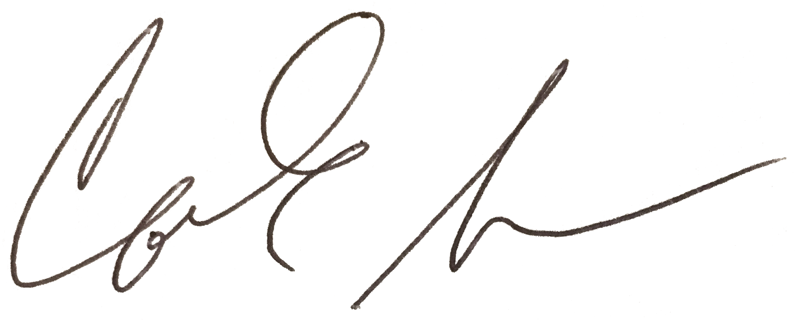
Corrinne E Grover, PhD
Associate Scientist
Department of Ecology, Evolution, & Organismal Biology
Iowa State University, Ames, IA 50011 USA
corrinne@iastate.edu

