Topic Exploration

Real-World Applications of Analytics
Before choosing my final project, I looked at different ways businesses could use data analytics to solve problems.
1. Supervised Machine Learning
A real estate company can use past house sales to estimate the price of a property. This can help real estate agents and sellers make better pricing decisions.
2. Unsupervised Machine Learning
A retail company can group customers based on their shopping habits. The company can use these groups to offer more relevant promotions instead of sending the same offers to everyone.
3. Dimensionality Reduction
A company may collect many customer variables, but not all of them provide useful information. Dimensionality reduction can help simplify the data and make patterns easier to understand.
4. Natural Language Processing (NLP)
An online retailer can analyze customer reviews to identify common complaints, such as shipping delays or product quality issues. The company can use the results to decide which problems to address first.
5. Sentiment Analysis
A hotel can analyze online reviews to understand whether guests are satisfied or dissatisfied. Managers can use this information to identify areas that need improvement.
6. Social Media Analytics
A business can examine engagement with its social media posts to understand what content attracts customers. This information can help the marketing team plan future campaigns.

Selected Project: House Price Prediction
I chose supervised machine learning because I wanted to work on a problem that could support a real business decision.
My project uses historical housing data from Ames, Iowa, to predict house sale prices.
The main stakeholders are real estate agents and home sellers. They could use the predicted prices as an additional reference when deciding how much to list a property for.
I compared Linear Regression, Ridge Regression, Huber Regression, and Random Forest to understand which model works better with this dataset.
The goal is not to replace professional property appraisals. Instead, the model could provide another useful reference when making pricing decisions.
The dataset comes from the Kaggle House Prices – Advanced Regression Techniques competition.
Dataset: https://www.kaggle.com/competitions/house-prices-advanced-regression-techniques/overview
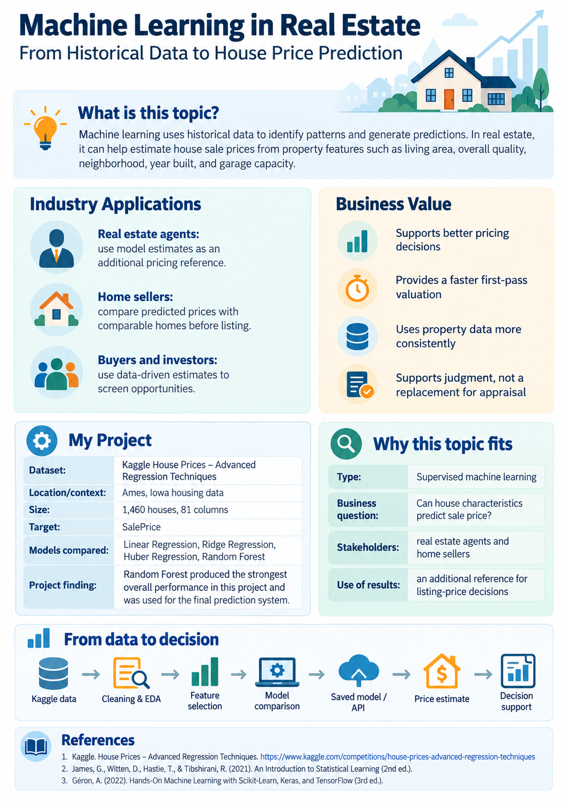

Project Proposal

Project Title
Predicting House Prices Using Machine Learning

Business Problem
House prices can be very different, even when houses are in the same area. Some houses are bigger, newer, or in better condition than others. This makes it hard for sellers to decide how much to ask for their homes.
This project explores whether house information can be used to estimate prices instead of relying only on guesses.

Stakeholders
The main stakeholders are home sellers and real estate agents who need additional information when deciding on a house price.

Project Question
Can machine learning predict house prices based on features such as house size, quality, and age?

Project Objective
The goal of this project is to compare different regression models and determine which one predicts house prices more accurately.
The project also examines which house features are important and why some houses may be harder to predict than others.

Intended Business Use
This project could help home sellers and real estate agents better understand how much a house might be worth.
Predicted prices could be used as an additional reference when setting a listing price instead of relying only on personal judgment.
The model is not intended to replace real estate agents or professional appraisals.

Dataset
The project uses the House Prices – Advanced Regression Techniques dataset from Kaggle.
The dataset comes from Ames, Iowa, and includes information such as house size, overall quality, year built, garage size, and sale price.
Dataset: https://www.kaggle.com/competitions/house-prices-advanced-regression-techniques/overview

Planned Method
This project uses supervised machine learning because the dataset includes house characteristics and actual sale prices.
A simple regression model will be used as a baseline and compared with other regression methods.
The goal is to identify a model that provides useful predictions while keeping the results understandable.

Success Measures
Model performance will be evaluated using RMSE, MAE, and R².
These measures will help determine how close the predicted prices are to actual sale prices and how well the models perform on unseen data.
Large prediction errors will also be examined instead of focusing only on average performance.

Expected Limitations
The dataset only includes historical house sales from Ames, Iowa, so the results may not apply to other housing markets.
Unusual properties may also be harder to predict because their characteristics may not be well represented in the training data.

Next Steps
The next steps include exploring the dataset, checking missing values, examining relationships between house characteristics and sale prices, and developing a baseline regression model.
Additional regression models will then be compared and evaluated to determine their prediction performance.

Initial Data Exploration

1. Dataset Overview
The project uses the House Prices – Advanced Regression Techniques dataset from Kaggle. It contains historical housing information from Ames, Iowa.
The training dataset includes 1,460 houses and 81 columns. The target variable is SalePrice, which represents the final sale price of each house.
The dataset includes 43 categorical variables, 35 integer variables, and 3 floating-point variables.

2. Data Quality Check
An initial data quality check was performed using Python and Pandas.
The results showed:
- Total records: 1,460
- Total variables: 81
- Duplicate rows: 0
- Missing SalePrice values: 0
These results show that the target variable is complete and no duplicate rows were found.

3. Missing Values
Several variables contain missing values.
The variables with the largest numbers of missing values include:
Variable | Missing Values
PoolQC | 1,453
MiscFeature | 1,406
Alley | 1,369
Fence | 1,179
MasVnrType | 872
FireplaceQu | 690
LotFrontage | 259
Some missing values may indicate that a house does not have a particular feature, such as a pool or fence.
Other missing values will need to be examined before model training.

4. Sale Price Distribution
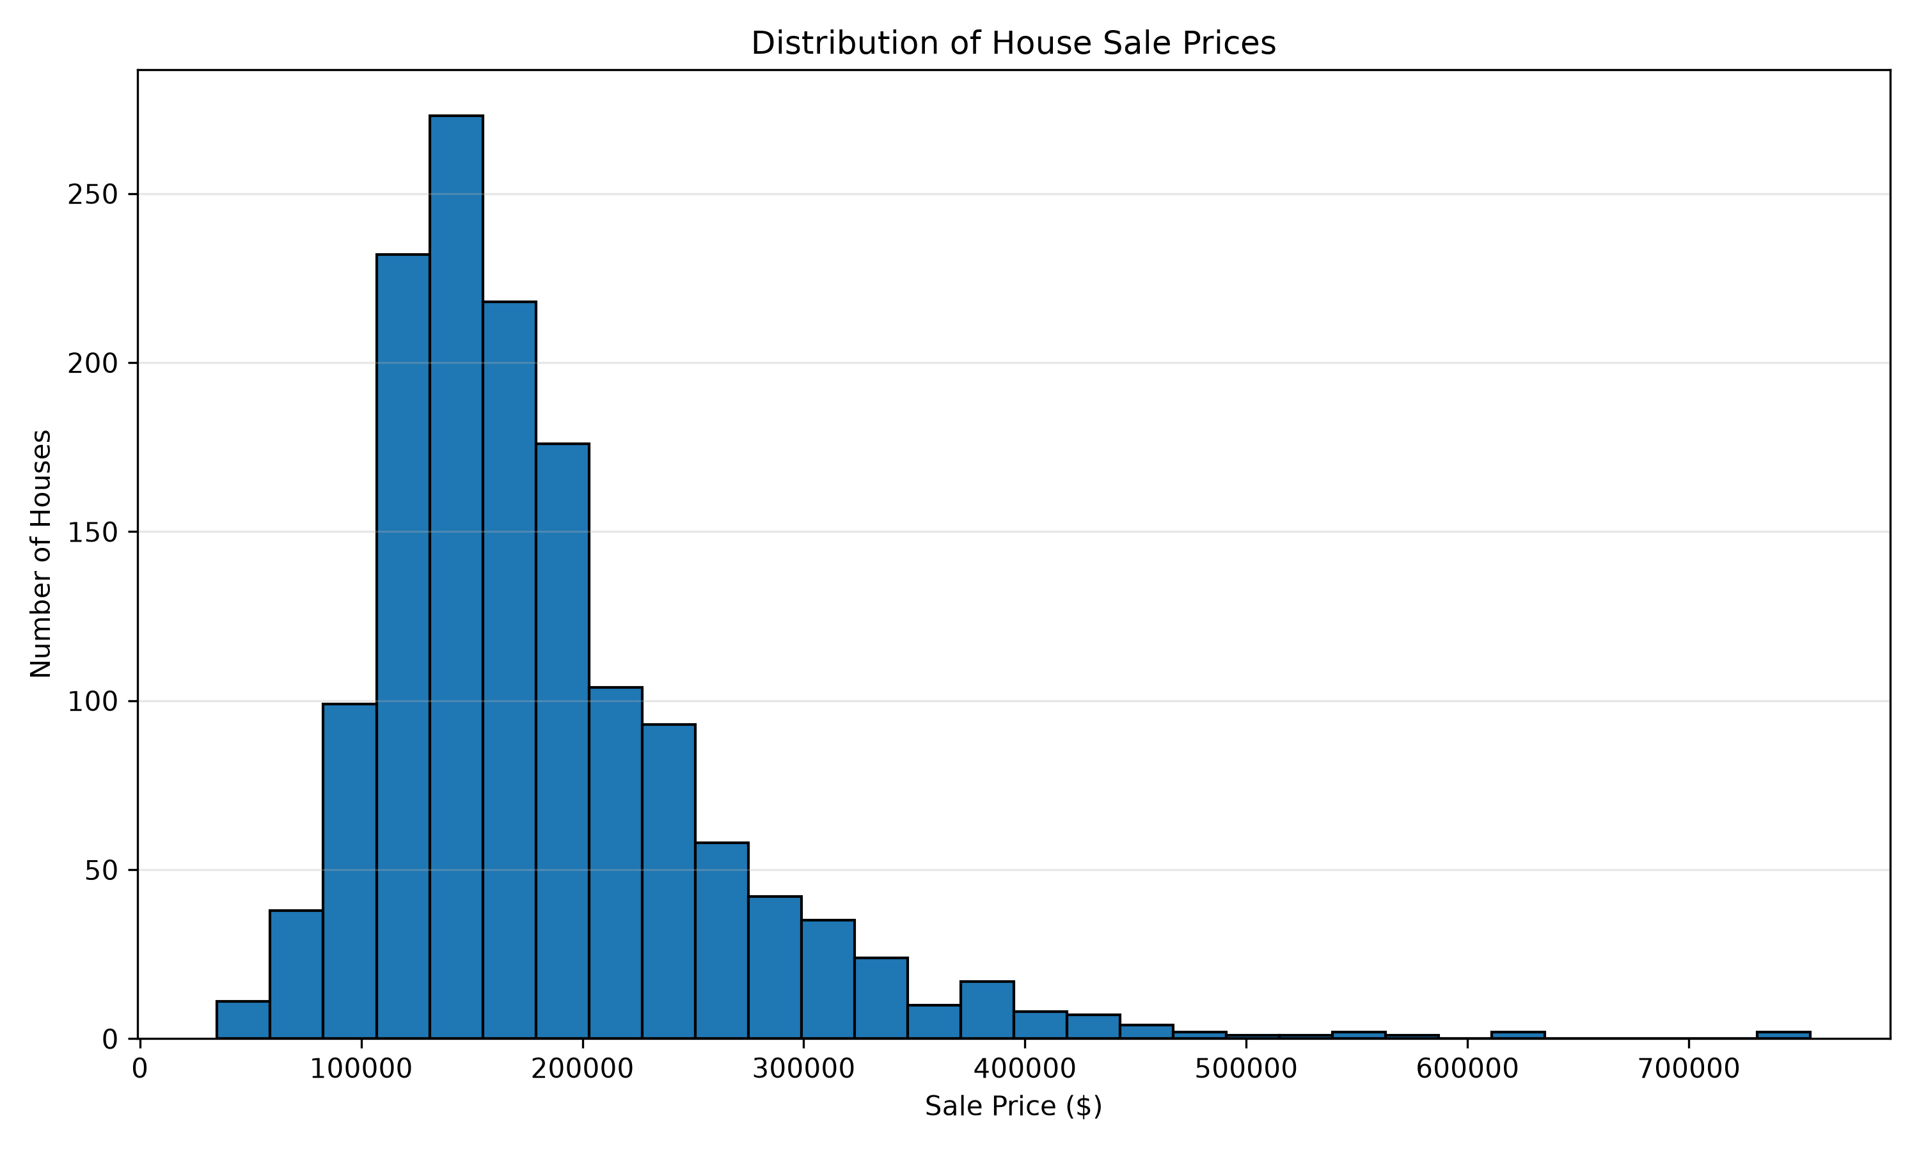
Sale Price Distribution
Figure 1. Distribution of House Sale Prices
The average house price is $180,921, while the median is $163,000. Most houses are priced in the lower to middle range, with 50% of sale prices between $129,975 and $214,000.
The distribution is right-skewed, with a skewness value of 1.88. This means that a smaller number of expensive houses increase the average price.
The results suggest that house prices vary considerably across the dataset. This is important when developing a prediction model because unusually expensive properties may be more difficult to predict accurately.

5. Living Area vs. SalePrice
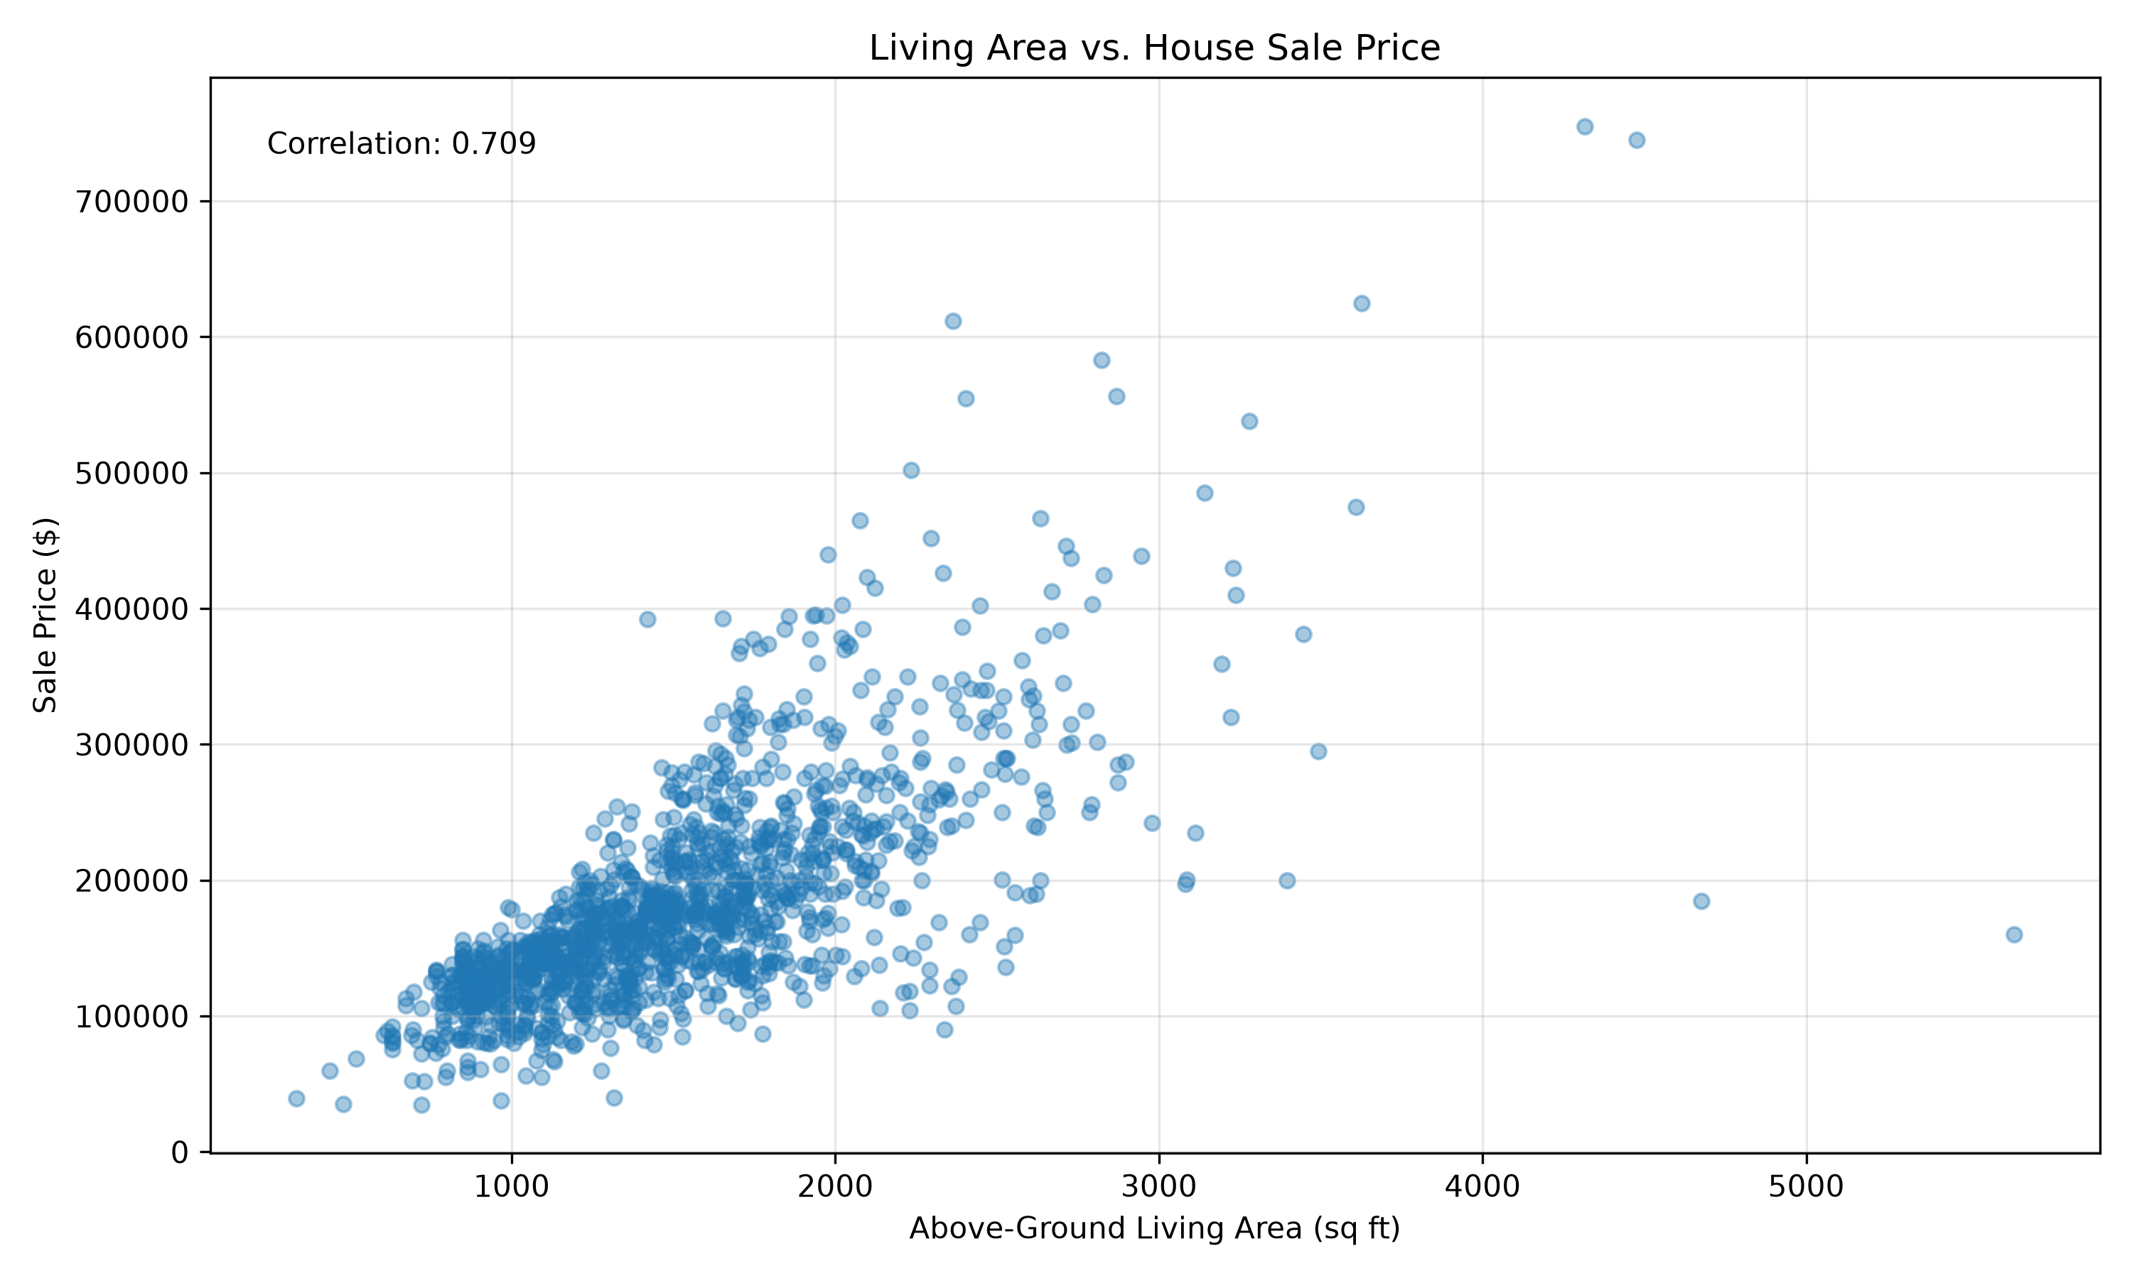
Living Area vs. SalePrice
Figure 2. Relationship Between Living Area and Sale Price
The correlation between above-ground living area (GrLivArea) and SalePrice is 0.7086, indicating a strong positive relationship. In general, houses with larger living areas tend to have higher sale prices.
However, some houses do not follow this pattern. For example, House ID 1299 has 5,642 square feet of living area but sold for only $160,000. House ID 524 also has a large living area of 4,676 square feet but sold for $184,750.
These observations suggest that house size alone cannot explain all differences in sale prices. Other features, such as overall quality, condition, and location, may also be important.
Unusual properties should be examined further because they may affect model performance.

6. Initial Findings
The data quality check suggests that the dataset is suitable for further exploration because there are no missing sale prices or duplicate rows.
However, missing values in other variables need to be handled carefully.
The next step is to examine the distribution of house prices and explore how property characteristics relate to sale prices.

7. Planned Data Preparation
Before training the models, the project will examine missing values and determine appropriate ways to handle them.
Numerical variables may require imputation, while categorical variables may need encoding before they can be used in regression models.
The dataset will also be divided into training and testing sets to evaluate prediction performance.

8. Next Steps
The next steps are to examine the distribution of SalePrice, identify unusual observations, explore important relationships between property characteristics and house prices, and develop a baseline regression model.
These results will help determine which machine learning methods are appropriate for the project.

Data Source
Kaggle. House Prices – Advanced Regression Techniques.
https://www.kaggle.com/competitions/house-prices-advanced-regression-techniques/overview

Baseline Model and Feasibility Analysis

1. Purpose
The purpose of the baseline model is to test whether basic house characteristics can be used to estimate sale prices.
A simple Linear Regression model was selected as the starting point before comparing more advanced methods.

2. Baseline Model
The baseline model uses two features:
- OverallQual: Overall material and finish quality of the house.
- GrLivArea: Above-ground living area in square feet.
The target variable is SalePrice.
The dataset was divided into 80% training data and 20% testing data using random_state=42.

3. Baseline Results
Metric | Result
Training Records | 1,168
Testing Records | 292
RMSE | $44,159.60
MAE | $28,555.25
R² | 0.7458
The baseline model achieved an R² of 0.7458 on the test set, indicating that the two selected features explain approximately 74.58% of the variation in house sale prices.
The MAE was $28,555.25, meaning that predictions differed from actual sale prices by approximately $28,555 on average.
The RMSE was $44,159.60, suggesting that some predictions had relatively large errors.

4. Feasibility Assessment
The baseline results suggest that machine learning can provide useful information for estimating house prices.
However, using only two features does not capture all the factors that may influence sale prices.
Additional property characteristics and alternative regression models may improve prediction performance.

5. Business Relevance
A basic prediction model could provide home sellers and real estate agents with an additional reference when estimating listing prices.
However, the prediction errors are still substantial. The model should not be used as the only basis for setting a house price.

6. Next Steps
The next steps are to compare additional regression models, evaluate more property features, and examine unusually large prediction errors.
The project will also use cross-validation to evaluate whether model performance is consistent across different training and validation samples.

Source
Baseline results generated using src/07_baseline_regression.py and the Kaggle House Prices training dataset.

References
De Cock, D. (2011). Ames, Iowa: Alternative to the Boston housing data as an end of semester regression project. Journal of Statistics Education, 19(3). https://doi.org/10.1080/10691898.2011.11889627
Kaggle. (n.d.). House prices – Advanced regression techniques. https://www.kaggle.com/competitions/house-prices-advanced-regression-techniques/overview
James, G., Witten, D., Hastie, T., & Tibshirani, R. (2021). An introduction to statistical learning: With applications in R (2nd ed.). Springer. https://www.statlearning.com/

