# **OS(Unix) – Linux – SunOS/Solaris**

https://en.wikipedia.org/wiki/Operating_system

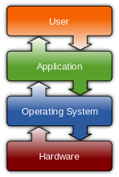 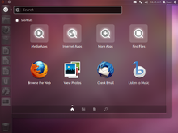 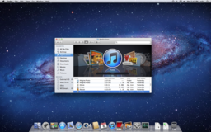  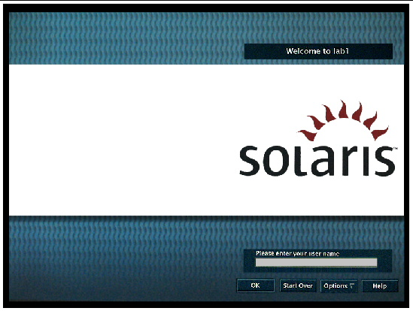

<https://upload.wikimedia.org/wikipedia/commons/7/77/Unix_history-simple.svg>

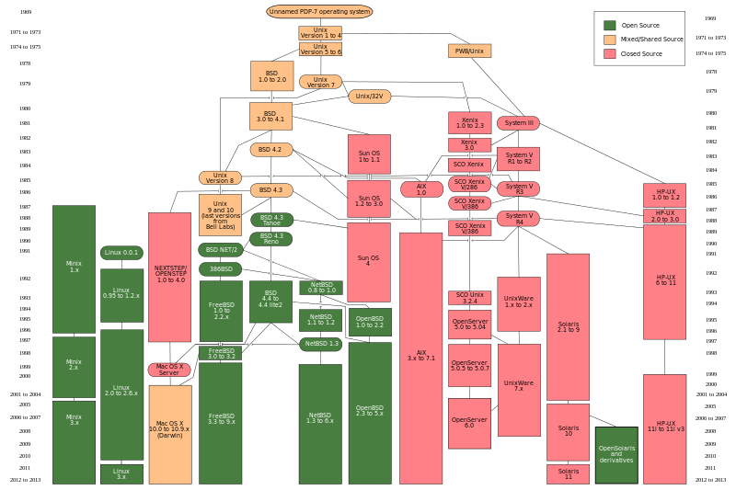

## User/Identity

***Who***

***ID***

## OS/Unix version

**Uname –av**

**showrev**

## File System

<http://www.ee.surrey.ac.uk/Teaching/Unix/unixintro.html>

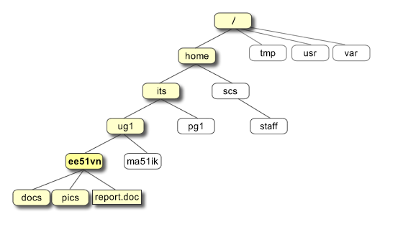

## Root, home, working directory

**- */, ~ , PWD***

# **Unix Shell (Bash)**

<http://www.ee.surrey.ac.uk/Teaching/Unix/unix1.html>

<http://www.ee.surrey.ac.uk/Teaching/Unix/unix2.html>

**echo $SHELL**

**bash --version**

|  |  |
| --- | --- |
| **Command** | **Meaning** |
| **ls** | list files and directories |
| **ls -a** | list all files and directories |
| **mkdir** | make a directory |
| **cd *directory*** | change to named directory |
| **cd** | change to home-directory |
| **cd ~** | change to home-directory |
| **cd ..** | change to parent directory |
| **pwd** | display the path of the current directory |

|  |  |
| --- | --- |
| **Command** | **Meaning** |
| **cp *file1 file2*** | copy file1 and call it file2 |
| **mv *file1 file2*** | move or rename file1 to file2 |
| **rm *file*** | remove a file |
| **rmdir *directory*** | remove a directory |
| **cat *file*** | display a file |
| **less *file*** | display a file a page at a time |
| **head *file*** | display the first few lines of a file |
| **tail *file*** | display the last few lines of a file |
| **grep *'keyword' file*** | search a file for keywords |
| **wc *file*** | count number of lines/words/characters in file |

Other Unix Command/Tools:

<https://en.wikipedia.org/wiki/List_of_Unix_commands>

1. Putty
2. Grep

<http://www.gnu.org/software/grep/manual/grep.html>

* 1. Grep –version
  2. grep options pattern <input_file_names>
  3. grep $’JSN500813-6688\01’ C20150813.log
  4. Grep –version

1. Less
2. **Tr ‘\01’ ‘|’**
3. Head
4. Tail
5. Awk

Awk condition { action }

<https://en.wikipedia.org/wiki/AWK>

* 1. Awk –version
  2. Awk –F, ‘{print $2}’ <input_file_names>
  3. Awk –F, ‘BEGIN{OFS=’,’} {print $2}’

1. Man
2. Ctrl^D
3. Ctrl^C
4. Q
5. Quit
6. Exit

# Regular Expressions

<https://en.wikipedia.org/wiki/Regular_expression>

|  |  |
| --- | --- |
| **Metacharacter** | **Description** |
| **.** | Matches any single character (many applications exclude [newlines](https://en.wikipedia.org/wiki/Newline), and exactly which characters are considered newlines is flavor-, character-encoding-, and platform-specific, but it is safe to assume that the line feed character is included). Within POSIX bracket expressions, the dot character matches a literal dot. For example, a.c matches "abc", etc., but [a.c]matches only "a", ".", or "c". |
| **\*** | Matches the preceding element zero or more times. For example, ab*c matches "ac", "abc", "abbbc", etc. [xyz]* matches "", "x", "y", "z", "zx", "zyx", "xyzzy", and so on. (ab)* matches "", "ab", "abab", "ababab", and so on. |

A regular expression may be followed by one of several repetition operators:

‘.’ The period ‘.’ matches any single character.

‘?’ The preceding item is optional and will be matched at most once.

‘*’ The preceding item will be matched zero or more times.

‘+’ The preceding item will be matched one or more times.

‘{n}’ The preceding item is matched exactly n times.

‘{n,}’ The preceding item is matched n or more times.

# ASCII

American Standard Code for Information Interchange

<https://en.wikipedia.org/wiki/ASCII>

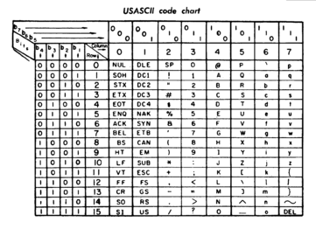

### ASCII control code chart

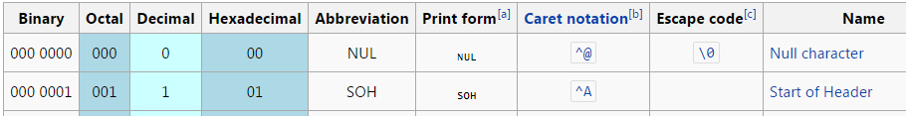

# **Unicode**



<https://en.wikipedia.org/wiki/Unicode>