BAC 3108: ARTIFICIAL INTELLIGENCE PROGRAMMING
PRACTICAL LAB EXERCISE 4
IN THIS LAB EXERCISE REFER TO LECTURE NOTES ON CHAPTER 4: KNOWLEDGE ENGINEERING
Important information and links:
- CLISP sandbox (TutorialPoint)-Online Lisp Interpreter
https://www.tutorialspoint.com/execute_lisp_online.php
- https://onecompiler.com/prolog
- https://www.tutorialspoint.com/prolog/prolog_hello_world.htm
- How to Compile and Run Prolog Code Online
You can use an online Prolog compiler to run this code. One popular option is SWI-Prolog, which you can access through its online version:
- SWI-Prolog Online: SWI-Prolog Online (SWISH -- SWI-Prolog for SHaring)
https://swish.swi-prolog.org/

Steps to Use the Online Compiler:
- Visit the SWI-Prolog Online link.
- Write and Copy the Prolog code.
- Paste it into the editor on the SWI-Prolog page.
- Click on "Run" or "Submit" to execute the code.
- You should see the recommended courses based on the facts you provided.

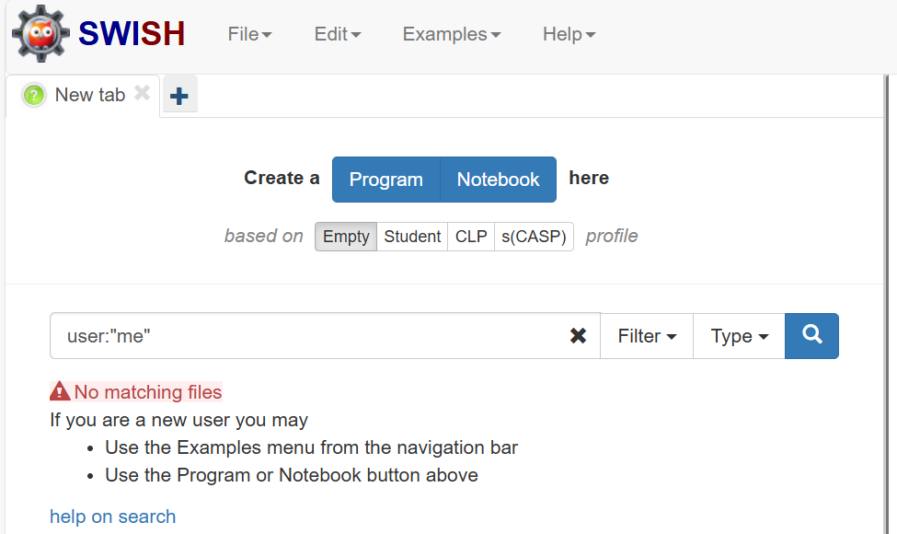
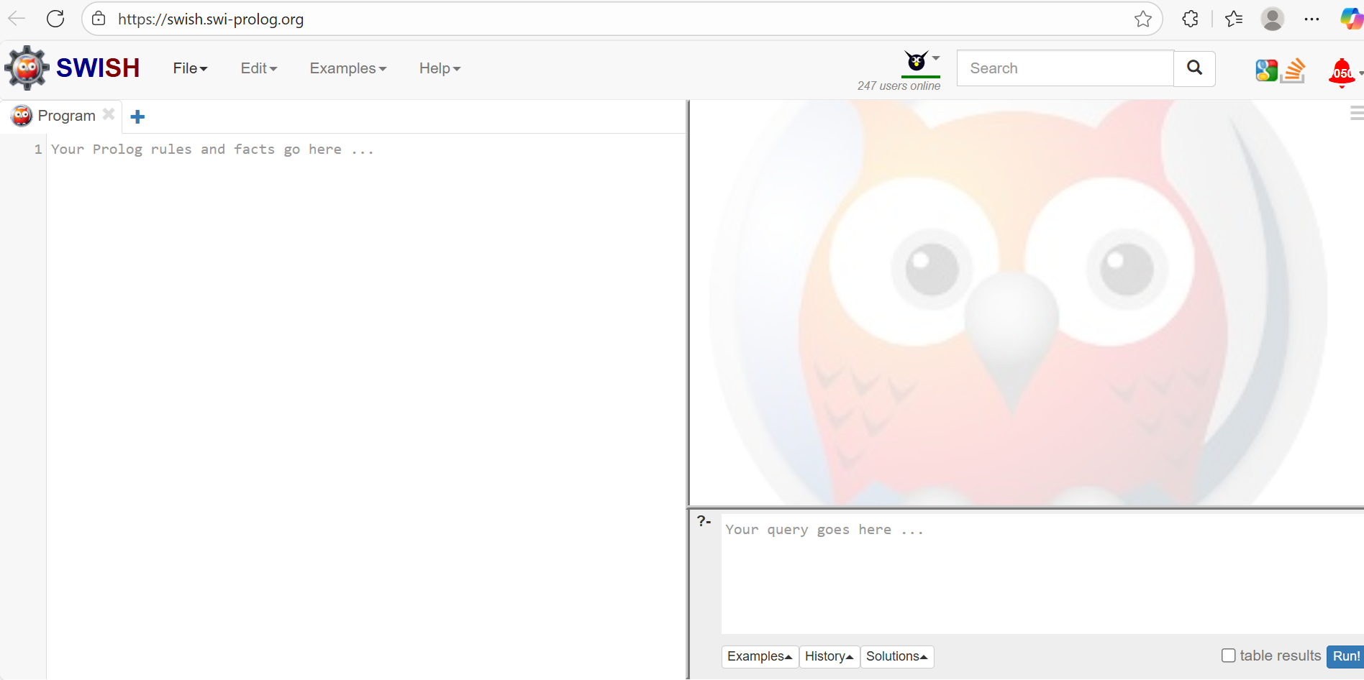
Perform the following tasks:
TASK 1: University Course Advisory System
A system advises a student which course they qualify for based on prerequisites:
Rules:
- IF completed(math101) AND completed(prog101) → take AI101
- IF completed(prog101) AND completed(data101) → take ML101
- IF completed(math101) ONLY → take Statistics101
Assume student has completed: math101, prog101. Write and simulate codes for LISP and PROLOG Implementations.

Sample Tips.
- LISP Implementation
; ------------------------------------------------------------
; FACTS: courses already completed by the student
; Equivalent to *completed* in Lisp.
; ------------------------------------------------------------
(defparameter *completed-courses* '(math101 prog101))
; Use a list to store completed courses

; ------------------------------------------------------------
; RULES: course recommendations
; Each rule states:
; To take Course, you must have completed the required subjects.
; ------------------------------------------------------------
(defparameter *recommended-courses*
'((ai101 (math101 prog101))
(ml101 (prog101 data101))
(statistics101 (math101))))

; ------------------------------------------------------------
; qualifies(Requirements)
; True if ALL courses in Requirements are completed.
; ------------------------------------------------------------
(defun qualifies (requirements)
(if (null requirements)
t
(and (member (first requirements) *completed-courses*)
(qualifies (rest requirements)))))

; ------------------------------------------------------------
; recommend
; Prints ALL courses for which the student qualifies.
; ------------------------------------------------------------
(defun recommend ()
(dolist (course *recommended-courses*)
(let ((course-name (first course))
(requirements (second course)))
(when (qualifies requirements)
(format t "~a is recommended.~%" course-name)))))

; To run the recommendation
(recommend)

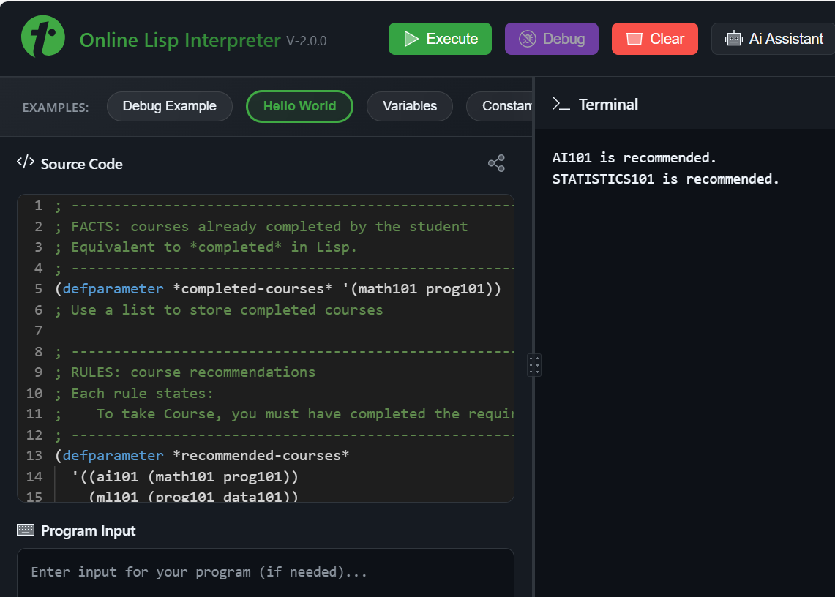
- PROLOG

% ------------------------------------------------------------
% FACTS: Courses the student has already completed
% Equivalent to *completed-courses* in Lisp.
% ------------------------------------------------------------

completed(math101).
completed(prog101).
completed(data101). % Added this line to complete data101
% Add others if needed:
% completed(data101). etc.

% ------------------------------------------------------------
% RULES: Course recommendations
% Format:
% recommended_course(CourseName, RequiredCoursesList).
% ------------------------------------------------------------

recommended_course(ai101, [math101, prog101]).
recommended_course(ml101, [prog101, data101]).
recommended_course(statistics101,[math101]).

% ------------------------------------------------------------
% qualifies(ListOfRequirements)
% Succeeds if ALL required courses are completed.
% Recursively checks each required item.
% ------------------------------------------------------------

qualifies([]). % Base case: no requirements left → true.

qualifies([R | Rest]) :-
completed(R), % R must be in the completed list
qualifies(Rest). % Recursively check remaining requirements

% ------------------------------------------------------------
% recommend
% Prints all course recommendations for which the student qualifies.
% Equivalent to Lisp (recommend)
% ------------------------------------------------------------

recommend :-
recommended_course(Course, Requirements),
qualifies(Requirements),
format("~w is recommended.~n", [Course]),
fail. % Force backtracking to find all recommendations

recommend. % Final success to end the predicate

% ------------------------------------------------------------
% RUN:
% ?- recommend.
% ------------------------------------------------------------

:- initialization(recommend). % Add this line

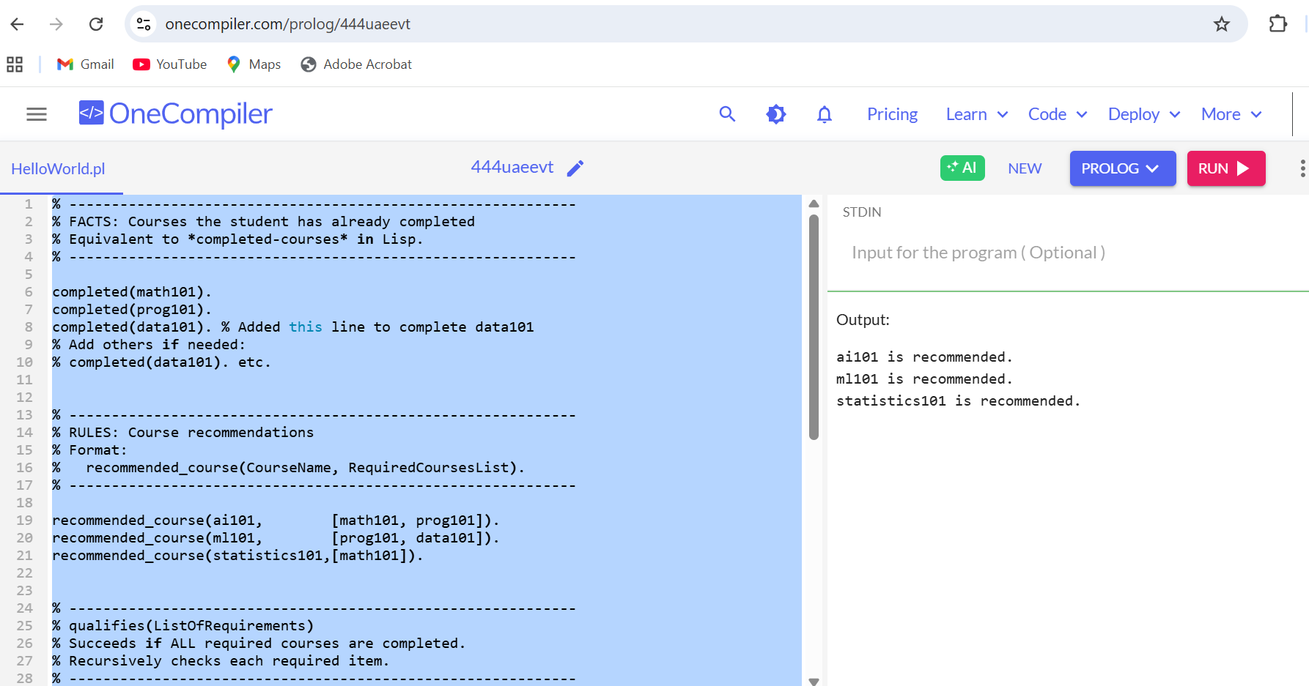

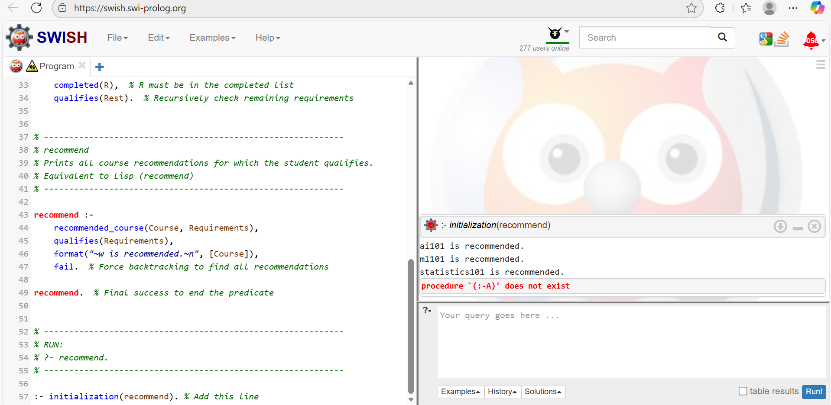

TASK 2: Medical Diagnosis System
Problem Description
A small expert system diagnoses whether a patient likely has:
  - flu
  - common cold
  - malaria
Given symptoms: fever, chills, cough, headache.
Rule examples:
- IF fever AND chills THEN malaria
- IF fever AND cough THEN flu
- IF cough AND headache THEN common cold
Write and simulate codes for LISP and PROLOG Implementations.

SAMPLE TIPS:
- LISP IMPLEMENTATION

;;; -----------------------------------------------------------
;;; FACTS: List of symptoms currently observed in the patient.
;;; This is the "working memory" of the expert system.
;;; -----------------------------------------------------------
(setq *symptoms* '(fever chills headache))

;;; -----------------------------------------------------------
;;; RULE BASE
;;; Each rule is of the form:
;;; ((symptom1 symptom2 ...) -> disease)
;;;
;;; Meaning:
;;; If all symptoms on the left match the patient’s symptoms,
;;; then the disease on the right is diagnosed.
;;; -----------------------------------------------------------
(setq *rules*
'(((fever chills) -> malaria)
((fever cough) -> flu)
((cough headache) -> common_cold)))
;;; -----------------------------------------------------------
;;; FUNCTION: subset?
;;; Purpose:
;;; Checks whether all items in list SMALL exist in BIG.
;;; Used to check if rule conditions are satisfied by symptoms.
;;;
;;; Example:
;;; (subset? '(fever chills) '(fever chills headache)) => T
;;;
;;; 'every' tests a predicate on every element of SMALL.
;;; -----------------------------------------------------------
(defun subset? (small big)
(every #'(lambda (x) (member x big)) small))
;;; -----------------------------------------------------------
;;; FUNCTION: diagnose
;;; Purpose:
;;; Goes through every rule.
;;; Extracts:
;;; - conditions (conds)
;;; - the corresponding disease
;;;
;;; If all conditions are present in *symptoms*,
;;; the rule is triggered and a diagnosis is printed.
;;;
;;; Note:
;;; (car rule) -> the list of required symptoms
;;; (caddr rule) -> the disease after the '->'
;;; -----------------------------------------------------------
(defun diagnose ()
(dolist (rule *rules*) ; Loop through all rules
(let ((conds (car rule)) ; Extract rule conditions
(disease (caddr rule))) ; Extract disease
(when (subset? conds *symptoms*) ; If rule matches WM
(format t "Diagnosis: ~a~%" disease))))) ; Print diagnosis
;;; -----------------------------------------------------------
;;; RUN THE EXPERT SYSTEM
;;; Output will show diseases for which all conditions are met.
;;; -----------------------------
(diagnose)

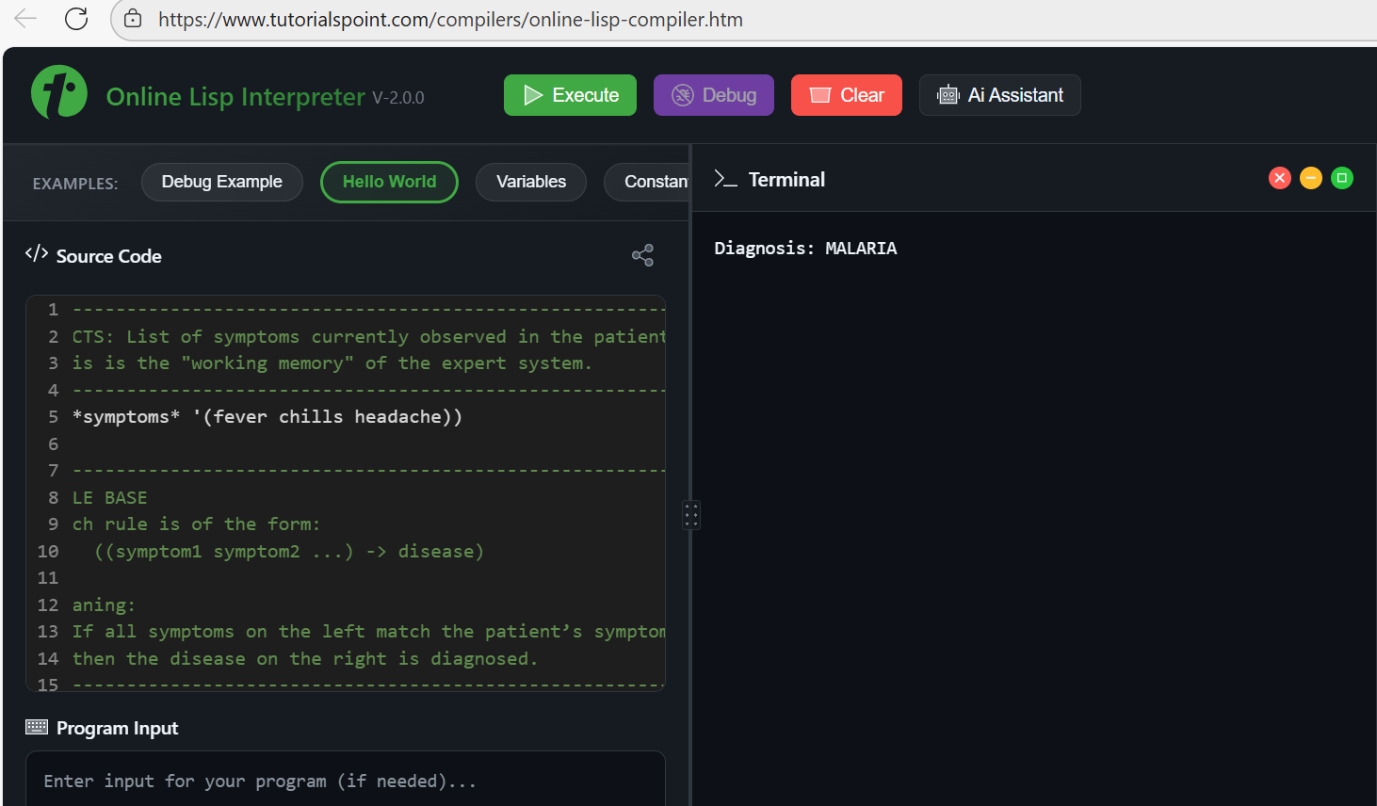

- PROLOG IMPLEMENTATION

/* ------------------------------------------------------------
FACTS: symptoms observed in the patient.
These correspond to *symptoms* in the Lisp version.
------------------------------------------------------------ */
symptom(fever).
symptom(chills).
symptom(headache).
/* ------------------------------------------------------------
RULES:
Each rule states the conditions that must be satisfied
for a disease to be diagnosed.
Format:
disease_name :- required_symptoms.
------------------------------------------------------------ */
% malaria requires: fever AND chills
disease(malaria) :-
symptom(fever),
symptom(chills).
% flu requires: fever AND cough
disease(flu) :-
symptom(fever),
symptom(cough).
% common cold requires: cough AND headache
disease(common_cold) :-
symptom(cough),
symptom(headache).
/* ------------------------------------------------------------
diagnose/0
Goes through all possible diseases and prints those whose
symptom conditions are satisfied.

'disease(D)' succeeds if all its required symptoms are true.
------------------------------------------------------------ */
diagnose :-
disease(D),
format("Diagnosis: ~w~n", [D]),
fail. % force Prolog to continue searching for MORE diseases
diagnose. % succeed cleanly after all diagnoses printed

:- initialization(diagnose). % Add this line

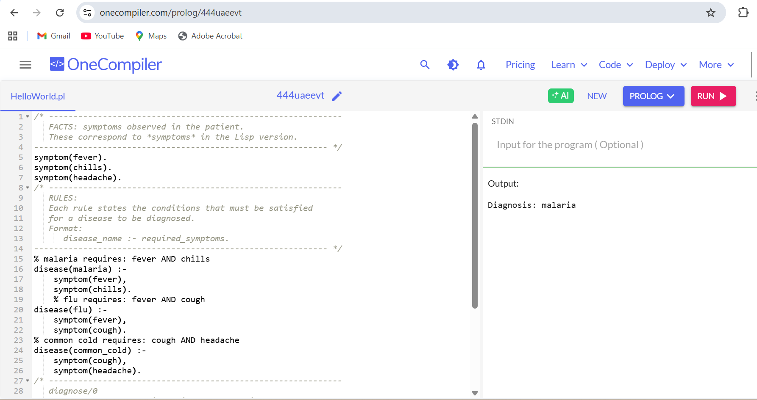
Task 3: Smart Home Decision System
Problem Description
A home automation system decides what action to take depending on environment conditions:
- Rules:
- IF temperature > 30 AND humidity > 70 → turn_on_air_conditioner
- IF temperature < 15 → turn_on_heater
- IF dark = true → turn_on_lights
- Facts for this example:
- temperature = 32
- humidity = 80
- dark = true
Write and simulate codes for LISP and PROLOG Implementations.
SAMPLE TIPS
- LISP IMPLEMENTATION

;;; ------------------------------------------------------------
;;; Environment Facts
;;; These global variables simulate sensor readings in a home.
;;; ------------------------------------------------------------

(setq *temp* 32) ;; Current temperature in degrees Celsius
(setq *humidity* 80) ;; Current humidity percentage
(setq *dark* t) ;; Boolean: t = dark, nil = not dark

;;; ------------------------------------------------------------
;;; Rule Functions
;;; These functions evaluate conditions based on sensor readings.
;;; ------------------------------------------------------------

(defun ac? ()
"Return T if temperature > 30 AND humidity > 70, meaning AC is needed."
(and (> *temp* 30)
(> *humidity* 70)))

(defun heater? ()
"Return T if temperature is below 15 degrees."
(< *temp* 15))

(defun lights? ()
"Return T if the environment is dark."
*dark*)

;;; ------------------------------------------------------------
;;; Main Smart Home Control Function
;;; Prints actions depending on which conditions are true.
;;; ------------------------------------------------------------

(defun smart-home ()
"Evaluate environmental conditions and print appropriate actions."
(when (ac?)
(format t "Action: turn_on_air_conditioner~%"))
(when (heater?)
(format t "Action: turn_on_heater~%"))
(when (lights?)
(format t "Action: turn_on_lights~%")))

;;; ------------------------------------------------------------
;;; Execute the Smart Home Logic
;;; ------------------------------------------------------------

(smart-home)

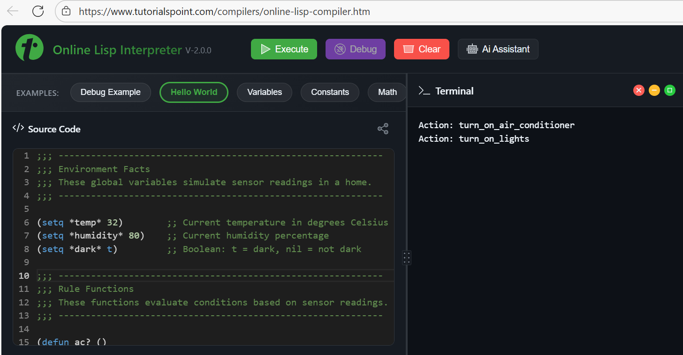

- PROLOG IMPLEMENTATION

% ------------------------------------------------------------
% Environment facts
% These correspond to the Lisp global variables.
% ------------------------------------------------------------

temperature(32). % Current temperature in °C
humidity(80). % Current humidity percentage
dark(true). % Whether the environment is dark

% ------------------------------------------------------------
% Rule conditions (predicate definitions)
% These decide whether AC, heater, or lights should be turned on.
% ------------------------------------------------------------

ac_needed :-
temperature(T),
humidity(H),
T > 30,
H > 70.
heater_needed :-
temperature(T),
T < 15.
lights_needed :-
dark(true).
% -----------------------------------------
% Smart home action rules
% These print what actions should be taken.
% -----------------------------------------
smart_home :-
( ac_needed
-> write('Action: turn_on_air_conditioner'), nl
; true
),
( heater_needed
-> write('Action: turn_on_heater'), nl
; true
),
( lights_needed
-> write('Action: turn_on_lights'), nl
; true
).
% ------------------------------------------------------------
% To run the system:
% ?- smart_home.
% ------------------------------------------------------------

:- initialization(smart_home).

