C程序设计基础作业-2022.11.25-12210159应逸雯
1.
Task:
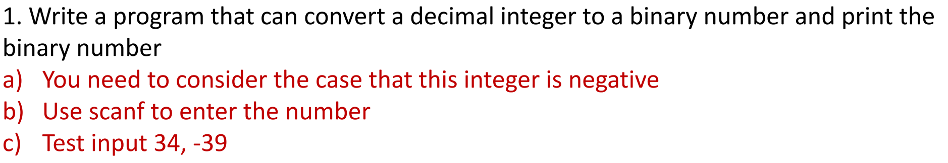

Project:
#include<stdio.h>
int main()
{
int a = 0;
printf("Please enter the number:");
scanf_s("%d", &a);
int sign = 0;
if (a < 0)
{
sign = 1;
a = 255+a;
}
int b[9]={"\0"};
int i = 0;
while (a != 0)
{
if (a % 2 == 1)
{
b[i] = 1;
}
else
{
b[i] = 0;
}
a = (int)a / 2;
i++;
}
/*if (sign == 0)
{
printf("+");
}
else
{
printf("-");
}*/
for (i = 7; i >= 0; i--)
{
if (b[i] != 0)
{
for (; i >= 0; i--)
{
printf("%d", b[i]);
}
break;
}
}
return 0;
}

Running page:
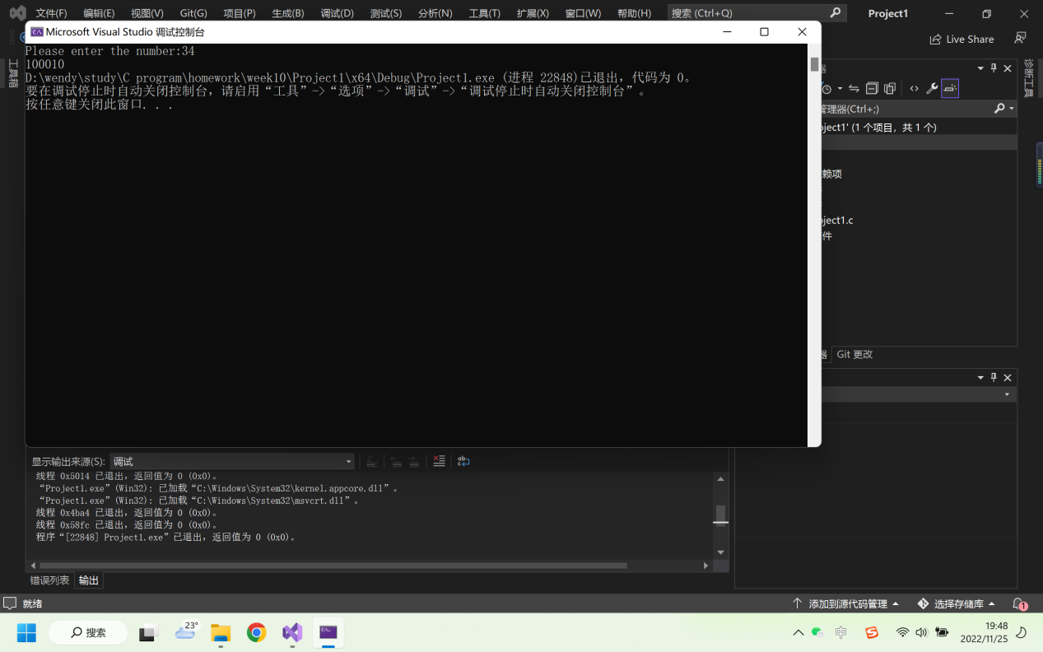
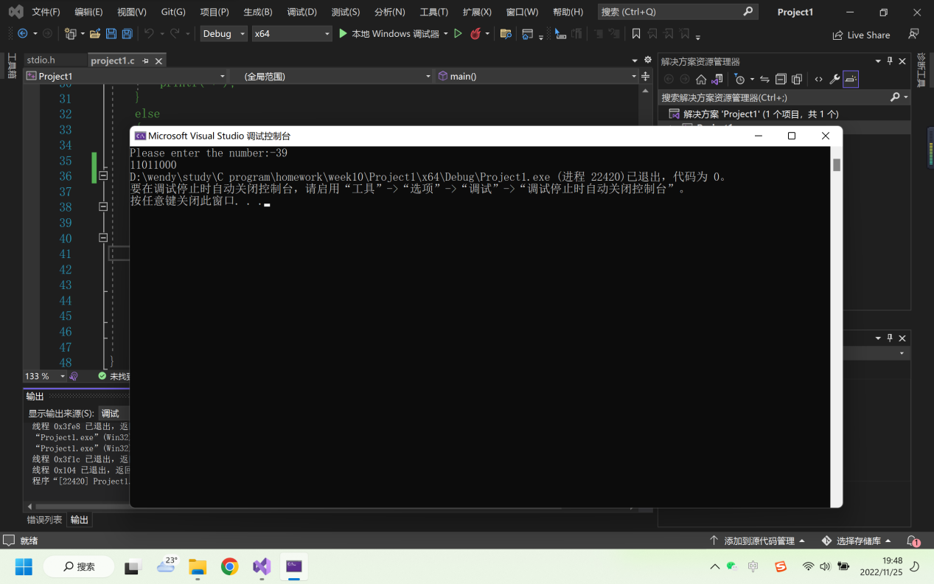
（输出反码）

2.
Task:

Project:
#include<stdio.h>
int main()
{
int i, j, k;
int m=0;
for (i = 0; i < 100; i++)
{
for (j = 0; j < 100; j++)
{
for (k = 0; k < 100; k++)
{
if ((i + j + k == 100) && (3*i + 2*j + 0.5*k == 100))
{
m++;
printf("第%d种可能：大马%d匹，中马%d匹，小马%d匹\n", m, i, j, k);
}
}
}
}
return 0;
}

Running page:
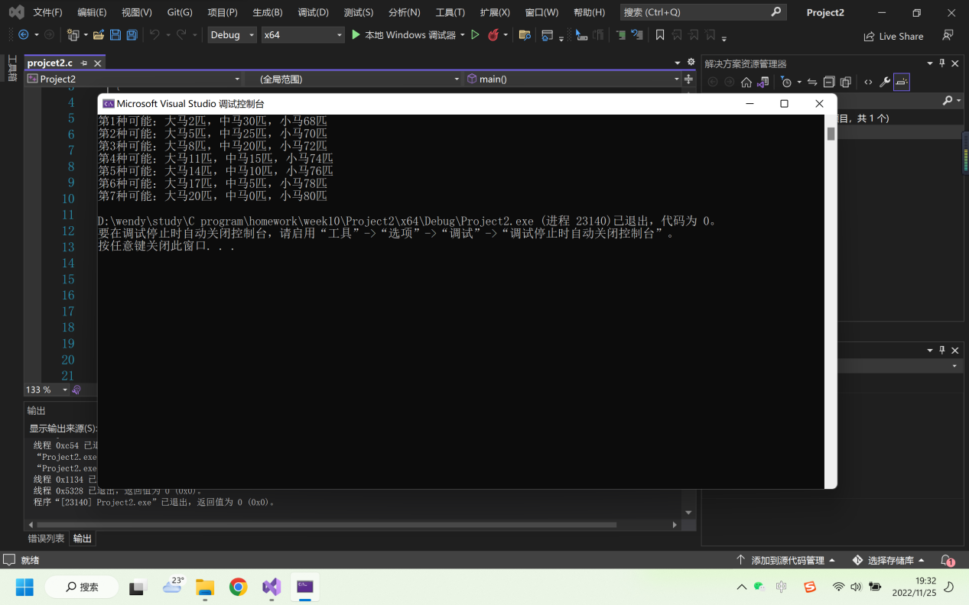
3.
Task:
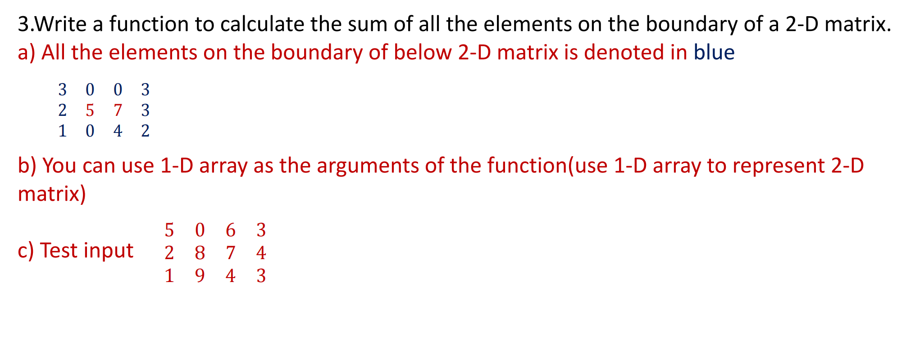
Project:
#include<stdio.h>
#include<malloc.h>
int main()
{
int row = 0;
int column = 0;
printf("How many rows do you want to print?\t");
scanf_s("%d", &row);
printf("How many columns do you want to print?\t");
scanf_s("%d", &column);

int* a = (int*)malloc(((row * column) + 1) * sizeof(int));
int i;
for (i = 0; i < row * column; i++)
{
scanf_s("%d", &(a[i]));
}
int sum=0;
for (i = 0; i < column; i++)
{
sum = sum + a[i];
}
int j;
i--;
for (j = 0; j < row - 2; j++)
{
i++;
sum = sum + a[i];
i = i + column - 1;
sum = sum + a[i];
}
i++;
for (; i < row * column; i++)
{
sum = sum + a[i];
}
printf("%d", sum);
free(a);
return 0;
}

Running page:
