C程序设计基础作业-2022.12.02-12210159应逸雯
1.
Task:
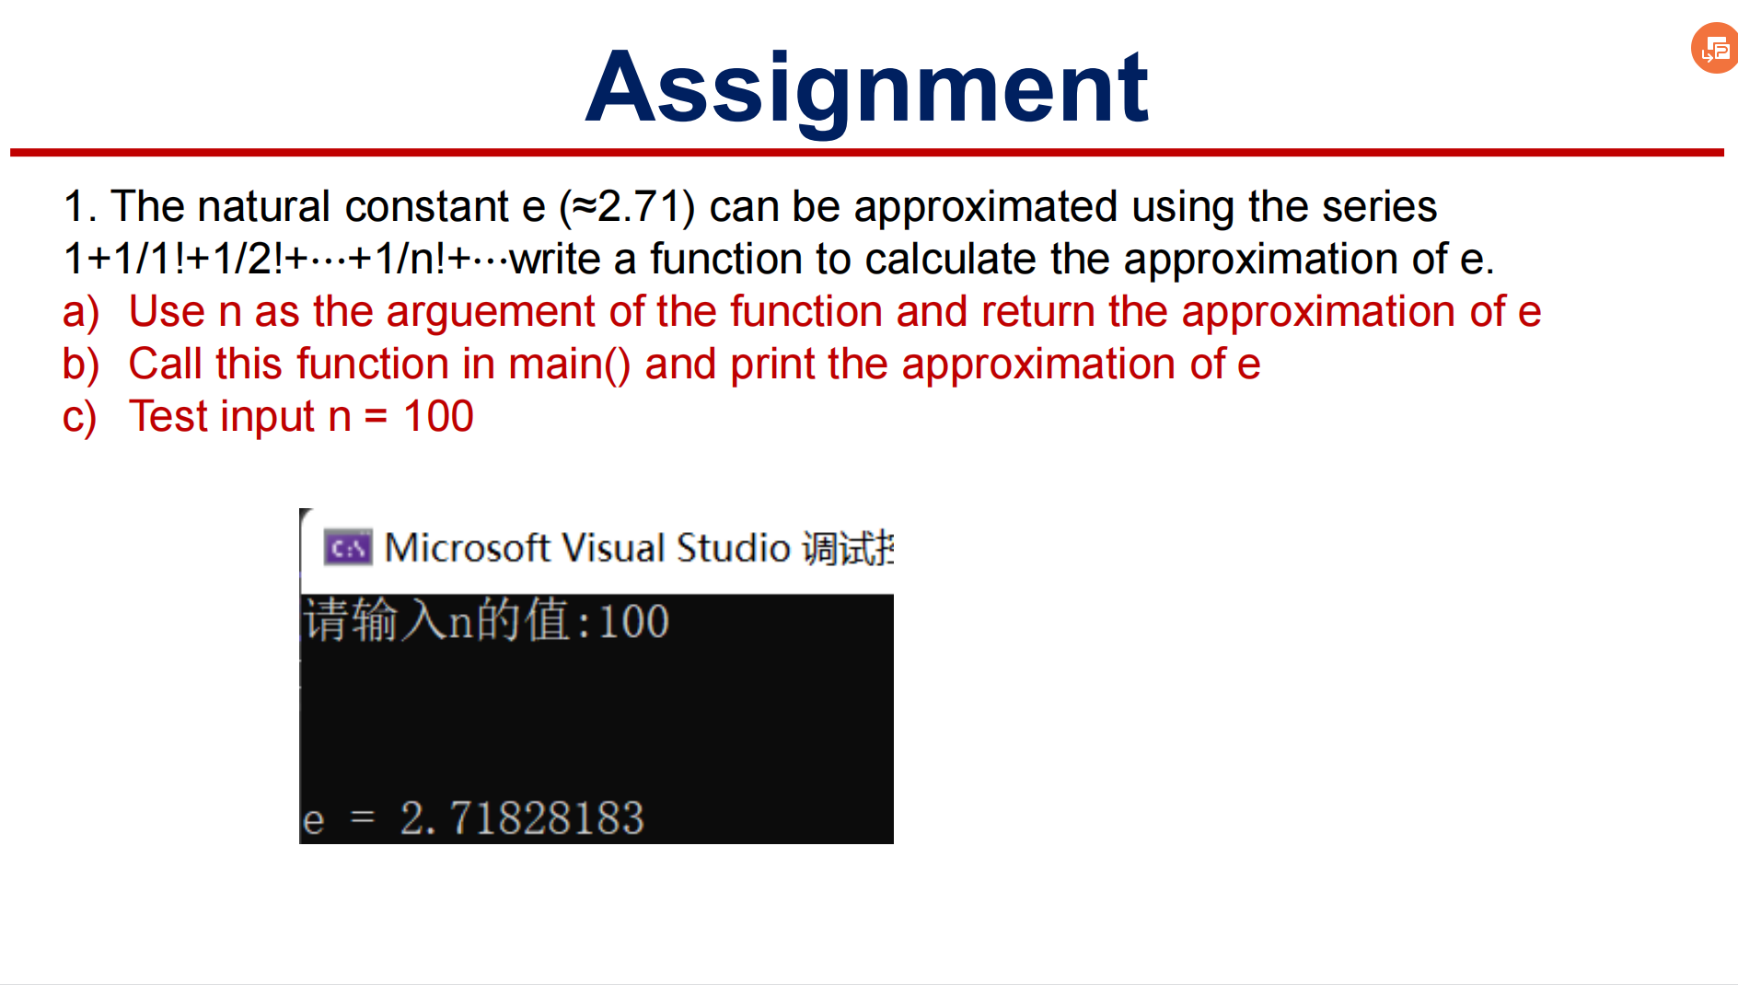

Project:
#include<stdio.h>
int main()
{
int n = 0;
int i = 0;
int j = 0;
float sum = 0;
float temp = 0;
printf("Please enter the number of n:");
scanf_s("%d", &n);
for (i = 0; i < n; i++)
{
temp = 1;
for (j = 0; j < i; j++)
{
temp = temp / (j + 1);
}
sum += temp;
}
printf("The approximation of e is: %f .", sum);
return 0;
}

Running page:
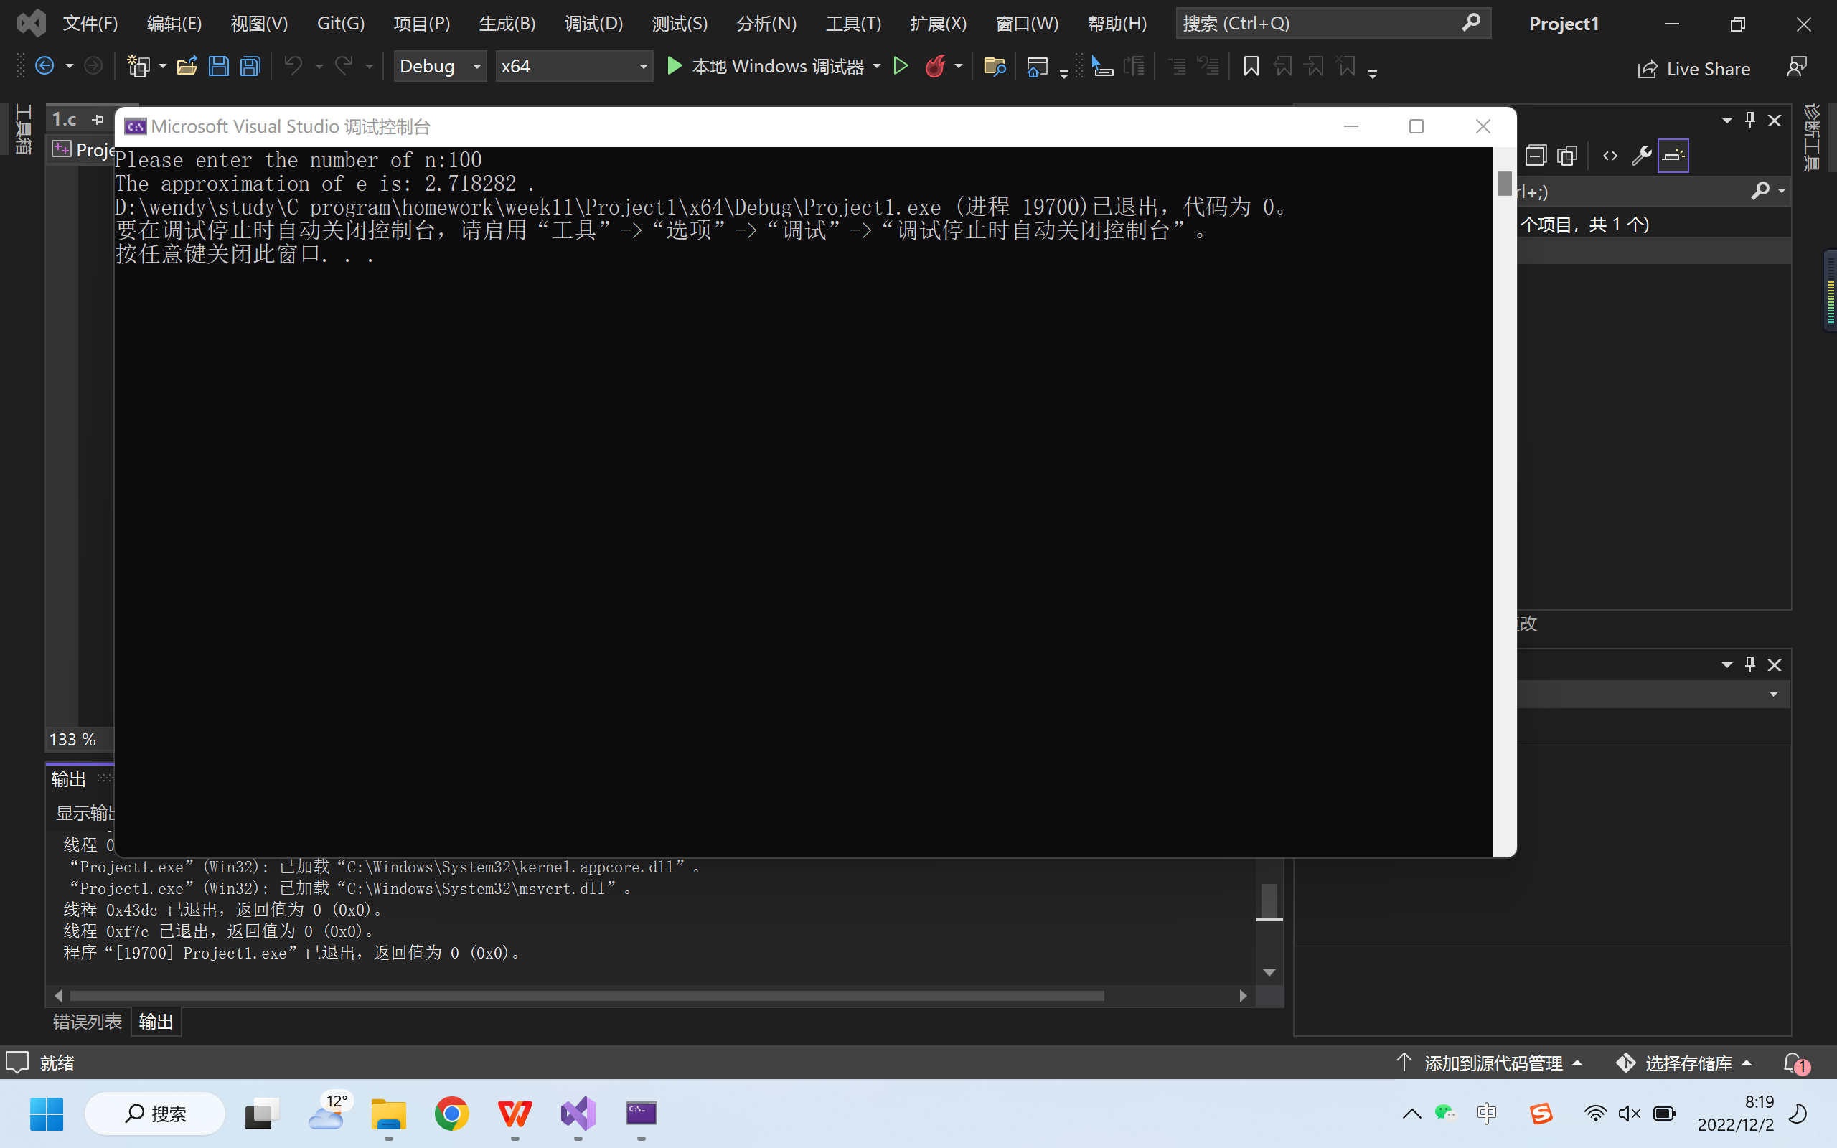

2.
Task:
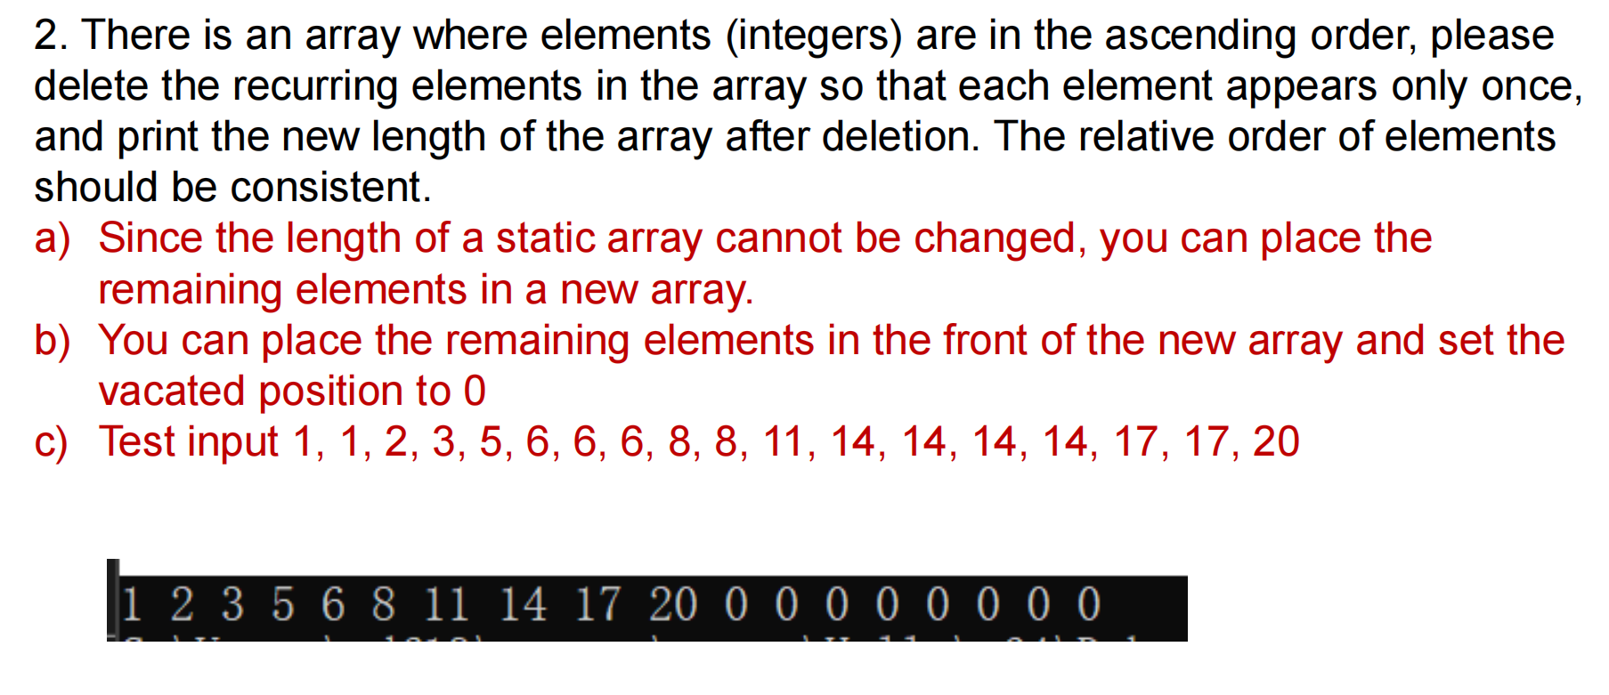

Project:
#include<stdio.h>
int main()
{
static int a[] = { 1,1,2,3,5,6,6,6,8,8,11,14,14,14,14,17,17,20 };
int i = 0;
for (i = 17; i >= 0; i--)
{
if (a[i] == a[i - 1])
{
a[i] = 0;
}
}
int j = 0;
int temp = 0;
for (i = 17; i >= 0; i--)
{
if (a[i] == 0)
{
for (j = i; j < 17; j++)
{
a[j] = a[j + 1];
}
a[17] = 0;
}
}
printf("The result is:\n");
for (i = 0; i < 18; i++)
{
printf("%d ", a[i]);
}
return 0;
}

Running page:
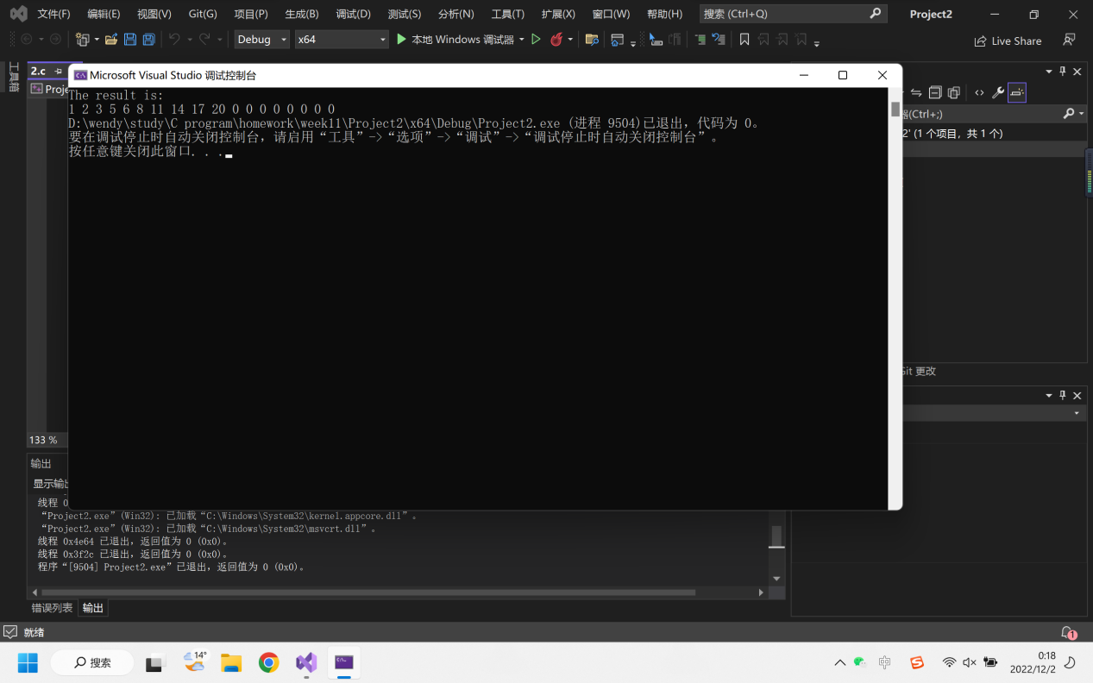

3.
Task:
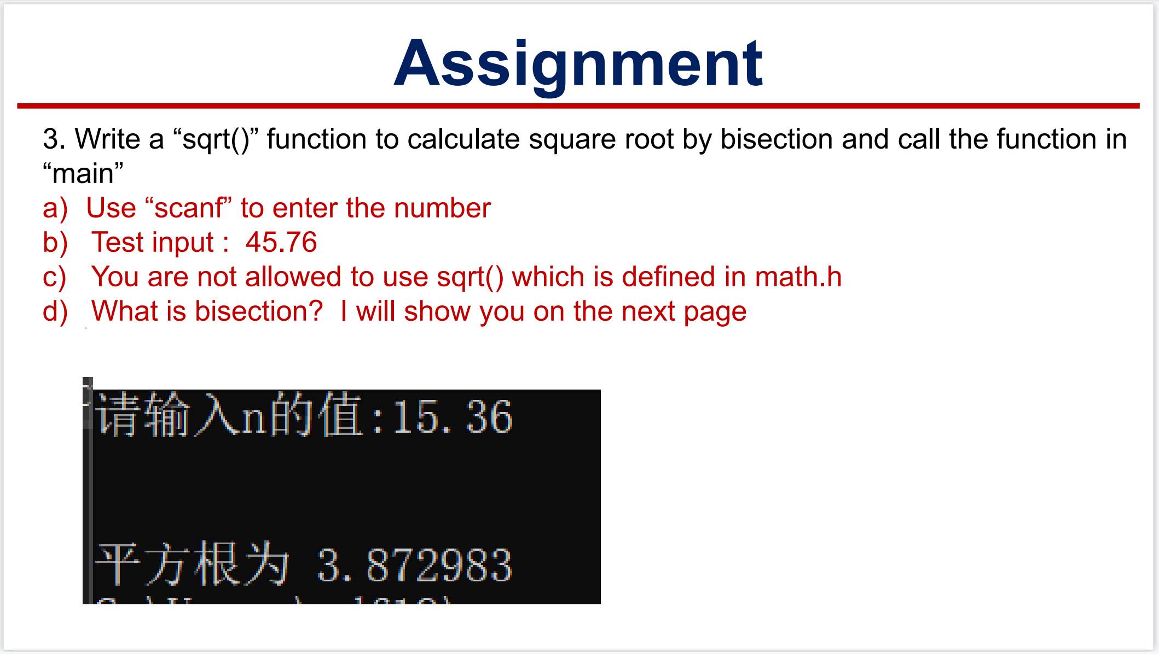
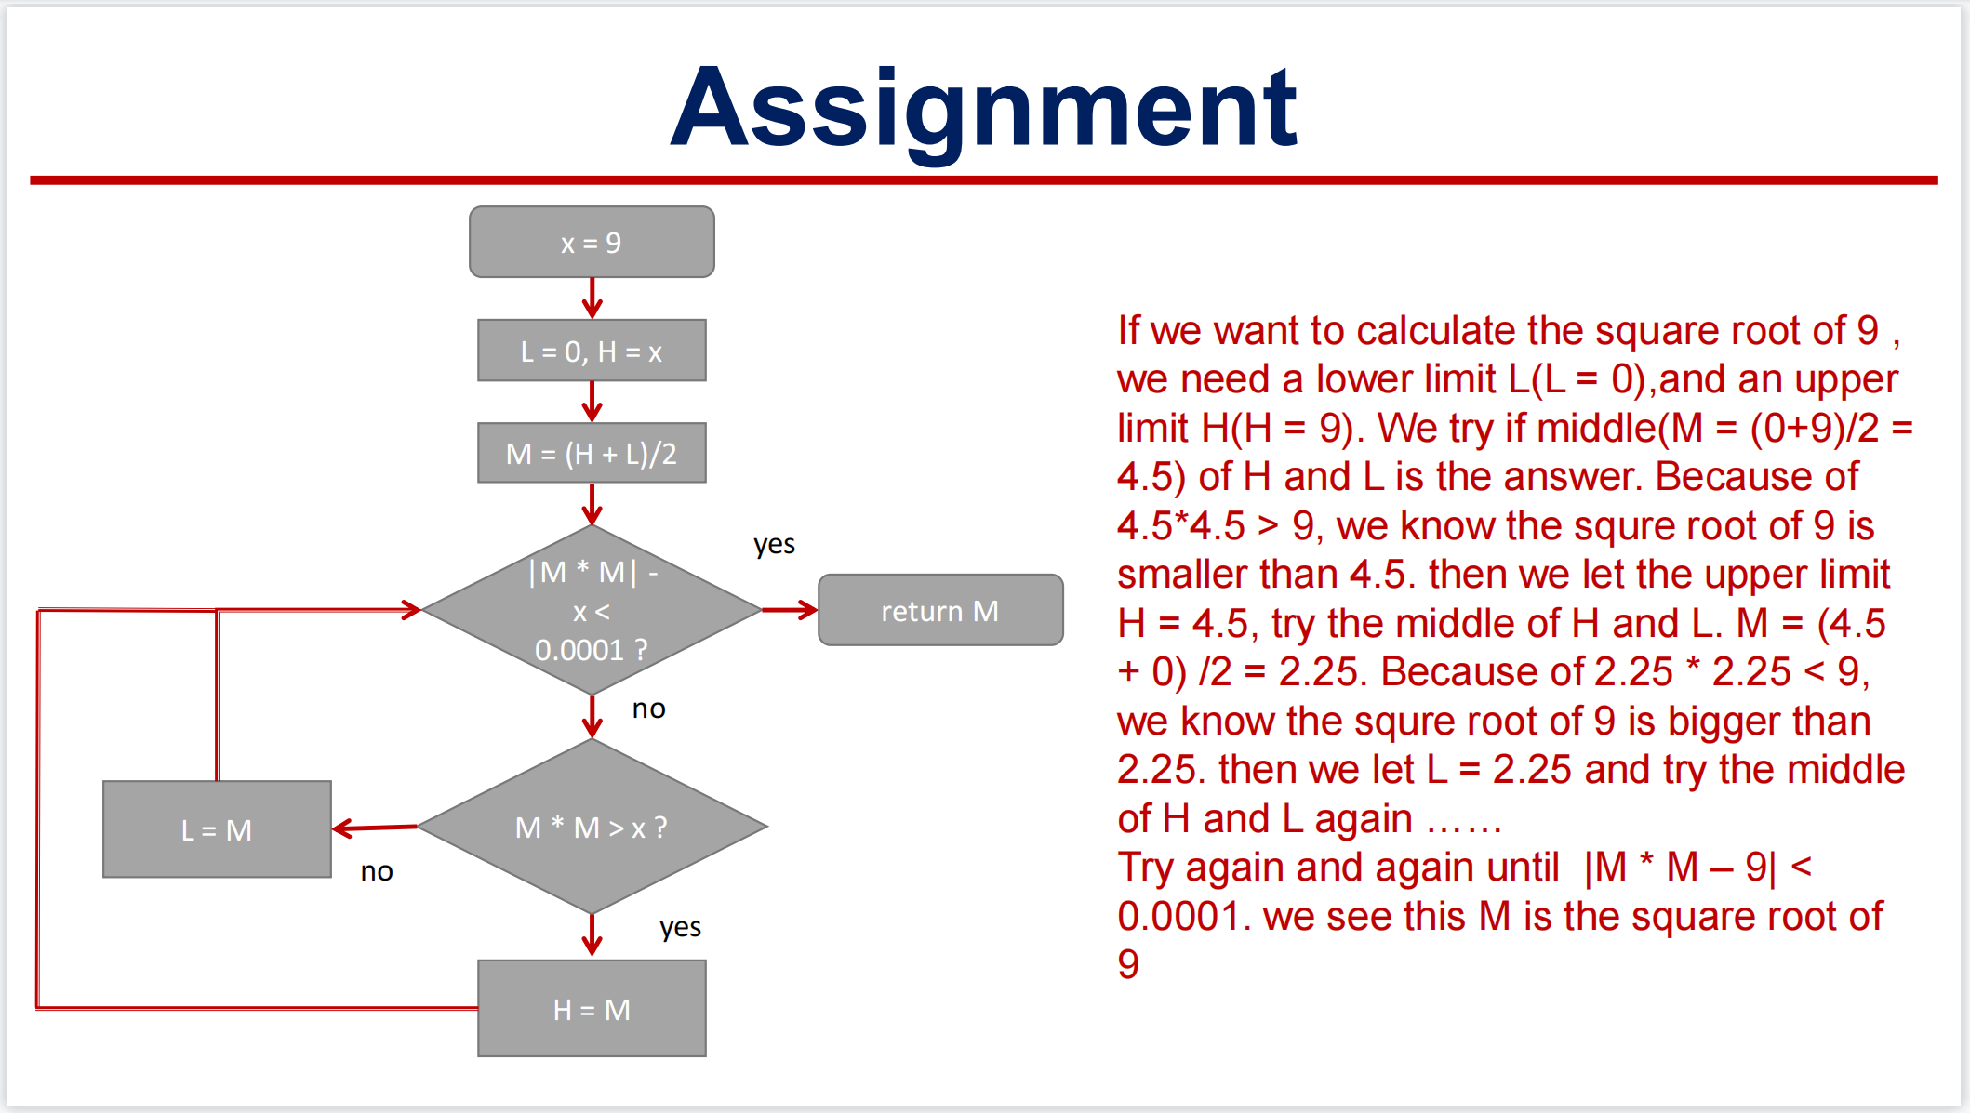

Project:
#include<stdio.h>
#include<math.h>
float square(float num);
int main()
{
float number = 0;
printf("Please enter the number to be calculated:");
scanf_s("%f", &number);
printf("The square root of %f is %f.", number, square(number));
return 0;
}
float square(float num)
{
float result = 0;
float h = num;
float l = 0;
float m = 0;
m = (h + l) / 2;
float temp=0;
while((m * m - num >= 0.0001)|| (m * m - num <= -0.0001))
{
if (m * m > num)
{
h = m;
}
else
{
l = m;
}
m = (h + l) / 2;
}
result = m;
return result;
}

Running page:
