C程序设计基础作业-2022.12.09-12210159应逸雯
1.
Task:
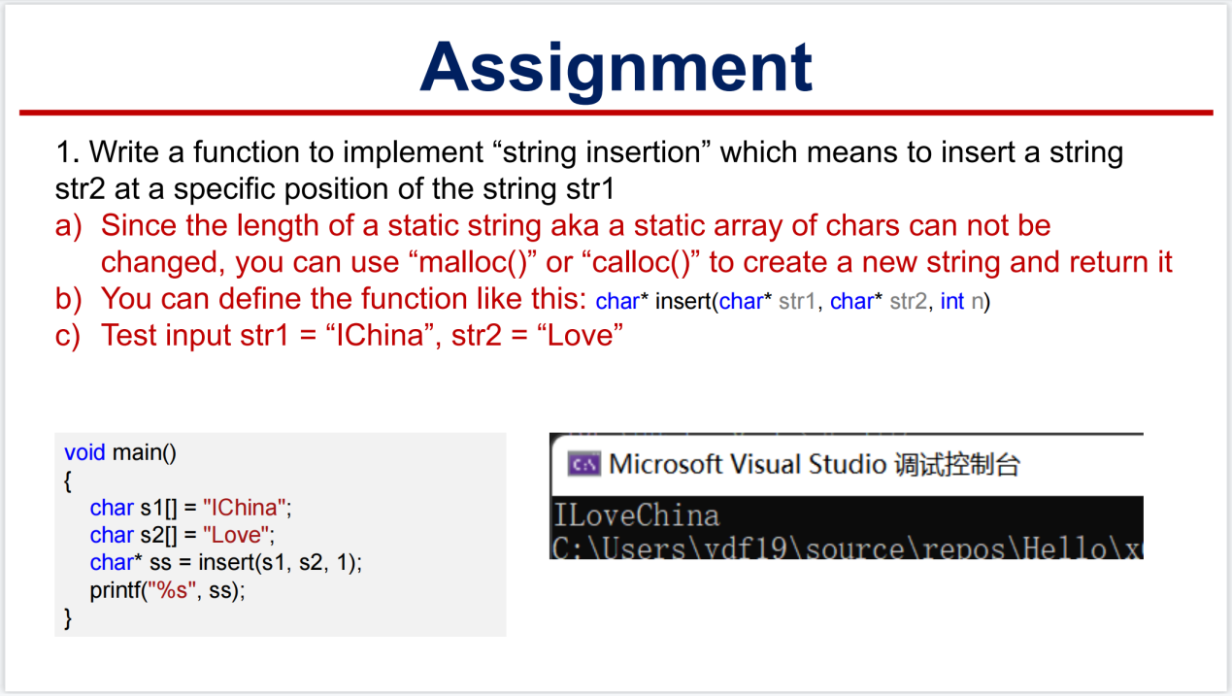

Project:
#include<stdio.h>
#include<stdlib.h>
#include<string.h>
char* insert(char* s1, char* s2, int num);
int main()
{
char s1[] = "IChina";
char s2[] = "Love";
char* ss = insert(s1, s2, 1);
printf("%s", ss);
return 0;
}
char* insert(char* s1, char* s2, int num)
{
char* ss = (char*)malloc((strlen(s1) + strlen(s2)+1)*sizeof(char));
char* save = ss;
int i;
int temp1 = (int)strlen(s1);
int temp2 = (int)strlen(s2);
for (i = 0; i < num; i++)
{
*ss = *s1;
ss++;
s1++;
}
for (i = 0; i < temp2; i++)
{
*ss = *s2;
ss++;
s2++;
}
for (i = 0; i < temp1 - num; i++)
{
*ss = *s1;
ss++;
s1++;
}
*ss = '\0';
return save;
}

Running page:
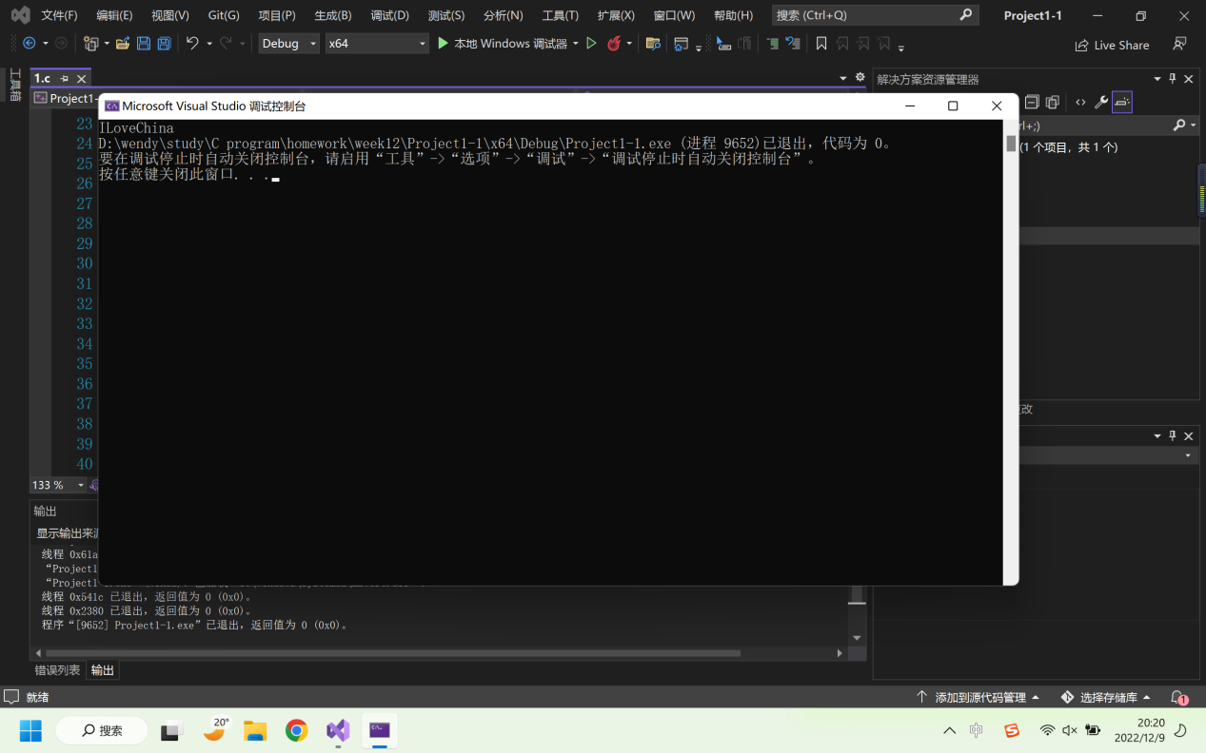

2.
Task:
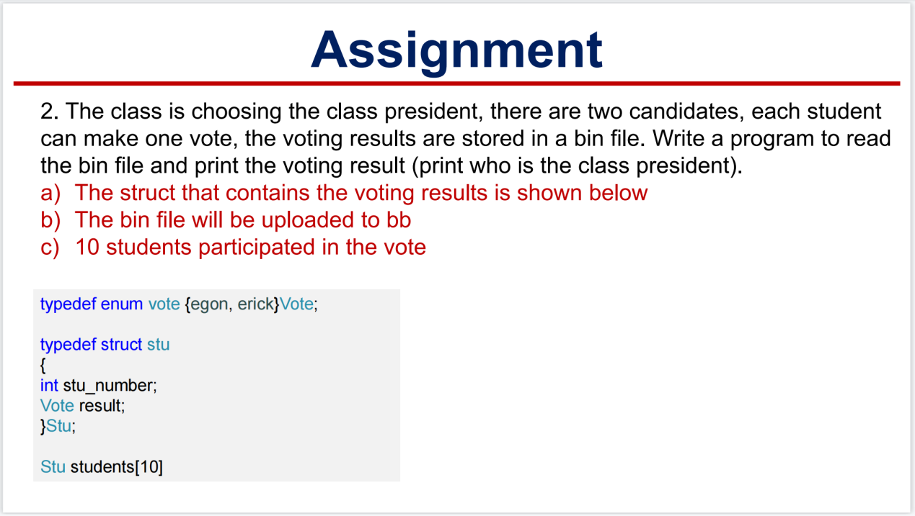

Project:
#define _CRT_SECURE_NO_WARNINGS
#include<stdio.h>
int main()
{
typedef enum vote { egon, erick }Vote;
typedef struct stu
{
int stu_number;
Vote result;
}Stu;
Stu students[10];
FILE* fp;
fp = fopen("D:\\wendy\\study\\C program\\homework\\week12\\data.bin", "rb");
fread(&students, sizeof(students), 10, fp);
int i = 0;
printf("The votes are:\n");
for (i = 0; i < 10; i++)
{
printf("student number:%d\tresult:%d\t\n", students[i].stu_number,students[i].result);
}
int sum = 0;
for (i = 0; i < 10; i++)
{
sum = sum + students[i].result;
}
printf("The winner is: ");
if (sum < 5)
{
printf("egon.");
}
if (sum > 5)
{
printf("erick.");
}
if (sum == 5)
{
printf("two candidates get the same votes.");
}
fclose(fp);
return 0;
}

Running page:
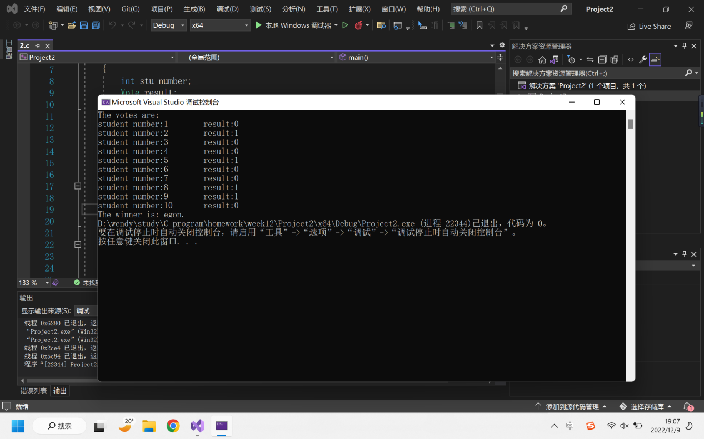

3.
Task:
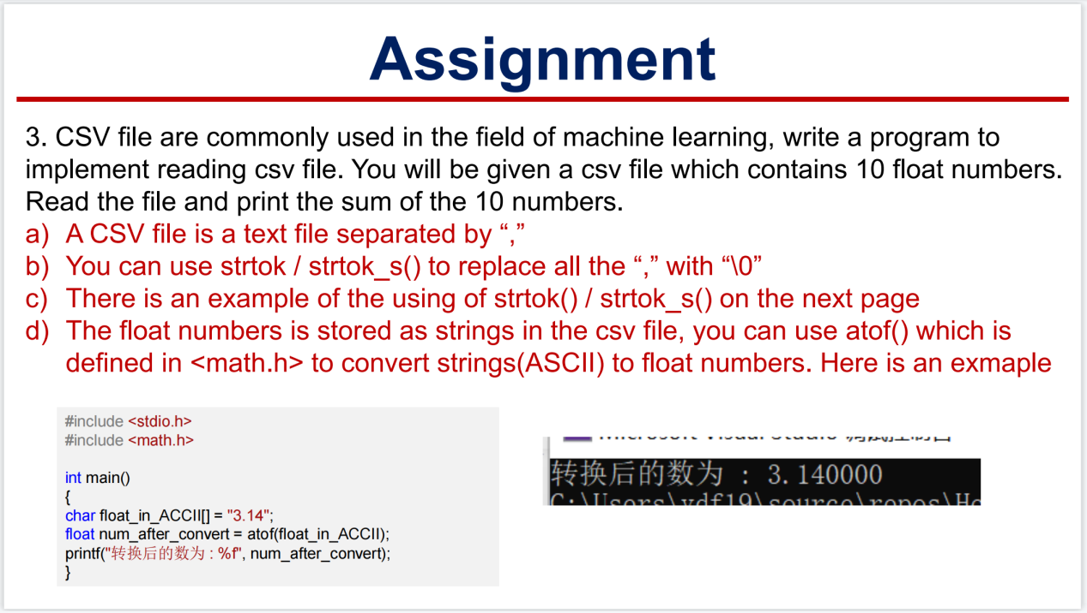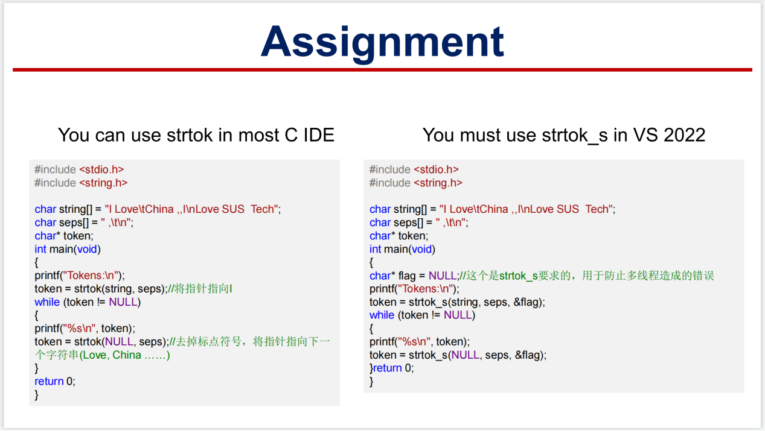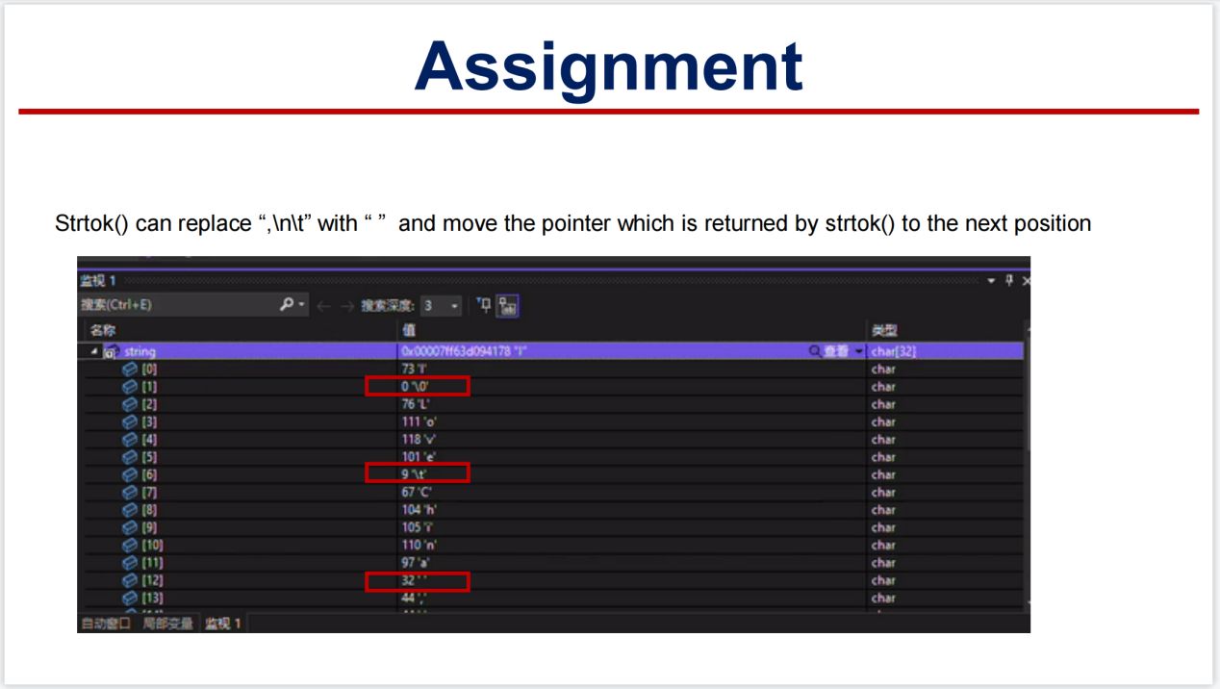

Project:
#define _CRT_SECURE_NO_WARNINGS
#include<stdio.h>
#include<stdlib.h>
#include<math.h>
#include<string.h>
int main()
{
FILE* fp;
fp = fopen("D:\\wendy\\study\\C program\\homework\\week12\\data.csv", "r");
char* buffer = malloc(100 * sizeof(char));
fgets(buffer, 100, fp);
printf("%s", buffer);
char seps[] = " ,";
char* token;
double number[10];
int i = 0;
token = strtok(buffer, seps);
while (token != NULL)
{
number[i] = atof(token);
i++;
token = strtok(NULL, seps);
}
for (i = 0; i < 10; i++)
{
printf("%f\n", number[i]);
}
double sum = 0;
for (i = 0; i < 10; i++)
{
sum = sum + number[i];
}
printf("The result is : %f.", sum);
fclose(fp);
free(buffer);
return 0;
}

Running page:
