C程序设计基础作业-2022.12.16-12210159应逸雯
Task:
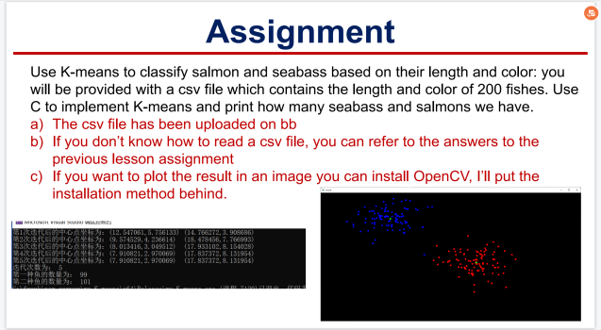
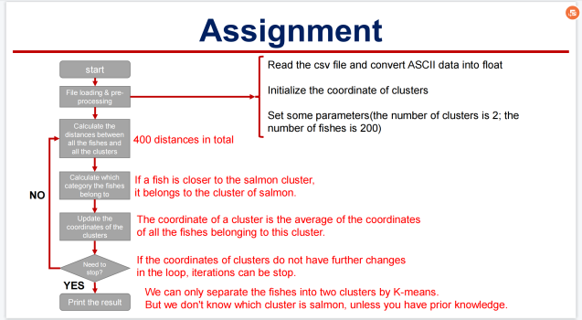
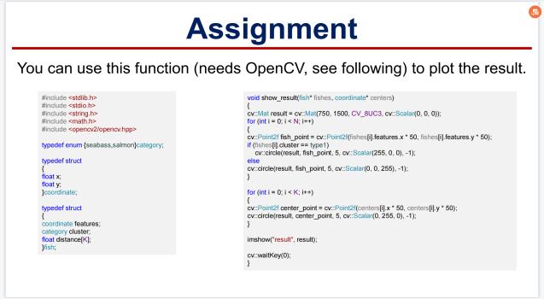
Project:
#define _CRT_SECURE_NO_WARNINGS
#include <iostream>
#include <opencv2/opencv.hpp>
#include<stdio.h>
#include<stdlib.h>
#include<math.h>
#include<string.h>

typedef enum { seabass, salmon }category;
typedef struct
{
float x;
float y;
}coordinate;
typedef struct
{
coordinate features;
category cluster;
float distance[2];
}fishes;

void show_result(fishes* fishes, coordinate* centers);

using namespace std;
using namespace cv;
int main()
{
//读取数据，分解，转换类型
FILE* fp;
fp = fopen("D:\\wendy\\study\\C program\\homework\\week13\\cluster.csv","r");
if (fp == NULL)
{
printf("文件读取失败");
}//读数据完毕

char* buffer = (char*)malloc(100 * sizeof(char));
char* save = buffer;//准备buffer

int i;
char seps[] = " ,";
char* token;//准备分割条件
double number[400];//number为预先存数据的数组
int j = 0;
for (i = 0; i < 200; i++)
{
fgets(buffer, 100, fp);
//printf("%s\t", buffer);//存数据完毕

token = strtok(buffer, seps);
while (token != NULL)
{
number[j] = atof(token);
//printf("%f\t", number[j]);
j++;
token = strtok(NULL, seps);
}
//一组数据分解完毕
}
fclose(fp);
free(buffer);//读取完毕，全部关闭释放

for (j = 0; j < 400; j++)
{
//printf("%f\n", number[j]);
}//检验数据读取分解无误

//得到鱼群数据
struct fish
{
double a = 0;
double b = 0;
double distance1 = 0;
double distance2 = 0;
int category = 0;
};//其中a、b各为一个坐标，distance1到类1距离，distance2到类2距离
struct fish fish[200];

for (i = 0; i < 200; i++)
{
fish[i].a = number[i * 2];
fish[i].b = number[i * 2 + 1];
}//复制处理好的数据到鱼群数据中

//产生初始值
double x1, x2, y1, y2;//a对应x,b对应y
srand((unsigned int)time(NULL));//随机函数
x1 = rand() % 10 + 10;
x2 = rand() % 10;
y1 = rand() % 5 + 5;
y2 = rand() % 5;
printf("初始中心坐标为：\t(%f,%f)\t(%f,%f)\n", x1, y1, x2, y2);

int times = 1;//记录运算次数

//sum记录总和，以便运算下一个值
double sum1x = 0;
double sum1y = 0;
double sum2x = 0;
double sum2y = 0;
//k记录个数
int k1 = 0;
int k2 = 0;
//temp留存数据
double temp1 = 0;
double temp2 = 0;
double temp3 = 0;
double temp4 = 0;

//开始运算
while (1)
{
//计算距离并判断类型
for (i = 0; i < 200; i++)
{
fish[i].distance1 = sqrt((x1 - fish[i].a) * (x1 - fish[i].a) + (y1 - fish[i].b) * (y1 - fish[i].b));
fish[i].distance2 = sqrt((x2 - fish[i].a) * (x2 - fish[i].a) + (y2 - fish[i].b) * (y2 - fish[i].b));
//计算出distance
if (fish[i].distance1 == fish[i].distance2)
{
printf("Wrong!\nThis fish is at the same distance from the two centers.");
}
if (fish[i].distance1 < fish[i].distance2)
{
fish[i].category = 1;
}
if (fish[i].distance1 > fish[i].distance2)
{
fish[i].category = 2;
}//判断类型，类1为1，类2为2
//printf("The category of fish %d is %d.\n", i, fish[i].category);
}

//保留原来的中心值数据，以便检验退出条件
temp1 = x1;
temp2 = y1;
temp3 = x2;
temp4 = y2;

//分配新的中心
sum1x = 0;
sum1y = 0;
sum2x = 0;
sum2y = 0;
k1 = 0;
k2 = 0;

for (i = 0; i < 200; i++)
{
if (fish[i].category == 1)
{
sum1x += fish[i].a;
sum1y += fish[i].b;
k1++;
}
if (fish[i].category == 2)
{
sum2x += fish[i].a;
sum2y += fish[i].b;
k2++;
}
}

x1 = (double)sum1x / k1;
y1 = (double)sum1y / k1;
x2 = (double)sum2x / k2;
y2 = (double)sum2y / k2;
//计算新坐标

printf("第%d次迭代后中心坐标为：\t(%f,%f)\t(%f,%f)\n", times, x1, y1, x2, y2);//重新分配坐标完毕

//寻找最终值，判断退出条件
if ((temp1 == x1) && (temp2 == y1) && (temp3 == x2) && (temp4 == y2))
{
break;
}

times++;//记录运算次数

}

//输出结果
printf("迭代次数：%d\n", times);

//求鱼的数量
int sum1 = 0;
int sum2 = 0;
for (i = 0; i < 200; i++)
{
if (fish[i].category == 1)
{
sum1++;
}
if (fish[i].category == 2)
{
sum2++;
}
}
printf("第一种鱼的数量为：%d\n", sum1);
printf("第二种鱼的数量为：%d\n", sum2);

//在opencv中呈现

fishes fishes[200];
for (i = 0; i < 200; i++)
{
fishes[i].features.x = fish[i].a;
fishes[i].features.y = fish[i].b;
if (fish[i].category == 1)
{
fishes[i].cluster = seabass;
}
if (fish[i].category == 2)
{
fishes[i].cluster = salmon;
}
fishes[i].distance[0] = fish[i].distance1;
fishes[i].distance[1] = fish[i].distance2;
}

coordinate centers[2];
centers[0].x = x1;
centers[0].y = y1;
centers[1].x = x2;
centers[1].y = y2;

show_result(fishes, centers);

return 0;
}

void show_result(fishes* fishes, coordinate* centers)
{
cv::Mat result = cv::Mat(750, 1500, CV_8UC3, cv::Scalar(0, 0, 0));
for (int i = 0; i < 200; i++)
{
cv::Point2f fish_point = cv::Point2f(fishes[i].features.x * 50, fishes[i].features.y * 50);
if (fishes[i].cluster == 0)
{
//printf("%f %f\n", fishes[i].features.x, fishes[i].features.y);
cv::circle(result, fish_point, 5, cv::Scalar(255, 0, 0), -1);
}
else
{
cv::circle(result, fish_point, 5, cv::Scalar(0, 0, 255), -1);
}
}
for (int i = 0; i < 2; i++)
{
cv::Point2f center_point = cv::Point2f(centers[i].x * 50, centers[i].y * 50);
cv::circle(result, center_point, 5, cv::Scalar(0, 255, 0), -1);
}
imshow("result", result);
cv::waitKey(0);
}

Running page:
