C程序设计基础作业-2022.12.23-12210159应逸雯
Task:
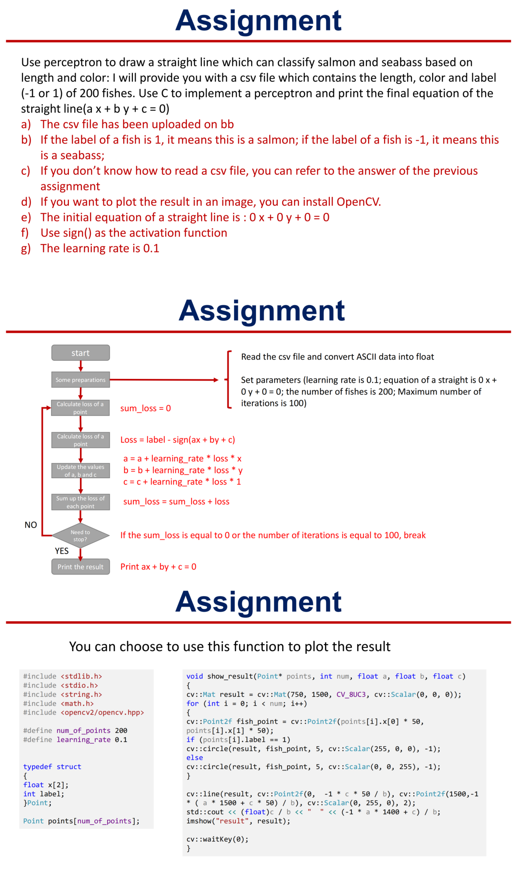
Project:
#define _CRT_SECURE_NO_WARNINGS
#include <stdlib.h>
#include <stdio.h>
#include <string.h>
#include <math.h>
#include <opencv2/opencv.hpp>
#define num_of_points 200
#define learning_rate 0.1
typedef struct
{
float x[2];
int label;
}Point;
Point points[num_of_points];

void show_result(Point* points, int num, float a, float b, float c);
int sign(float i);

int main()
{
//打开文件
FILE* fp;
fp = fopen("D://wendy//study//C program//homework//week14//perception.csv", "r");
if (fp == NULL)
{
printf("读取数据失败");
}

//读数据
char* buffer = (char*)malloc(50 * sizeof(char));
char seps[] = " ,";
char* token;
double number[600];//number为预先存数据的数组

int i = 0;
int j = 0;

for (i = 0; i < 200; i++)
{
fgets(buffer, 50, fp);//存数据
token = strtok(buffer, seps);

while (token != NULL)
{
number[j] = atof(token);
j++;
token = strtok(NULL, seps);
}
//一组数据分解完毕
}
fclose(fp);
free(buffer);//读取完毕，全部关闭释放

for (j = 0; j < 600; j++)
{
//printf("%f\n", number[j]);
}//检验数据读取分解无误

for (i = 0; i < 200; i++)
{
points[i].x[0] = (float)number[i * 3];
points[i].x[1] = (float)number[i * 3 + 1];
points[i].label = (int)number[i * 3 + 2];
}//保存数据到结构体中

for (i = 0; i < 200; i++)
{
//printf("The %d point is: \tlength:%f \tcolour:%f \tlabel:%d\n", (i + 1), points[i].x[0], points[i].x[1], points[i].label);
}//检验上述所有操作，完成准备工作 Read the csv file and convert ASCII data into float

//进入循环
int sum_loss = 0;
float c1 = 0;
float c2 = 0;
float c3 = 0;
int iteration = 0;
int loss = 0;
float temp = 0;
//准备变量

while(1)
{
iteration++;//记录迭代次数

sum_loss = 0;//重置

for (i = 0; i < 200; i++)
{
temp = (float)c1 * points[i].x[0] + c2 * points[i].x[1] + c3;
loss = points[i].label - sign(temp);
loss = loss / 2;
c1 = c1 + learning_rate * loss * points[i].x[0];
c2 = c2 + learning_rate * loss * points[i].x[1];
c3 = c3 + learning_rate * loss;
sum_loss = sum_loss + abs(loss);
}//计算每组数据

if (iteration == 100)
{
break;
}
if (sum_loss == 0)
{
break;
}//判断退出条件
}

//printf("%d\n", iteration);//了解退出条件

//输出结果
if (c2 < 0)
{
if (c3 < 0)
{
printf("The result is :\t%fx %fy %f=0\n", c1, c2, c3);
}
else
{
printf("The result is :\t%fx %fy +%f=0\n", c1, c2, c3);
}
}
else
{
if (c3 < 0)
{
printf("The result is :\t%fx +%fy %f=0\n", c1, c2, c3);
}
else
{
printf("The result is :\t%fx +%fy +%f=0\n", c1, c2, c3);
}
}

//在opencv中查看结果
show_result(points, 200, c1, c2, c3);

return 0;
}
void show_result(Point* points, int num, float a, float b, float c)
{
cv::Mat result = cv::Mat(750, 1500, CV_8UC3, cv::Scalar(0, 0, 0));
for (int i = 0; i < num; i++)
{
cv::Point2f fish_point = cv::Point2f(points[i].x[0] * 50,
points[i].x[1] * 50);
if (points[i].label == 1)
cv::circle(result, fish_point, 5, cv::Scalar(255, 0, 0), -1);
else
cv::circle(result, fish_point, 5, cv::Scalar(0, 0, 255), -1);
}
cv::line(result, cv::Point2f(0, -1 * c * 50 / b), cv::Point2f(1500, -1
* (a * 1500 + c * 50) / b), cv::Scalar(0, 255, 0), 2);
std::cout << (float)c / b << " " << (-1 * a * 1400 + c) / b;
imshow("result", result);
cv::waitKey(0);
}
int sign(float i)
{
int k = 0;
if (i < 0)
{
k = -1;
}
else
{
k = 1;
}
return k;
}

Running page:
