C程序设计基础作业2022.9.9-12210159应逸雯

- print hello world
#include<stdio.h>

int main() {

printf("Hello world!");

return 0;

}
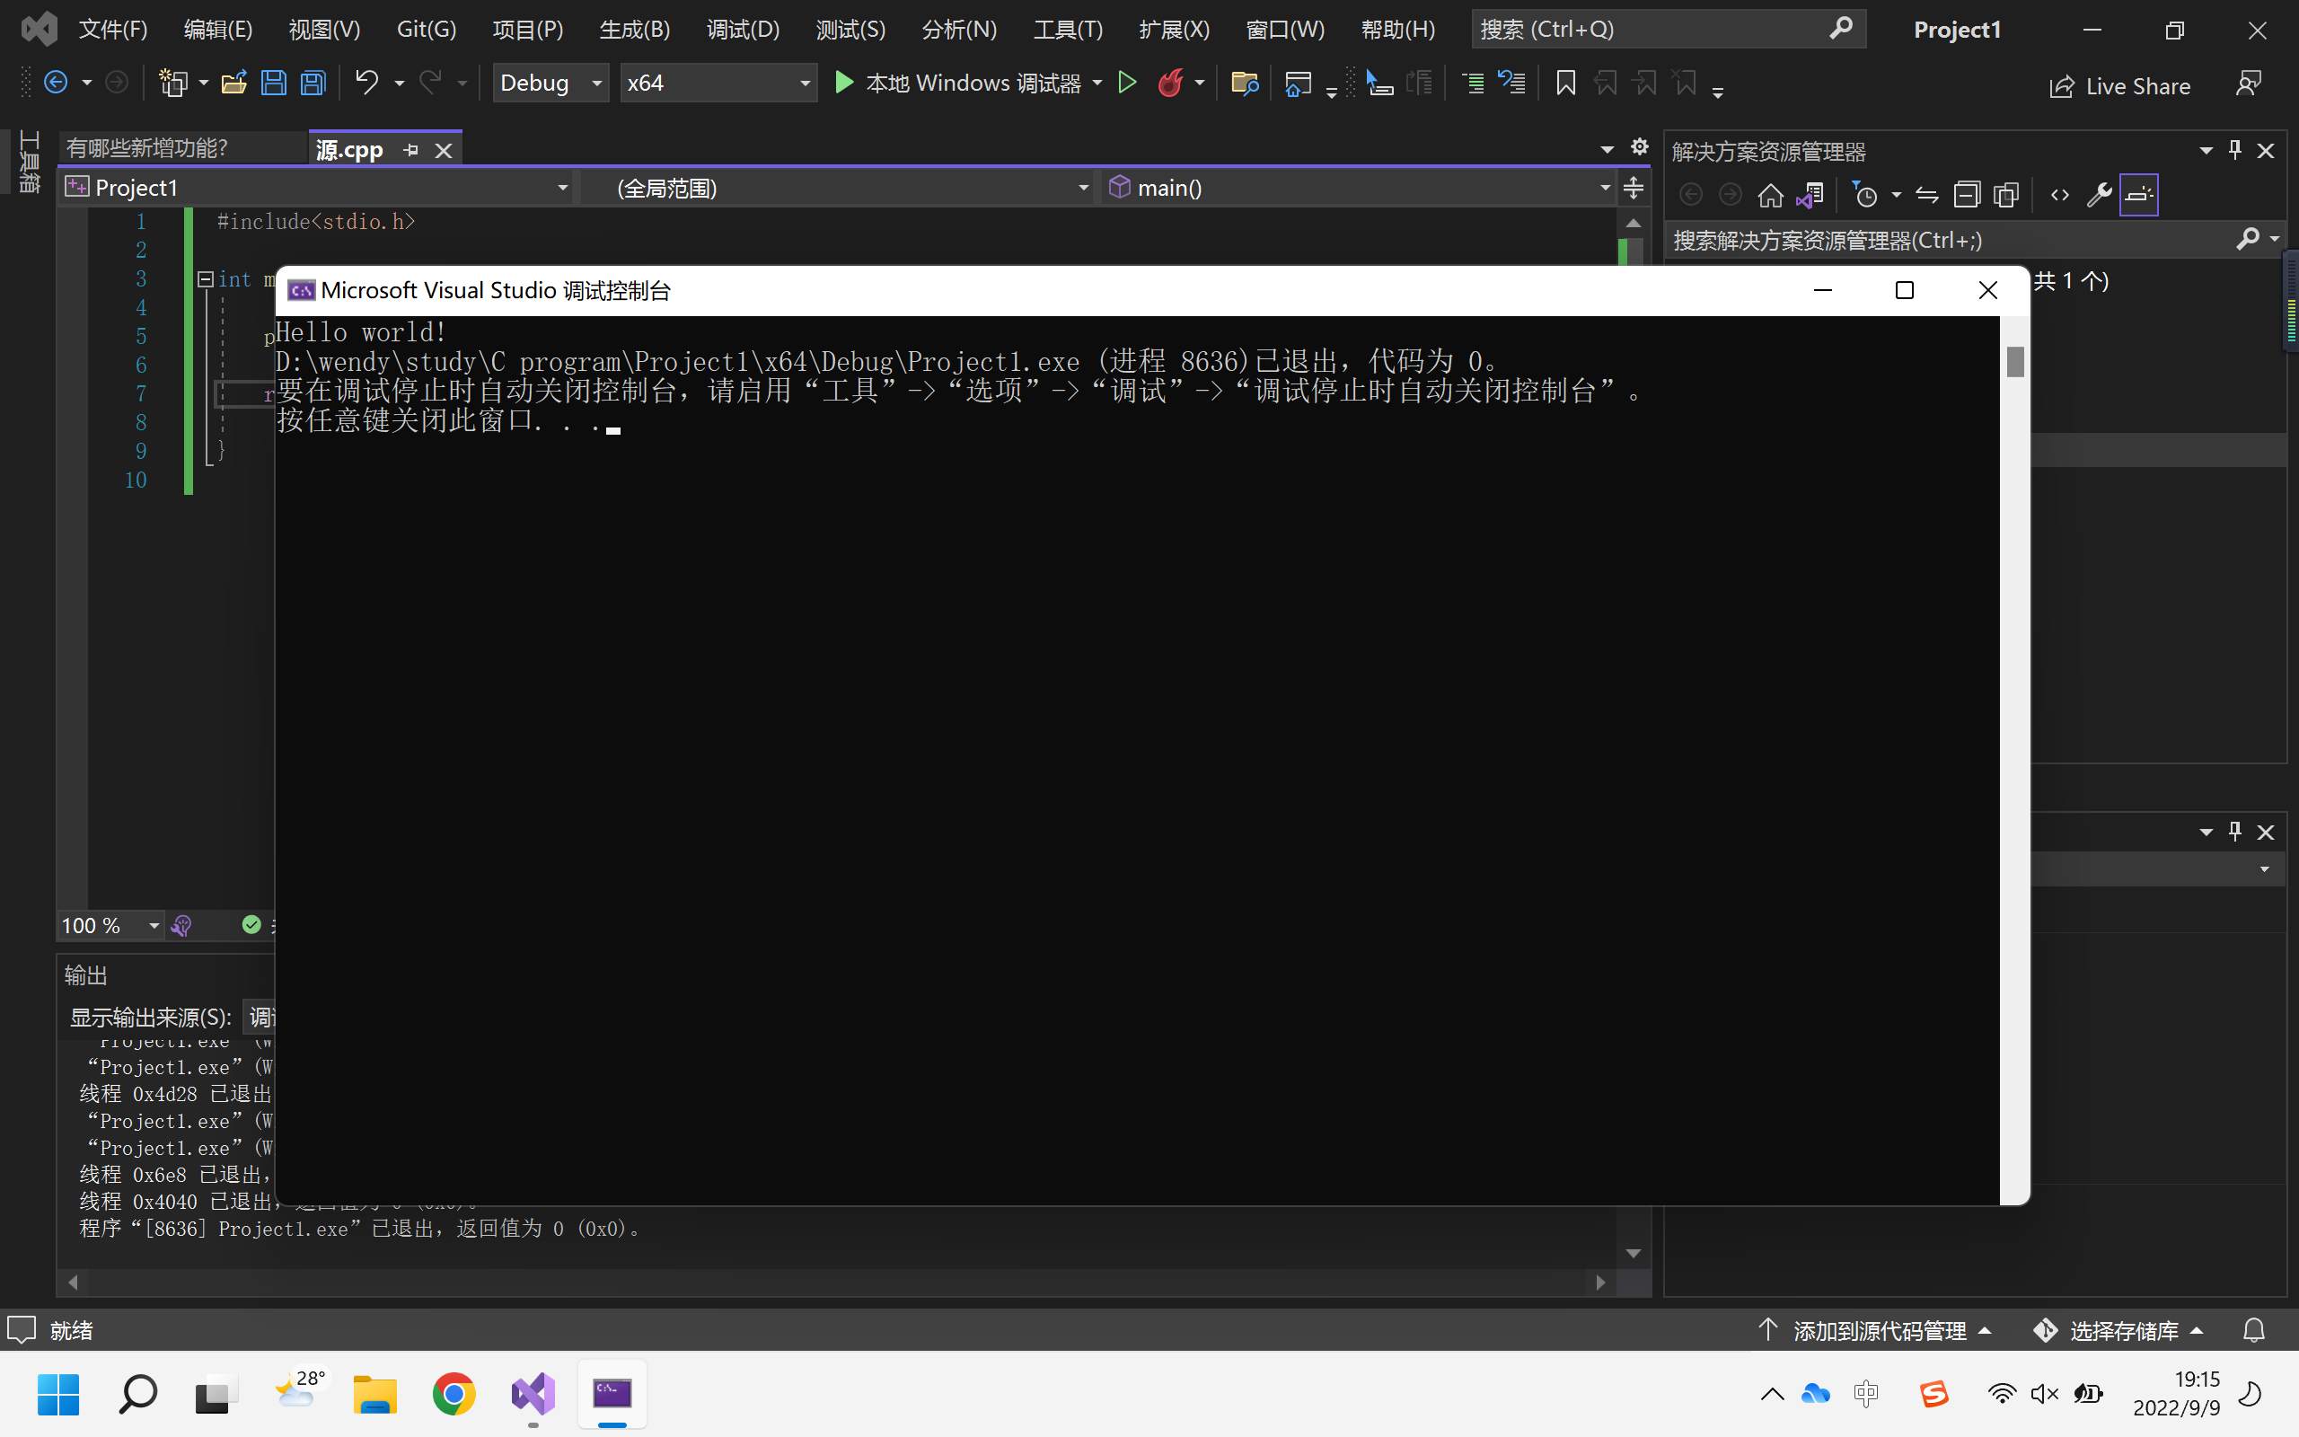

- print your name and student number with two “printf”
#include<stdio.h>

int main() {

printf("name:应逸雯\n");
printf("student number:12210159\n");

return 0;

}
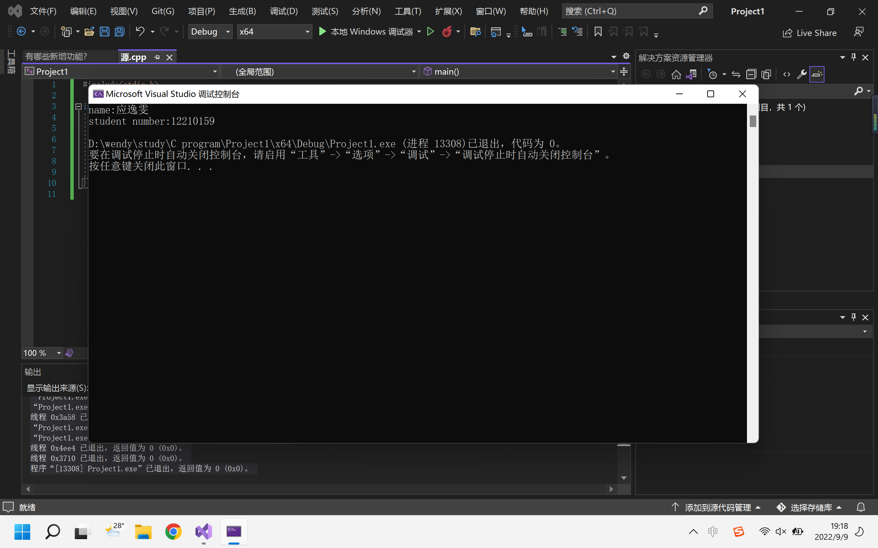

- print your name and student number with only one “printf”
#include<stdio.h>

int main() {

printf("name:应逸雯\nstudent number:12210159\n");

return 0;

}
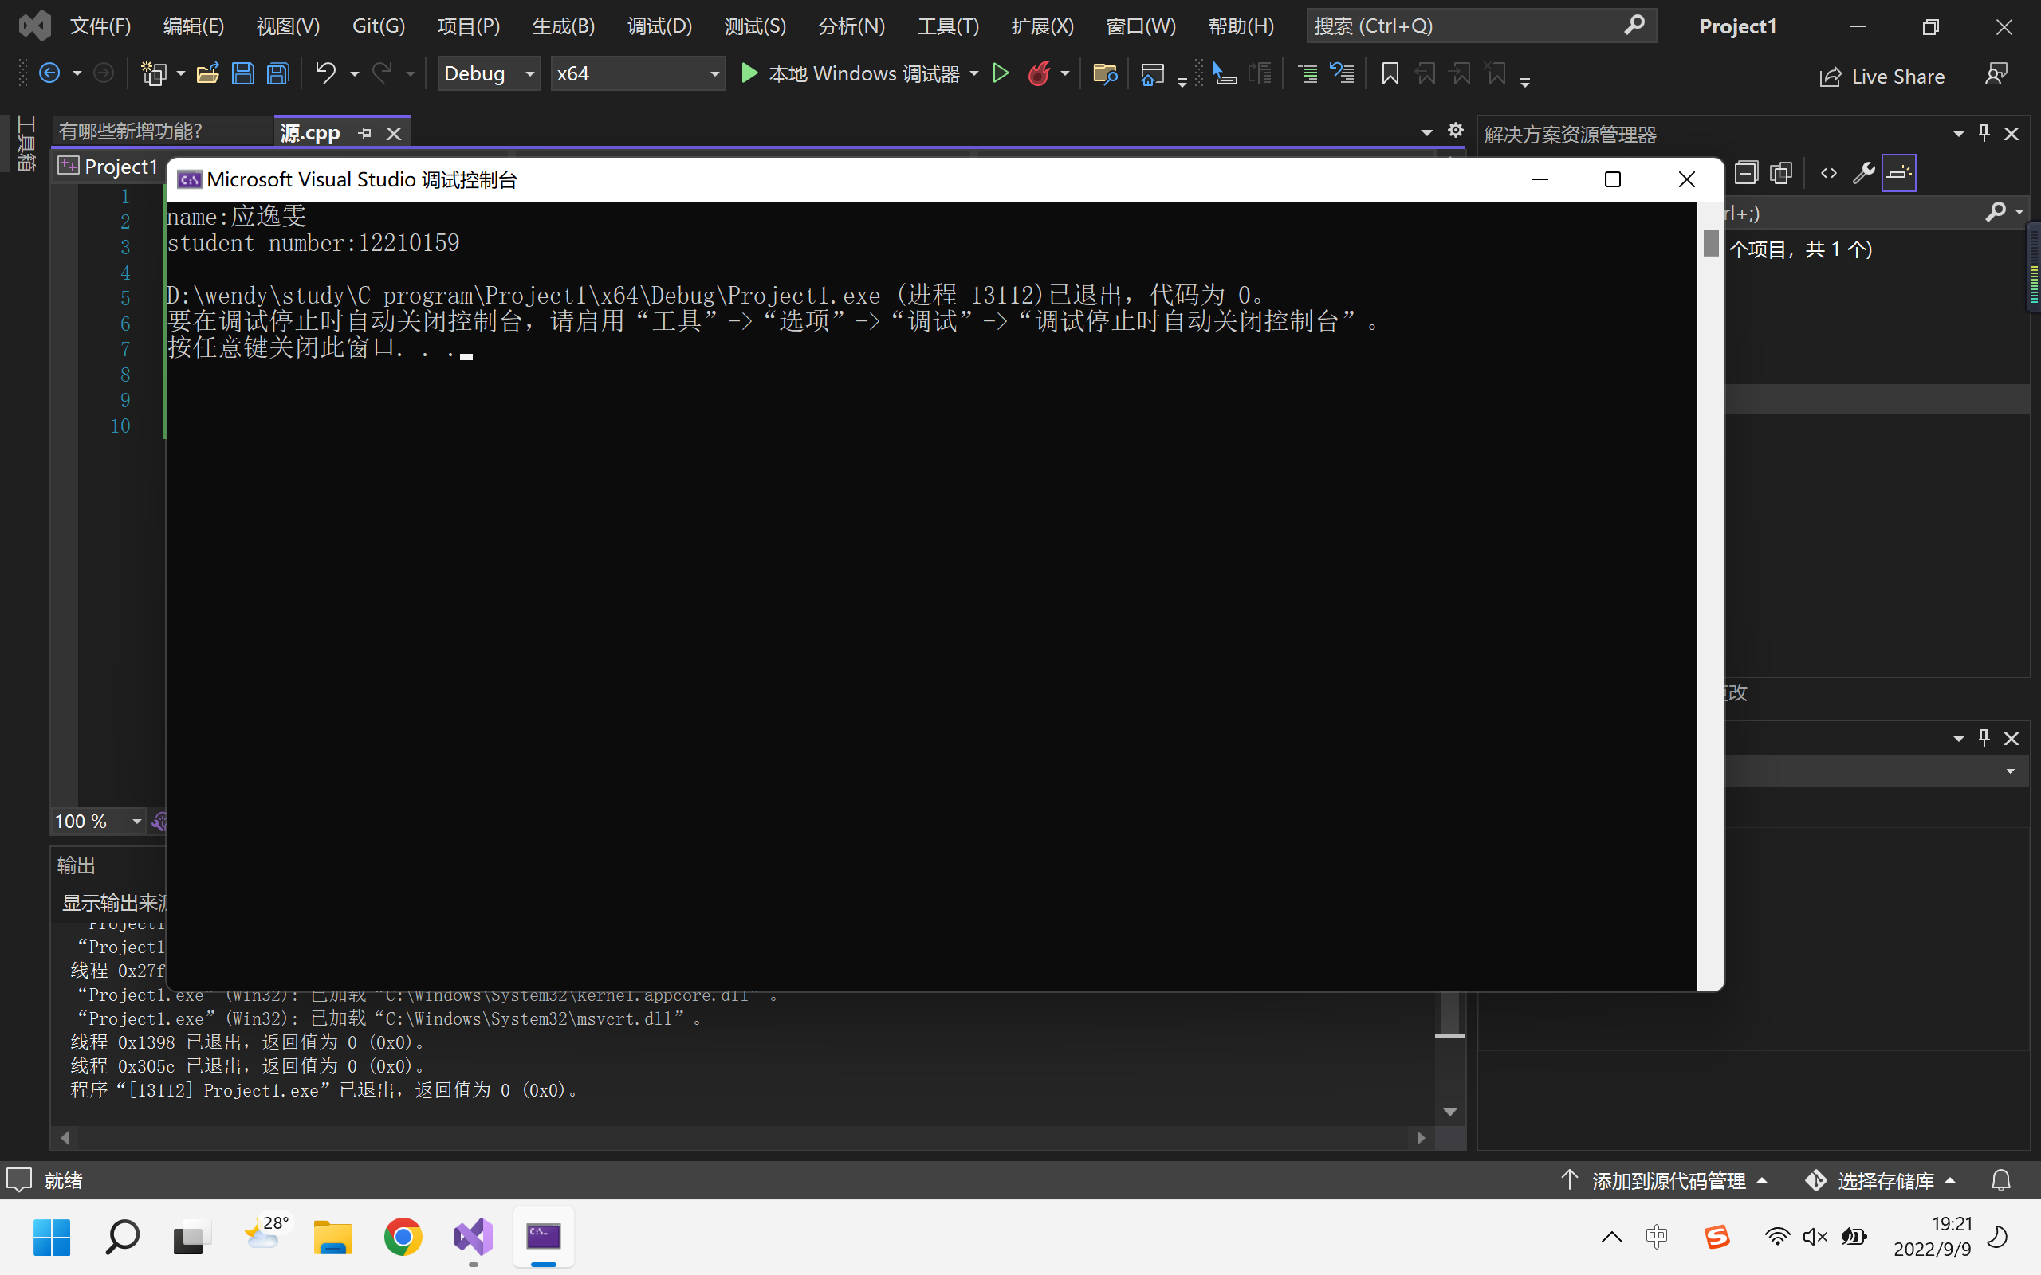

- print an equation adding two integer numbers
#include<stdio.h>

int main() {

int a,b,c;
a = 2;
b = 3;
c = a + b;

printf("%d+%d=%d\n",a,b,c);

return 0;

}
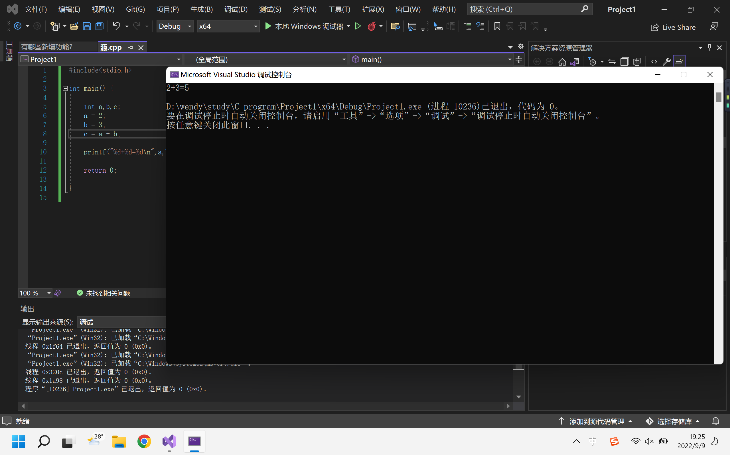

- print an equation multiplying two float numbers
#include<stdio.h>

int main() {

float a,b,c;
a = 1.7;
b = 2.2;
c = a * b;

printf("%f*%f=%f\n",a,b,c);

return 0;

}
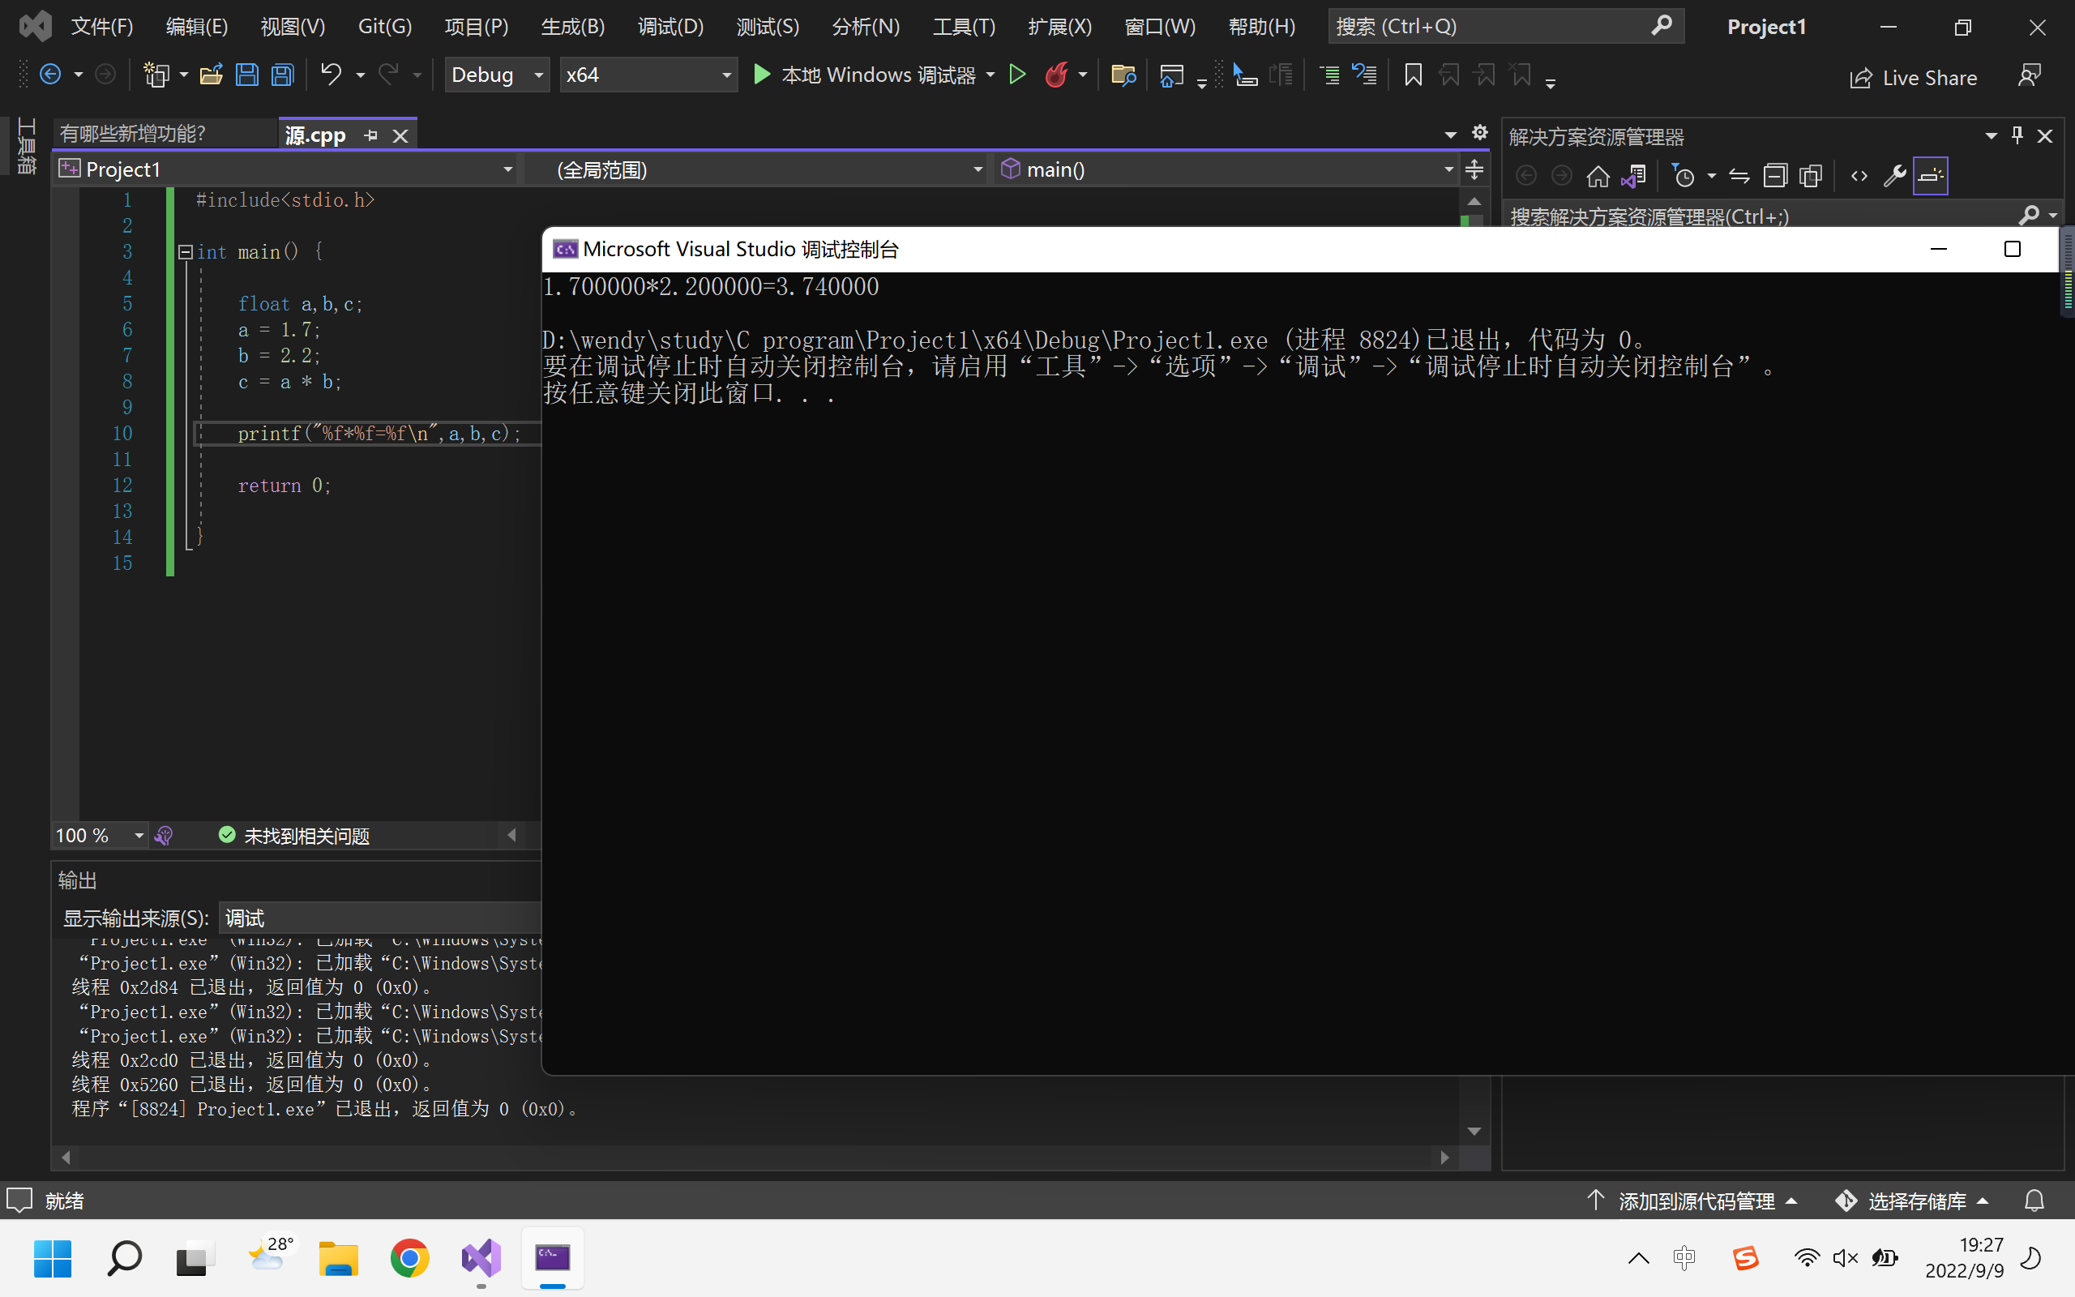

- briefly describe how a C program is executed
A C program is based on a machine, a compiler and some programs in programming language, which is typed by man. The head profile guarantees the operation of the program. What we can see and type on the typing screen may be called as “source code”. That is in programming language. The compiler precompiles it first (delete some unneeded words, and add some necessary things, like line numbers and file IDs) so that the words are easier to be translated. The compiler then reads that profile, analyzes them, and translates them into such kind of “assembly language”. That step can be called as compiling (including lexical analysis, semantic analysis, code optimization, generating assembly language). After that, the compiler translate that into machine language, which only contains simple things like 0 and 1. The profile in machine language is a kind of inter mediate profile, which can be comprehended by both human and machines (although that is too hard). Then the profile is transferred into an executable profile. That profile can be operated by the machine now. Finally, the machine runs the project, and it comes out with the results and output them. So far, the C program is executed successfully!

