C程序设计基础作业-2022.9.16-12210159应逸雯

- Write following base-10 numbers in base-2 format: 10, 1024 and 1025.
Write the following base-2 numbers in base-10 format: 11110 and 1011101.
The base-2 format of 10 is 1010.
The base-2 format of 1024 is 10000000000.
The base-2 format of 1025 is 10000000001.
The base-10 format of 11110 is 30.
The base-10 format of 1011101 is 93.

2. Write a program that prints the minimum, maximum, average and standard
deviation of 5 floats.
a. use “scanf()” to read the number
b. test input : 23.5 47 -20.1 13 36

The project:
#include <stdio.h>
#include <stdlib.h>
#include <math.h>

/* run this program using the console pauser or add your own getch, system("pause") or input loop */

int main(int argc, char *argv[]) {
float a, b, c, d, e;
printf("Please type the numbers:\n");
scanf("%f", &a);
scanf("%f", &b);
scanf("%f", &c);
scanf("%f", &d);
scanf("%f", &e);

float minimum;
minimum = a;
minimum = minimum<b?minimum:b;
minimum = minimum<c?minimum:c;
minimum = minimum<d?minimum:d;
minimum = minimum<e?minimum:e;

float maximum;
maximum = a;
maximum = maximum>b?maximum:b;
maximum = maximum>c?maximum:c;
maximum = maximum>d?maximum:d;
maximum = maximum>e?maximum:e;

float average;
average=a+b+c+d+e;
average=average/5;

float standard_deviation;
standard_deviation=0;
standard_deviation+=(a-average)*(a-average);
standard_deviation+=(b-average)*(b-average);
standard_deviation+=(c-average)*(c-average);
standard_deviation+=(d-average)*(d-average);
standard_deviation+=(e-average)*(e-average);
standard_deviation=standard_deviation/5;
standard_deviation=sqrt(standard_deviation);

printf("minimum=%f\n",minimum);
printf("maximum=%f\n",maximum);
printf("average=%f\n",average);
printf("standard_deviation=%f\n",standard_deviation);

return 0;
}

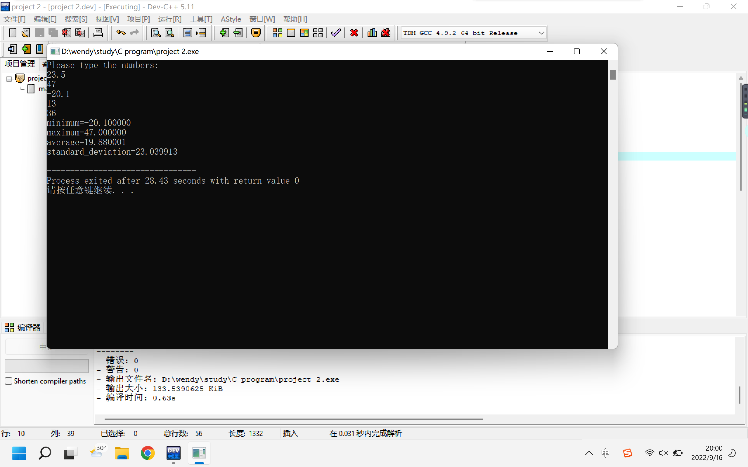

3. Write a program that reads the radius of a circle and outputs perimetric and area.
a. use “scanf()” to read the radius
b. PI = 3.14
c. test input : radius of the circle is 3

The project:
#include <stdio.h>
#include <stdlib.h>

/* run this program using the console pauser or add your own getch, system("pause") or input loop */

int main(int argc, char *argv[]) {
float radius;
float perimetric;
float area;

printf("The radius is\n");
scanf("%f",&radius);
perimetric = 2*3.14*radius;
area = 3.14*radius*radius;

printf("The perimetric is %f\n",perimetric);
printf("The area is %f\n",area);

return 0;
}
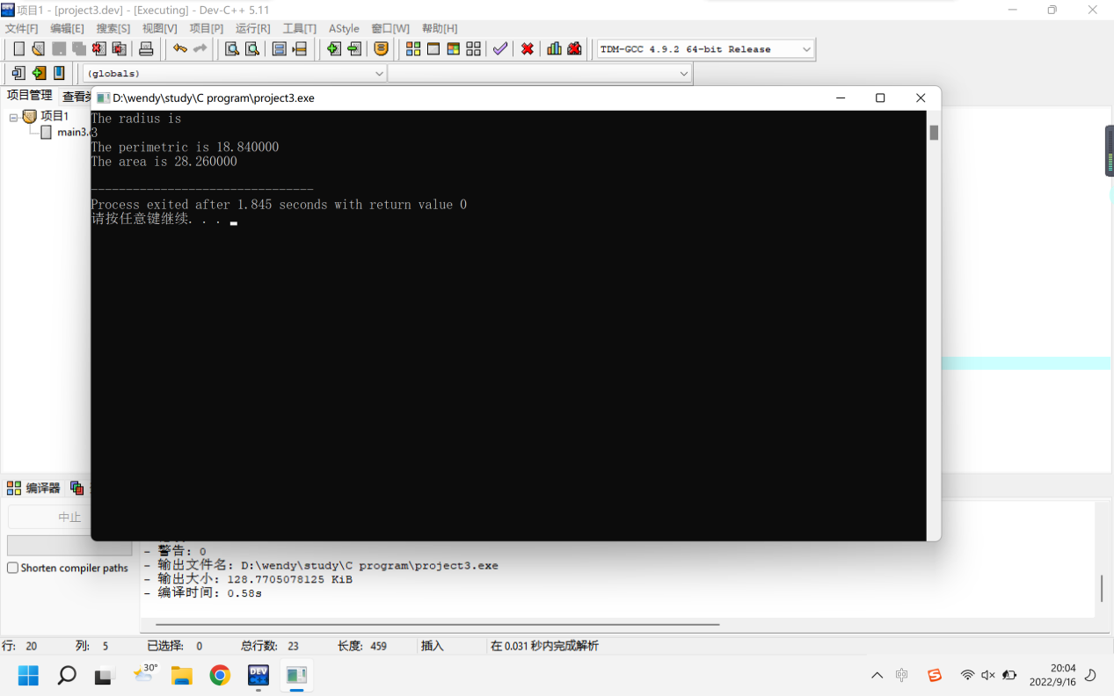

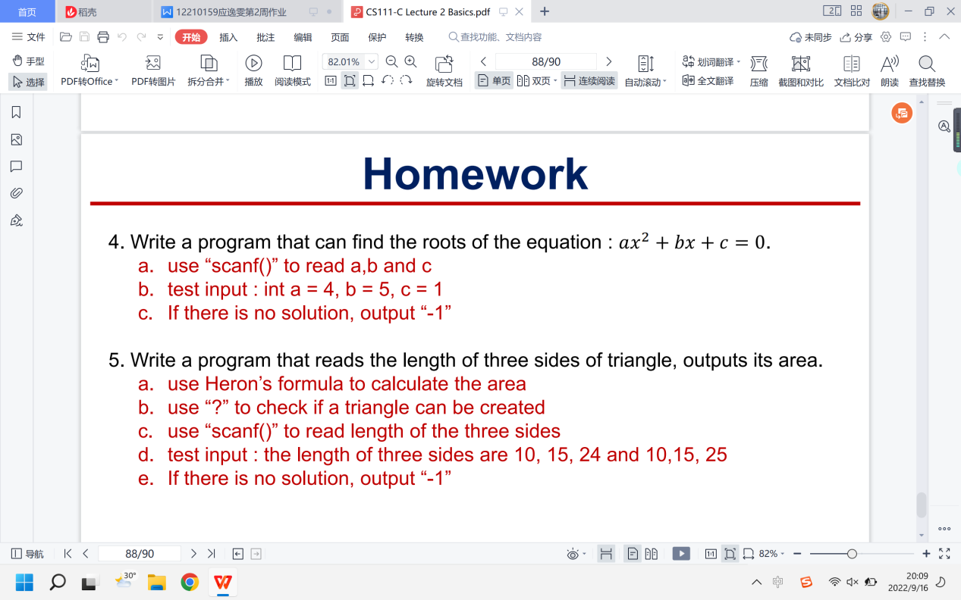
- Write a program that can find the roots of the equation :
a. use “scanf()” to read a,b and c
b. test input : int a = 4, b = 5, c = 1
c. If there is no solution, output “-1”
The project:
#include <stdio.h>
#include <stdlib.h>
#include <math.h>
/* run this program using the console pauser or add your own getch, system("pause") or input loop */
int main(int argc, char *argv[]) {
int a,b,c;
printf("For the equation:ax^2+bx=c=0,please give the a,b,c.\n");
printf("a=");
scanf("%d",&a);
printf("b=");
scanf("%d",&b);
printf("c=");
scanf("%d",&c);
printf("The solution:");
float i;
i=b*b-4*a*c;
if(i<0){
printf("-1");
}else{
float delta,root_1,root_2;
delta=sqrt(i);
root_1=(delta-b)/(2*a);
root_2=(-delta-b)/(2*a);
printf("The root 1 is %f.\nThe root 2 is %f.\n",root_1,root_2);
}
return 0;
}
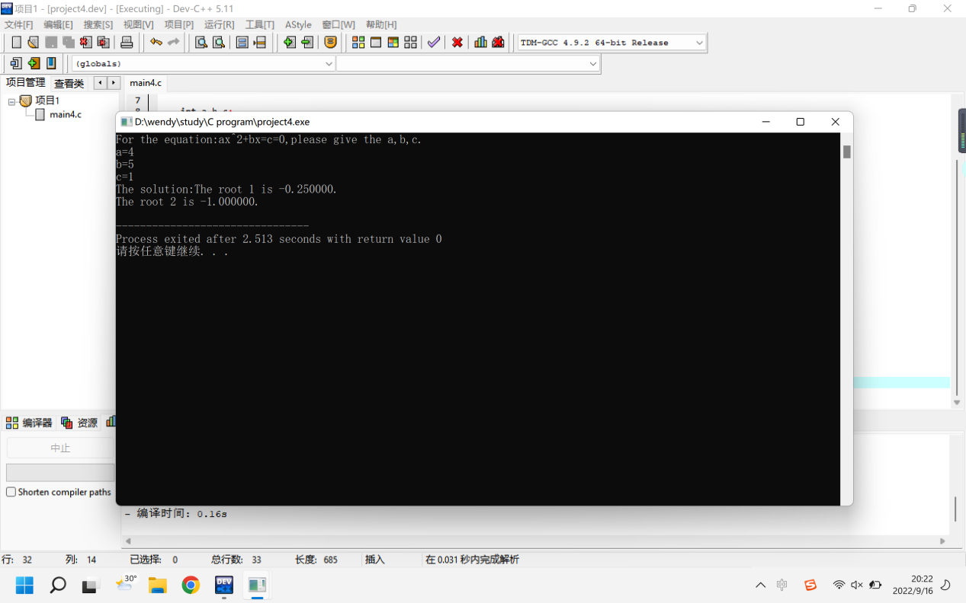
5. Write a program that reads the length of three sides of triangle, outputs its area.
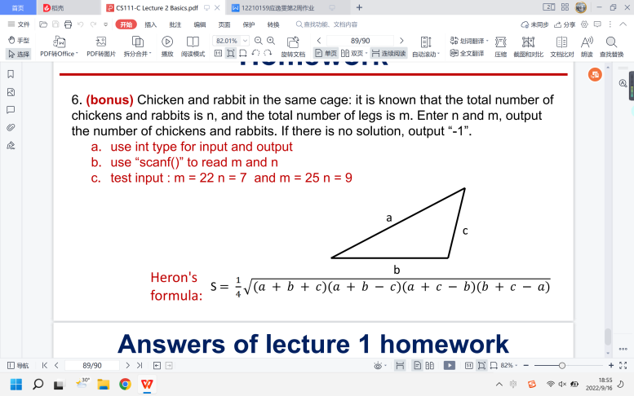
a. use Heron’s formula to calculate the area
b. use “?” to check if a triangle can be created
c. use “scanf()” to read length of the three sides
d. test input : the length of three sides are 10, 15, 24 and 10,15, 25
e. If there is no solution, output “-1”

The project :
#include <stdio.h>
#include <stdlib.h>
#include <math.h>
/* run this program using the console pauser or add your own getch, system("pause") or input loop */

int main(int argc, char *argv[]) {

int a,b,c;

printf("The lengths of the triangle are:\n");
printf("a=");
scanf("%d",&a);
printf("b=");
scanf("%d",&b);
printf("c=");
scanf("%d",&c);

printf("The solutions:");
int i,j,k;
i=a+b>c?1:0;
j=b+c>a?1:0;
k=a+c>b?1:0;

if(i+j+k!=3)
{
printf("-1");
}
if(i+j+k==3)
{
float product;
product=(a+b+c)*(a+b-c)*(a-b+c)*(-a+b+c);
float area;
area=sqrt(product);
area=0.25*area;
printf("%f",area);
}

return 0;
}
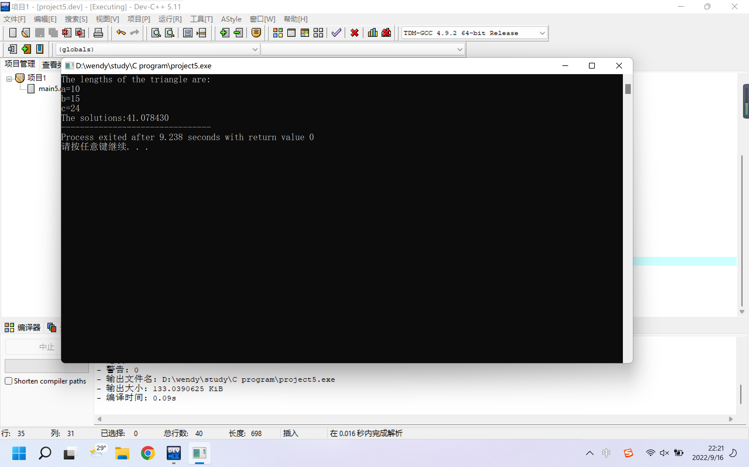

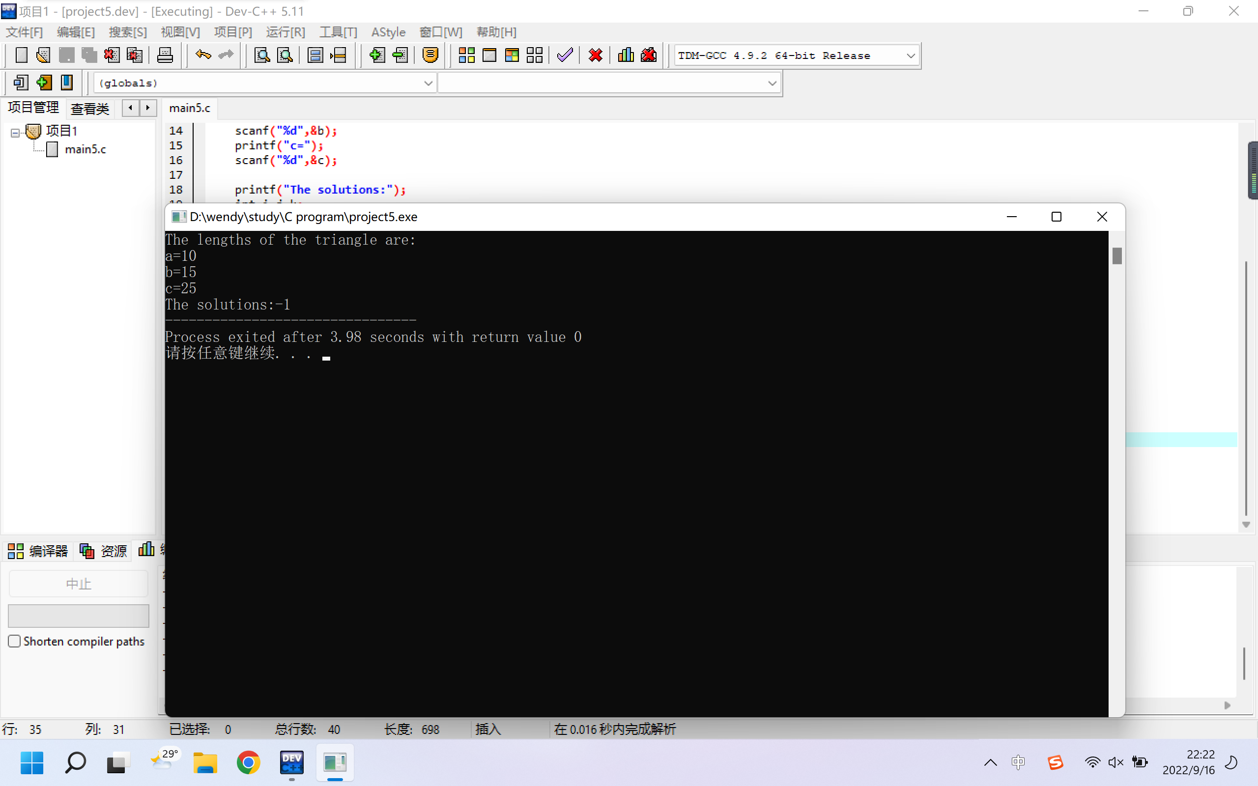

6. (bonus) Chicken and rabbit in the same cage: it is known that the total number of chickens and rabbits is n, and the total number of legs is m. Enter n and m, output the number of chickens and rabbits. If there is no solution, output “-1”.
a. use int type for input and output
b. use “scanf()” to read m and n
c. test input : m = 22 n = 7 and m = 25 n = 9

The project:
#include <stdio.h>
#include <stdlib.h>

/* run this program using the console pauser or add your own getch, system("pause") or input loop */

int main(int argc, char *argv[]) {

int n,m;
printf("The total number of chickens and rabbits is ") ;
scanf("%d",&n);
printf("The total number of legs is ");
scanf("%d",&m);

if (m%2==1) {printf("-1"); }
else if (m>4*n) {printf("-1"); }
else if (m<2*n) {printf("-1"); }
else {
int t;
int num_rabbit,num_chicken;
t=m-2*n;
t=0.5*t;
num_rabbit=t;
num_chicken=n-t;
printf("The number of rabbit is %d\n",num_chicken);
printf("The number of chickens is %d\n",num_rabbit);
}

return 0;
}
