C程序设计基础作业-2022.9.23-12210159应逸雯
1. Enter a score (in range 0 to 100) and convert it to a corresponding grade. The conversion rules are as follows:
a) A: 90~100;
B: 80~89;
C: 70~79;
D: 60~69;
E: 0~59;
b) Enter the score with “scanf” and print the corresponding grade with “printf”
c) Test input: 95, 59

Project:
#include <stdio.h>
#include <stdlib.h>

/* run this program using the console pauser or add your own getch, system("pause") or input loop */

int main(int argc, char *argv[]) {
int i;
for(i=0;i<2;i++)
{
int score;
printf("Please enter a score:");
scanf("%d",&score);
printf("The grade is:");
if(score>=90&&score<=100){printf("A");}
if(score>=80&&score<=89){printf("B");}
if(score>=70&&score<=79){printf("C");}
if(score>=60&&score<=69){printf("D");}
if(score>=0&&score<=59){printf("E");}
printf("\n");
}
return 0;
}
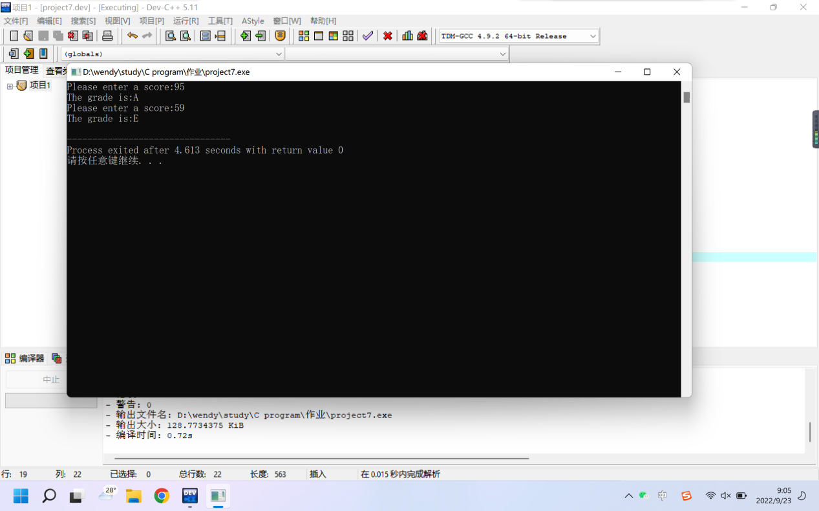

2. Enter an integer and print factorial of the number(n!).
a) Enter the integer with “scanf”
b) Test input :10

Project:
#include <stdio.h>
#include <stdlib.h>

/* run this program using the console pauser or add your own getch, system("pause") or input loop */

int main(int argc, char *argv[]) {

int product=1;
int num;
printf("Please print the number:");
scanf("%d",&num);
for(num;num>0;num--)
{
product=product*num;
}

printf("The factorial of the number is:%d",product);

return 0;
}
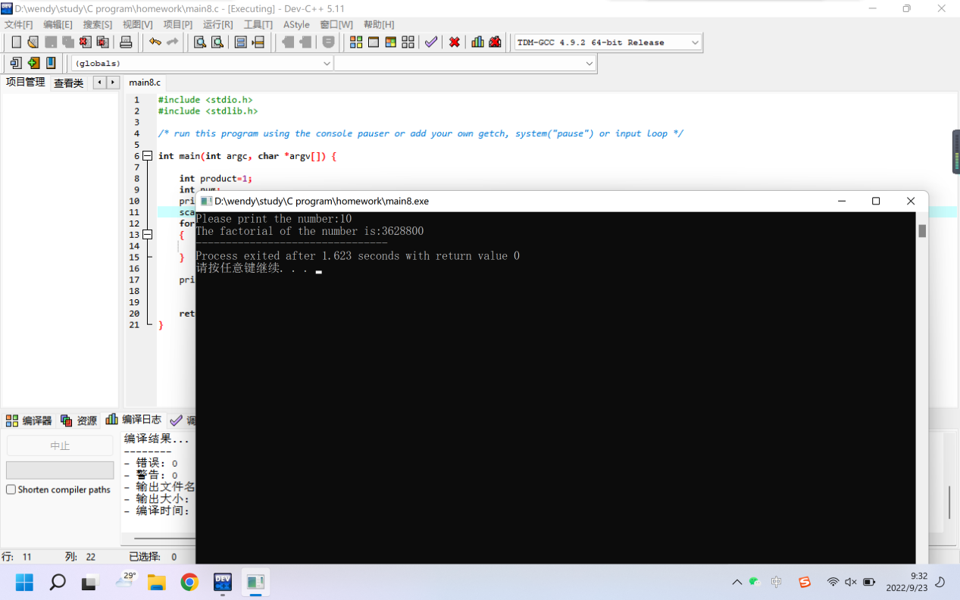

3. Find and print the prime numbers (integer) between 100 - 200.
a) A prime number is a natural number greater than 1 and it has no other factors except 1 and itself

Project:
#include <stdio.h>
#include <stdlib.h>

/* run this program using the console pauser or add your own getch, system("pause") or input loop */

int main(int argc, char *argv[]) {
int num;
printf("The prime numbers are:");
for(num=100;num<=200;num++)
{
int result=1;
int i;
for(i=num-1;i>1;i--)
{
// printf("%d\t",i);
if(num%i==0)
{
result=0;
}
}
// printf("%d\n",result);
if(result==1)
{
printf("%d,",num);
}
}
return 0;
}

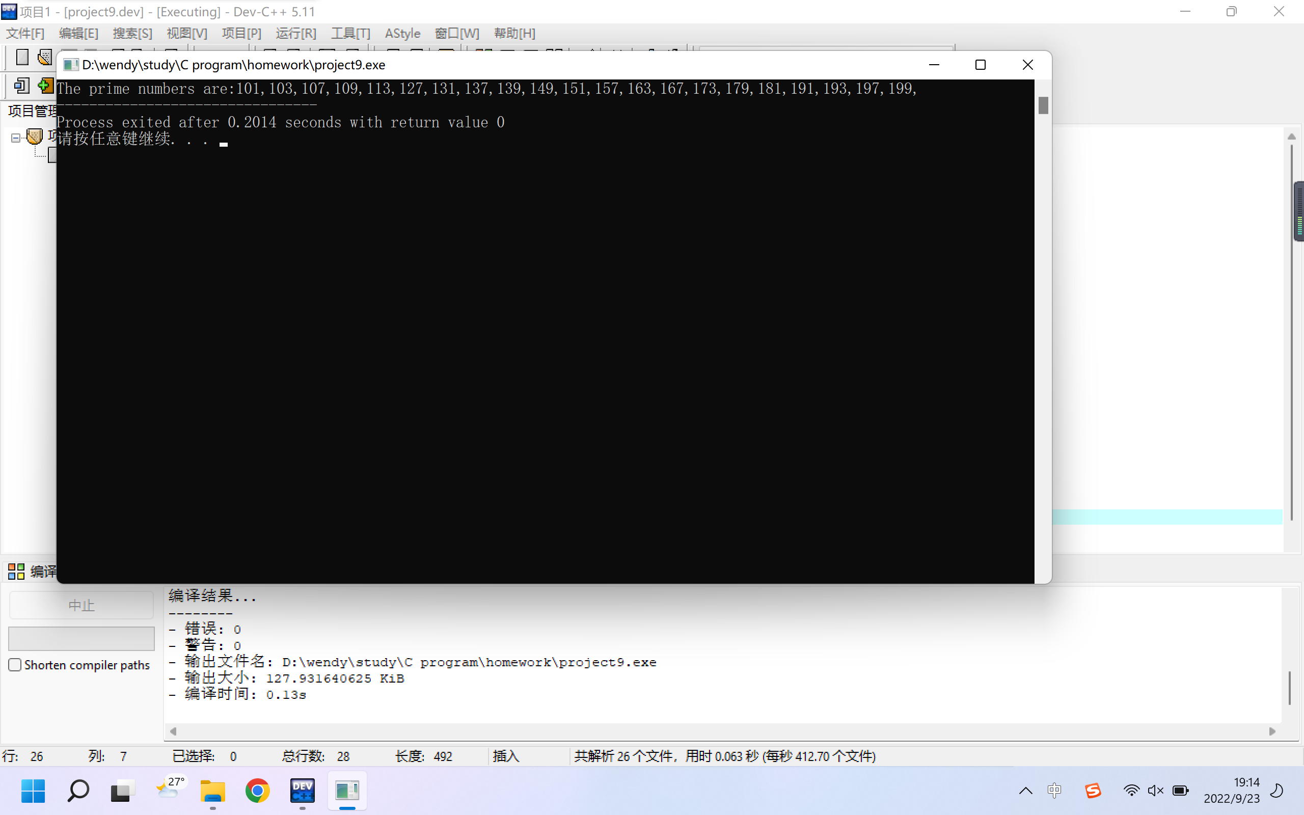

4. Print a diagonal matrix with 4 rows and 4 cols, the value on the diagonal is equal to its row number.
a) Use nested loops (for-for) to print the matrix and specify the values on the diagonal using if statement
b) The matrix looks like
1 0 0 0
0 2 0 0
0 0 3 0
0 0 0 4

Project:
#include <stdio.h>
#include <stdlib.h>

/* run this program using the console pauser or add your own getch, system("pause") or input loop */

int main(int argc, char *argv[]) {

int a[4][4];
int m,n;
for(m=0;m<=3;m++)
{
for(n=0;n<=3;n++)
{
if(m==n)
{
a[m][n]=m+1;
}
else
{
a[m][n]=0;
}
}
}

for(m=0;m<=3;m++)
{
for(n=0;n<=3;n++)
{
printf("%d\t",a[m][n]);
}
printf("\n");
}
return 0;
}

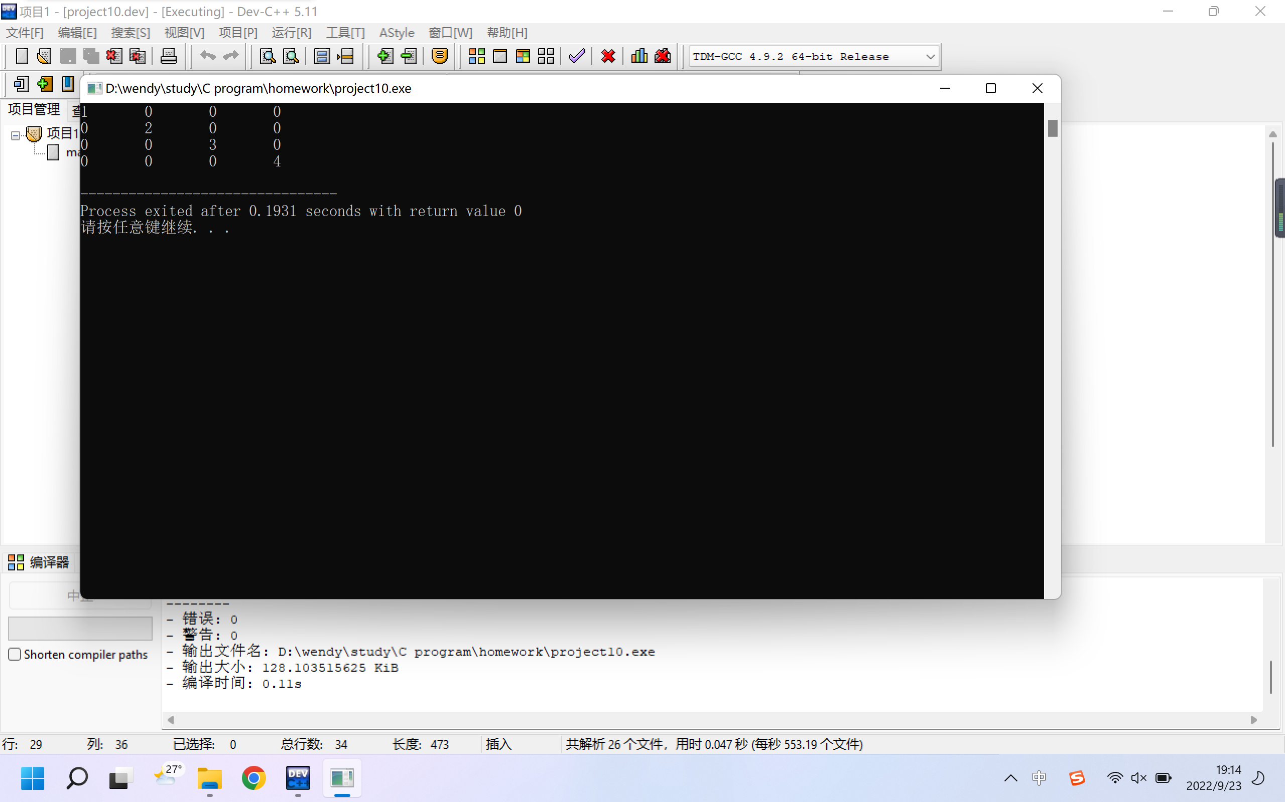

5. Students are on the playground, grouping as 3 persons in a row, 5 in a row and 7 in a row, respectively. The number of students in the last row are a , b , c. How many students are on the playground ?
a) The total number of students is between 10 and 100
b) a = 2; b = 4; c = 5

Project:
#include <stdio.h>
#include <stdlib.h>

/* run this program using the console pauser or add your own getch, system("pause") or input loop */

int main(int argc, char *argv[]) {

int student;
int a,b,c;
printf("The number of students in the last row is: (group as 3 persons in a row)");
scanf("%d",&a);
printf("The number of students in the last row is: (group as 5 persons in a row)");
scanf("%d",&b);
printf("The number of students in the last row is: (group as 7 persons in a row)");
scanf("%d",&c);

for(student=10;student<=100;student++)
{
if((student%3==a)&&(student%5==b)&&(student%7==c))
{
printf("There are %d students on the playground.",student);
}
}

return 0;
}
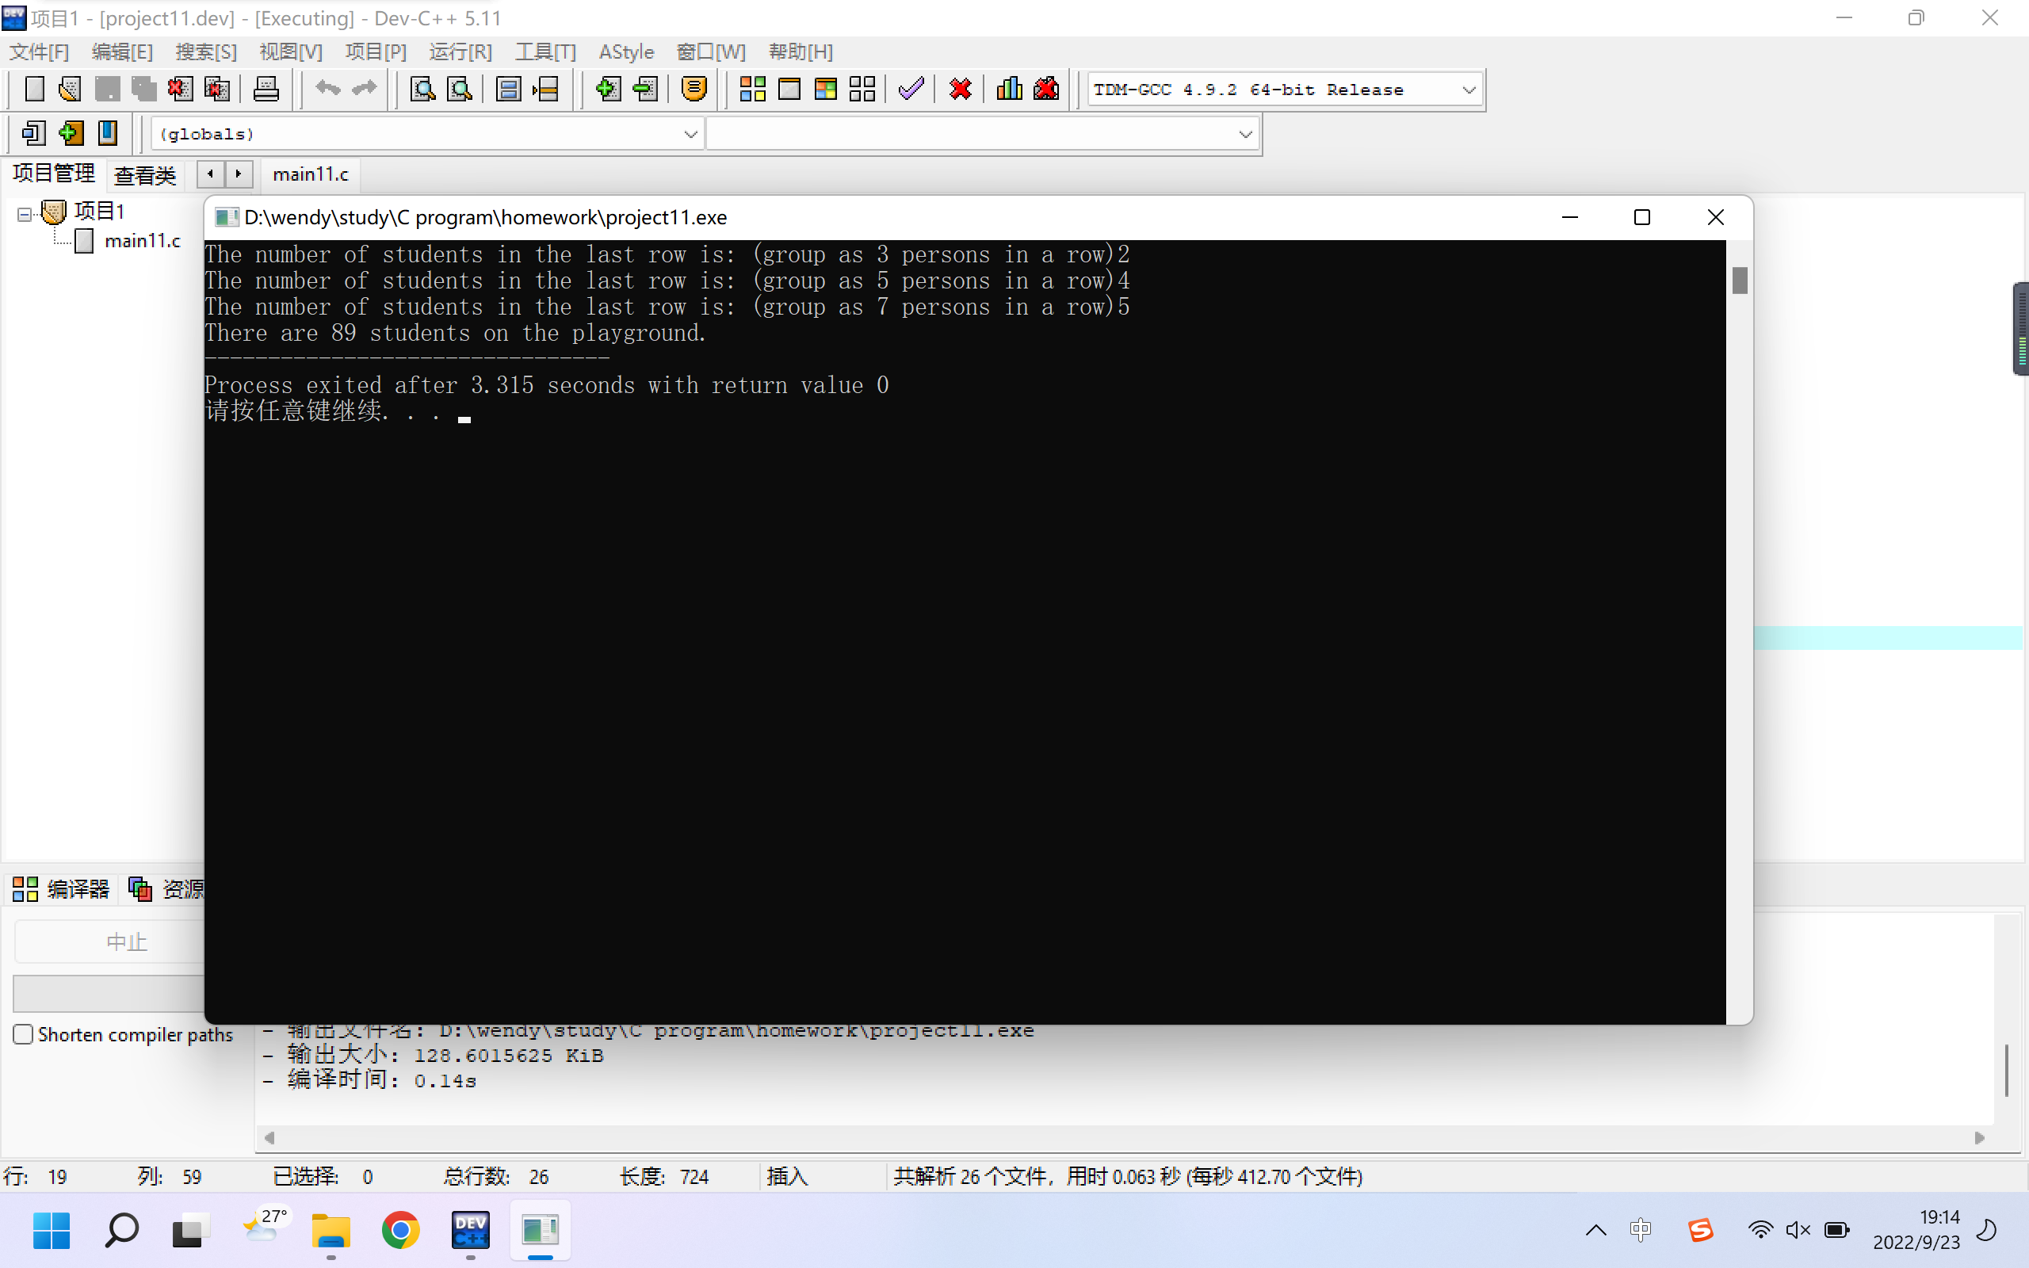

6-A. (bonus) There is a pair of rabbits. From the third month after birth, a pair of rabbits are born every month. After the little rabbit grows to the third month, another pair of rabbits is born every month. Please print the total number of rabbits on each month.
a) The rabbits will die on the 6 month
b) You should print the number of rabbits for the first 20 months

Project:
#include <stdio.h>
#include <stdlib.h>

/* run this program using the console pauser or add your own getch, system("pause") or input loop */

int main(int argc, char *argv[]) {

int total;
int month_1=2;
int month_2=0;
int month_3=0;
int month_4=0;
int month_5=0;

int time;
printf("How many months have passed?");
scanf("%d",&time);

int i;
for(i=time;i>1;i--)
{
int t;
t=month_1;
month_1=month_2+month_3+month_4;
month_5=month_4;
month_4=month_3;
month_3=month_2;
month_2=t;
}

total=month_1+month_2+month_3+month_4+month_5;
printf("There are %d rabbits in month %d .",total,time);

return 0;
}