C程序设计基础作业-2022.9.30-12210159应逸雯
1. Enter 5 float numbers, store them in an array and print their reciprocals in the reverse order.
a) Use “scanf” to enter the float numbers
b) Test input : 0.5 , 0.9 , 1.3 , 4.7 , 9.3

Project:
#include <stdio.h>
#include <stdlib.h>

/* run this program using the console pauser or add your own getch, system("pause") or input loop */

int main(int argc, char *argv[]) {

float a[5];
int i;
for(i=0;i<5;i++)
{
printf("Please type the number %d :",i+1);
scanf("%f",&a[i]);
}
printf("The result is:\n");
for(i=4;i>=0;i--)
{
printf("%f\t",1/a[i]);
}

return 0;
}

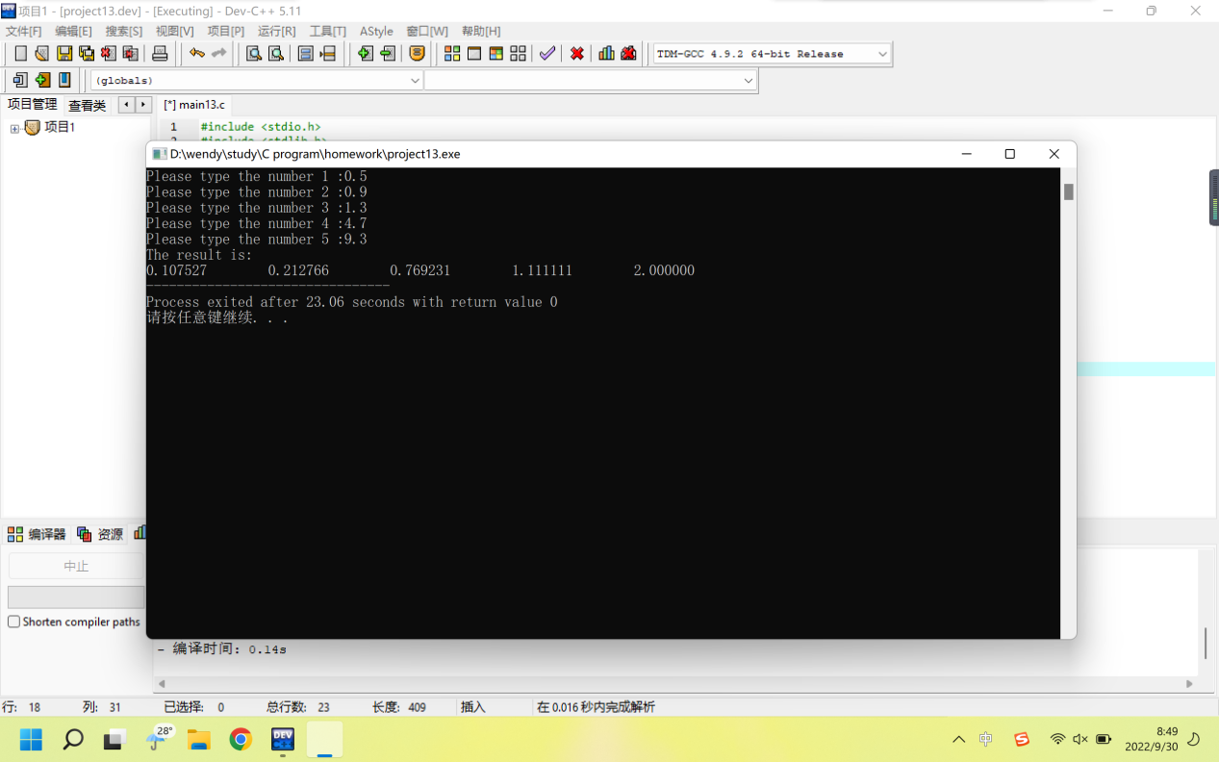

2. Enter three strings, convert “china” from lowercase to uppercase, combine them into one string and print how many words are in it
a) Use “scanf” to enter the strings
b) Test input : “I” , “love” , “china”

Project:
#include <stdio.h>
#include <stdlib.h>
#include <string.h>
/* run this program using the console pauser or add your own getch, system("pause") or input loop */

int main(int argc, char *argv[]) {

char a[3][15];
char b[3][15];
printf("Please type the words:");
scanf("%s %s %s",&a[0],&a[1],&a[2]);
//复制数组
int i,j;
for(i=0;i<3;i++)
{
for(j=0;j<15;j++)
{
b[i][j]=a[i][j];
}
}
//修改文字
char e[15]="china";
int k;
for(k=0;k<3;k++)
{
if(strcmp(a[k],e)==0)
{
strupr(a[k]);
}
}
strcat(a[0],a[1]);
strcat(a[0],a[2]);
//打印结果
printf("%s\n",a[0]);
// printf("There are %d words in the sentence.",strlen(a[0]));
//计算单词数
char c[6]="@";
strcat(b[0],c);
strcat(b[1],c);
strcat(b[2],c);
strcat(b[0],b[1]);
strcat(b[0],b[2]);
// printf("%s\n",b[0]);
// printf("There are %d words in the sentence.",strlen(a[0]));
// printf("There are %d words in the sentence.",strlen(b[0]));
printf("There are %d words in the sentence.",(strlen(b[0])-strlen(a[0])));
return 0;
}
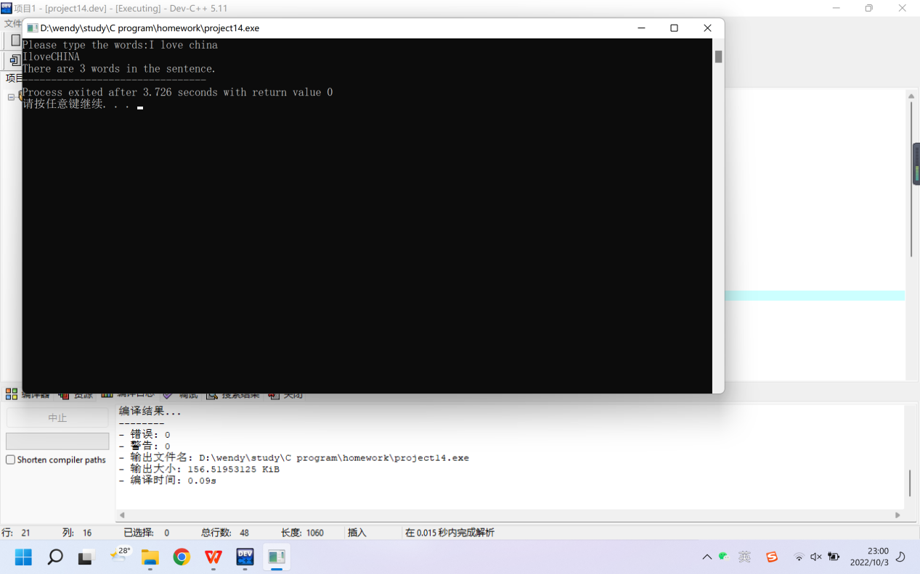

3.
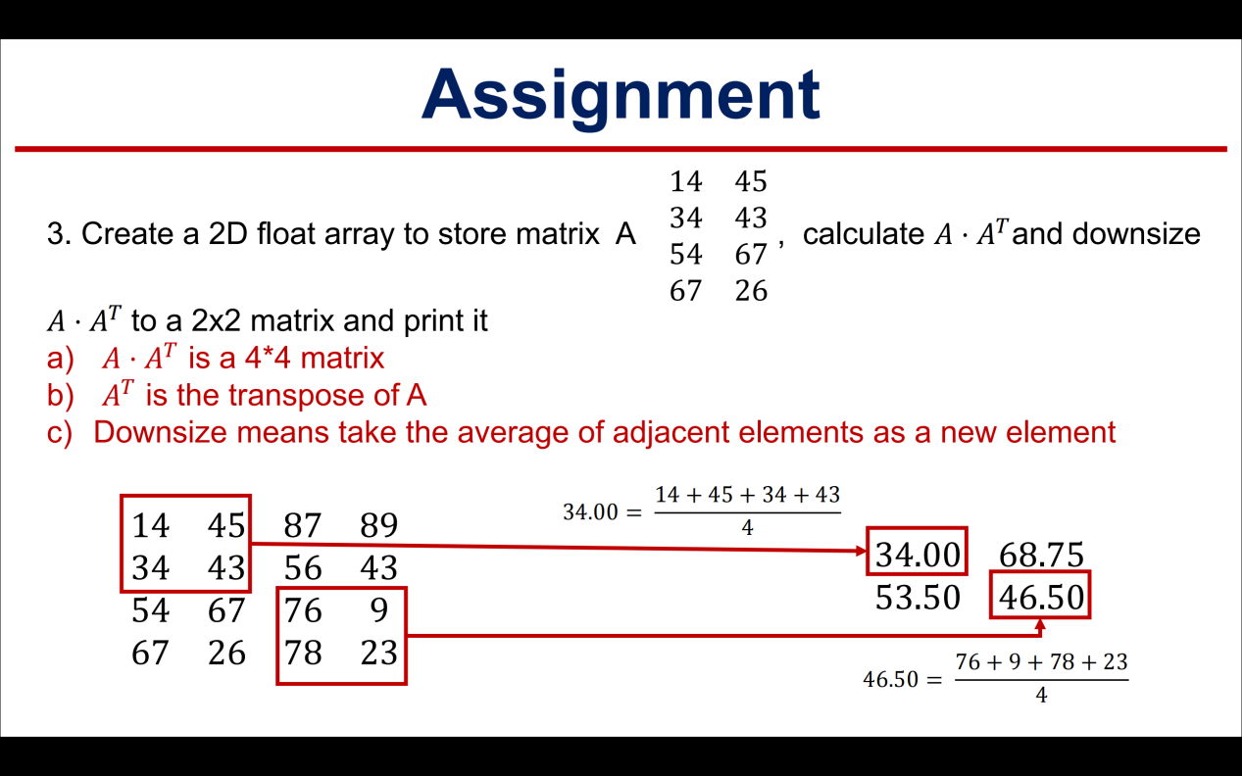

Project：
#include <stdio.h>
#include <stdlib.h>

/* run this program using the console pauser or add your own getch, system("pause") or input loop */

int main(int argc, char *argv[]) {

//输入矩阵
int a[4][2]={14,45,34,43,54,67,67,26};
int b[2][4];
int m,n;
for(m=0;m<4;m++)
{
for(n=0;n<2;n++)
{
b[n][m]=a[m][n];
}
}

/* //确认矩阵a、b无误
for(n=0;n<2;n++)
{
for(m=0;m<4;m++)
{
printf("%d\t",b[n][m]);
}
printf("\n");
}
*/

//计算出c
float c[4][4];
int i,j,t;
for(i=0;i<4;i++)
{
for(j=0;j<4;j++)
{
for(t=0;t<2;t++)
{
c[i][j]+=(float)a[i][t]*b[t][j];
}
}
}

/* //确认c无误
for(i=0;i<4;i++)
{
for(j=0;j<4;j++)
{
printf("%f\t",c[i][j]);
}
printf("\n");
}
*/

//形成压缩矩阵
float d[2][2];
int p,q;
for(p=0;p<2;p++)
{
for(q=0;q<2;q++)
{
d[p][q]=c[2*p][2*q]+c[2*p+1][2*q]+c[2*p][2*q+1]+c[2*p+1][2*q+1];
d[p][q]=d[p][q]/4;
}
}

//打印结果
for(p=0;p<2;p++)
{
for(q=0;q<2;q++)
{
printf("%f\t",d[p][q]);
}
printf("\n");
}

return 0;
}

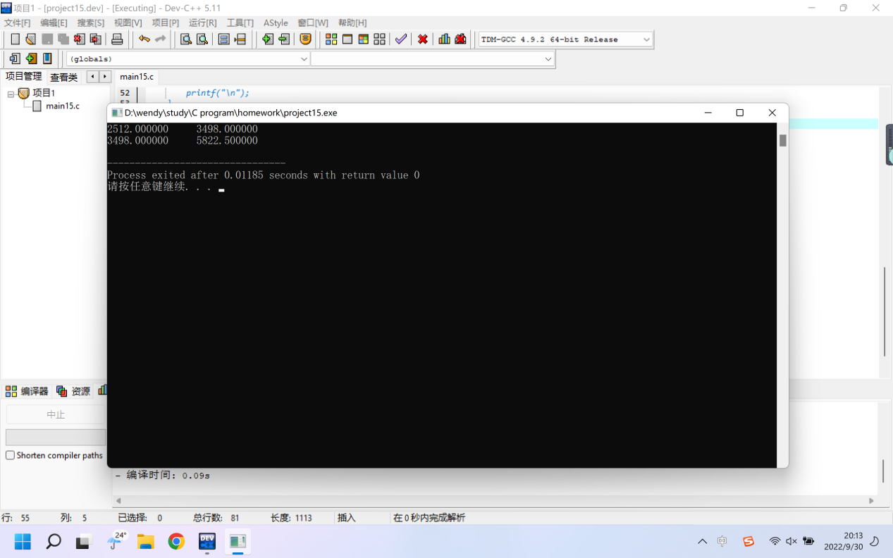

4. Enter a date in the format such as: 2010 10 24 and print the number of day of the year.
a) For example, 2010 10 24 is 297th day of 2010
b) Test input: 2022 9 30

Project：
#include <stdio.h>
#include <stdlib.h>

/* run this program using the console pauser or add your own getch, system("pause") or input loop */

int main(int argc, char *argv[]) {

int pmonth[12]={31,28,31,30,31,30,31,31,30,31,30,31};
int rmonth[12]={31,29,31,30,31,30,31,31,30,31,30,31};

int year,month,day;
printf("The date is:");
scanf("%d %d %d",&year,&month,&day);

int date;
int i;
for(i=0;i<month-1;i++)
{
if(year%4!=0)
{
date+=pmonth[i];
}
if(year%4==0)
{
date+=rmonth[i];
}
}
date+=day;

// printf("%d",date);

if(date%10==1){printf("%d %d %d is %dst day of %d.\n",year,month,day,date,year); }
if(date%10==2){printf("%d %d %d is %dnd day of %d.\n",year,month,day,date,year); }
if(date%10==3){printf("%d %d %d is %drd day of %d.\n",year,month,day,date,year); }
if((date%10>4)||(date%10==0)){printf("%d %d %d is %dth day of %d.\n",year,month,day,date,year); }

return 0;
}

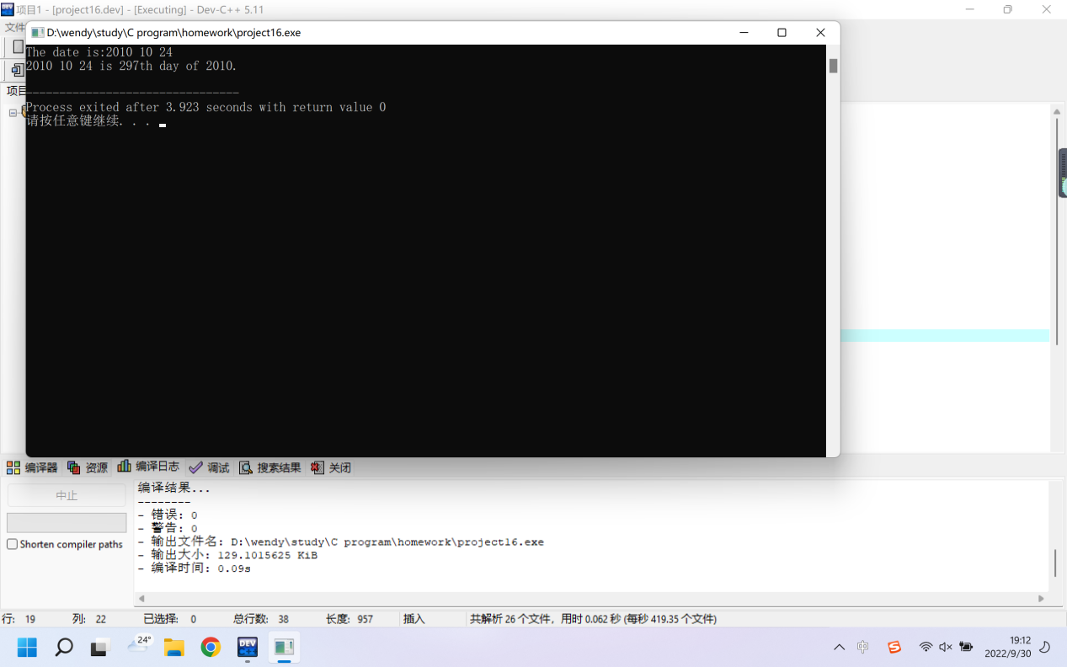

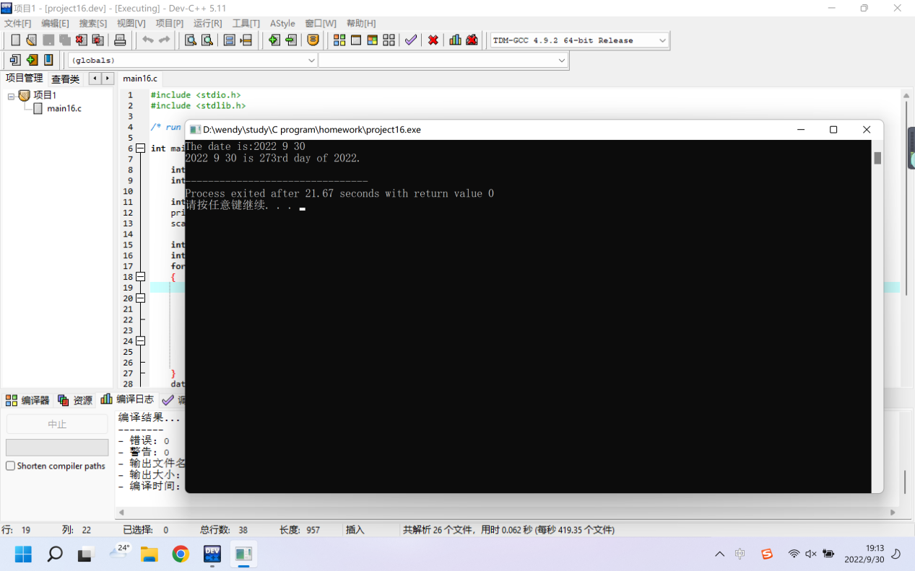

5. Use insertion sort (mentioned in the 1D array operation) to sort 15 integers and print them in the ascending order (from min to max)
a) The 15 integers are 3,44,38,5,47,15,36,26,27,2,46,4,19,50,48

Project：
#include <stdio.h>
#include <stdlib.h>

/* run this program using the console pauser or add your own getch, system("pause") or input loop */

int main(int argc, char *argv[]) {
//输入
int num[15];
printf("Please print the numbers:");
int i;
for(i=0;i<15;i++)
{
scanf("%d",&num[i]);
}

//排序
int j,k,s;
int temp;
for(j=1;j<15;j++)
{
//label:
k=j-1;
s=j;
while(k>=0)
{
//s=j;
if(num[k]<num[s])
{
break;
}
else
{
temp=num[k];
num[k]=num[s];
num[s]=temp;
s = s-1;
k=s-1;
}
}
}

//输出
for(i=0;i<15;i++)
{
printf("%d\t",num[i]);
}
printf("\n");
return 0;
}

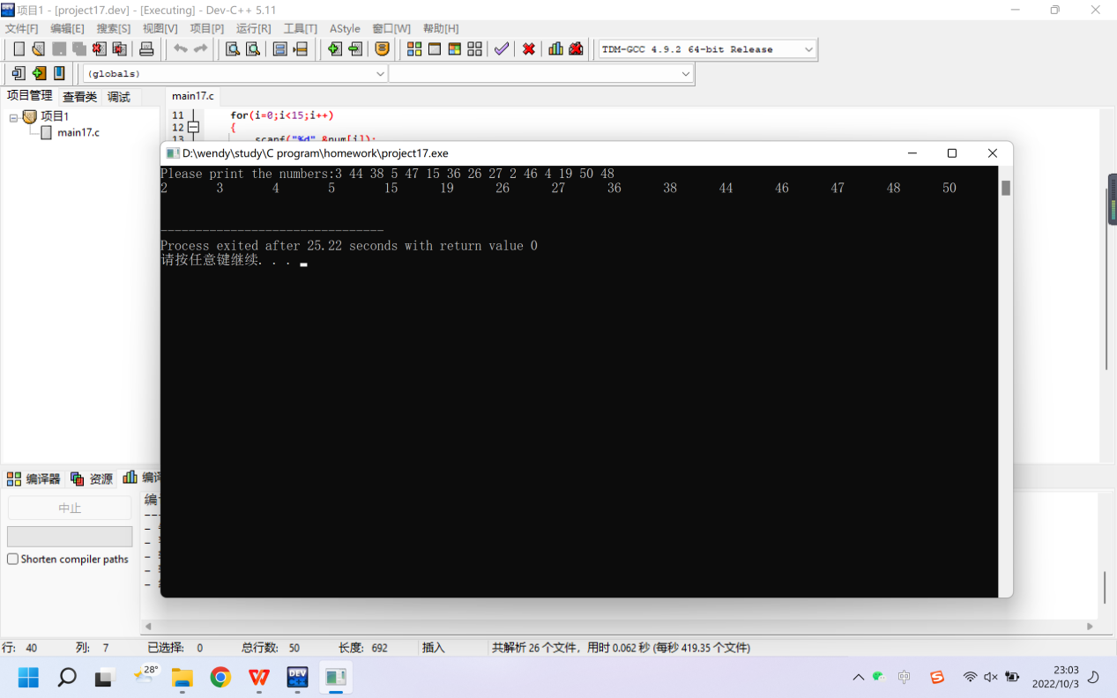

6. (bonus) There are 100 lights (numbered 1 ~ n), the 1st person turns on all lights; the 2nd person presses all switches numbered in multiples of 2; the 3rd person presses all switches numbered in multiples of 3; the 4th person presses all switches numbered in multiples of 4 ………… There are 100 people in total. Which lights are on in the end?
a) When a person presses the switch of a light, the light will be turned on if it was off or turned off if it was on
b) Print the index of lights which are on in the end
c) Multiples of 3 means 3, 6, 9, 12, 15, 18 …; multiples of 5 means 5, 10, 15, 20, …

Project：
#include <stdio.h>
#include <stdlib.h>

/* run this program using the console pauser or add your own getch, system("pause") or input loop */

int main(int argc, char *argv[]) {

int a[101];
int i,t;
//所有灯关闭
for(i=1;i<=100;i++)
{
a[i]=0;
}
//开关灯
for(i=1;i<=100;i++)
{
for(t=1;t<=100;t++)
{
if(i%t==0)
{
a[i]=1-a[i];
}
}
}
printf("The lights below are on:");
//输出开灯的灯
for(i=1;i<=100;i++)
{
if(a[i]==1)
{
printf("%d\t",i);
}
}
return 0;
}
