C程序设计基础作业-2022.10.09-12210159应逸雯
1.
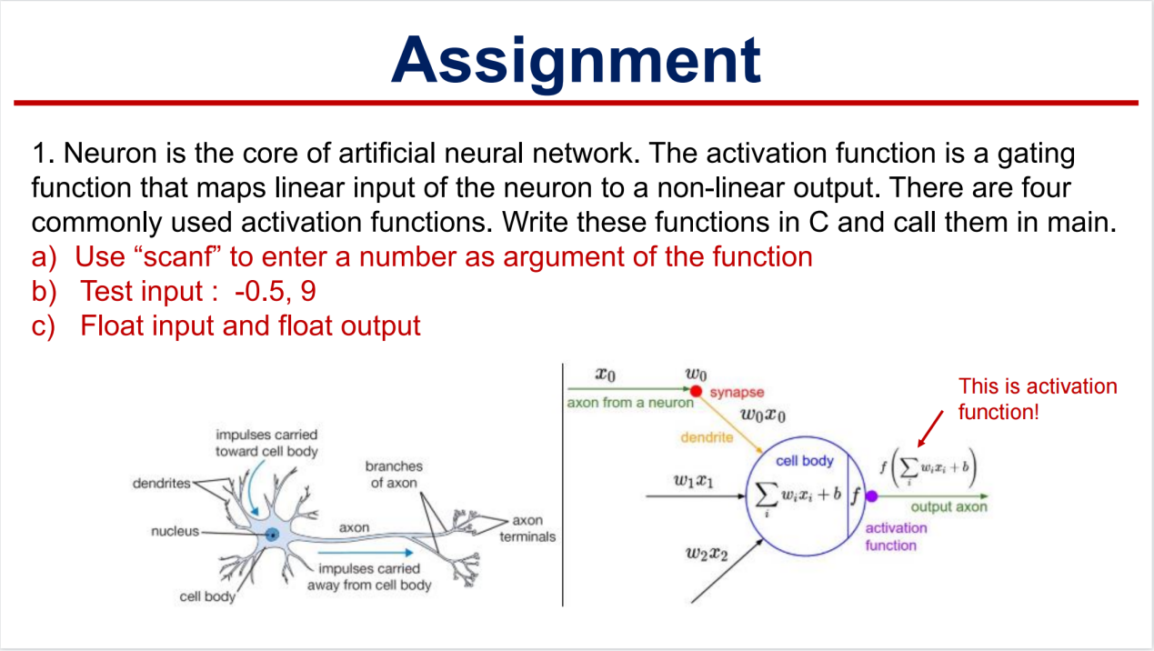
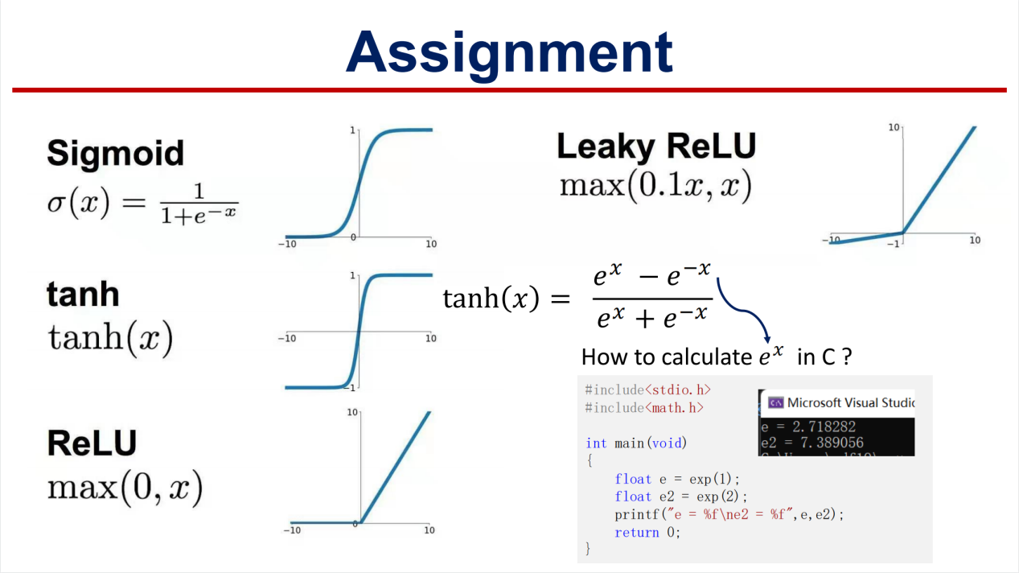

Project：
#include <stdio.h>
#include <stdlib.h>
#include <math.h>
/* run this program using the console pauser or add your own getch, system("pause") or input loop */

float sigmoid(float num)
{
float dividend=exp(num);
float divisor=exp(num)+1;
return dividend/divisor;
}

float tanh1(float num)
{
float dividend=exp(num*2)-1;
float divisor=exp(num*2)+1;
return dividend/divisor;
}

float ReLU(float num)
{
return num>0?num:0;
}

float Leaky_ReLU(float num)
{
float i=0.1*num;
return num>i?num:i;
}

int main(int argc, char *argv[]) {

float num;
printf("Please enter a number:");
scanf("%f",&num);
printf("sigmoid of %f is %f\n",num,sigmoid(num)) ;
printf("tanh of %f is %f\n",num,tanh1(num)) ;
printf("ReLU of %f is %f\n",num,ReLU(num)) ;
printf("Leaky_ReLU of %f is %f\n",num,Leaky_ReLU(num)) ;

return 0;
}
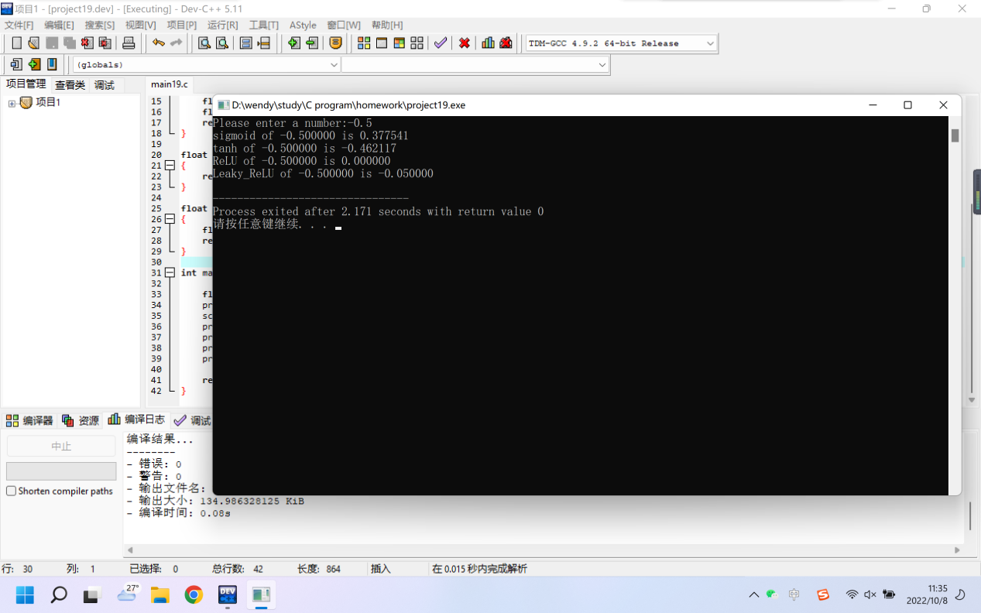
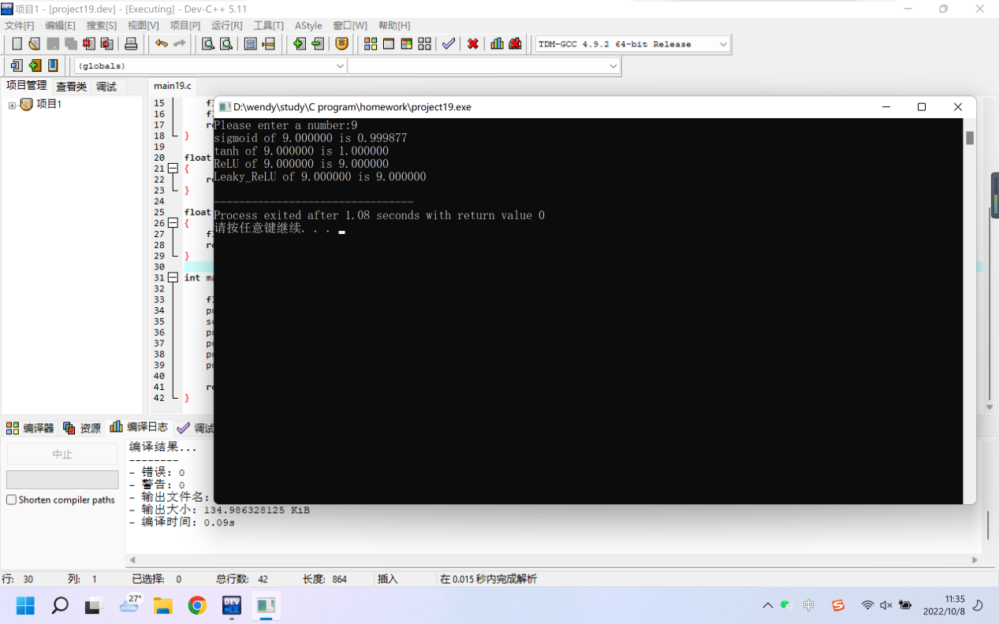

2.
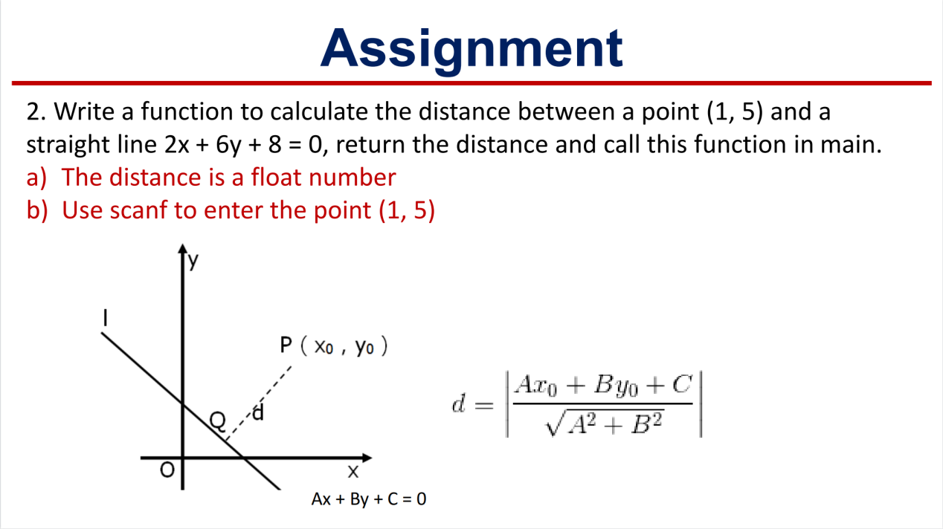

Project：
#include <stdio.h>
#include <stdlib.h>
#include <math.h>
/* run this program using the console pauser or add your own getch, system("pause") or input loop */

float distance(float i,float j)
{
float dividend=2*i+6*j+8;
float divisor=sqrt(40);
float d;
d=dividend/divisor;
if(d<0){d=-d;}
return d;
}

int main(int argc, char *argv[]) {
printf("Where is the point?");
float i,j;
scanf("%f,%f",&i,&j);
printf("The distance is from 2x+6y+8=0 to (%f,%f) is%f.",i,j,distance(i,j));
return 0;
}
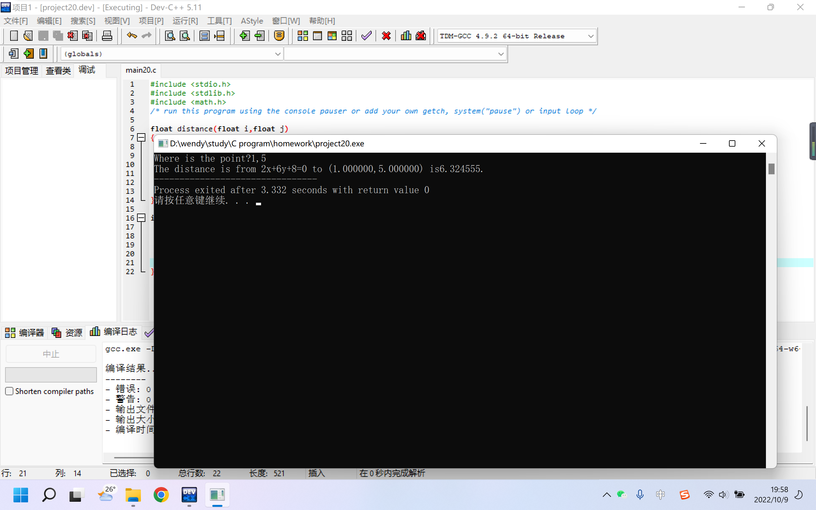

3.
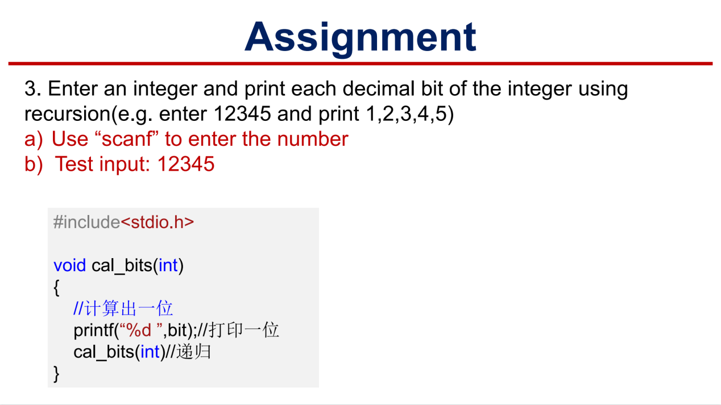

Project：
#include <stdio.h>
#include <stdlib.h>

/* run this program using the console pauser or add your own getch, system("pause") or input loop */

int index1(int i)
{
int m=0;
while(i!=0)
{
m++;
i=i/10;
}
return m;
}

int cal_bits(int i)
{
//计算
int bit;
int t=1;
int k=index1(i);
for(;k>1;k--)
{
t=10*t;
}
bit=i/t;//输出的数
i=i-bit*t;//剩下的数
//打印
printf("%d\t",bit);
//递归
if(i!=0)
{
cal_bits(i);
}
}

int main(int argc, char *argv[]) {
printf("Please enter the number:");
int num;
scanf("%d",&num);
printf("The result is:\n");
cal_bits(num);
return 0;
}

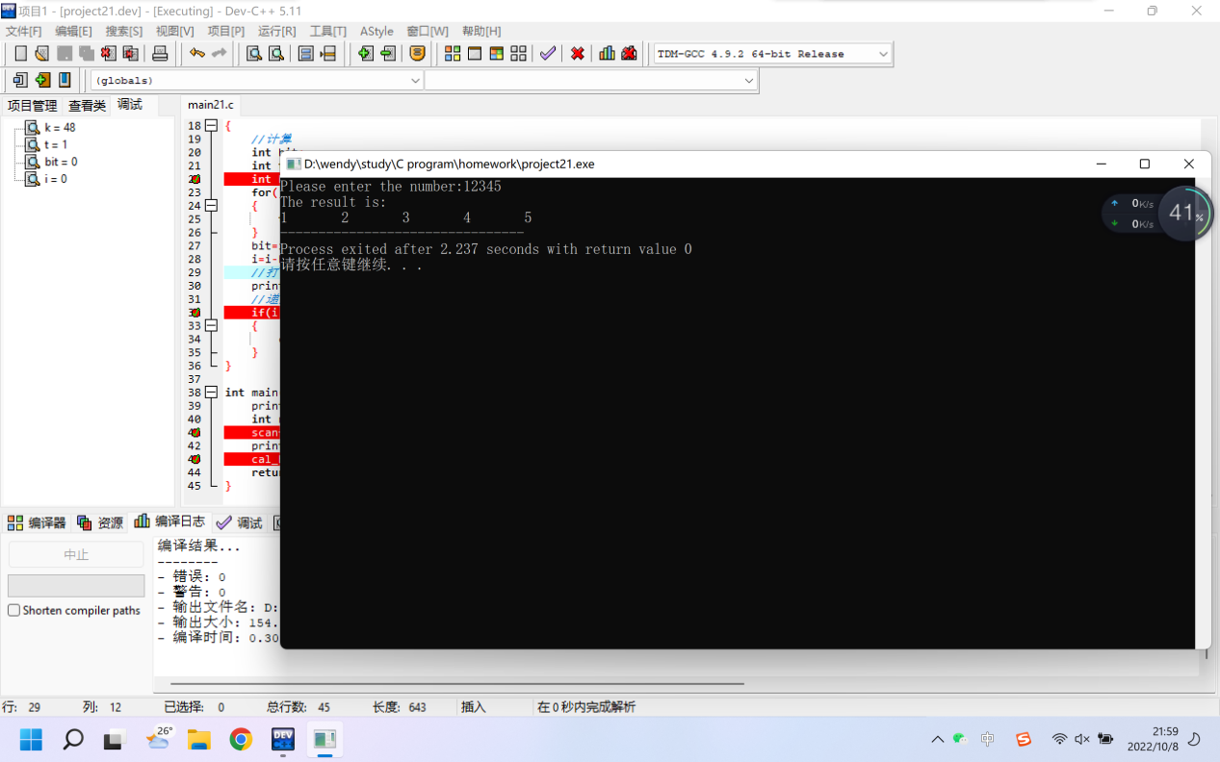

4.
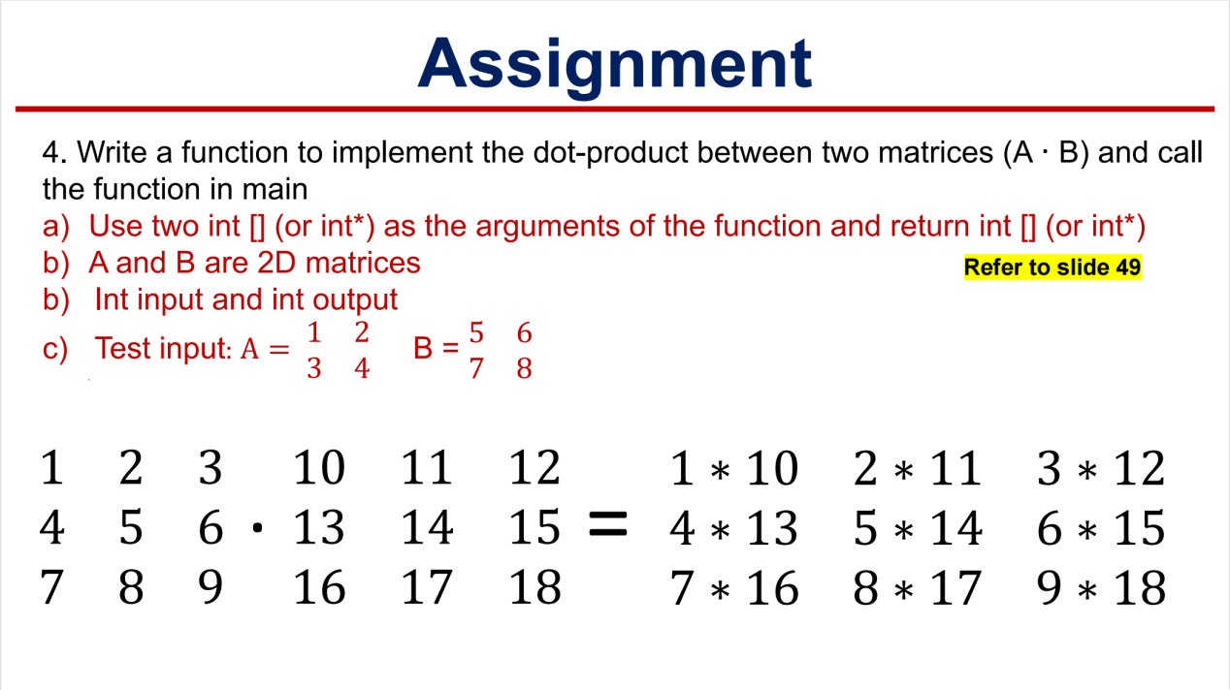

Project：
#include <stdio.h>
#include <stdlib.h>

/* run this program using the console pauser or add your own getch, system("pause") or input loop */

int product(int m[2][2],int n[2][2])
{
int i,j;
for(i=0;i<2;i++)
{
for(j=0;j<2;j++)
{
printf("%d\t",m[i][j]*n[i][j]);
}
printf("\n");
}
}

int main(int argc, char *argv[]) {
int a[2][2];
int b[2][2];
printf("Please enter matrix A:\n");
scanf("%d %d %d %d",&a[0][0],&a[0][1],&a[1][0],&a[1][1]);
printf("Please enter matrix B:\n");
scanf("%d %d %d %d",&b[0][0],&b[0][1],&b[1][0],&b[1][1]);
printf("The result is:\n");
product(a,b);
return 0;
}

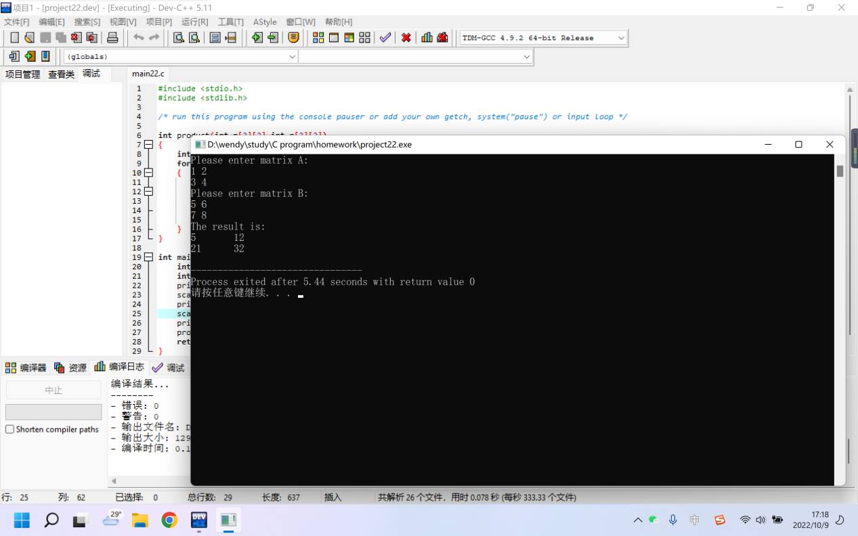

5.
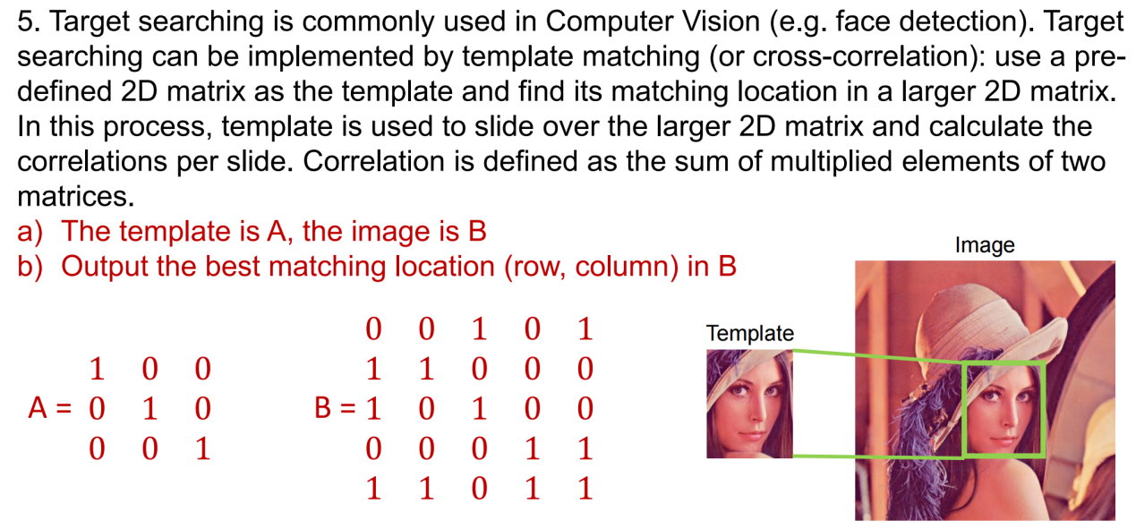

Project：
#include <stdio.h>
#include <stdlib.h>

/* run this program using the console pauser or add your own getch, system("pause") or input loop */

int search(int a[3][3],int b[5][5]);
float correlation(int a[3][3],int b[5][5],int i,int j);

int main(int argc, char *argv[]) {
int a[3][3];
int i,j;
printf("Please enter matrix A:\n");
for(i=0;i<3;i++)
{
for(j=0;j<3;j++)
{
scanf("%d",&a[i][j]);
}
}
printf("Please enter matrix B:\n");
int b[5][5];
for(i=0;i<5;i++)
{
for(j=0;j<5;j++)
{
scanf("%d",&b[i][j]);
}
}
int t;
t=search(a,b);
printf("The most related location is:\n");
printf("row: %d to %d\ncolumn: %d to %d\n",(t/10+1),(t/10+3),(t%10+1),(t%10+3));
printf("which is:\n");
for(i=0;i<3;i++)
{
for(j=0;j<3;j++)
{
printf("%d\t",b[t/10+i][t%10+j]);
}
printf("\n");
}
return 0;
}

int search(int a[3][3],int b[5][5])
{
float c[3][3];
int i,j;
for(i=0;i<=2;i++)
{
for(j=0;j<=2;j++)
{
c[i][j]=(float)correlation(a,b,i,j);
}
}
float max=0;
int t=-1;
for(i=0;i<=2;i++)
{
for(j=0;j<=2;j++)
{
if(c[i][j]>max)
{
max=c[i][j];
t=i*10+j;
}
}
}
return t;
}

float correlation(int a[3][3],int b[5][5],int i,int j)
{
int sum=0;
int m,n;
int divisor=0;
for(m=0;m<=2;m++)
{
for(n=0;n<=2;n++)
{
int p=m+i;
int q=n+j;
sum+=a[p][q]*b[p][q];
divisor+=b[p][q];
}
}
return (float)sum/divisor;
}

