C程序设计基础作业-2022.10.14-12210159应逸雯

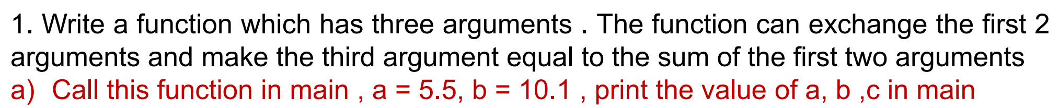

Project：
#include <stdio.h>
#include <stdlib.h>

/* run this program using the console pauser or add your own getch, system("pause") or input loop */

float function(float *a,float *b,float *sum);

int main(int argc, char *argv[]) {
printf("Please type the arguments:\n");
float a,b,sum;
scanf("%f %f",&a,&b);
// printf("a = %f\n",a);
// printf("b = %f\n",b);
function(&a,&b,&sum);
printf("a = %f\n",a);
printf("b = %f\n",b);
printf("sum = %f\n",sum);
return 0;
}

float function(float *a,float *b,float *sum)
{
float temp;
temp=*a;
*a=*b;
*b=temp;
*sum=*a+*b;
}

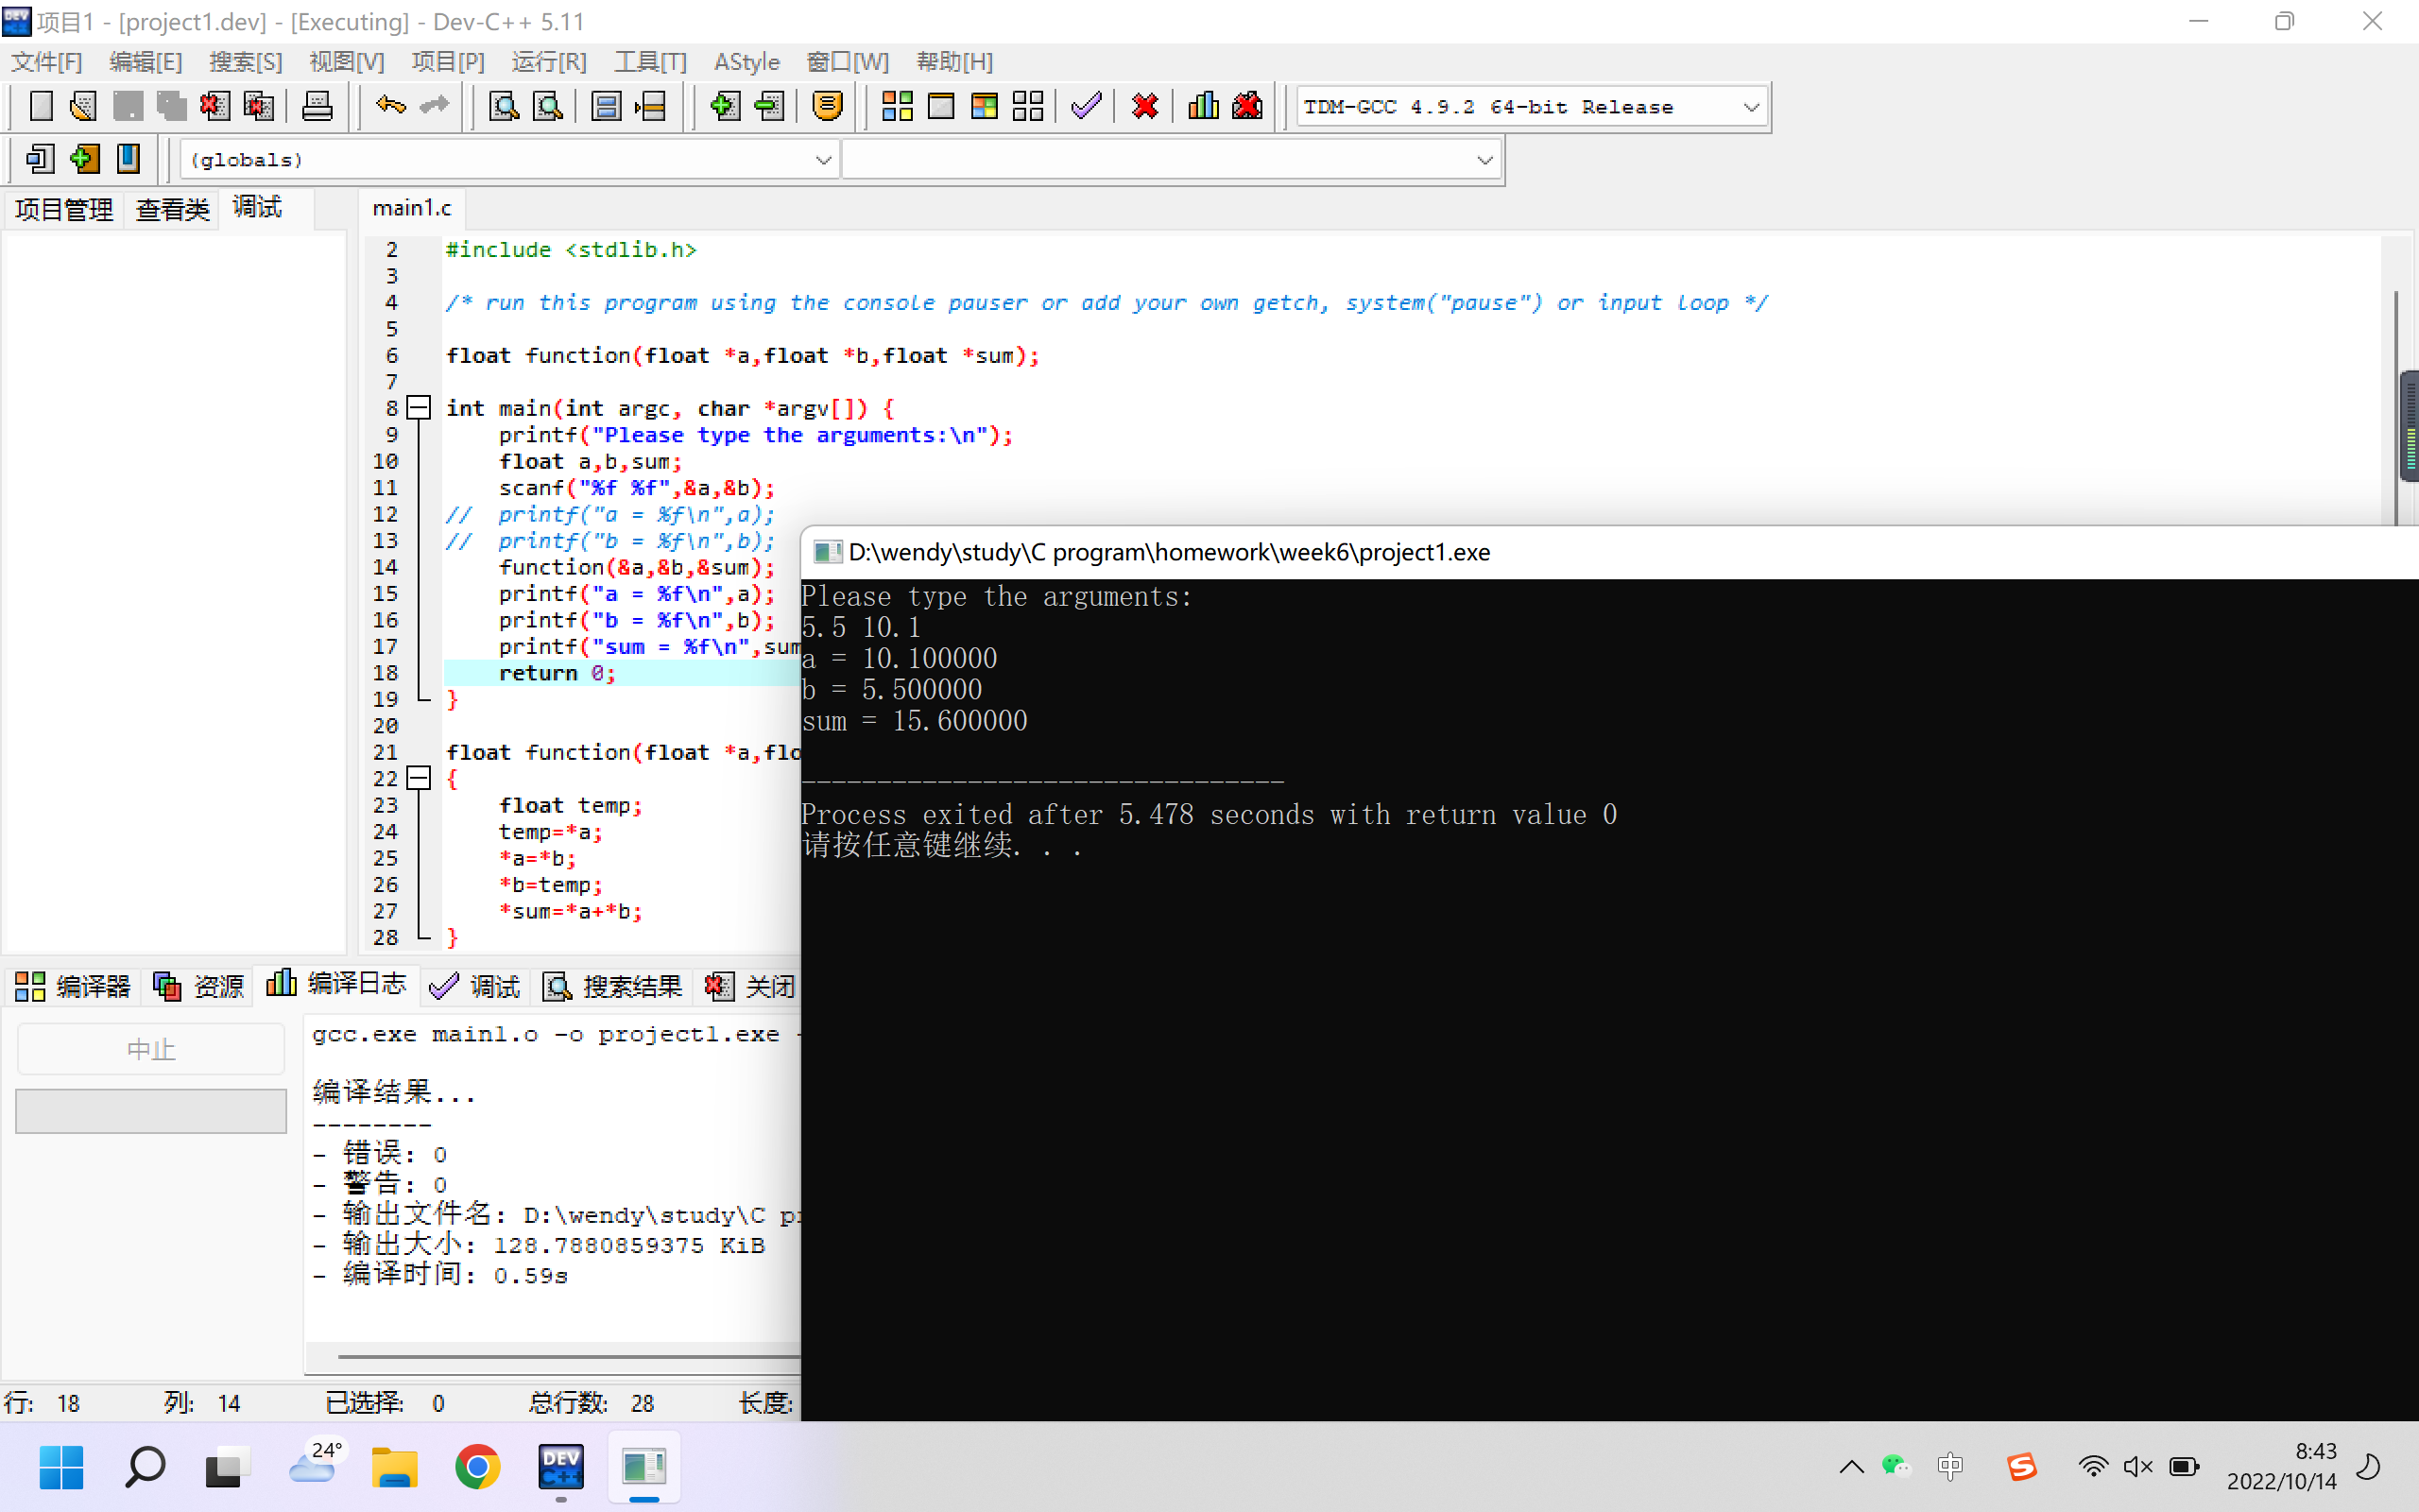

2.
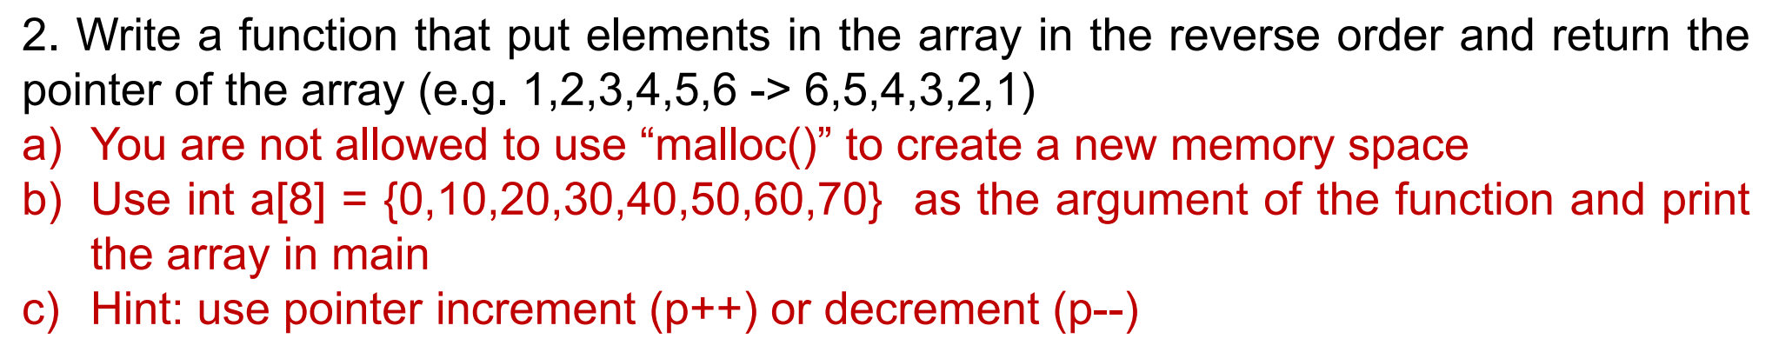

Project：

#include <stdio.h>
#include <stdlib.h>

/* run this program using the console pauser or add your own getch, system("pause") or input loop */

int reverse(int *a,int t);

int main(int argc, char *argv[]) {
int a[8]={0,10,20,30,40,50,60,70};
int t=sizeof(a)/4;
reverse(a,t);
int i;
for(i=0;i<sizeof(a)/4;i++)
{
printf("%d\t",a[i]);
}
return 0;
}

int reverse(int *a,int t)
{
int i;
i=t-1;
int j=0;
int temp;
for(;i>j;i--,j++)
{
temp=a[i];
a[i]=a[j];
a[j]=temp;
}
}
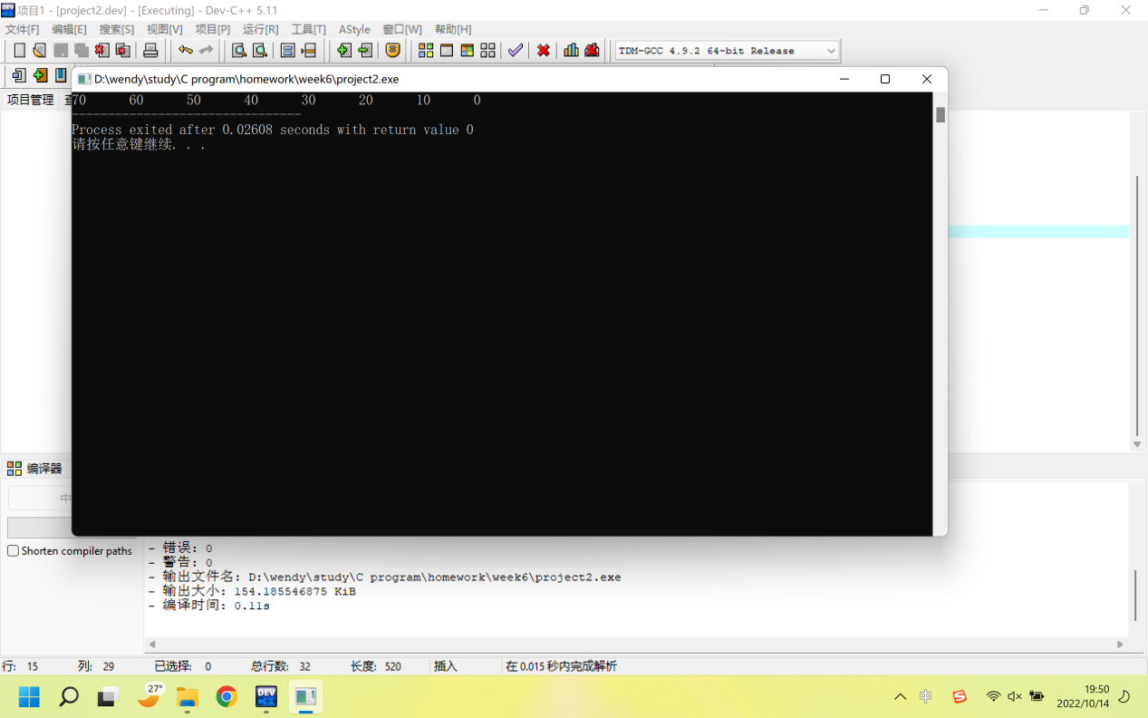

3.
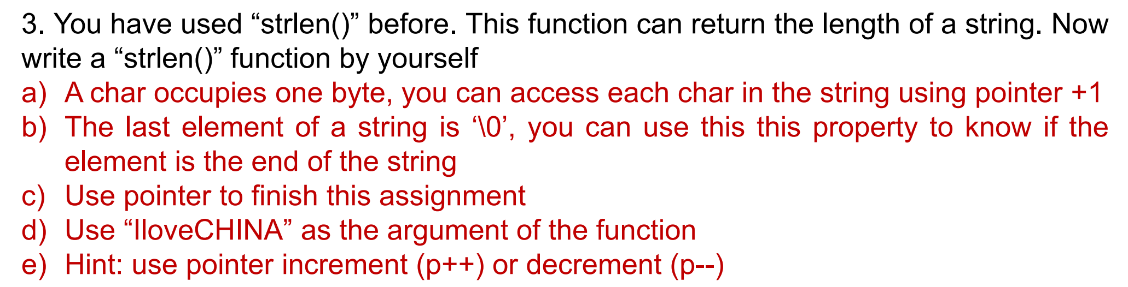

Project：

#include <stdio.h>
#include <stdlib.h>
#include <math.h>
/* run this program using the console pauser or add your own getch, system("pause") or input loop */

int length(char *a);

int main(int argc, char *argv[]) {
printf("Please type the words:\n");
char a[50];
scanf("%s",a);
printf("The length is %d.\n",length(a));
return 0;
}

int length(char *a)
{
int len=0;
char *i=a;
for(;*i!=0;i++)
{
len++;
}
return len;
}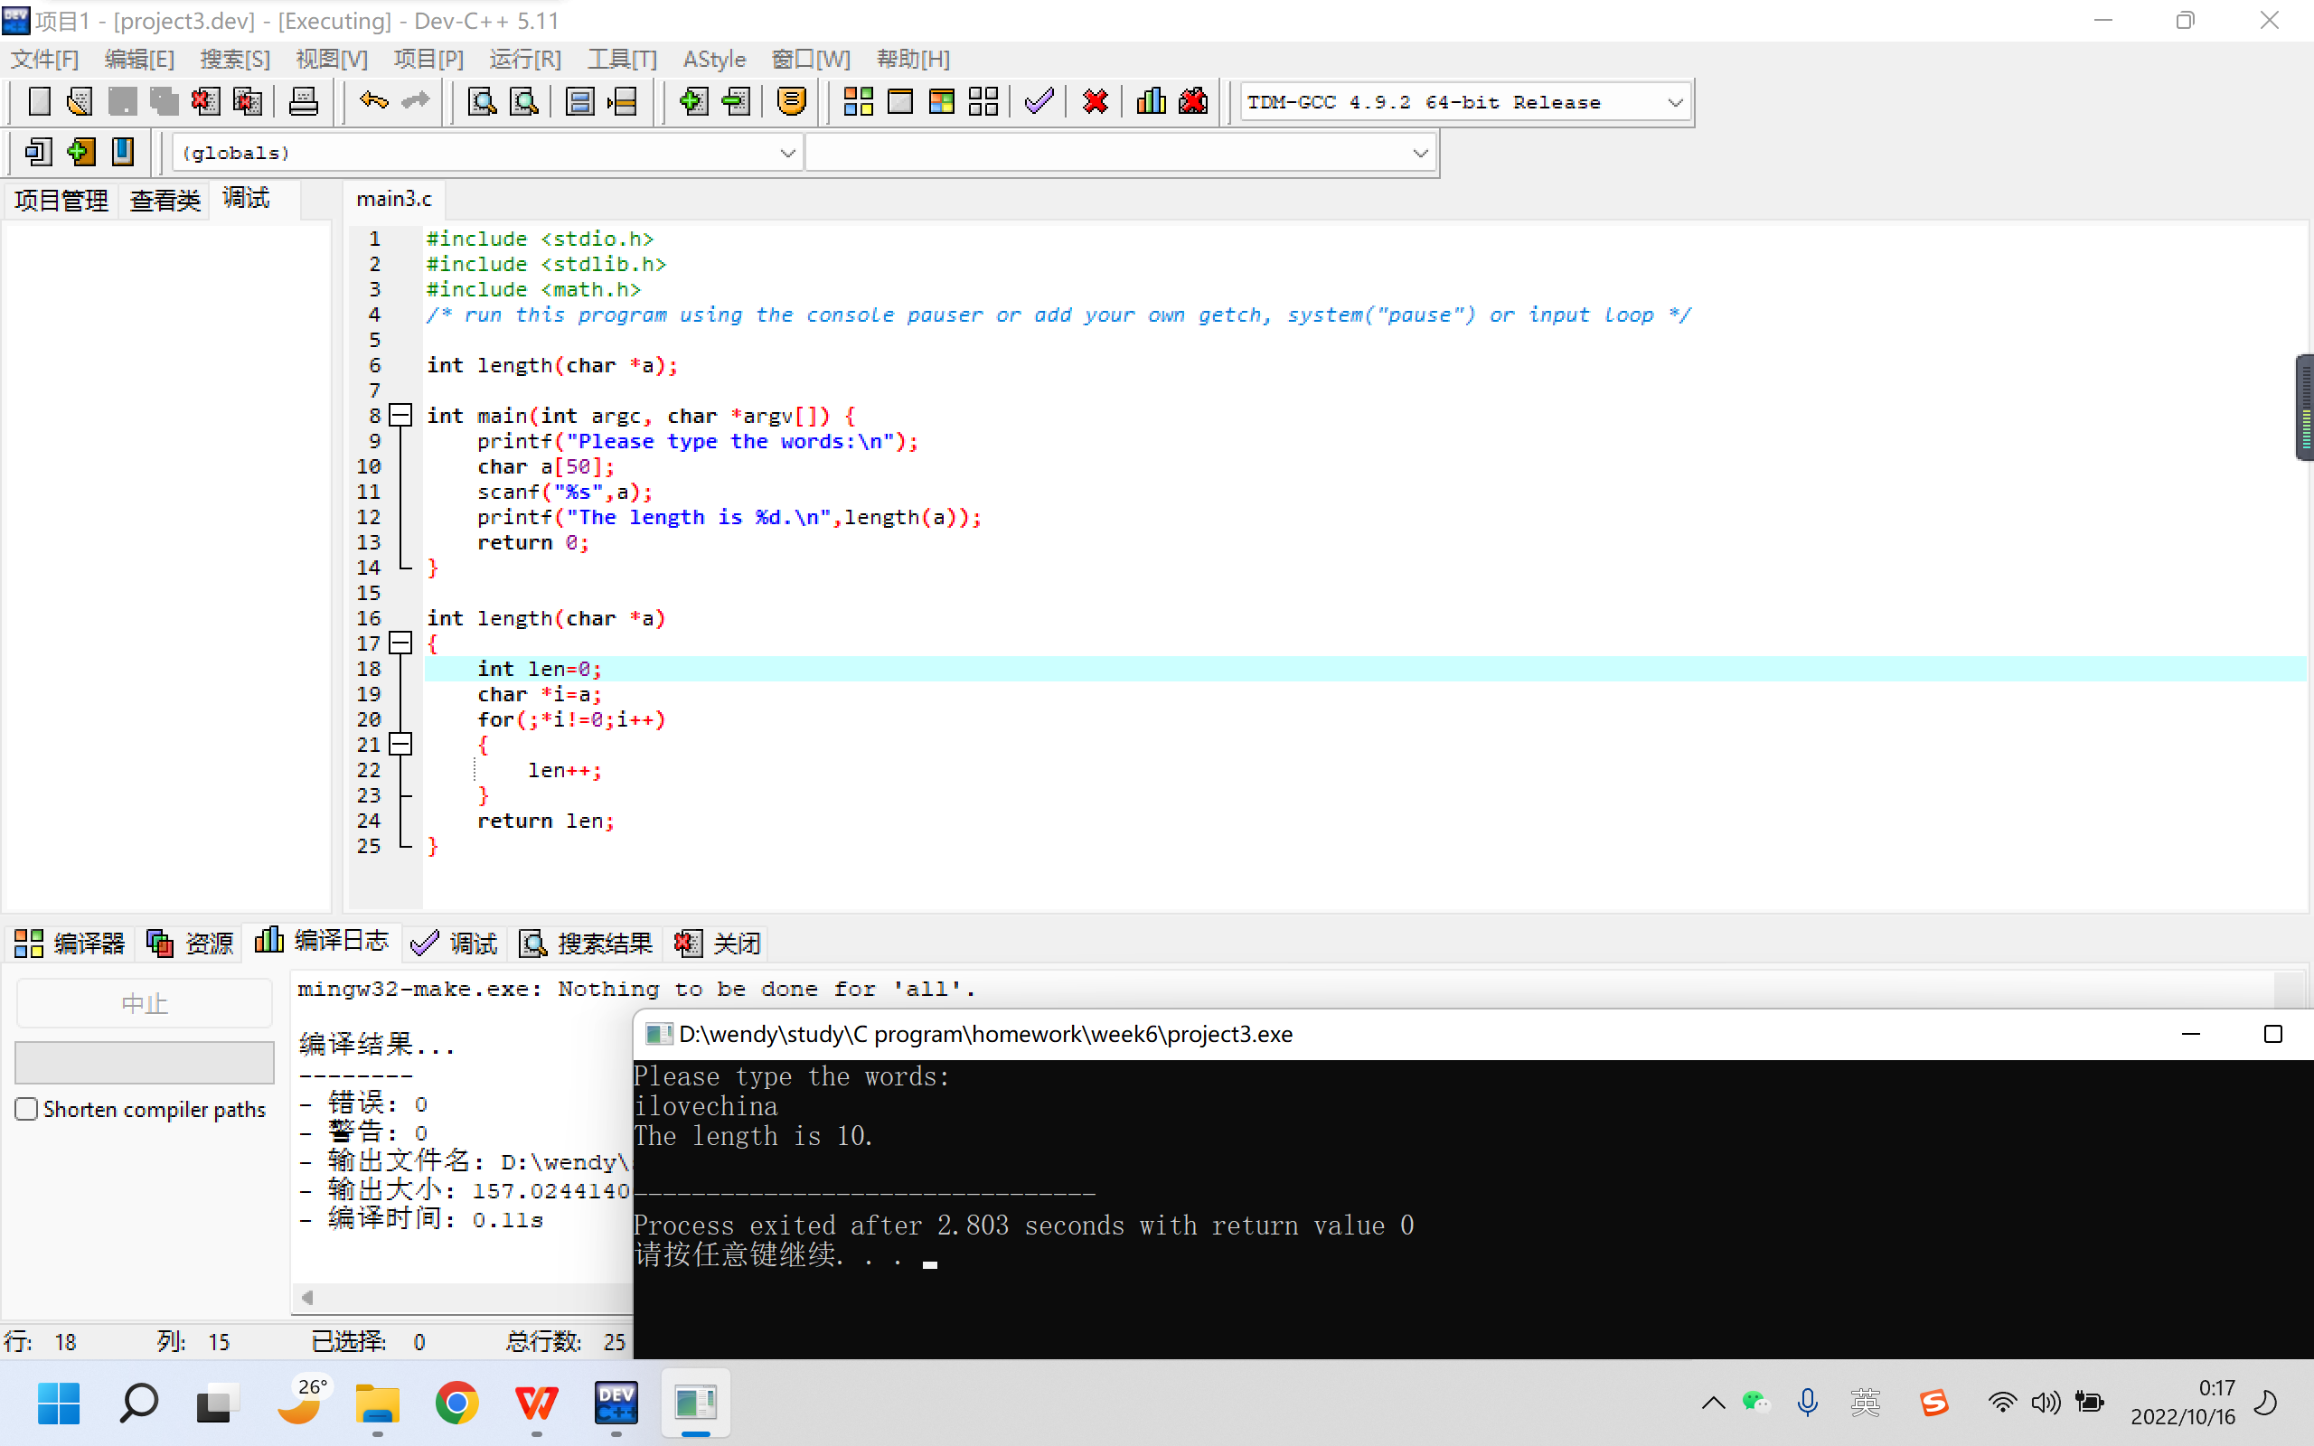

4.
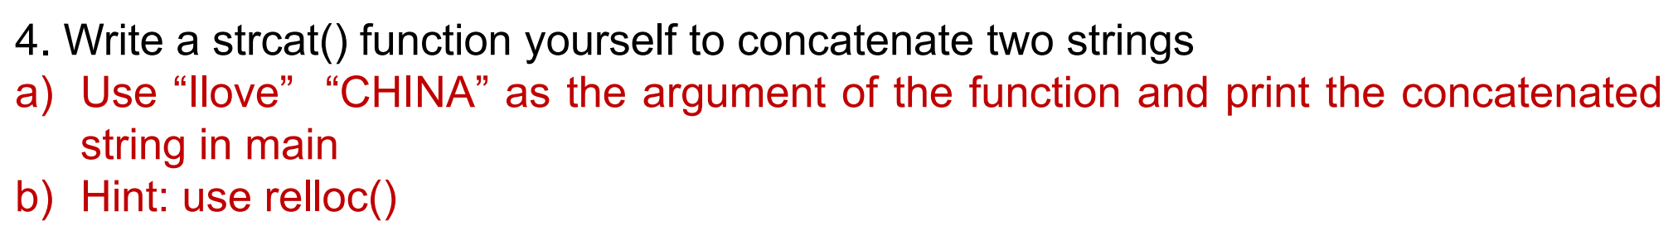

Project:

#include <stdio.h>
#include <stdlib.h>

/* run this program using the console pauser or add your own getch, system("pause") or input loop */

char strcat1(char *a,char *b,int i,char *c);

int main(int argc, char *argv[]){
char a[]="Ilove\0";
char b[]="CHINA\0";
int i;
i=sizeof(a)+sizeof(b);
char c[20];
strcat1(&a,&b,i,c);
printf("The result is %s.",c);
return 0;
}

char strcat1(char *a,char *b,int i,char *c)
{
int p=0;
int t;
for(t=0;a[t]!=0;t++)
{
c[p]=a[t];
p++;
}
for(t=0;b[t]!=0;t++)
{
c[p]=b[t];
p++;
}
}

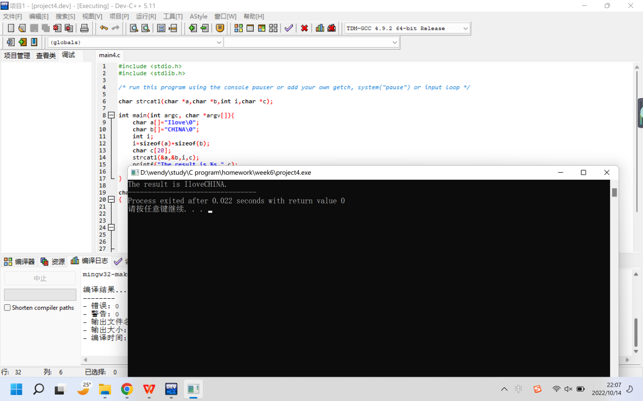

5.
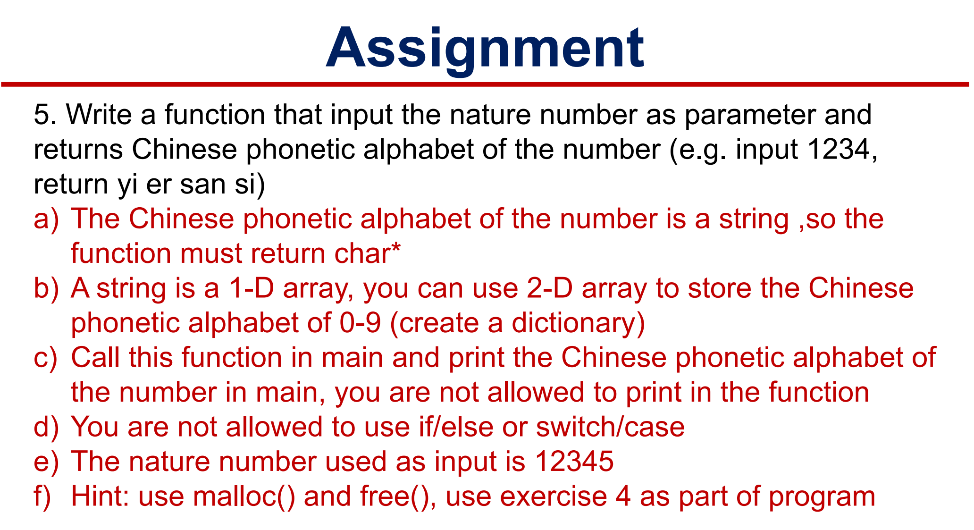

Project：

#include <stdio.h>
#include <stdlib.h>
#include <string.h>

/* run this program using the console pauser or add your own getch, system("pause") or input loop */

#define MAX 6

int chinese(char *dest, int num);

int main(int argc, char *argv[]) {
int Len, Val;
char *Buf;
printf("How many numbers do you want to type: ");
scanf("%d",&Len);
printf("Please type the numbers: ");
scanf("%d",&Val);
Buf = (char *)malloc(Len*MAX*sizeof(char));
chinese(Buf, Val);
printf("Result = [%s]\n", Buf);
free(Buf);
return 0;
}

char * strcat2(char *a, const char *b)
{
char *save = a;
while((*a))
a++;
while(((*a++)=(*b++))!=0)
return save;
}

int chinese(char *dest, int num)
{
char *Table[10] = {" gniL", " iY", " rE", " naS", " iS", " uW", " uiL", " iQ", " aB", " uiJ"};
*dest = 0;
int cur;
do
{
cur = num % 10;
num = num / 10;
strcat2(dest, Table[cur]);
} while(num != 0);

char *Tmp;
int StrLen;
int i;
StrLen = strlen(dest);
Tmp = (char *)malloc(StrLen);
for(i=StrLen-1; i>=0; i--)
{
Tmp[StrLen-1-i]=dest[i];
}
Tmp[StrLen-1]= 0;
strcpy(dest, Tmp);
free(Tmp);

return 1;
}

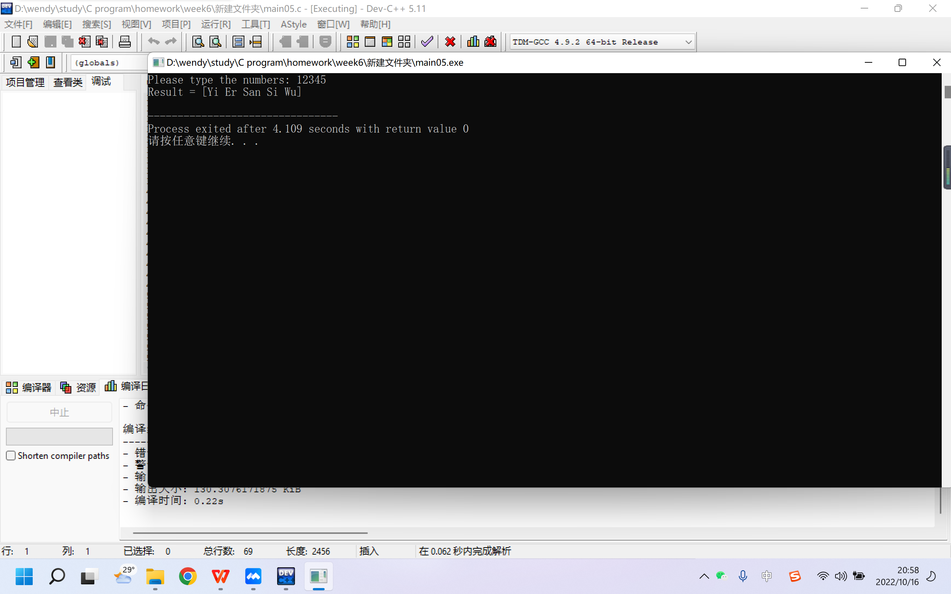

6.
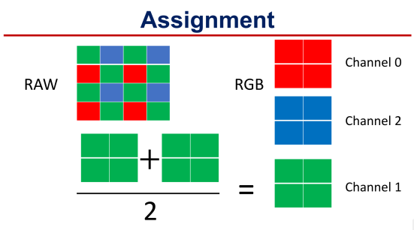
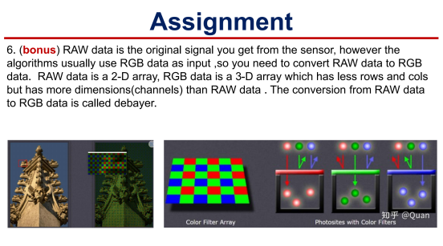

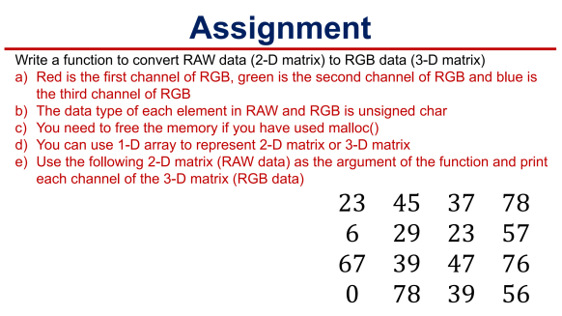
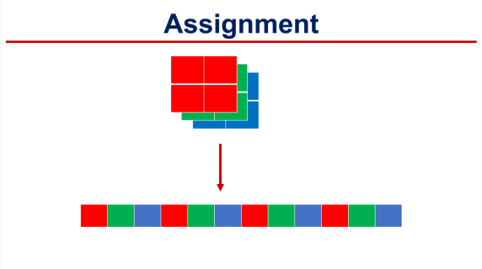

Project：
#include <stdio.h>
#include <stdlib.h>

/* run this program using the console pauser or add your own getch, system("pause") or input loop */

int transfer(int *raw,int *rgb);

int main(int argc, char *argv[]) {

//输入raw
printf("Please type the matrix:\n");
int raw[16];
int m,n;
for(m=0;m<4;m++)
{
for(n=0;n<4;n++)
{
scanf("%d",&raw[m*4+n]);
}
}

//变成RGB
int rgb[12];
transfer(raw,rgb);

//打印RGB
printf("The result is:\n");
for(m=0;m<2;m++)
{
for(n=0;n<2;n++)
{
printf("r%dg%db%d\t",rgb[m*6+n*3+0],rgb[m*6+n*3+1],rgb[m*6+n*3+2]);
}
printf("\n");
}

return 0;
}

int transfer(int *raw,int *rgb)
{
int m,n;
for(m=0;m<4;m=m+2)
{
for(n=0;n<4;n=n+2)
{
int i,j;
i=m/2;
j=n/2;
rgb[6*i+j*3+0]=raw[(m+1)*4+n];
rgb[6*i+j*3+1]=(raw[m*4+n]+raw[(m+1)*4+n+1])/2;
rgb[6*i+j*3+2]=raw[m*4+n+1];
}
}
}

