C程序设计基础作业-2022.10.21-12210159应逸雯

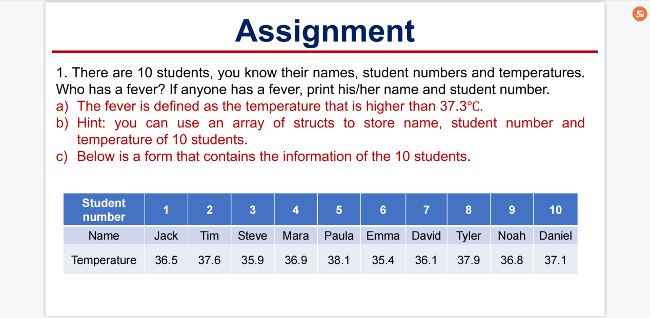

Project:
#include <stdio.h>
#include <stdlib.h>

/* run this program using the console pauser or add your own getch, system("pause") or input loop */

int main(int argc, char *argv[]) {

struct student
{
char name[20];
float temperature;
};

struct student stu[10]={{"Jack",36.5},{"Tim",37.6},{"Steve",35.9},{"Mara",36.9},{"Paula",38.1},{"Emma",35.4},{"David",36.1},{"Tyler",37.9},{"Noah",36.8},{"Daniel",37.1}};

struct student *p=stu;
printf("The students who have a fever are:\n");
int i;
for(i=0;i<10;i++)
{
if(p->temperature>37.3)
{
printf("Name:%s\t",p->name);
printf("Number:%d\n",i+1);
}
p++;
}

return 0;
}

Running screenshot:
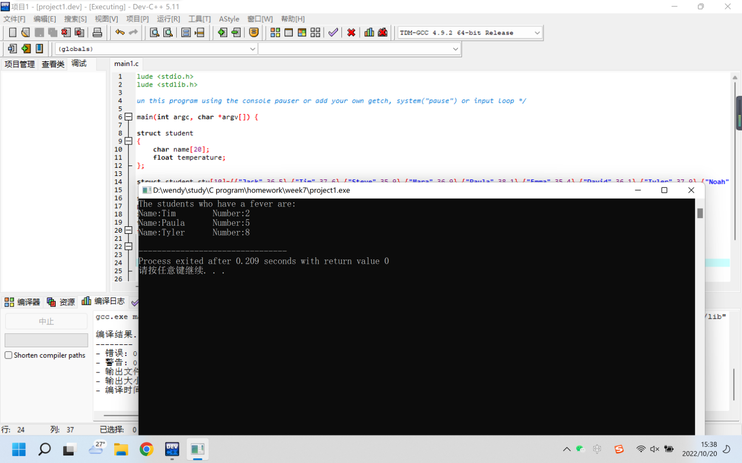

2.
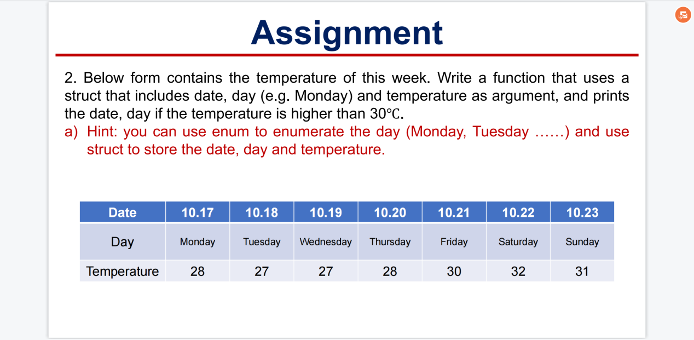

Project:
#include <stdio.h>
#include <stdlib.h>

/* run this program using the console pauser or add your own getch, system("pause") or input loop */

int main(int argc, char *argv[]) {

struct weather
{
int date;
char day[10];
int temperature;
};

enum week {Monday=0,Tuesday,Wednesday,Thursday,Friday,Saturday,Sunday};

struct weather weather[7]={
{17,"Monday",28},
{18,"Tuesday",27},
{19,"Wednesday",27},
{20,"Thurday",28},
{21,"Friday",30},
{22,"Saturday",32},
{23,"Sunday",31}
};

struct weather *p=weather;
printf("Hot days are:\n");
int i;
for(i=Monday;i<=Sunday;i++)
{
if(p->temperature>30)
{
printf("Date:10.%d\t",p->date);
printf("Day:%s\n",p->day);
}
p++;
}

return 0;
}

Running screenshot:
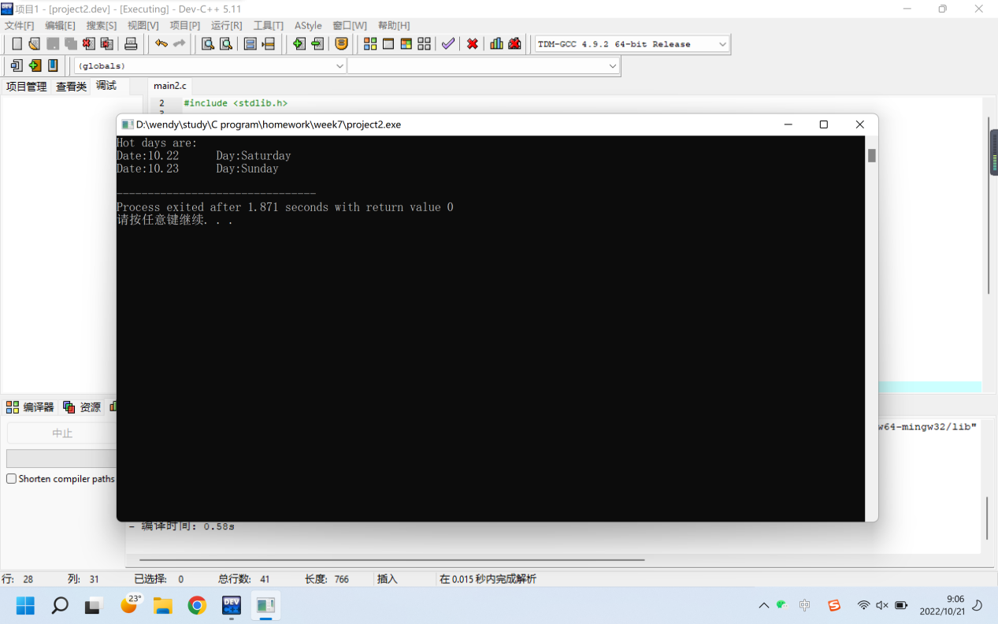

3.
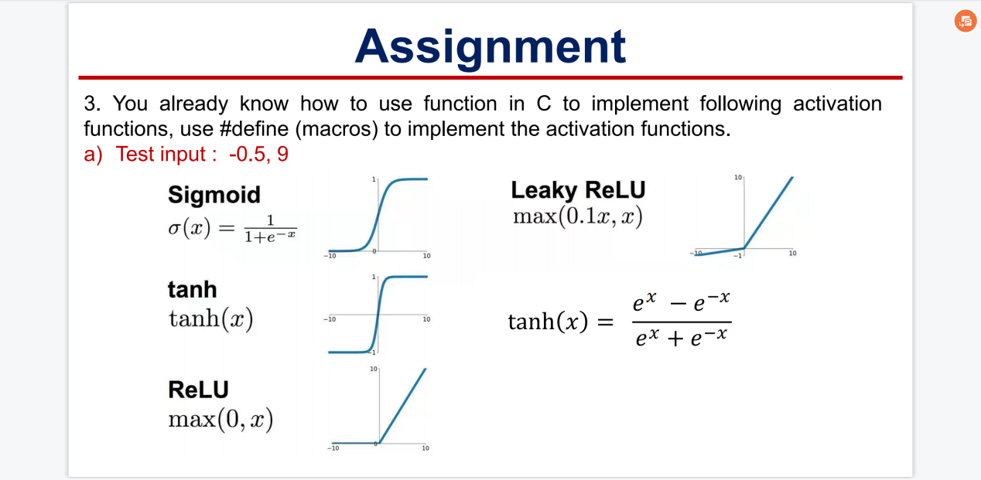

Project:
#include <stdio.h>
#include <stdlib.h>
#include <math.h>
/* run this program using the console pauser or add your own getch, system("pause") or input loop */

#define sigmoid(num) (exp(num)/(exp(num)+1))

#define tanh1(num) ((exp(num*2)-1)/(exp(num*2)+1))

#define ReLU(num) (num>0?num:0)

#define Leaky_ReLU(num) (num>0.1*num?num:0.1*num)

int main(int argc, char *argv[]) {

float num;
printf("Please enter a number:");
scanf("%f",&num);
printf("sigmoid of %f is %f\n",num,sigmoid(num)) ;
printf("tanh of %f is %f\n",num,tanh1(num)) ;
printf("ReLU of %f is %f\n",num,ReLU(num)) ;
printf("Leaky_ReLU of %f is %f\n",num,Leaky_ReLU(num)) ;

return 0;
}

Running screenshot:
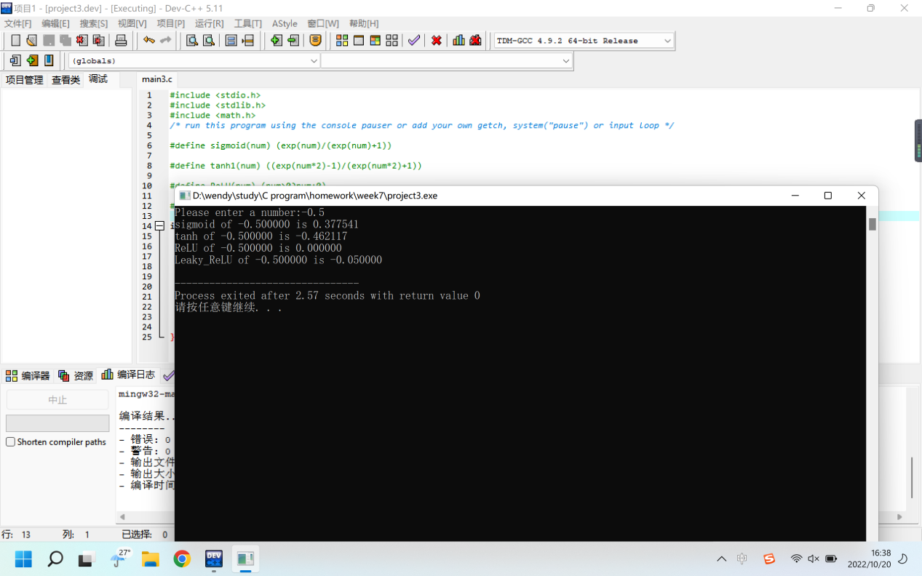

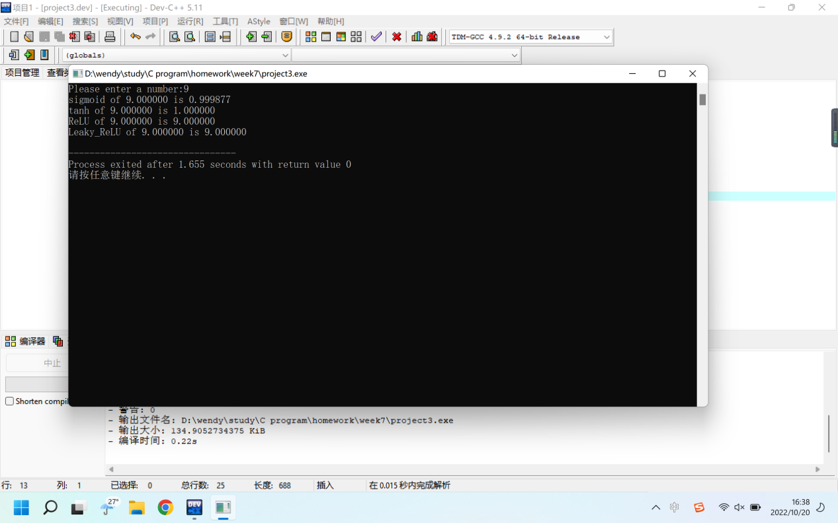

4.
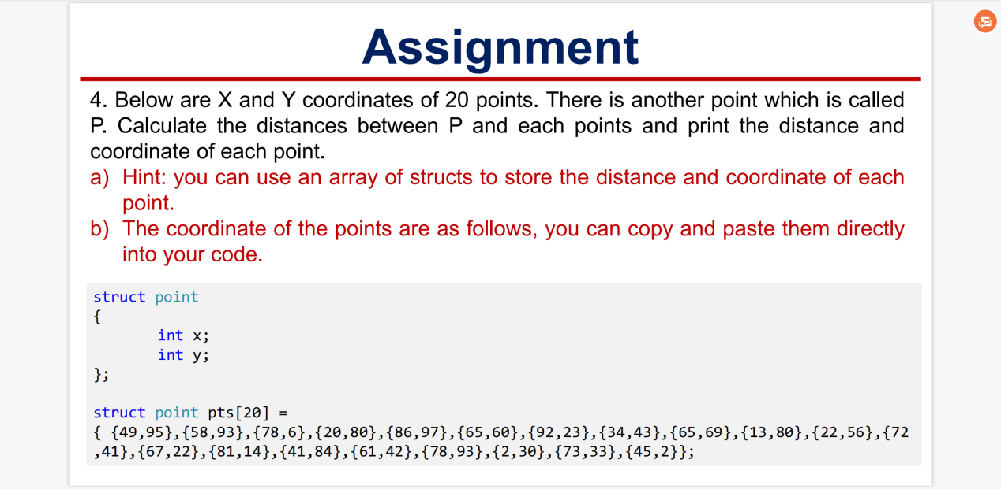

Project:
#include <stdio.h>
#include <stdlib.h>
#include <math.h>

/* run this program using the console pauser or add your own getch, system("pause") or input loop */

int main(int argc, char *argv[]) {

struct point
{
int x;
int y;
float distance;
};

struct point pts[20] = { {49,95},{58,93},{78,6},{20,80},{86,97},
{65,60},{92,23},{34,43},{65,69},{13,80},
{22,56},{72,41},{67,22},{81,14},{41,84},
{61,42},{78,93},{2,30},{73,33},{45,2}};

int i;
for(i=0;i<20;i++)
{
pts[i].distance=sqrt((40-pts[i].x)*(40-pts[i].x)+(65-pts[i].y)*(65-pts[i].y));
printf("The distance of P and point %d\t（%d,%d) is %f.\n",i+1,pts[i].x,pts[i].y,pts[i].distance);
}

return 0;
}

Running screenshot:
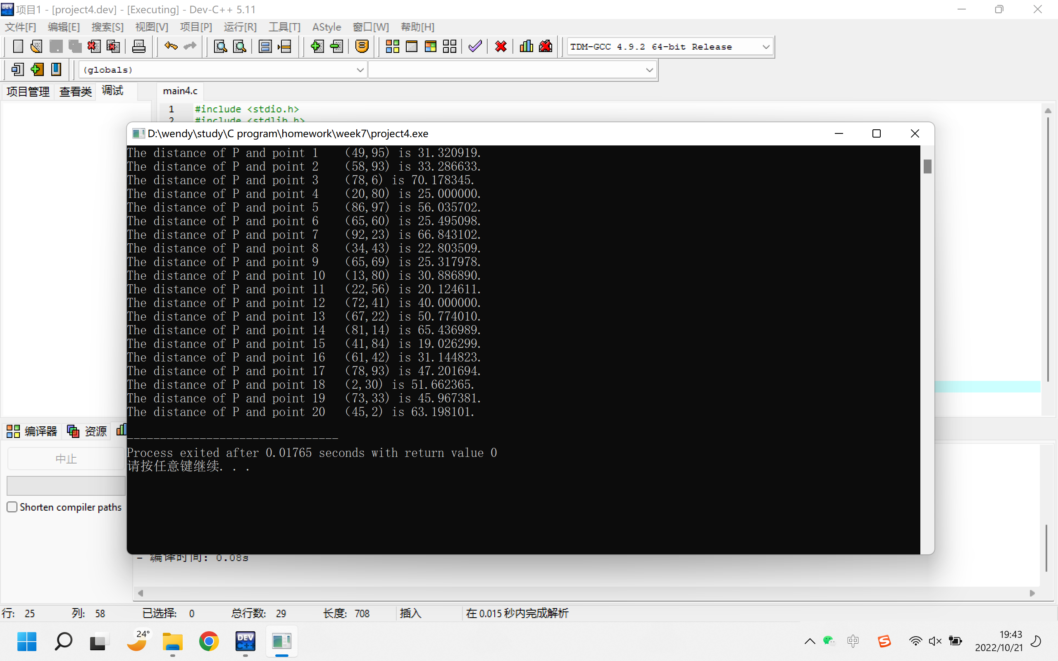

5.
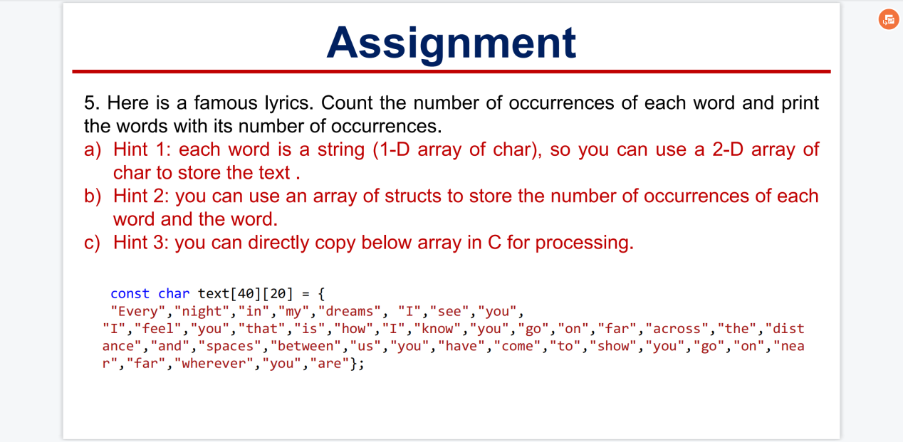

Project:
#include <stdio.h>
#include <stdlib.h>

/* run this program using the console pauser or add your own getch, system("pause") or input loop */

int main(int argc, char *argv[]) {

const char text[40][20] = {"Every","night","in","my","dreams", "I","see","you",
"I","feel","you","that","is","how","I","know","you","go","on","far","across",
"the","distance","and","spaces","between","us","you","have","come","to","show",
"you","go","on","near","far","wherever","you","are"};

char dictionary[40][20]={"Every","night","in","my","dreams","I","see","you",
"I","feel","you","that","is","how","I","know","you","go","on","far","across",
"the","distance","and","spaces","between","us","you","have","come","to","show",
"you","go","on","near","far","wherever","you","are"};

int occur[40];

int i,j;

for(i=0;i<40;i++)
{
occur[i]=1;
for(j=39;j>i;j--)
if(strcmp(dictionary[i],text[j])==0)
{
*dictionary[j]='z';
occur[i]++;
}
}

for(i=0;i<40;i++)
{
if(*dictionary[i]!='z')
{
printf("The word %s\toccurs %d times.\n",dictionary[i],occur[i]);
}
}

return 0;
}

Running screenshot:
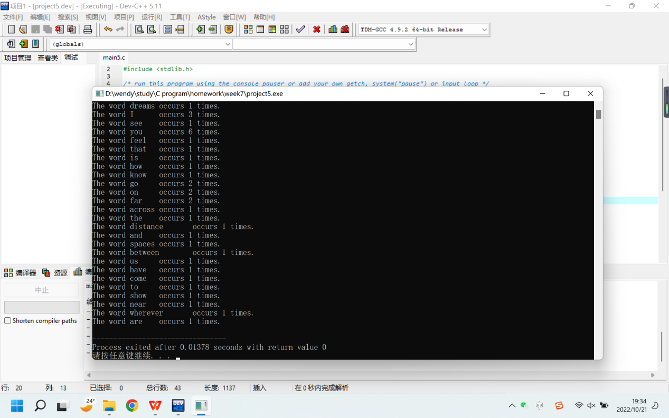

6.
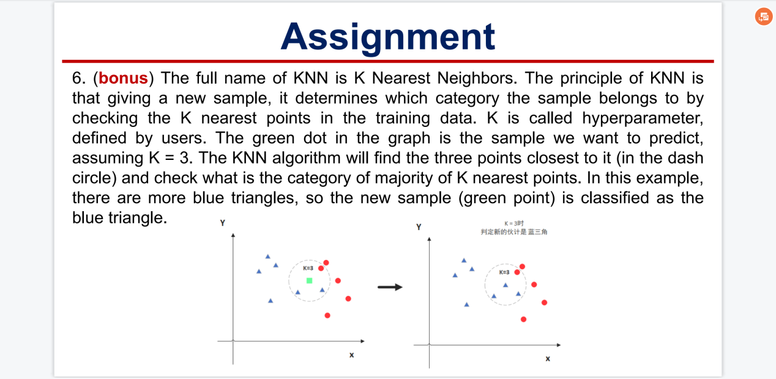
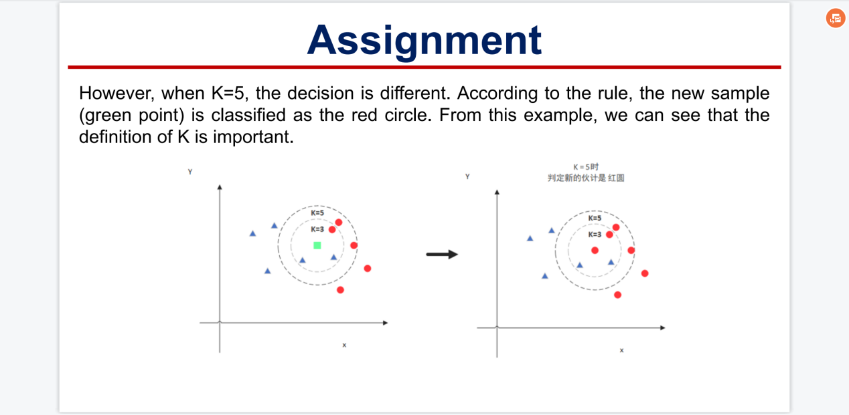
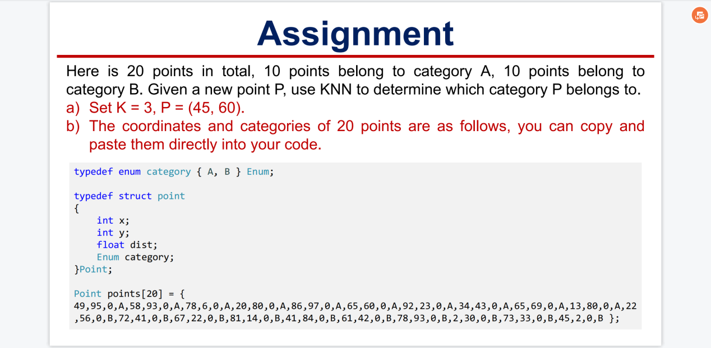

Project:
#include <stdio.h>
#include <stdlib.h>
#include <math.h>

/* run this program using the console pauser or add your own getch, system("pause") or input loop */

int main(int argc, char *argv[]) {

typedef enum category {A, B} Enum;
typedef struct point
{
int x;
int y;
float dist;
Enum category;
}Point;

Point points[20] = {49,95,0,A,58,93,0,A,78,6,0,A,20,80,0,A,
86,97,0,A,65,60,0,A,92,23,0,A,34,43,0,A,65,69,0,A,13,80,0,A,
22,56,0,B,72,41,0,B,67,22,0,B,81,14,0,B,41,84,0,B,61,42,0,B,
78,93,0,B,2,30,0,B,73,33,0,B,45,2,0,B};

int i;
for(i=0;i<20;i++)
{
points[i].dist=sqrt((45-points[i].x)*(45-points[i].x)+(60-points[i].y)*(60-points[i].y));
}

/* for(i=0;i<20;i++)
{
printf("%f\n",points[i].dist);
}
printf("\n");
*/
int m,n;
for(m=0;m<19;m++)
{
for(n=0;n<19-m;n++)
{
if(points[n].dist>points[n+1].dist)
{
float temp;
temp=points[n].dist;
points[n].dist=points[n+1].dist;
points[n+1].dist=temp;
temp=points[n].x;
points[n].x=points[n+1].x;
points[n+1].x=temp;
temp=points[n].y;
points[n].y=points[n+1].y;
points[n+1].y=temp;
Enum c=points[n].category;
points[n].category=points[n+1].category;
points[n+1].category=c;
}
}
}

/* for(i=0;i<20;i++)
{
printf("%f\n",points[i].dist);
}
*/

printf("P belongs to: ");
// printf("%d,%d,%d\n",points[0].category,points[1].category,points[2].category);

if(points[0].category+points[1].category+points[2].category>=2)
{
printf("B.\n");
}
else
{
printf("A.\n");
}

return 0;
}

Running screenshot:
