C程序设计基础作业-2022.10.28-12210159应逸雯
1.
Task:
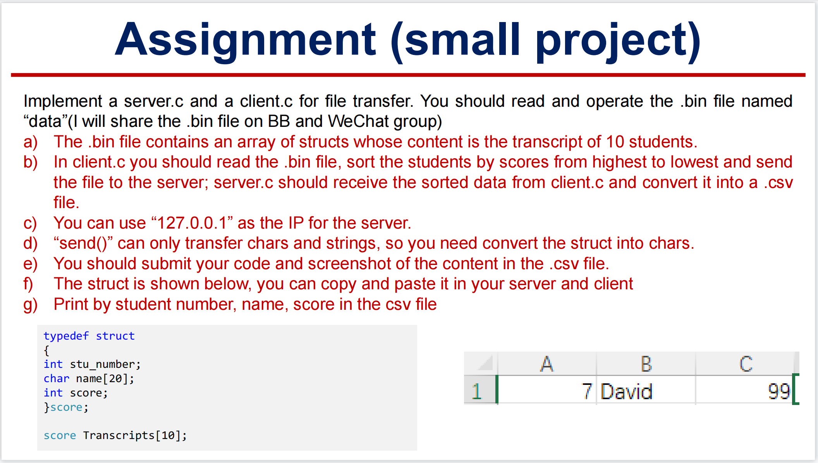

Project:

In Sever:
#define _WINSOCK_DEPRECATED_NO_WARNINGS
#define _CRT_SECURE_NO_WARNINGS
#include <winsock2.h>
#include <stdlib.h>
#include <conio.h>
#include <stdio.h>
#pragma comment(lib, "WS2_32") // 链接到WS2_32.lib

void CInitSock_func(BYTE minorVer, BYTE majorVer)
{
// 初始化WS2_32.dll
WSADATA wsaData;
WORD sockVersion = MAKEWORD(minorVer, majorVer);
if (WSAStartup(sockVersion, &wsaData) != 0)
{
exit(0);
}
}

int main()
{
CInitSock_func(2, 2);
//CDeleteSock_func();
// 创建套节字
SOCKET sockfd = socket(AF_INET, SOCK_STREAM, IPPROTO_TCP);
//用来指定套接字使用的地址格式，通常使用AF_INET
//指定套接字的类型，若是SOCK_DGRAM，则用的是udp不可靠传输
//配合type参数使用，指定使用的协议类型（当指定套接字类型后，可以设置为0，因为默认为UDP或TCP）
if (sockfd == INVALID_SOCKET)
{
printf("Failed socket() \n");
return 0;
}
// 填充sockaddr_in结构 ,是个结构体

struct sockaddr_in sin;
sin.sin_family = AF_INET;
sin.sin_port = htons(4567); //1024 ~ 49151：普通用户注册的端口号
sin.sin_addr.S_un.S_addr = INADDR_ANY;
// 绑定这个套节字到一个本地地址
if (bind(sockfd, &sin, sizeof(sin)) == SOCKET_ERROR)
{
printf("Failed bind() \n");
return 0;
}
// 进入监听模式
//2指的是，监听队列中允许保持的尚未处理的最大连接数
if (listen(sockfd, 2) == SOCKET_ERROR)
{
printf("Failed listen() \n");
return 0;
}
// 接受客户的连接请求
struct sockaddr_in remoteAddr;
int nAddrLen = sizeof(remoteAddr);
SOCKET sClient = 0;
char szText[] = " TCP Server connected! \r\n";

// 接受一个新连接
//（(SOCKADDR*)&remoteAddr）一个指向sockaddr_in结构的指针，用于获取对方地址
sClient = accept(sockfd, &remoteAddr, &nAddrLen);
if (sClient == INVALID_SOCKET)
{
printf("Failed accept()");
return 0;
}
printf("接受到一个连接：%s \r\n", inet_ntoa(remoteAddr.sin_addr));
send(sClient, szText, strlen(szText) + 1, 0);// 向客户端发送数据

// 从客户端接收数据
char buff[256] = "\0";
int nRecv;
nRecv = recv(sClient,buff, 256, 0);
printf("%d\n", nRecv);
if (nRecv > 0)
{
printf("接收到数据：\n%s\n", buff);
//send(sClient, buff, strlen(buff) + 1, 0);
}

closesocket(sClient);// 关闭同客户端的连接

closesocket(sockfd);// 关闭监听套节字

//开始输出
FILE* pfile;
pfile=fopen("output.csv", "w+");
fprintf(pfile, "Number,Name,Score\n");
fprintf(pfile, "%s\n",buff);

return 0;
}

In Client:
#define _CRT_SECURE_NO_WARNINGS
#define _WINSOCK_DEPRECATED_NO_WARNINGS
#include <winsock2.h>
#include <stdlib.h>
#include <conio.h>
#include <stdio.h>
#include <string.h>
#pragma comment(lib, "WS2_32") // 链接到WS2_32.lib

#define server_IP "127.0.0.1"
//#define server_IP "10.27.44.83"

void CInitSock(BYTE minorVer, BYTE majorVer)
{
// 初始化WS2_32.dll
WSADATA wsaData;
WORD sockVersion = MAKEWORD(minorVer, majorVer);
if (WSAStartup(sockVersion, &wsaData) != 0)
{
exit(0);
}
}

int main()
{
//设置类型
typedef struct
{
int stu_number;
char name[20];
int score;
}score;
score Transcripts[10];

int i, j;
for (i = 0; i < 10; i++)
{
Transcripts[i].stu_number = 0;
Transcripts[i].name[0] = '\0';
Transcripts[i].score = 0;
}

/* for(i=0;i<10;i++)
{
printf("number:%d\t\tname:%s\t\tscore:%d\n",Transcripts[i].stu_number,Transcripts[i].name,Transcripts[i].score);
}
printf("\n");
*/

//开始读取数据
FILE* pfile;
pfile = fopen("D:/wendy/study/C program/homework/week8/data.bin", "rb");

fread(Transcripts, sizeof(score), 10, pfile);

/* for(i=0;i<10;i++)
{
printf("number:%d\t\tname:%s\t\tscore:%d\n",Transcripts[i].stu_number,Transcripts[i].name,Transcripts[i].score);
}
printf("\n");
*/
//读取数据完毕

//排序
score temp;
for (i = 0; i < 9; i++)
{
for (j = 8 - i; j >= 0; j--)
{
if (Transcripts[j].score < Transcripts[j + 1].score)
{
temp = Transcripts[j];
Transcripts[j] = Transcripts[j + 1];
Transcripts[j + 1] = temp;
}
}
}

for (i = 0; i < 10; i++)
{
printf("number:%d\t\tname:%s\t\tscore:%d\n", Transcripts[i].stu_number, Transcripts[i].name, Transcripts[i].score);
}

//排序完毕
//关闭文件
fclose(pfile);

CInitSock(2, 2);//设置版本信息

SOCKET sockfd = socket(AF_INET, SOCK_STREAM, IPPROTO_TCP);// 创建套节字

if (sockfd == INVALID_SOCKET)
{
printf(" Failed socket() \n");
return 0;
}

// 填写远程地址信息
struct sockaddr_in servAddr;
servAddr.sin_family = AF_INET;
servAddr.sin_port = htons(4567);
// 注意，这里要填写服务器程序（TCPServer程序）所在机器的IP地址
// 如果你的计算机没有联网，直接使用127.0.0.1即可
servAddr.sin_addr.S_un.S_addr = inet_addr("127.0.0.1");
if (connect(sockfd, (const struct sockaddr*)&servAddr, sizeof(servAddr)) == -1)
{
printf(" Failed connect() \n");
return 0;
}
char buff[256];
char szText[256]="\0";

//从服务器端接收数据
int length = sizeof(servAddr);
int nRecv = recvfrom(sockfd, buff, 256, 0, (struct sockaddr*)&servAddr, &length);
//int nRecv = recv(sockfd, buff, 256, 0);
if (nRecv > 0)
printf("接收到数据：%s\n", buff);

//发送数据
char a[256];
for (i = 0; i < 10; i++)
{
sprintf(a,"%d,", Transcripts[i].stu_number);
strcat(szText, a);
sprintf(a, "%s,", Transcripts[i].name);
strcat(szText, a);
sprintf(a, "%d\n", Transcripts[i].score);
strcat(szText, a);
}

sendto(sockfd, szText, strlen(szText) + 1, 0, (const struct sockaddr*)&servAddr, sizeof(servAddr));

//send(sockfd, szText, strlen(szText), 0);

// 关闭套节字
closesocket(sockfd);
return 0;
}

Running screenshot:

The “Server”:
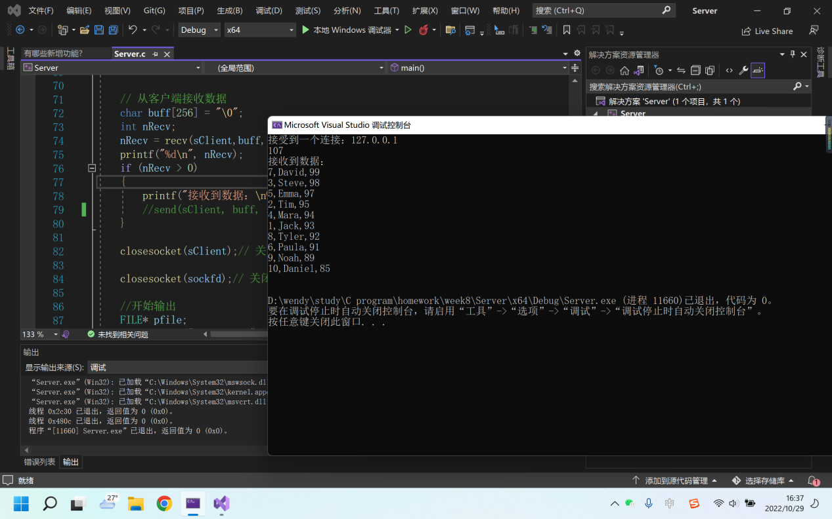

The “Client”:
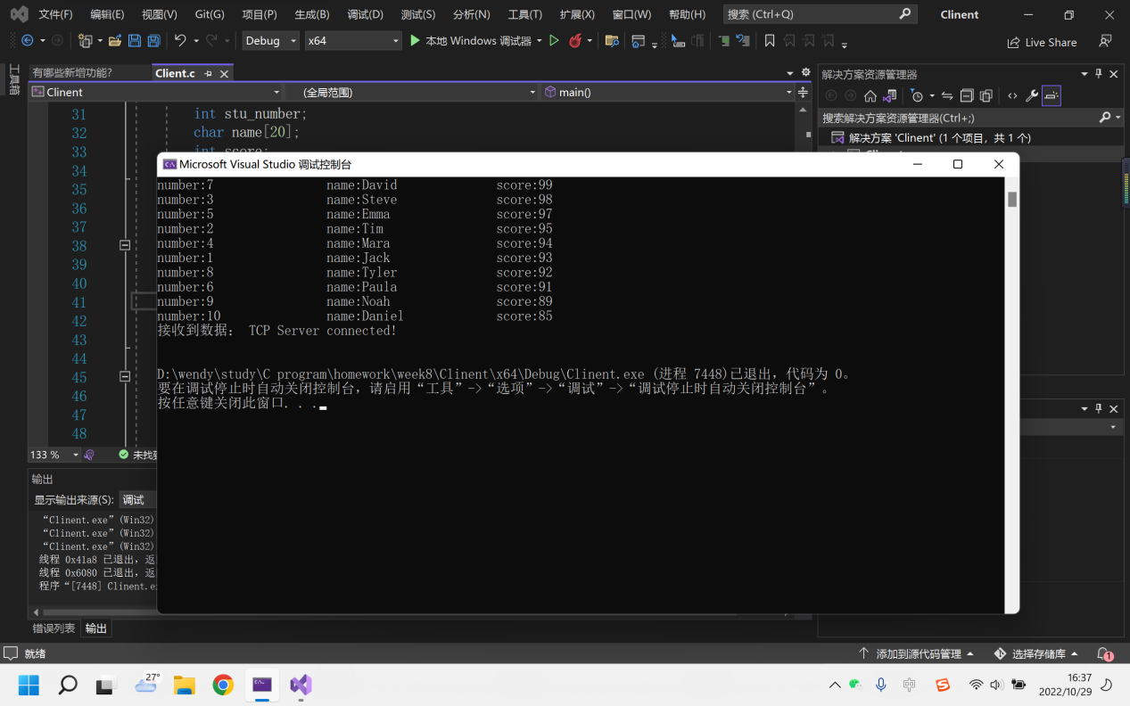
The output:


