C程序设计基础作业-2022.11.05-12210159应逸雯
Task:
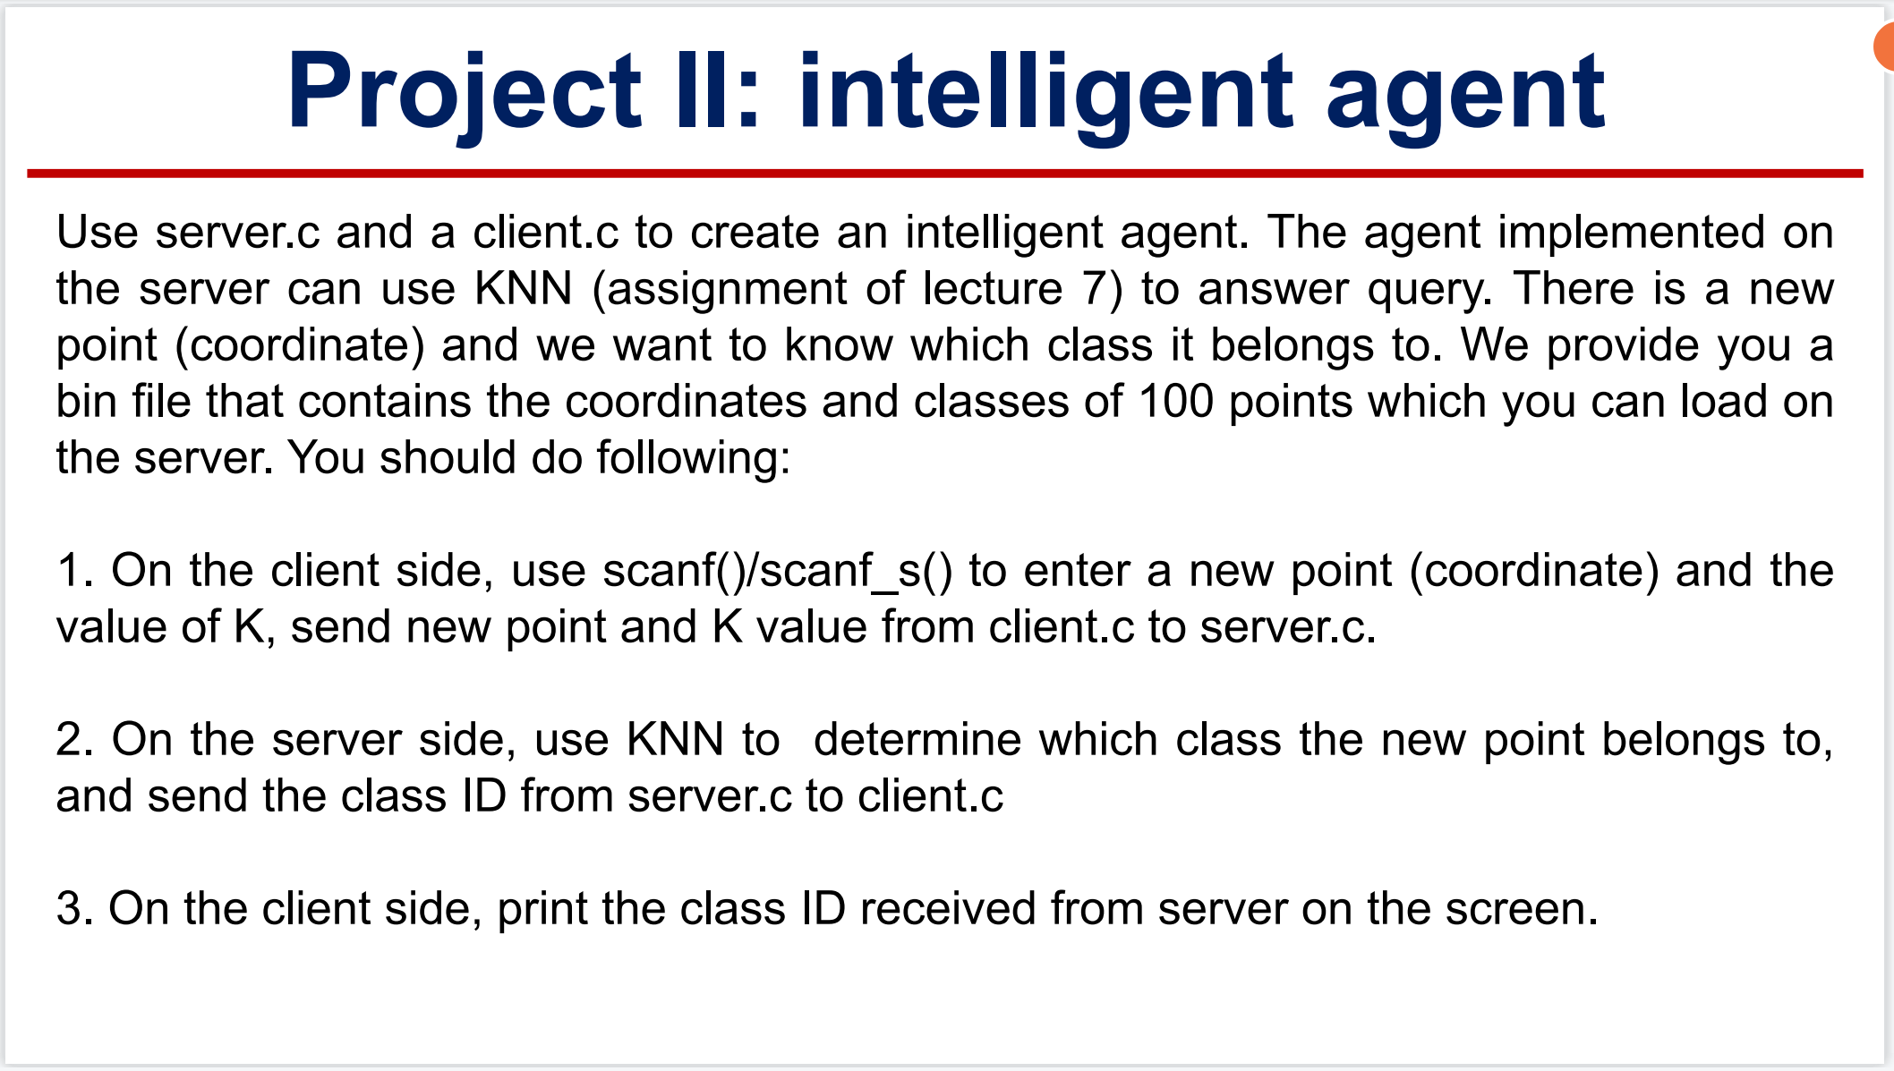
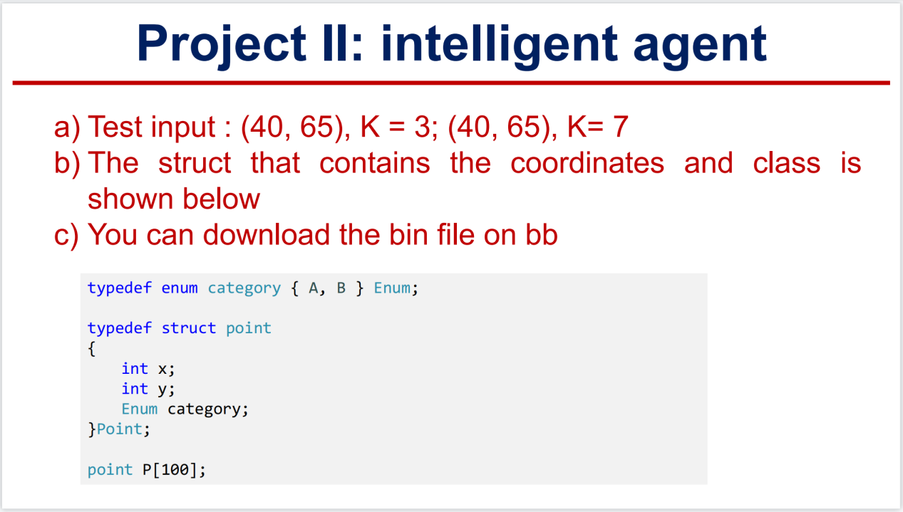

Project:

In Sever:
#define _CRT_SECURE_NO_WARNINGS
#define _WINSOCK_DEPRECATED_NO_WARNINGS
#include <winsock2.h>
#include <stdlib.h>
#include <conio.h>
#include <stdio.h>
#pragma comment(lib, "WS2_32") // 链接到WS2_32.lib

void CInitSock_func(BYTE minorVer, BYTE majorVer)
{
// 初始化WS2_32.dll
WSADATA wsaData;
WORD sockVersion = MAKEWORD(minorVer, majorVer);
if (WSAStartup(sockVersion, &wsaData) != 0)
{
exit(0);
}
}

int main()
{
CInitSock_func(2, 2);
//CDeleteSock_func();
// 创建套节字
SOCKET sockfd = socket(AF_INET, SOCK_STREAM, IPPROTO_TCP);
//用来指定套接字使用的地址格式，通常使用AF_INET
//指定套接字的类型，若是SOCK_DGRAM，则用的是udp不可靠传输
//配合type参数使用，指定使用的协议类型（当指定套接字类型后，可以设置为0，因为默认为UDP或TCP）
if (sockfd == INVALID_SOCKET)
{
printf("Failed socket() \n");
return 0;
}
// 填充sockaddr_in结构 ,是个结构体

struct sockaddr_in sin;
sin.sin_family = AF_INET;
sin.sin_port = htons(4567); //1024 ~ 49151：普通用户注册的端口号
sin.sin_addr.S_un.S_addr = INADDR_ANY;
// 绑定这个套节字到一个本地地址
if (bind(sockfd, &sin, sizeof(sin)) == SOCKET_ERROR)
{
printf("Failed bind() \n");
return 0;
}
// 进入监听模式
//2指的是，监听队列中允许保持的尚未处理的最大连接数
if (listen(sockfd, 2) == SOCKET_ERROR)
{
printf("Failed listen() \n");
return 0;
}
// 接受客户的连接请求
struct sockaddr_in remoteAddr;
int nAddrLen = sizeof(remoteAddr);
SOCKET sClient = 0;
char szText[] = " TCP Server connected! \r\n";

// 接受一个新连接
//（(SOCKADDR*)&remoteAddr）一个指向sockaddr_in结构的指针，用于获取对方地址
sClient = accept(sockfd, &remoteAddr, &nAddrLen);
if (sClient == INVALID_SOCKET)
{
printf("Failed accept()");
return 0;
}
printf("接受到一个连接：%s \r\n", inet_ntoa(remoteAddr.sin_addr));
send(sClient, szText, strlen(szText) + 1, 0);// 向客户端发送数据

// 从客户端接收数据
char buff[256]="\0";
int nRecv = recv(sClient, buff, 256, 0);
if (nRecv > 0)
{
printf("接收到数据：%s\n", buff);
//send(sClient, buff, strlen(buff) + 1, 0);
}

//拆分数据
char* p1 = strtok(buff, ",");
char* p2 = strtok(NULL, ",");
char* p3 = strtok(NULL, ",");

//printf("%s %s %s\n", p1, p2, p3);

int x1, y1, k;
x1 = atoi(p1);
y1 = atoi(p2);
k = atoi(p3);

//printf("%d %d %d\n", x1, y1, k);

int i;

//定义
typedef enum category { A, B } Enum;
typedef struct point
{
int x;
int y;
Enum category;
}Point;

Point points[100];
float distance[100];

//初始化数据
for (i = 0; i < 100; i++)
{
points[i].x = 0;
points[i].y = 0;
points[i].category = 0;
distance[i] = 0;
}

//读入数据
FILE* fp;
fp = fopen("D:\\wendy\\study\\C program\\homework\\week9\\Points.bin", "rb");
fread(&points, sizeof(Point), 100, fp);

//检查输入
/* for (i = 0; i < 100; i++)
{
printf("%d. x:%d y:%d category:%d\n", (i + 1), points[i].x, points[i].y, points[i].category);
}
*/
//计算长度
for (i = 0; i < 100; i++)
{
distance[i] = (float)sqrt((x1 - points[i].x) * (x1 - points[i].x) + (y1 - points[i].y) * (y1 - points[i].y));
}

//排序
int m, n;
for (m = 0; m < 99; m++)
{
for (n = 0; n < 99 - m; n++)
{
if (distance[n] > distance[n + 1])
{
float temp = 0;
temp = distance[n];
distance[n] = distance[n + 1];
distance[n + 1] = temp;
int value = 0;
value = points[n].x;
points[n].x = points[n + 1].x;
points[n + 1].x = value;
value = points[n].y;
points[n].y = points[n + 1].y;
points[n + 1].y = value;
Enum c = points[n].category;
points[n].category = points[n + 1].category;
points[n + 1].category = c;
}
}
}

//检验
/* for (i = 0; i < 100; i++)
{
printf("%d. x:%d y:%d distance:%f category:%d\n", (i + 1), points[i].x, points[i].y, distance[i], points[i].category);
}
*/
//输出结果

float sum = 0;
for (i = 0; i < k; i++)
{
sum += points[i].category;
}

float s = 0;
s = (float)k;
s = s / 2;

printf("sum:%f\tcompare:%f\n", sum, s);

//char result[100]="\0";

if (sum >= s)
{
char result[100] = "The result is : B.\0";
send(sClient, "The result is: B.\0", 100, 0);
printf("The result is: %s.\n", result);
}
else
{
char result[100] = "The result is : A.\0";
send(sClient, "The result is: A.\0", 100, 0);
printf("%s\n", result);
}
//检查结果
//printf("The result is: %s.\n", result);

//返回结果
//sendto(sClient, result, sizeof(result), 0, (const struct sockaddr*)&remoteAddr, &nAddrLen);
//send(sClient, result, sizeof(result), 0);

closesocket(sClient);// 关闭同客户端的连接

closesocket(sockfd);// 关闭监听套节字
return 0;
}

In Client:
#define _CRT_SECURE_NO_WARNINGS
#define _WINSOCK_DEPRECATED_NO_WARNINGS
#include <winsock2.h>
#include <stdlib.h>
#include <conio.h>
#include <stdio.h>
#pragma comment(lib, "WS2_32") // 链接到WS2_32.lib

#define server_IP "127.0.0.1"
//#define server_IP "10.27.44.83"

void CInitSock(BYTE minorVer, BYTE majorVer)
{
// 初始化WS2_32.dll
WSADATA wsaData;
WORD sockVersion = MAKEWORD(minorVer, majorVer);
if (WSAStartup(sockVersion, &wsaData) != 0)
{
exit(0);
}
}

int main()
{
//输入数据
int x1, y1, k;
printf("Please enter the coordinate of a new point(x,y):\n");
scanf("%d,%d", &x1, &y1);

printf("The value of K is:\n");
scanf("%d", &k);

//printf("%d,%d,%d\n", x1,y1,k);

CInitSock(2, 2);//设置版本信息

SOCKET sockfd = socket(AF_INET, SOCK_STREAM, IPPROTO_TCP);// 创建套节字

if (sockfd == INVALID_SOCKET)
{
printf(" Failed socket() \n");
return 0;
}

// 填写远程地址信息
struct sockaddr_in servAddr;
servAddr.sin_family = AF_INET;
servAddr.sin_port = htons(4567);
// 注意，这里要填写服务器程序（TCPServer程序）所在机器的IP地址
// 如果你的计算机没有联网，直接使用127.0.0.1即可
servAddr.sin_addr.S_un.S_addr = inet_addr("127.0.0.1");
if (connect(sockfd, (const struct sockaddr*)&servAddr, sizeof(servAddr)) == -1)
{
printf("Failed connect() \n");
return 0;
}
char buff[256];
char szText[256];
//从服务器端接收数据
int length = sizeof(servAddr);
int nRecv = recvfrom(sockfd, buff, 256, 0, (struct sockaddr*)&servAddr, &length);
//int nRecv = recv(sockfd, buff, 256, 0);
if (nRecv > 0)
printf("接收到数据：%s\n", buff);

// 向服务器端发送数据
//scanf_s("%s", szText, 256);

sprintf_s(szText, 256, "%d,%d,%d\0", x1, y1, k);
//printf("%s", szText);

//send(sockfd, szText, strlen(szText), 0);
sendto(sockfd, szText, strlen(szText), 0, (const struct sockaddr*)&servAddr, sizeof(servAddr));

//printf("run here!\n");

//接受结果数据
length = sizeof(servAddr);
char result[100]="\0";
//while (1)
{
nRecv = recvfrom(sockfd, (char*)result, 100, 0, (struct sockaddr*)&servAddr, &length);
if (nRecv > 0)
printf("接收到数据：%s\n", result);
}
// 关闭套节字
closesocket(sockfd);
return 0;
}

Running screenshot:

Input (40,65,3):

The “Server”:
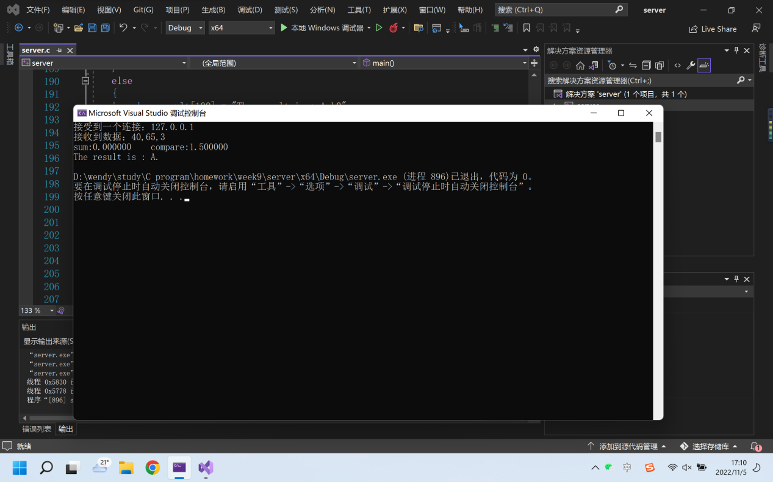

The “Client”:
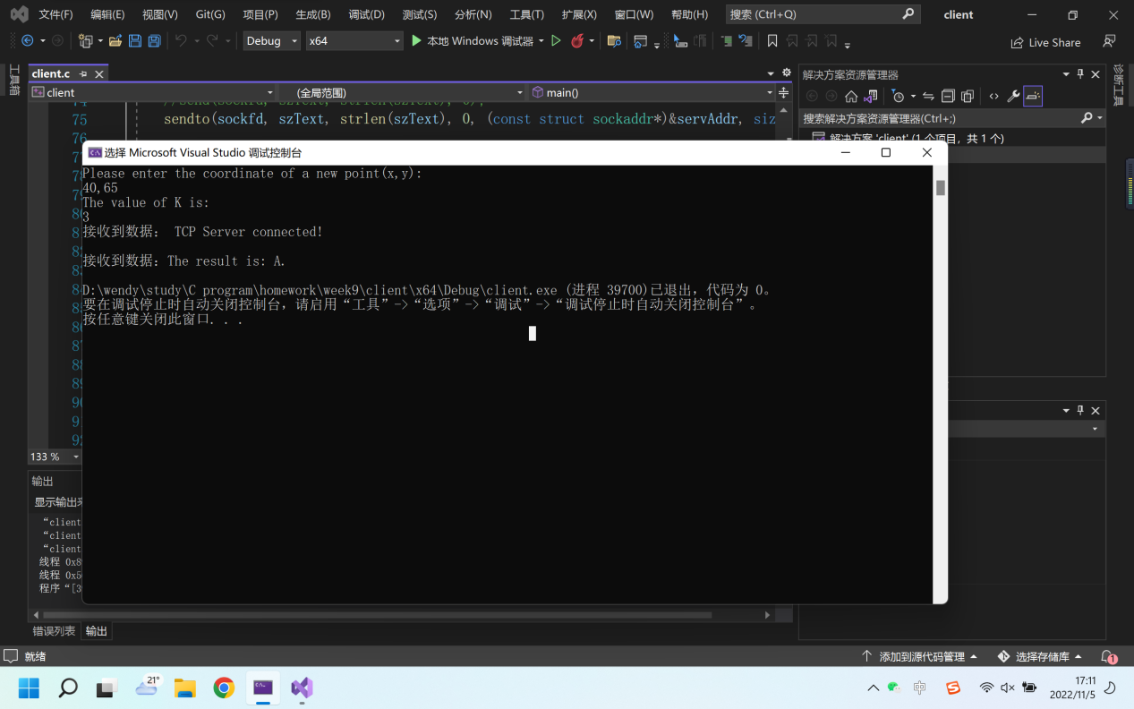

Input (40,65,7):

The “Server”:
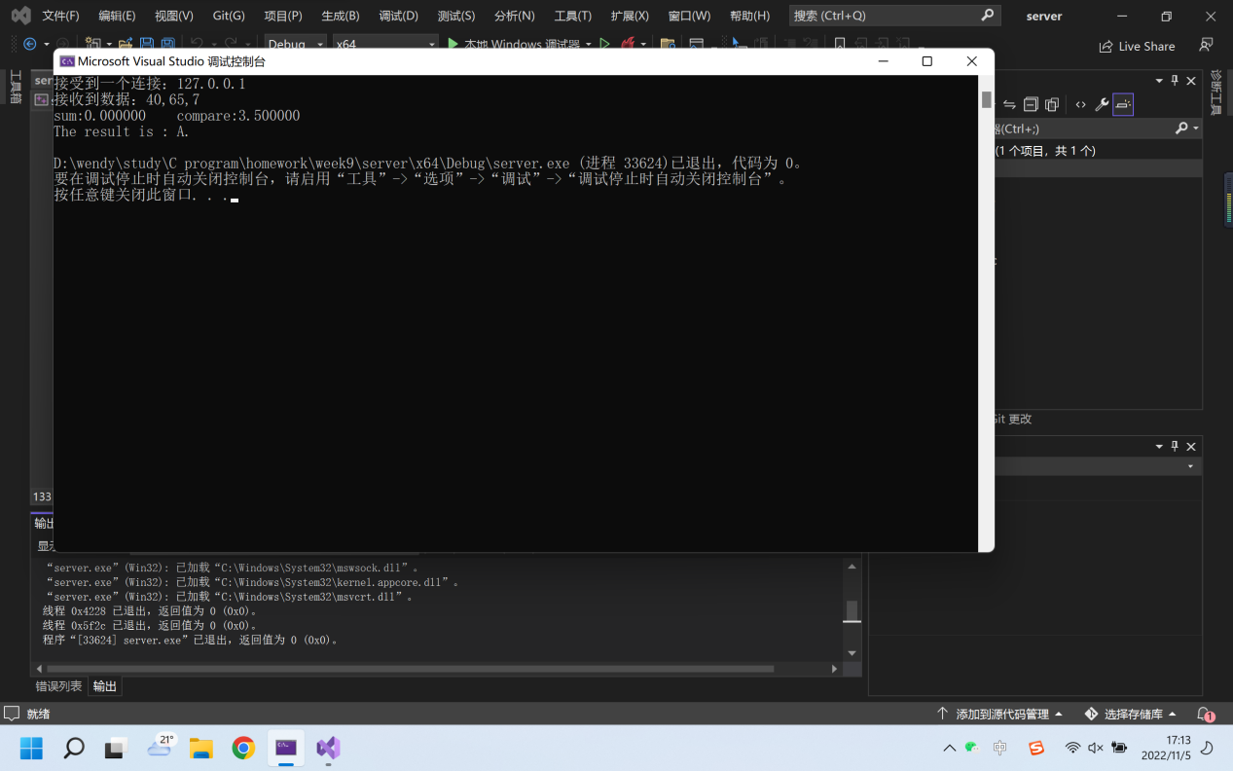

The “Client”:
