Name: Latorre, Wendy Alyssa C. Date: 03-15-26
Year&Section: BSIT_WMT 3-1
Richest and Most Successful Tech Tycoons
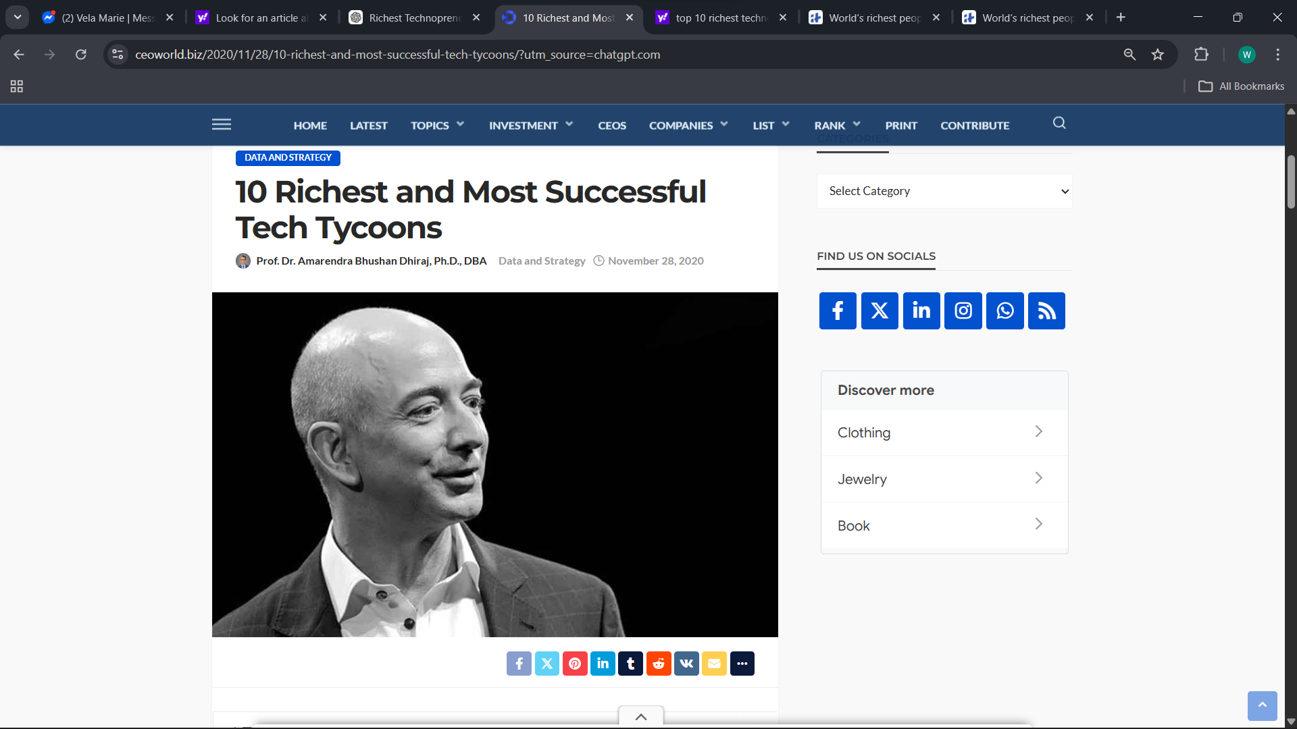
Source: CEOWORLD
https://ceoworld.biz/2020/11/28/10-richest-and-most-successful-tech-tycoons/
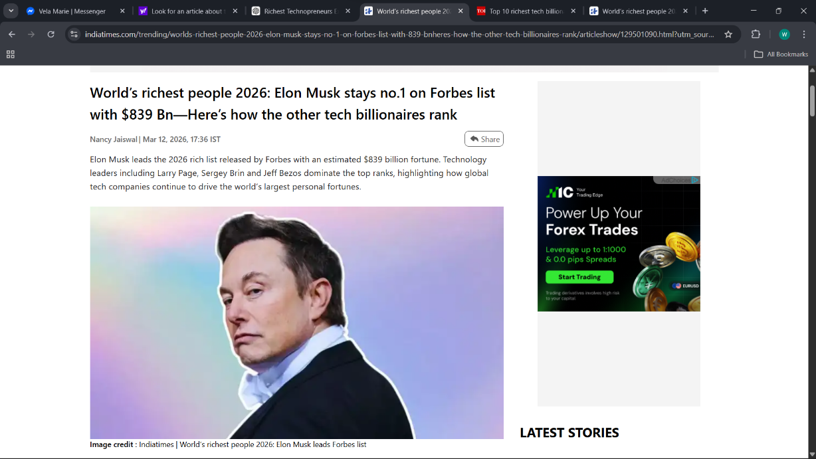
Source: india times
https://www.indiatimes.com/trending/worlds-richest-people-2026-elon-musk-stays-no-1-on-forbes-list-with-839-bnheres-how-the-other-tech-billionaires-rank/articleshow/129501090.html?

