Labyrinth
CS480 Assignment 11

Aaron Solomon
Overview

The Labyrinth is a game in which a board is rotated about to navigate a ball through a maze. Holes are scattered all over the maze.

The movement of the ball was implemented by changing the rotation of the gravity vector. Graphics were rotated by rotating the entire world. Certain things rotated with the world, certain things didn't. This kept the true position of the graphic element separate from where it was displayed, allowing it to interact normally with the physics component.

To prevent the ball from hopping over holes, a very strong impulse is always applied to the ball along the y-axis. This forces it down the holes, even if the ball tries to race past them.

The board was also constrained to a maximum of 45 degrees for each direction.

This Labyrinth includes

Simple Level Generation by Parsing Files
A board made up of cubes that rotates about
Two orbs, one at the base of the board, the other to the right, that act as knobs
The two orbs spin about as the board rotates, just like a knob would
Dynamic texture binding across the cubes and spheres
A ball
A start position and goal position, marked by textures
Holes, marked by the lack of a cube
Basic physics
Multiple lights, including a point light, ambient light, and directional light
A camera
Score display
Clock display
Level display
A menu that includes start, quit, pause, and replay
Controls to tilt the board
Lives and life display

The extra credit done included the following

5 levels
Game replay
3 sounds
Top 10 scoreboard
User Manual

Controls:

Camera:

FPS controls with the mouse weren't done because I wanted to keep the mouse free.

W: move camera forward
A: move camera left
S: move camera back
D: move camera right
Page Up: move camera vertically up
Page Down: move camera vertically down
Q: rotate camera left about the y-axis
E: rotate camera right about the y-axis
R: rotate camera forward about the x-axis
F: rotate camera backward about the x-axis

Admin:

Escape: immediately exit the game

Board:

Rotations are limited to 45 degrees in any direction. This is to prevent cheating.

Up Arrow: rotate board forward about the x-axis
Back Arrow: rotate board backward about the x-axis
Left Arrow: rotate board left about the z-axis
Right Arrow: rotate board right about the z-axis

Running:

Go to build
Open a prompt
Type make
Go to bin
Type ./Program
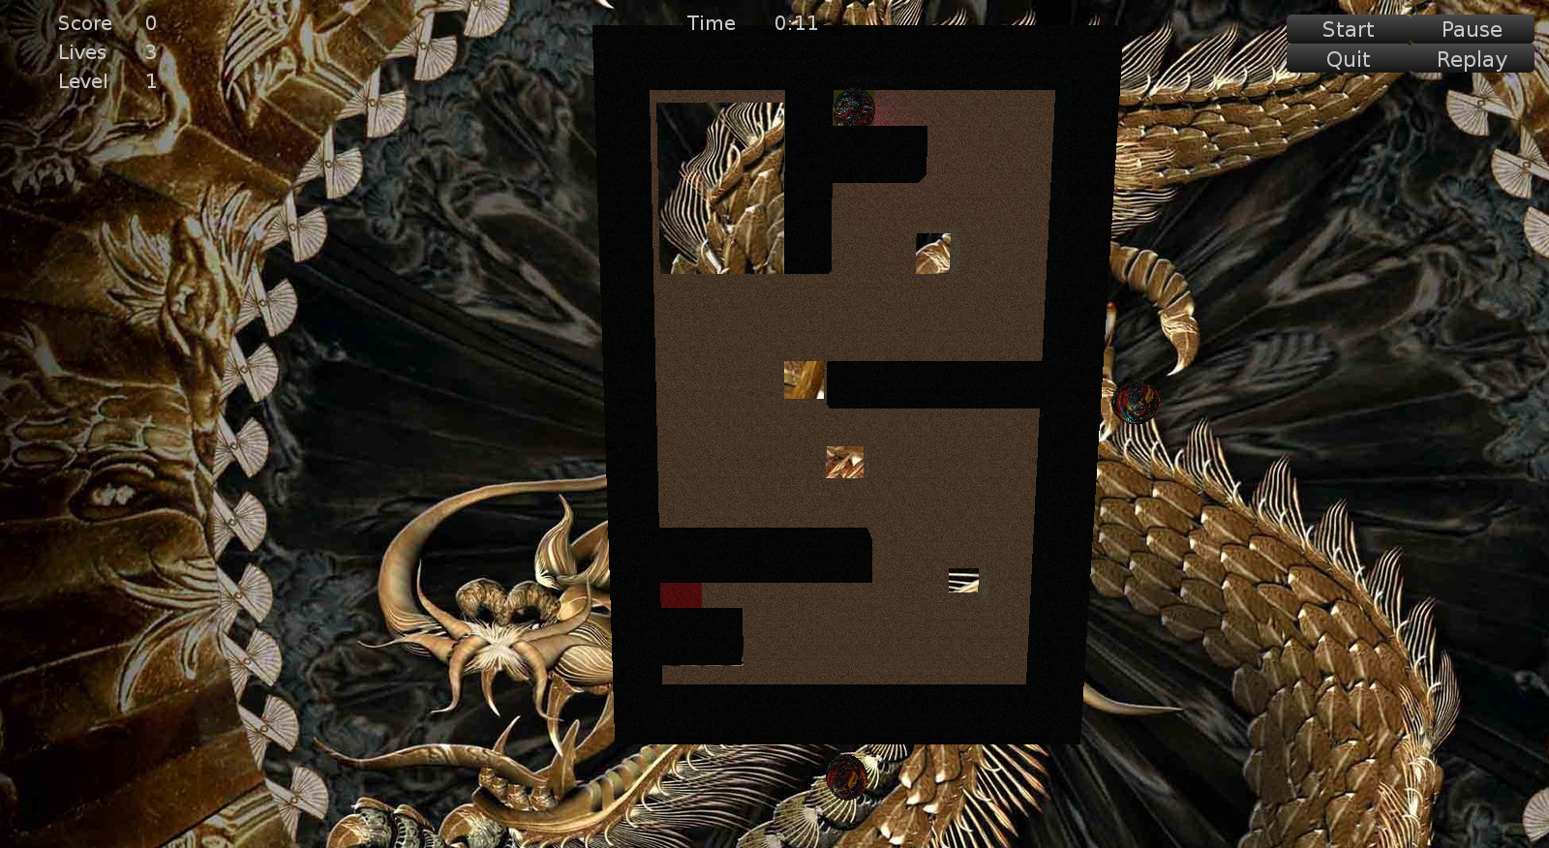
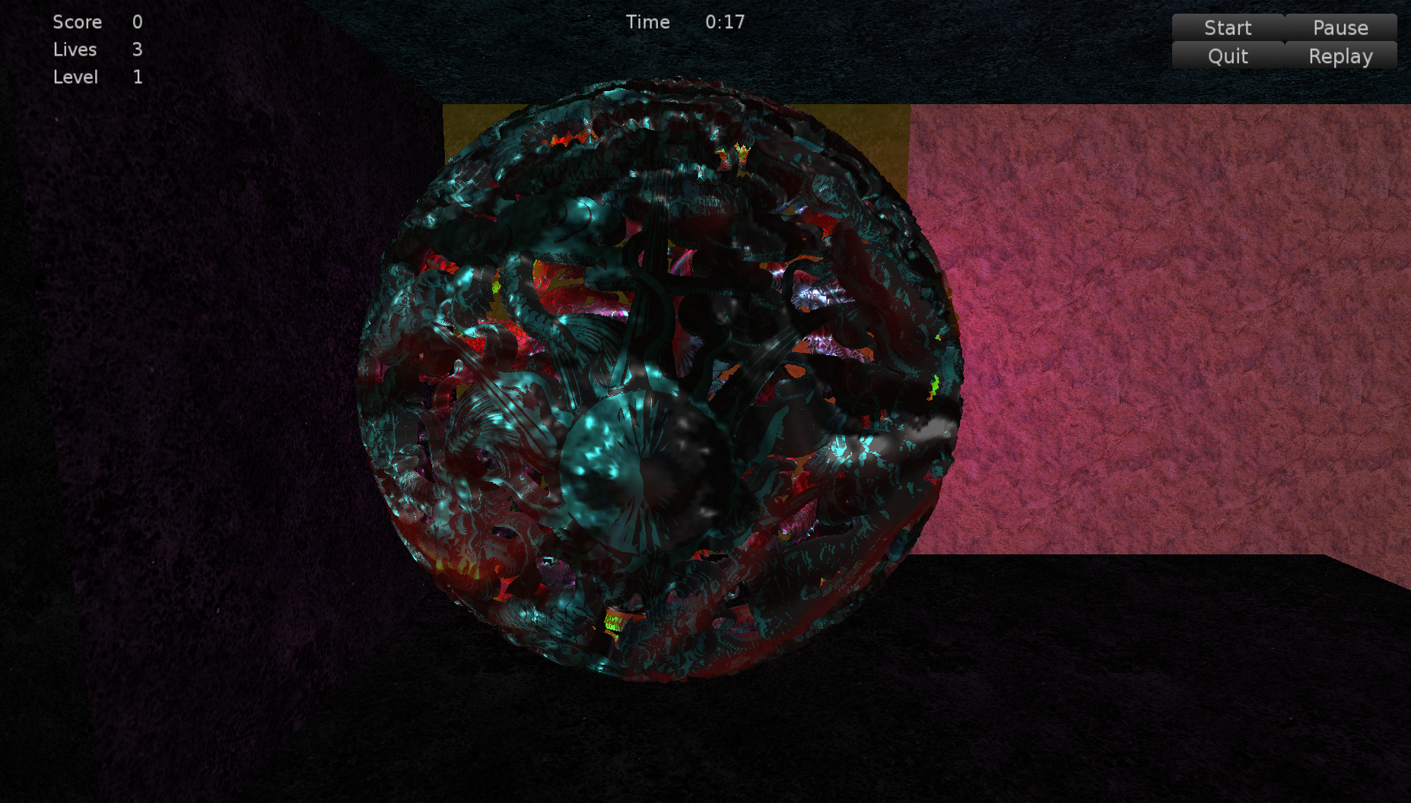

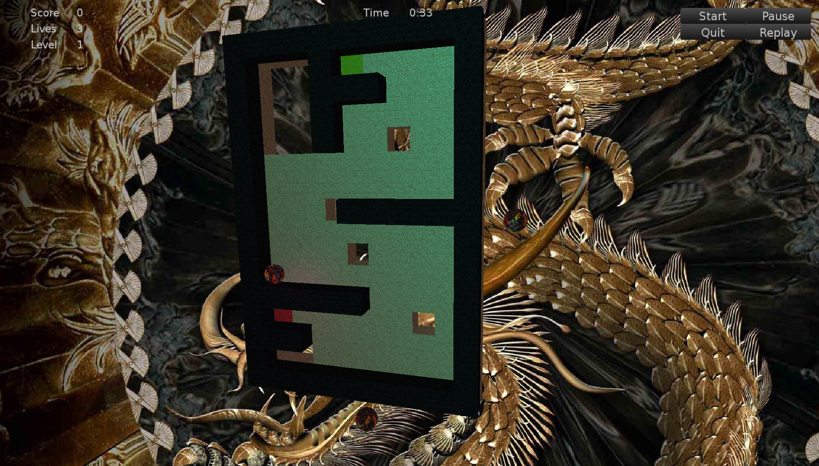
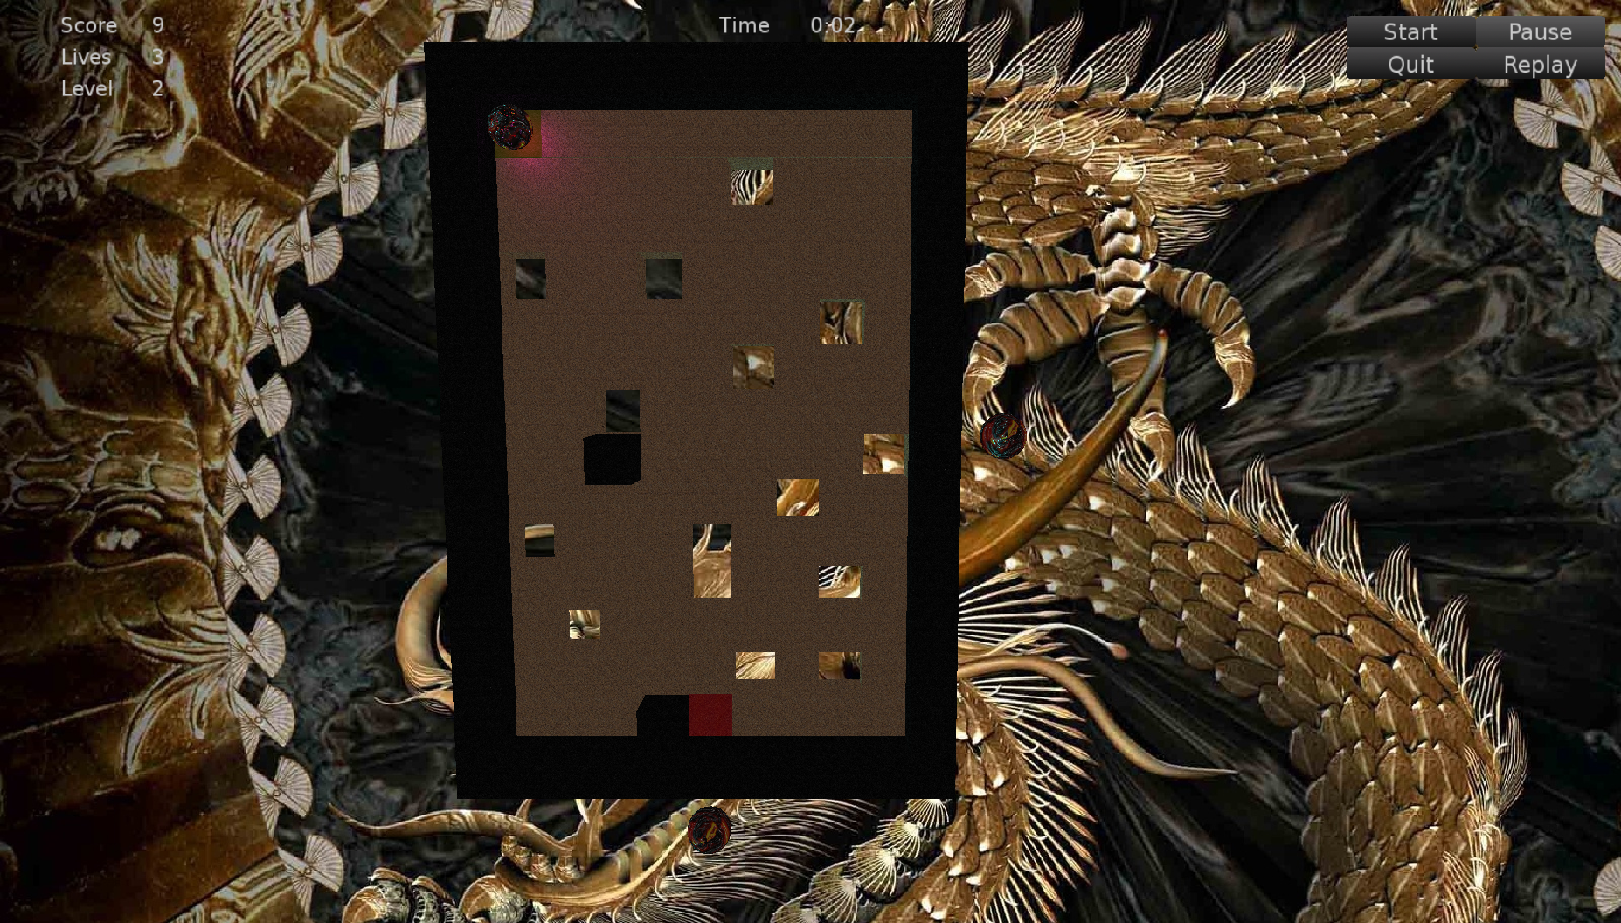

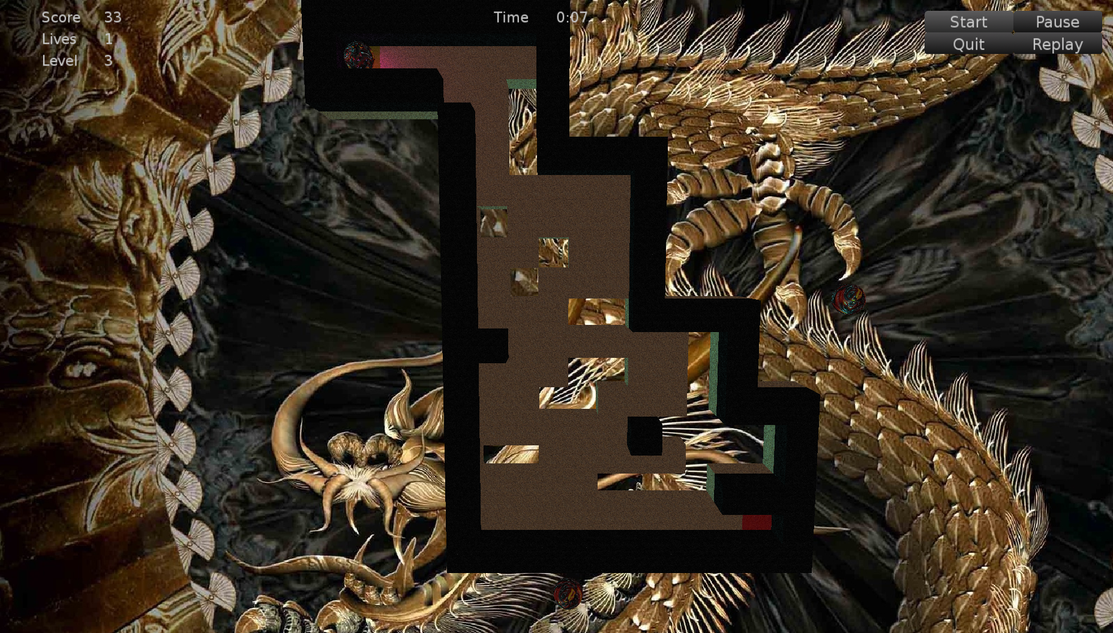
aw
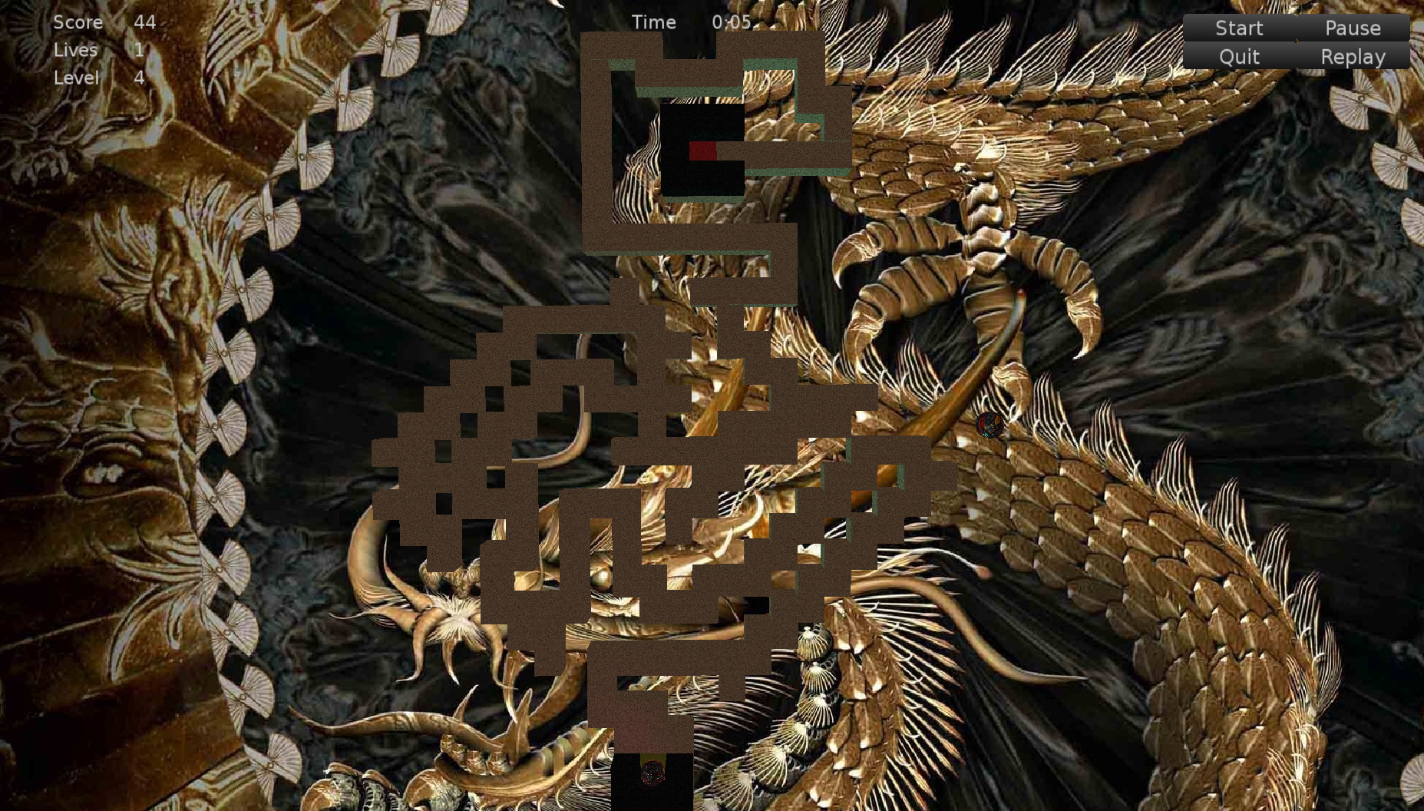


Input name for high score screen. Lost at level 4.

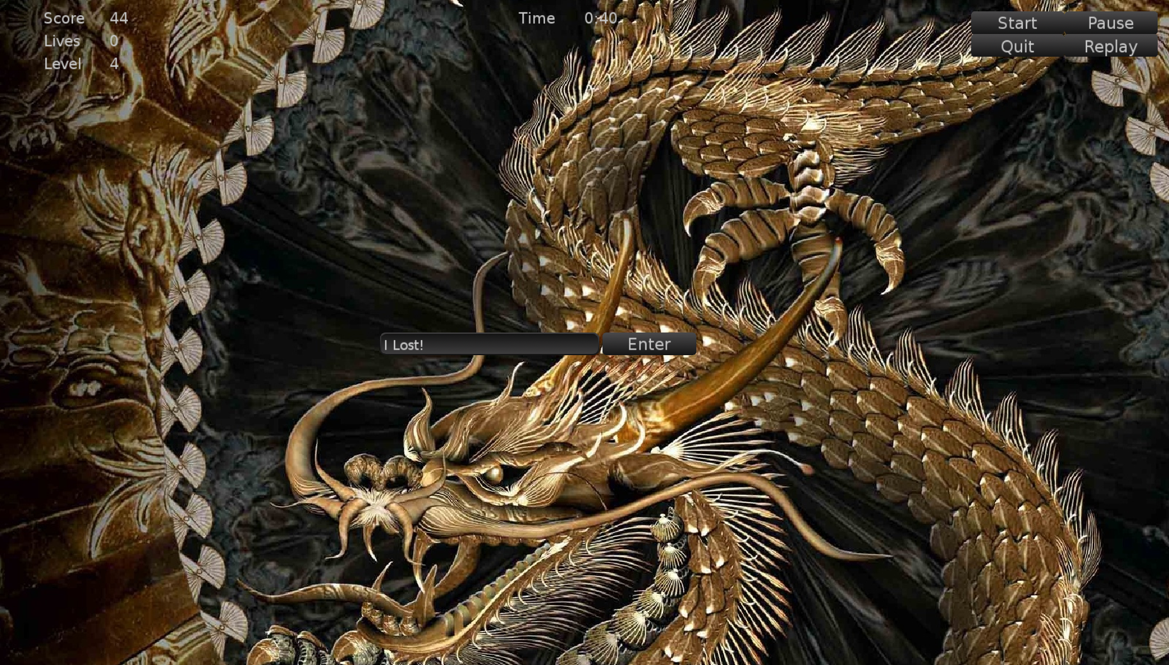

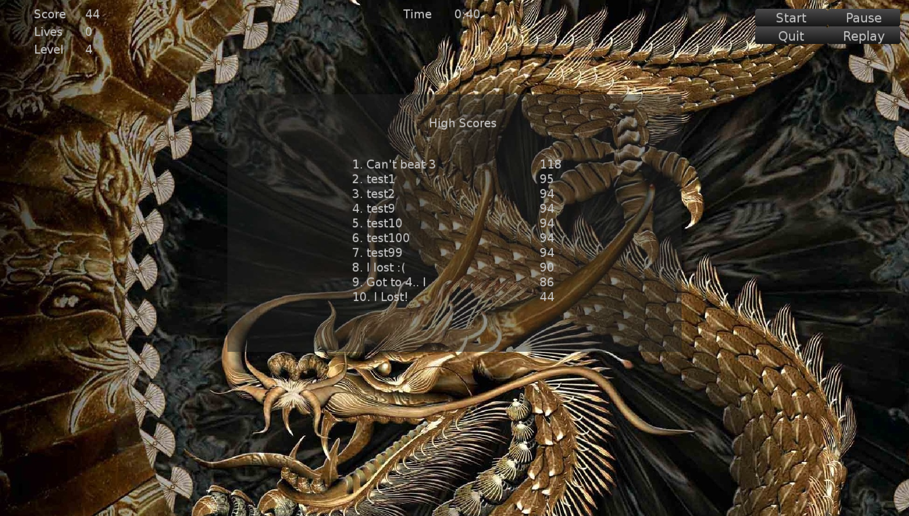
The high score screen. The play I did for these screenshots is at the very bottom. The previous plays were from previous plays.
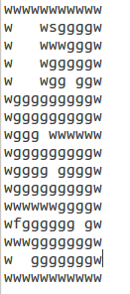

Level 1

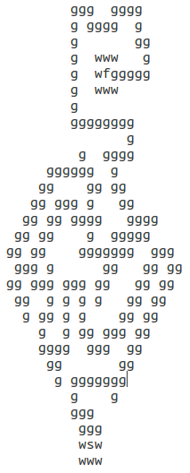
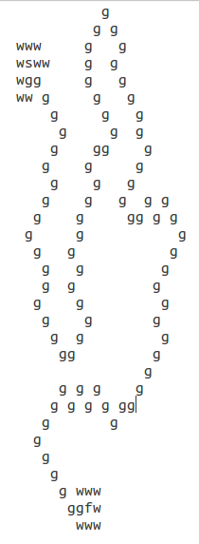

Level 4

Level 5
Tech Manual

Issues:

Point light and directional light seem a bit odd
-No particular fix for this.

The current actors and components in the game have no autostart.
-Add autostart. Behaviors have a boolean that shows whether they are running or not.

High score files were only reading the first record
-The new lines weren't being chomped on, which messed up the input.

High score board had all names and scores on one side
-This was because of the new lines not getting chomped on in input, resulting in malformed data.

Widget text alignment was getting weird or not showing at all
-Had to set text every time it got added to a container.

The high score handling is a total mess. It jumps from function to function and from input to input. It's all over the place.
-std::bind

Code is kind of a jmbled mess and it's difficult to find anything
-Refactor

Boards were getting built in reverse order
-Flip z axis from negative to positive

Physics gravity was doing weird things
-Rotate the default gravity vector, 0, 1, 0, not the graphics one, 0, 0, -1. Also, keep the negative in the scalar, not the vector.

Replay was seg faulting after two times
-Clear the vector containing all of the level blocks so that they don't get deleted twice.

Have updates everywhere for the labels
-Need to use setters/getters instead.

Ball jumped over holes with enough speed
-Make a really big impulse along the y-axis to force it into the holes.

Ball jumped over stages by banging against walls with enough speed
-Do big impulse along y-axis.

Lives were showing as 0
-Update lives display in the constructor. Score should be updated for testing purposes as well.

Music was playing multiple times
-Check Playing state. It was a curiosity whether this needed to be checked or not, or whether there was a state. After one run, it definitely needed to be handled.

