PA11 – Labyrinth

# Denver Liu, Soohyun Yoon

# 11/25/2013

# CS480RUser Manual

The following libraries are needed to compile and run the program:

OpenGL, GLM, GLUT, GLEW, Assimp, ImageMagik, and Bullet

**Build instructions:** Navigate to the “build” directory from the terminal and type “make.”

**Run instructions:** To run the game, type “./../bin/Physics” or navigate to the ‘bin’ directory and click on the executable.

**How to play Labyrinth:**

There are two colored dots that indicate the start and end location of the maze. The objective is to navigate the ball from the green dot on the maze to the red dot. The player wins the game when the ball falls into the red hole. If the ball falls into one of the black “trap” holes, the ball will be returned to the green dot and the player will need to start again. When the player successfully reaches a green hole, the score will be updated and displayed in the terminal.

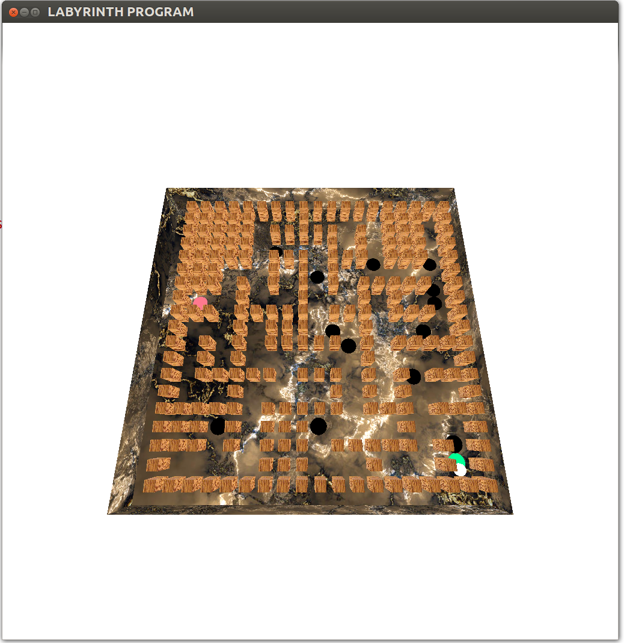

[Figure 1] Green area is the starting point, black areas are traps, and the red area is the goal.

**Movement:**

The ball is controlled indirectly by tilting the board in different directions. Either the mouse or keyboard can be used to tilt the board:

* Mouse: move the mouse while holding down the left button will turn the board in the direction of the mouse movement.
* Keyboard: The WASD keys will move the board. W tilts the board up, S tilts the board down, A tilts the board left, and D tilts the board right.

**Menu:**

The menu is displayed when the user right-clicks the mouse anywhere in the game. The menu options are:

**Start** **Menu:** Pause, Resume, Restart

**Settings Menu:**

**Sensitivity** – Increases the sensitivity of the mouse and keyboard (faster board tilt upon input)

**Bounciness** – The force that the ball will ricochet after hitting a wall.

**Difficulty** – The number of black holes located along the maze.

**Quit:** Quit the game.

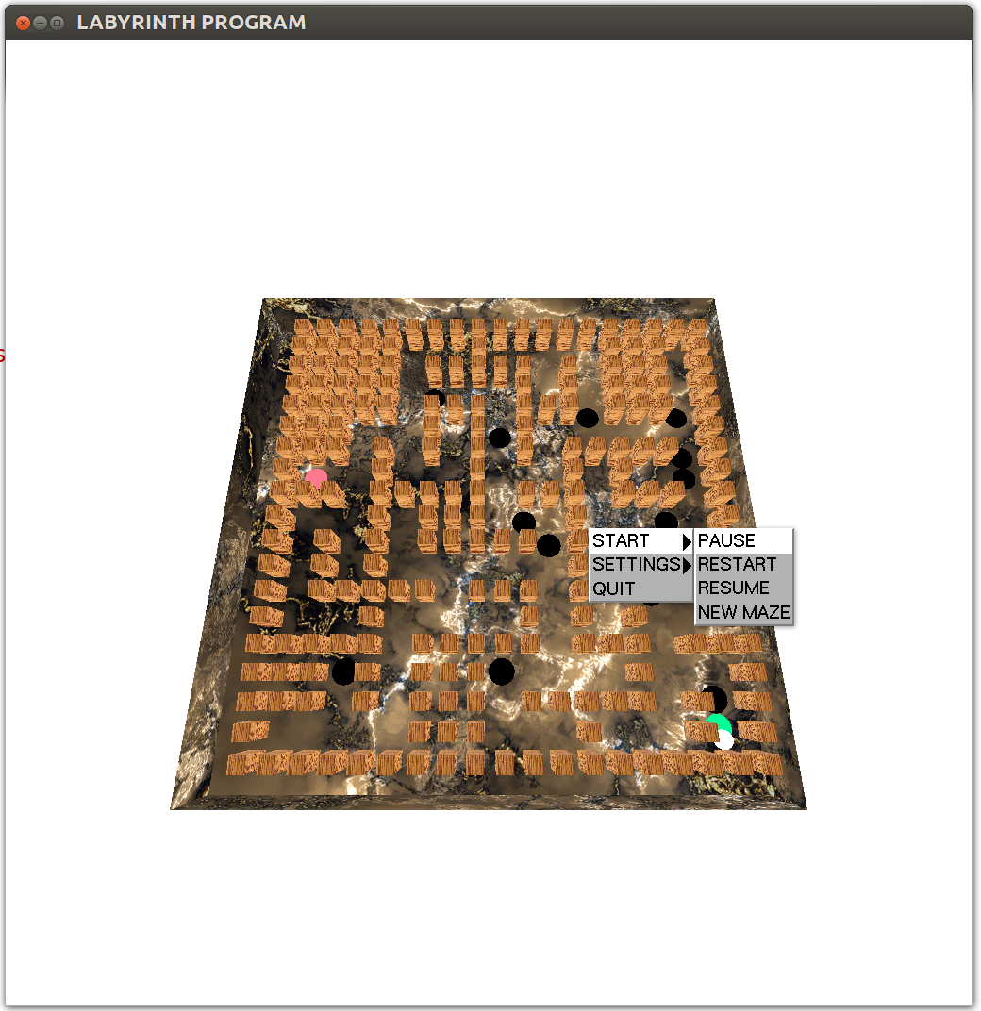

[Figure 2] Menu interface

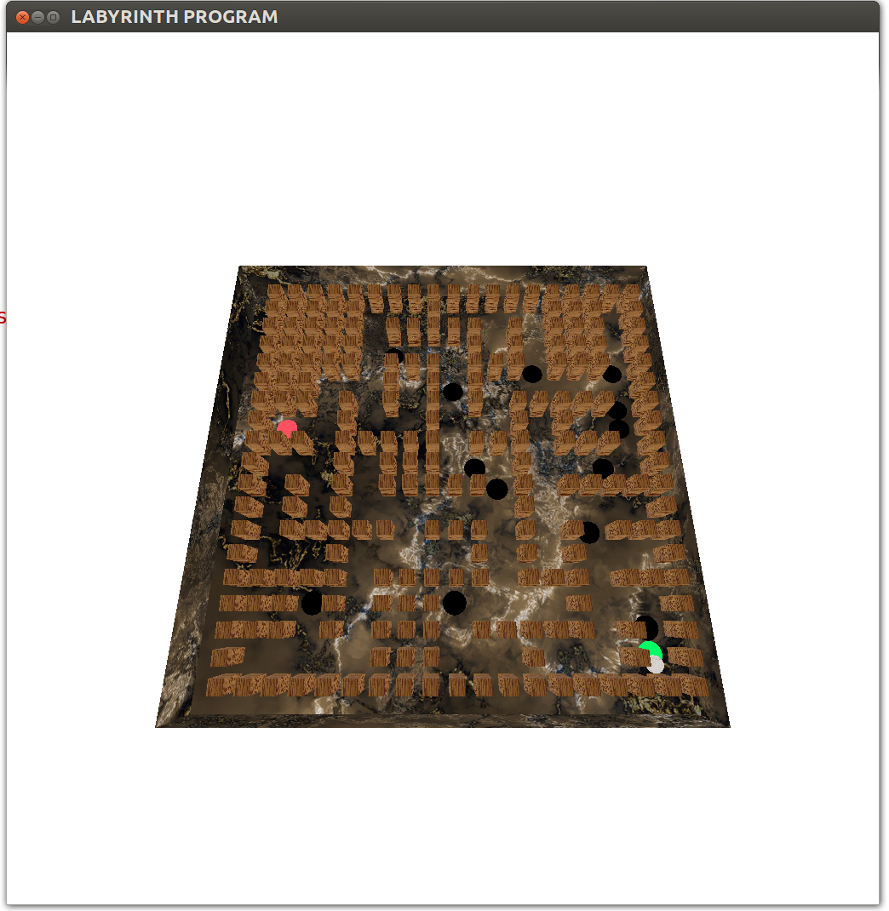

# [Figure 3] Ambient light offTechnical Manual