实验题目：lab0，操作系统的编程基础

实验环境

<http://www.shiyanlou.com/courses/221>

安装linux环境，并安装gcc和gdb。

1. 了解汇编

尝试理解下面的命令

$gcc -S -m32 lab0_ex1.c

接着我们将得到lab0_ex1.s文件，请写出汇编代码与c代码之间的关系。

它们都是让人与机器交流的语言，C语言更接近自然语言，代码比较容易阅读，汇编更接近机器，掌握它可以从更深层次去理解机器，它们经过编译程序处理后得到的都是二进制指令数据，对机器来说无区别。

1. 用gdb调试

尝试下面的命令，

$gcc -g -m32 lab0_ex2.c

接着我们会得到a.out文件，请用gdb调试，并写出设置断点、单步执行及查看变量的过程。

**设置断点：**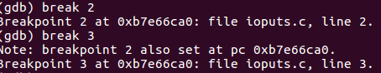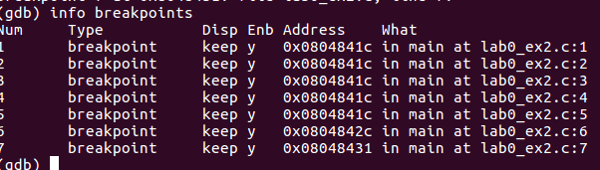

**单步执行：**

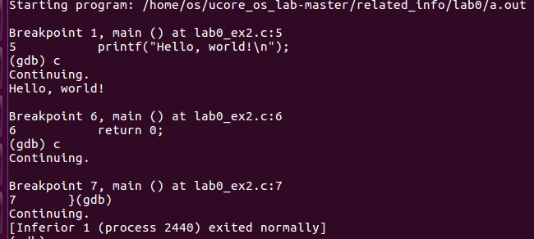

**查看变量：**

1. 掌握指针和类型转换相关的Ｃ编程

分析如下代码段，

#include <stdio.h>

#define STS_IG32 0xE // 32-bit Interrupt Gate

#define STS_TG32 0xF // 32-bit Trap Gate

typedef unsigned uint32_t;

#define SETGATE(gate, istrap, sel, off, dpl) { \

(gate).gd_off_15_0 = (uint32_t)(off) & 0xffff; \

(gate).gd_ss = (sel); \

(gate).gd_args = 0; \

(gate).gd_rsv1 = 0; \

(gate).gd_type = (istrap) ? STS_TG32 : STS_IG32; \

(gate).gd_s = 0; \

(gate).gd_dpl = (dpl); \

(gate).gd_p = 1; \

(gate).gd_off_31_16 = (uint32_t)(off) >> 16; \

}

/* Gate descriptors for interrupts and traps */

struct gatedesc {

unsigned gd_off_15_0 : 16; // low 16 bits of offset in segment

unsigned gd_ss : 16; // segment selector

unsigned gd_args : 5; // # args, 0 for interrupt/trap gates

unsigned gd_rsv1 : 3; // reserved(should be zero I guess)

unsigned gd_type : 4; // type(STS_{TG,IG32,TG32})

unsigned gd_s : 1; // must be 0 (system)

unsigned gd_dpl : 2; // descriptor(meaning new) privilege level

unsigned gd_p : 1; // Present

unsigned gd_off_31_16 : 16; // high bits of offset in segment

};

int

main(void)

{

unsigned before;

unsigned intr;

unsigned after;

struct gatedesc gintr;

intr=8;

before=after=0;

gintr=*((struct gatedesc *)&intr);

SETGATE(gintr, 0,1,2,3);

intr=*(unsigned *)&(gintr);

printf("intr is 0x%x\n",intr);

printf("intr is 0x%llx\n", gintr);

return 0;

}

写出gintr和intr的结果，试着编译这段代码，如果遇到错误进行改正，并分析错误原因。

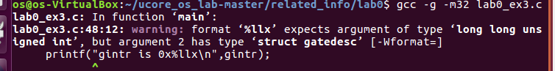

将printf("intr is 0x%llx\n", gintr);

改为：printf("intr is 0x%llx\n",*(long long unsigned *)&gintr );

修改之后的结果：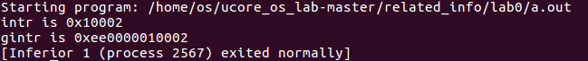

4. 掌握通用链表结构相关的Ｃ编程

查看list.h和lab0_ex4.c，编写一个程序，利用list.h中的链表结构，将26个英文字母存入链表中，并逆序打印出来。

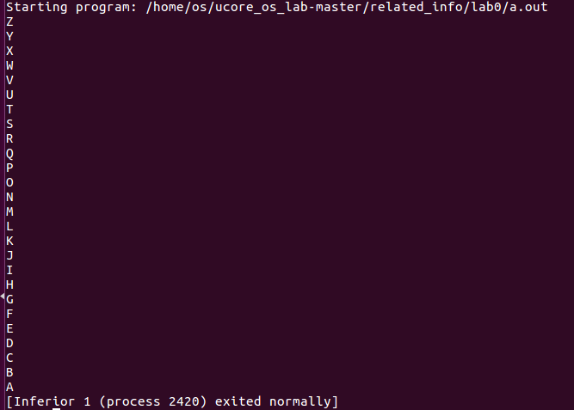

在list.h文件中注释#include<defs.h> 增加typedef int bool;

lab0_ex4.c中主函数修改为：

int main() {

struct entry head;

list_entry_t* p = &head.node;

list_init(p);

head.num = 0;

int i;

for (i = 'A'; i != '['; i ++) {

struct entry * e = (struct entry *)malloc(sizeof(struct entry));

e->num = i;

list_add(p, &(e->node));

p = list_next(p);

}

//reverse list all node

printf("%c\n",((struct entry *)p)->num);

while ((p = list_prev(p)) != &head.node)

printf("%c\n", ((struct entry *)p)->num);

return 0;

}