四皇后问题

实验代码

global N # 皇后个数  
global SUM # 当前已找到的可行方案数  
N = 4  
SUM = 0  
def print_solution(x):  
 for i in range(len(x)):  
 print('0'*x[i]+'1'+'0'*(4-x[i]-1))  
 print()  
def is_safe(k):  
 for i in range(k):  
 if x[i] == x[k]:  
 return False  
 if (x[i] - x[k]) == (i - k):  
 return False  
 if (x[i] - x[k]) == (k - i):  
 return False  
 return True  
def backtrack(t):  
 global SUM  
 if t >= N:  
 SUM += 1  
 print_solution(x)  
 else:  
 for i in range(N):  
 x[t] = i  
 if is_safe(t):  
 backtrack(t + 1)  
if __name__ == "__main__":  
 x = [0 for i in range(N)]  
 backtrack(0)  
 print("sum =" + str(SUM))

实验截图

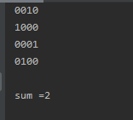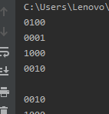

实验总结

通过对四皇后问题的编程练习，我对回溯法的掌握更加熟练，并对搜索策略有了更深的理解