实验题目：lab0，操作系统的编程基础

安装linux环境，并安装gcc和gdb。

1.了解汇编
尝试理解下面的命令
$gcc -S -m32 lab0_ex1.c
接着我们将得到lab0_ex1.s文件，请写出汇编代码与c代码之间的关系。

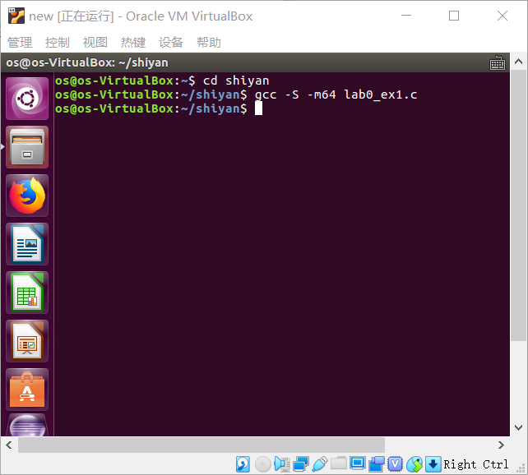

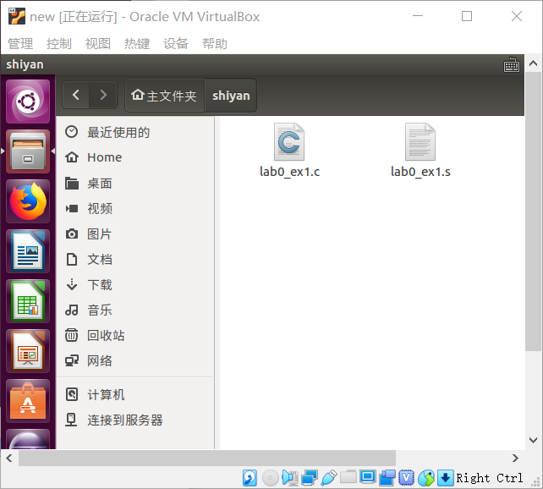

汇编语言是比C语言更低级的语言，C语言在运行之前必须编译成汇编语言，方便直接指向硬件，操控硬件

2.用gdb调试
尝试下面的命令，
$gcc -g -m32 lab0_ex2.c
接着我们会得到a.out文件，请用gdb调试，并写出设置断点、单步执行及查看变量的过程。
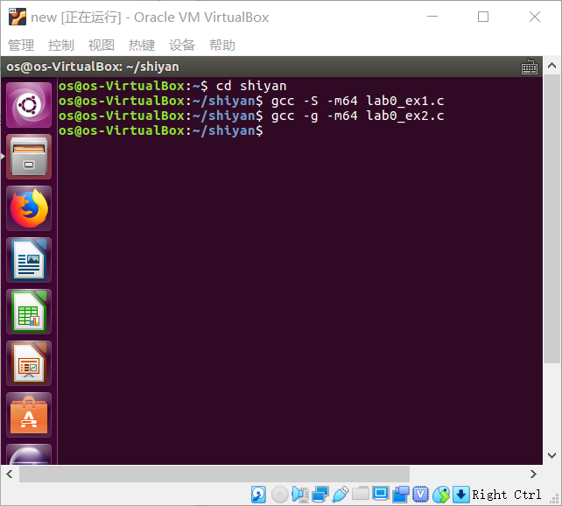
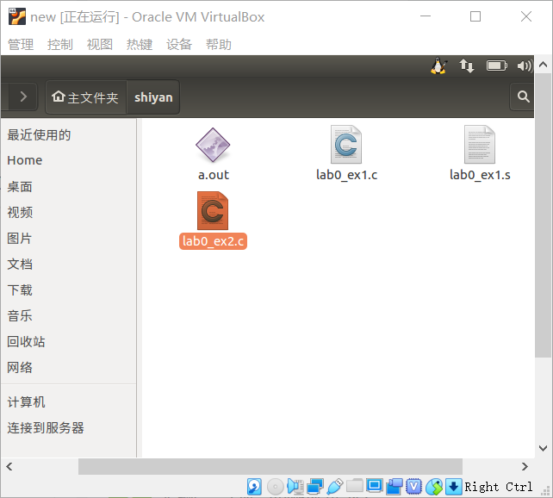
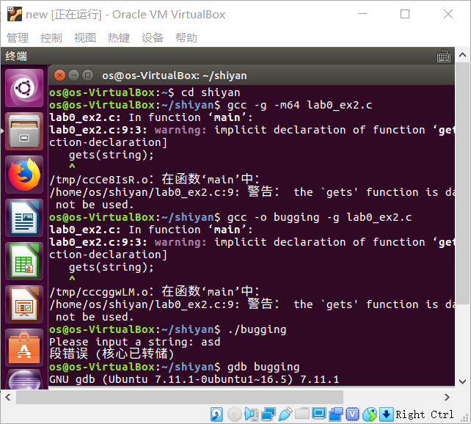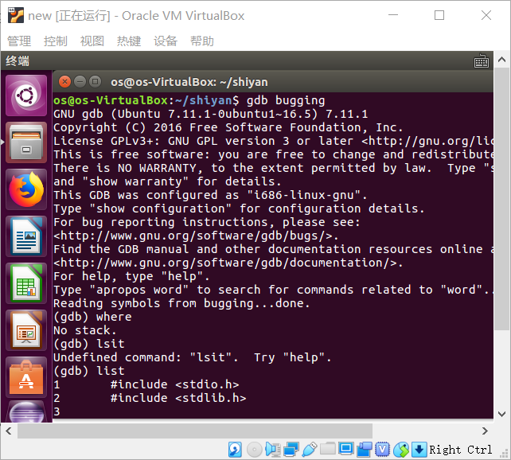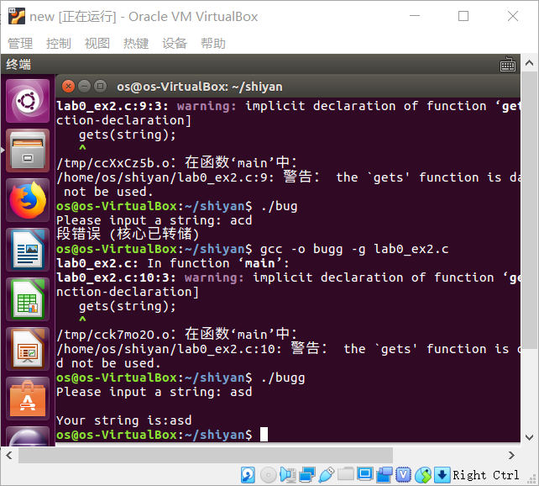

掌握指针和类型转化相关的编程
分析如下代码段，
#include <stdio.h>

#define STS_IG32 0xE // 32-bit Interrupt Gate
#define STS_TG32 0xF // 32-bit Trap Gate

typedef unsigned uint32_t;

#define SETGATE(gate, istrap, sel, off, dpl) { \
(gate).gd_off_15_0 = (uint32_t)(off) & 0xffff; \
(gate).gd_ss = (sel); \
(gate).gd_args = 0; \
(gate).gd_rsv1 = 0; \
(gate).gd_type = (istrap) ? STS_TG32 : STS_IG32; \
(gate).gd_s = 0; \
(gate).gd_dpl = (dpl); \
(gate).gd_p = 1; \
(gate).gd_off_31_16 = (uint32_t)(off) >> 16; \
}

/* Gate descriptors for interrupts and traps */
struct gatedesc {
unsigned gd_off_15_0 : 16; // low 16 bits of offset in segment
unsigned gd_ss : 16; // segment selector
unsigned gd_args : 5; // # args, 0 for interrupt/trap gates
unsigned gd_rsv1 : 3; // reserved(should be zero I guess)
unsigned gd_type : 4; // type(STS_{TG,IG32,TG32})
unsigned gd_s : 1; // must be 0 (system)
unsigned gd_dpl : 2; // descriptor(meaning new) privilege level
unsigned gd_p : 1; // Present
unsigned gd_off_31_16 : 16; // high bits of offset in segment
};
int
main(void)
{
unsigned before;
unsigned intr;
unsigned after;
struct gatedesc gintr;
intr=8;
before=after=0;

gintr=*((struct gatedesc *)&intr);
SETGATE(gintr, 0,1,2,3);
intr=*(unsigned *)&(gintr);
printf("intr is 0x%x\n",intr);
printf("intr is 0x%llx\n", gintr);
return 0;
}
写出gintr和intr的结果，试着编译这段代码，如果遇到错误进行改正，并分析错误原因。
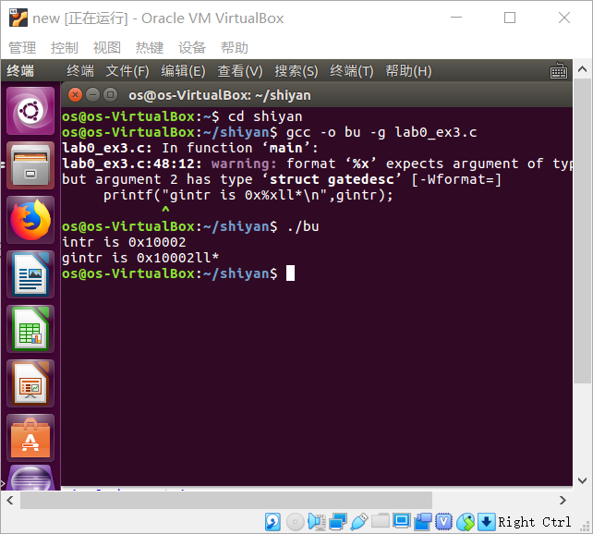
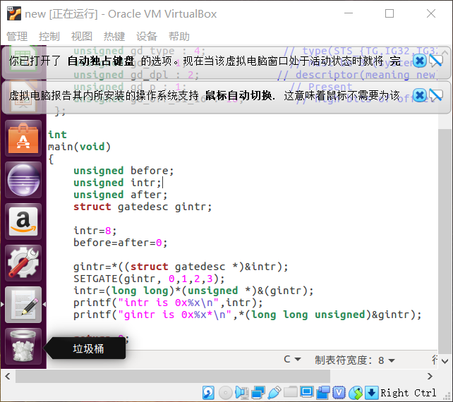

4. 掌握通用链表结构相关的Ｃ编程
查看list.h和lab0_ex4.c，编写一个程序，利用list.h中的链表结构，将26个英文字母存入链表中，并逆序打印出来。
