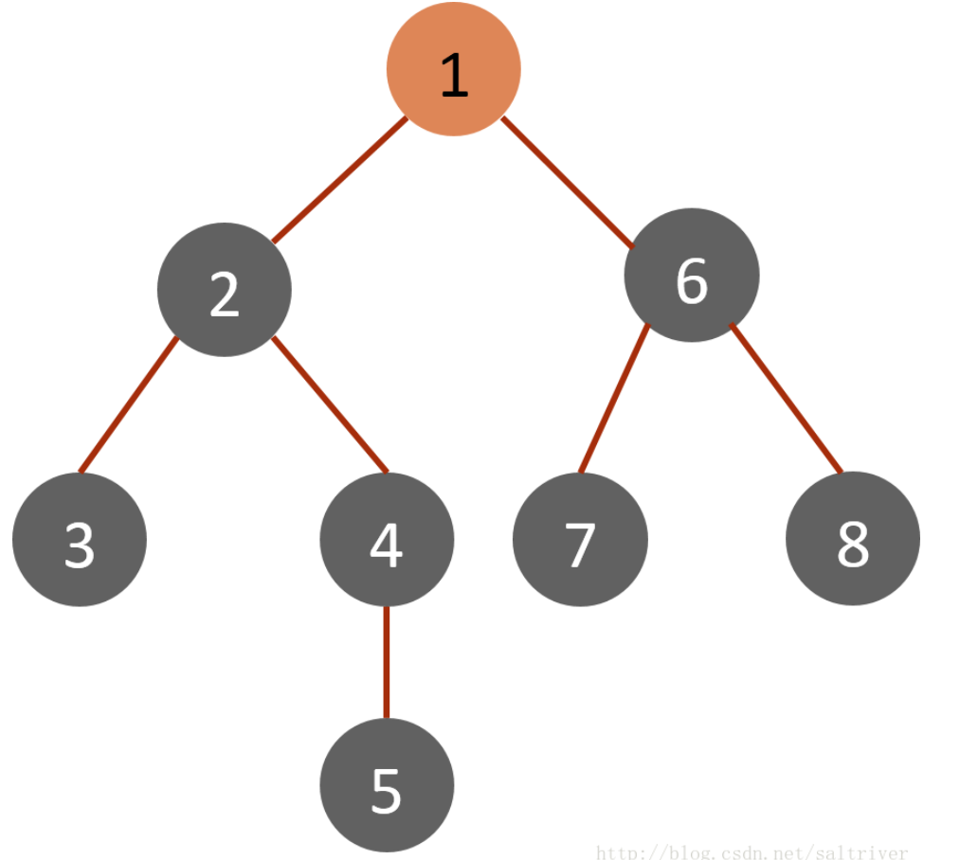

实验代码：
// DFS的递归实现

void DFS_Recursive(Node* pRoot)

{

if (pRoot==NULL)

return;

cout<<pRoot->nVal<<" ";

if (pRoot->pLeft!=NULL)

DFS_Recursive(pRoot->pLeft);

if (pRoot->pRight!=NULL)

DFS_Recursive(pRoot->pRight);

}

// DFS的迭代实现版本（stack）

void DFS_Iterative(Node* pRoot)

{

if (pRoot==NULL)

return;

stack<Node*> S;

S.push(pRoot);

while (!S.empty())

{

Node *node=S.top();

cout<<node->nVal<<",";

S.pop();

if (node->pRight!=NULL) //注意进栈方式--先右后左

{

S.push(node->pRight);

}

if (node->pLeft!=NULL)

{

S.push(node->pLeft);

}

}

}

