Linux实验报告

1. 实验目的

了解Linux下的一些命令，打开目录，创建文档，打开文件。熟悉Linux的操作环境，了解如何使用GitHub提交作业。

1. 实验环境

Linux

1. 实验效果

微信小程序抽奖系统

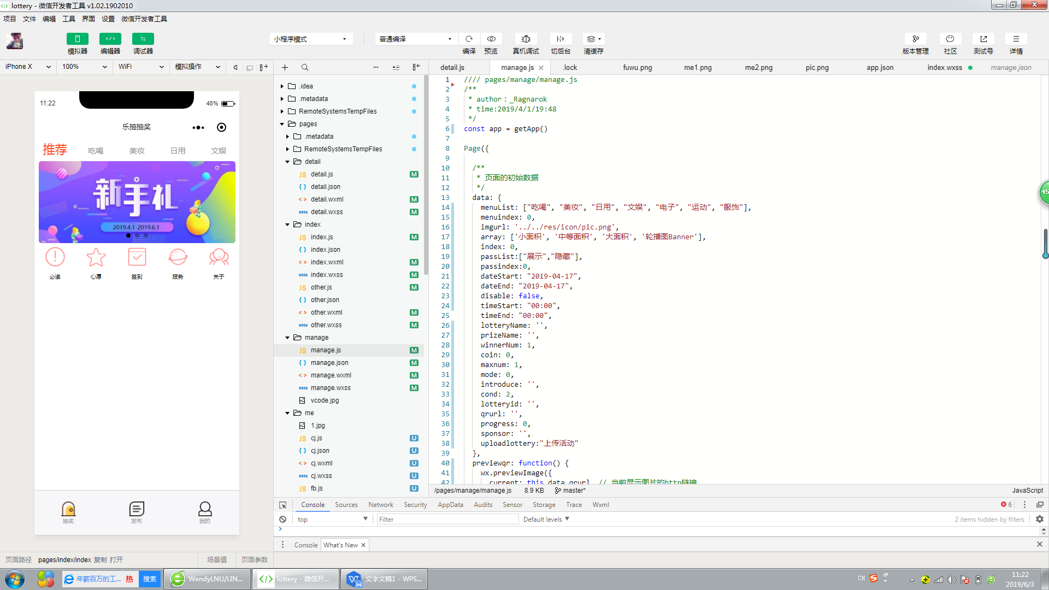

1. 部分代码

实现主页面部分功能

data: {

menuList: ["吃喝", "美妆", "日用", "文娱", "电子", "运动", "服饰"],

menuindex: 0,

imgurl: '../../res/icon/pic.png',

array: ['小面积', '中等面积', '大面积', '轮播图Banner'],

index: 0,

passList:["展示","隐藏"],

passindex:0,

dateStart: "2019-04-17",

dateEnd: "2019-04-17",

disable: false,

timeStart: "00:00",

timeEnd: "00:00",

lotteryName: '',

prizeName: '',

winnerNum: 1,

coin: 0,

maxnum: 1,

mode: 0,

introduce: '',

cond: 2,

lotteryid: '',

qrurl: '',

progress: 0,

sponsor: '',

uploadlottery:"上传活动"

},

效果如图

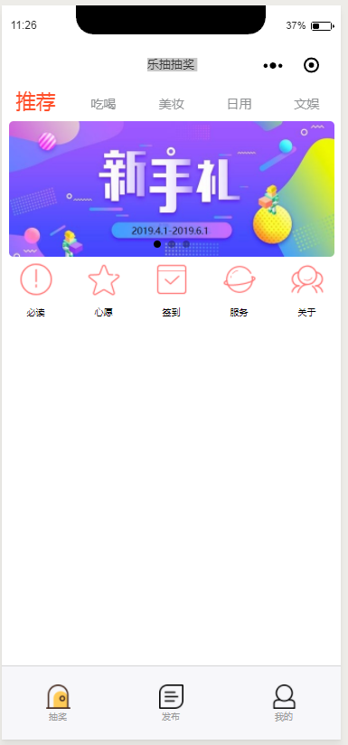

抽奖部分代码展示

<view class="weui__bd">

<form bindsubmit='getform' bindreset="formReset">

<!------------------------------->

<view class="weui-cells__title">点击下方预览选头部图(可点击重复更改)：</view>

<view class="qpiccon">

<image class='qpic' src='{{imgurl}}' bindtap='chooseimg'></image>

</view>

<!------------------------------->

<view class="weui-cells__title">请输入活动标题：</view>

<view class="weui-cells weui-cells_after-title">

<view class="weui-cell weui-cell_input">

<view class="weui-cell__bd">

<input name="lotteryname" class="weui-input" placeholder="请输入标题(必填)" />

</view>

</view>

</view>

<!------------------------------->

<view class="weui-cells__title">请输入活动描述：</view>

<view class="weui-cells weui-cells_after-title">

<view class="weui-cell">

<view class="weui-cell__bd">

<textarea name="introduce" class="weui-textarea" placeholder="请输入文本(可选)" style="height: 3.3em" />

<view class="weui-textarea-counter">0/200</view>

</view>

</view>

</view>

<!------------------------------->

<view class="weui-cells__title">请输入奖品名称：</view>

<view class="weui-cells weui-cells_after-title">

<view class="weui-cell weui-cell_input">

<view class="weui-cell__hd">

<view class="weui-label">奖品名称</view>

</view>

<view class="weui-cell__bd">

<input name="prizename" class="weui-input" placeholder="必填" />

</view>

</view>

</view>

<view class="weui-cells__title">请输入奖品数量：</view>

<view class="weui-cells weui-cells_after-title">

<view class="weui-cell weui-cell_input">

<view class="weui-cell__hd">

<view class="weui-label">奖品数量</view>

</view>

<view class="weui-cell__bd">

<input type='number' name="prizenum" class="weui-input" placeholder="不填默认为1" />

</view>

</view>

</view>

<!------------------------------->

<view class="weui-cells__title">请输入赞助人/商名称：</view>

<view class="weui-cells weui-cells_after-title">

<view class="weui-cell weui-cell_input">

<view class="weui-cell__hd">

<view class="weui-label">赞助人/商</view>

</view>

<view class="weui-cell__bd">

<input name="sponsor" class="weui-input" placeholder="不填默认微信昵称" />

</view>

</view>

</view>

代码效果

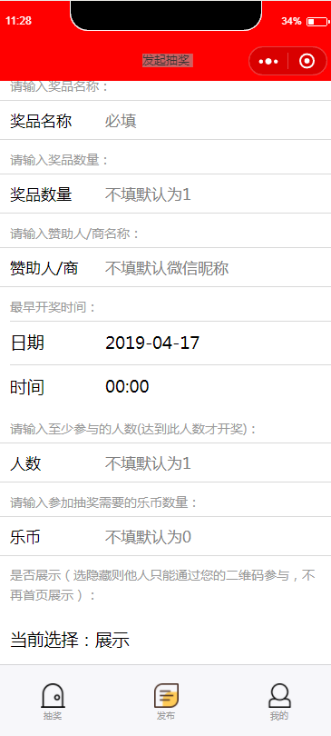

顶部循环播放部分代码实现

<view class='authorview' wx:if="{{!hasUserInfo && canIUse}}">

<button class='authorbutton' open-type="getUserInfo" bindgetuserinfo="getUserInfo"> 点击授权后继续 </button>

<text class='authortext'>\n这将不会泄露您的隐私信息，请放心使用\n</text>

</view>

<!--获取权限结束-->

<!--正式页面开始-->

<view class='content-box' wx:else>

<!--顶部TAB开始-->

<scroll-view class="tab" scroll-x scroll-left="{{tabScroll}}" scroll-with-animation="true">

<block wx:for="{{menuList}}" wx:key="index">

<view class="tab-item {{currentTab == index ? 'active' : ''}}" data-current="{{index}}" bindtap='clickMenu'>{{item.name}}</view>

</block>

</scroll-view>

<!--顶部TAB结束-->

<!--轮播图开始-->

<swiper indicator-dots="true" autoplay="true" interval="3000" circular="true">

<swiper-item class="banner" wx:for="{{menuLists[currentTab]}}" wx:key="index">

<navigator url='{{bannerto[currentTab][index]}}'>

<image src="{{item}}" class='banner-image'></image>

</navigator>

</swiper-item>

</swiper>

<!--轮播图结束-->

<view class='indexbuttons' wx:if="{{currentTab==0}}">

<navigator url="other?page=shengming" hover-class="none">

<image style='height:80rpx;width:80rpx' src='../../res/icon/shengming.png' mode='scaleToFill'></image>

</navigator>

<navigator url="other?page=xinyuan" hover-class="none">

<image style='height:80rpx;width:80rpx' src='../../res/icon/xinyuan.png' mode='scaleToFill'></image>

</navigator>

<navigator url="other?page=qiandao" hover-class="none">

<image style='height:80rpx;width:80rpx' src='../../res/icon/qiandao.png' mode='scaleToFill'></image>

</navigator>

<navigator url="other?page=fuwu" hover-class="none">

<image style='height:80rpx;width:80rpx' src='../../res/icon/fuwu.png' mode='scaleToFill'></image>

</navigator>

<navigator url="other?page=guanyu" hover-class="none">

<image style='height:80rpx;width:80rpx;text-color:red' src='../../res/icon/guanyu.png' mode='scaleToFill'></image>

</navigator>

</view>

<view class='indexbuttonstext' wx:if="{{currentTab==0}}">

<text>必读</text>

<text>心愿</text>

<text>签到</text>

<text>服务</text>

<text>关于</text>

</view>

<!--瀑布流开始-->

<swiper class="content" style='height:{{feedHeight*1.07}}rpx' current="{{currentTab}}" bindchange="changeContent">

<swiper-item class="content-item" wx:for="{{menuList}}" wx:key="index" bindchange="changeContent">

<view class="cp">

<view class="c1">

<view wx:for="{{c1List}}" wx:key="index" wx:for-item="i" class='content-box-{{i[1]}}' data-toid="{{i[2]}}" bindtap='changePageToDetail'>

<image src='{{i[0]}}' class='feed-image' mode='scaleToFill'></image>

</view>

</view>

<view class="c2">

<view wx:for="{{c2List}}" wx:key="index" wx:for-item="j" class='content-box-{{j[1]}}' data-toid="{{j[2]}}" bindtap='changePageToDetail'>

<image src='{{j[0]}}' class='feed-image' mode='scaleToFill'></image>

</view>

</view>

</view>

</swiper-item>

</swiper>



1. 实验小结

通过本次实验，我了解了微信开发程序的部分功能，可以初步使用微信开发软件，我也初步了解了Linux环境下的基本操作。