Generalidades
1. Utilization
1.1 What is utilization?
Utilization refers to the percentage of available time that an employee is actively working based on claiming.
It is a key indicator of client-centricity and, therefore it is tracked at both the unit and the individual level.
Which claim codes impact my utilization?
All non-billable codes decrease the utilization percentage, including:
• Productive codes
• Learning
• Vacation
• Illness
• Any other time off
1.2 Utilization Types
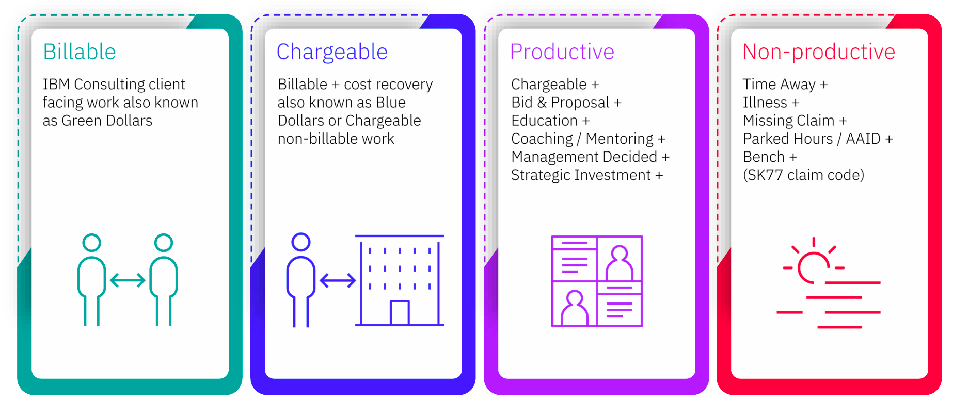
2. Forecast
2.1 Forecast Details
At the beginning of each year, managers work with employees to create an annual UTE forecast, predicting billable and non-billable hours to be claimed.
Gathered information is used to define the annual utilization targets for the employees, as well for our Center and the rates for our Business Unit.
Remember, every employee must record labor claim accurately and honestly on a weekly basis.
Weekly deadline for claim submission is Wednesday and deadline for corrections is Friday.
Claim data is compared directly with the UTE forecast to determine if the forecast is accurate or not. If not, the variances should be justified by the manager.
If utilization targets are not met; this will impact the Center performance over/under (O/U) and your individual UTE target (MyScore metrics).
2.2 Forecast Tools
MyScore — Dashboard that provides an overview of your performance and goals. Helps track your progress, identify areas for improvement, and make informed decisions about your career development.
MySA (Staffing Advisor) — Designed for staffing decisions and workforce planning. Provides data on staffing levels, skill mix, and talent development. Helps Managers optimize team performance and handle staffing needs.
CV Builder — CV is compliant if updated within 6 months. The report cutoff is Thursday evening.
Missing Claim — Submit your claim time entries by Wednesday end of day, every week, to be compliant.
JRS Assessment — Your Primary JRS and Skills should be assessed each half.
My Hours Plan Compliance — How close your forecasted hours are to hours you worked. Difference should be 10% below to 20% above forecasted hours for compliance.
My Hours Plan Completeness — Refers to having at least one assignment for each of the next 13 weeks.
3. Claim
3.1 Claim Tools
TIME@IBM — Tool is used to submit time worked against internal or external service projects and customers, as well as report non-worked time. The data reported through this tool is what IBM Costa Rica uses to recover cost.
This tool is required to report and track vacation, illness, overtime, worked holidays and any time off request that have been previously approved by your manager. (Functional / In-country and both when applicable).
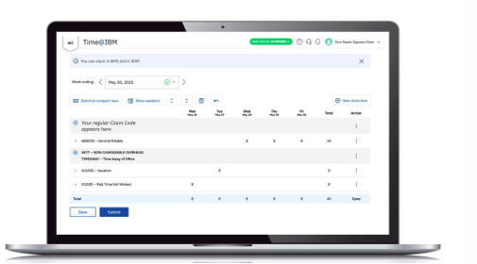
SAP SUCCESS FACTORS — Used for the applicable employee time and absence reporting processes described in the course.
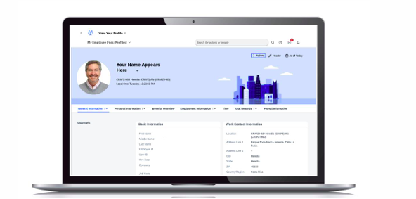
LOCKED PERIOD ADJUSTMENT (LPA) — A tool to perform labor claim adjustments for locked periods (Backclaim for prior month). Locks occur right at the end of each quarter.
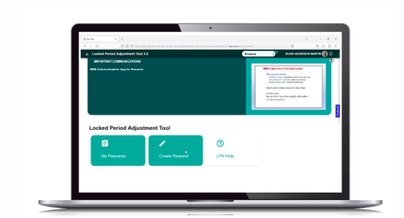
3.2 Time Claim
Weekly claim must be submitted on Wednesday before end of day.
The Minimum weekly hours for day shift: 40 hours per week.
The Minimum Weekly hours for night shift: 30 hours per week.
You need three codes to create a claim line: Account ID, Work Item and Activity Code (Provided by your Manager or PM).
Any change or update to weekly claim must be submitted on Friday before end of day.
Claiming Calendar is released by IBM Finance every year for your reference: https://w3.ibm.com/w3publisher/bms-ierp-knowledgebase/1-about-bms/schedules/ilc-weekending-schedule-2026
Time Impact Calendar — A comprehensive resource designed to inform users about the specific months, quarters, or years affected by changes in claim processes, such as vacation, holiday, overtime, or other time events.
Pre-submission Consultation — Utilize this calendar as a reference point before submitting time-off requests or forecasting future time events, ensuring compliance with evolving claim procedures.
Strategic Planning — Leverage this tool to anticipate potential impacts on your time management and make informed decisions when scheduling vacations, holidays, or overtime, minimizing disruptions and streamlining administrative tasks.
3.3 Backclaim
Quarterly Locks occur at the conclusion of each month; a temporary restriction on certain system functions.
These locks ensure a system-wide pause for maintenance, updates, or evaluations.
Be aware that your payroll may be positively or negatively impacted by SAP SSFF changes.
From a payroll perspective there are taxes (for example CCSS), 'Aguinaldo' and other payments that will require adjustments.
To reduce impact to your payroll, as employees we should ensure all adjustments are completed within the same month or quarter.
Considerations regarding your payroll:
Corrections to the current claim month — If Time@IBM is not yet closed for the month, go to the tool and correct the time. In case of doubts refer to your manager.
Corrections to any previous claim month — According to the Time@IBM claim calendar if there is a correction required in a closed period, it is important to inform your manager. Proactively follow the backclaim request by LPA (Locked Period Adjustment) Tool process by notifying your manager via LPA approval flow: https://lpa.lpa-prod.wdc.app.cirrus.ibm.com/lpa/login
Missing entries (missing claim) — If data is missing in the system, submit the entry in SAP SSFF aligned with Time@IBM claiming, and ask your manager to approve it.
4. Controls
4.1 Accuracy & Timeliness
There are 2 main activities followed within BPO Costa Rica to ensure claiming accuracy and timeliness, for now both are performed by managers.
Monthly Manager’s Validation — Process to validate data reported in Time@IBM and SAP SSFF, using:
• Monthly claiming report — Contains the data claimed by all employees to the respective billable and non-billable codes.
• Checker report — Contains all discrepancies between Time@IBM & SAP SSFF related to OT (Overtime) and non-billable codes.
Manager validation includes confirmation of claiming timeliness, completeness, codes and time distribution accuracy for all direct reports.
The errors found within the process should be solved by the employee and manager within 5 business days.
Chasey – Missing Claim Bot / Claim on Time:
• Chasey will remind employees via slack/email on Wednesday, Thursday and Friday to submit their claim via Time@IBM.
• At the end of the week, Chasey will send e-mail notifications to employees asking to validate their submissions and make corrections if necessary.
• Every week, the BPO Center Leaders receive reports of all employees with missing claim or less than 40 regular claimed hours during the week.
Always claim on time to avoid Manager follow up and/or disciplinary actions.
4.2 Audit / Compliance
Business controls (BC) is responsible to validate that Costa Rica BPO is compliant.
Country Internal Testing:
• Compliance squad carries out monthly assessments to validate the accuracy of time claiming and monitoring of the process.
• Includes country internal testing by department where weekly claiming is validated with SAP SSFF approved data.
Global IKC Controls:
• BPO centers are tested for Global Internal Key Controls (IKC) Assessments, including 'IKC05 - Labor Claiming'.
• Defects will cause negative results which impact perception of Costa Rica compared to other delivery centers.
• Report issues on Time@IBM or SAP SSFF will lead to internal defects for specific departments or accounts, also impacting final area rate (Satisfactory, Marginal or Unsatisfactory).
BPO Audit Compliance:
• All employees must understand and be aware that our Center is subject to Corporate and Internal Audits, please commit to working hard and report timely and accurate data.
• Favorable ratings will position IBM Costa Rica as a desirable destination for new services and opportunities.

5 Use of codes and Systems
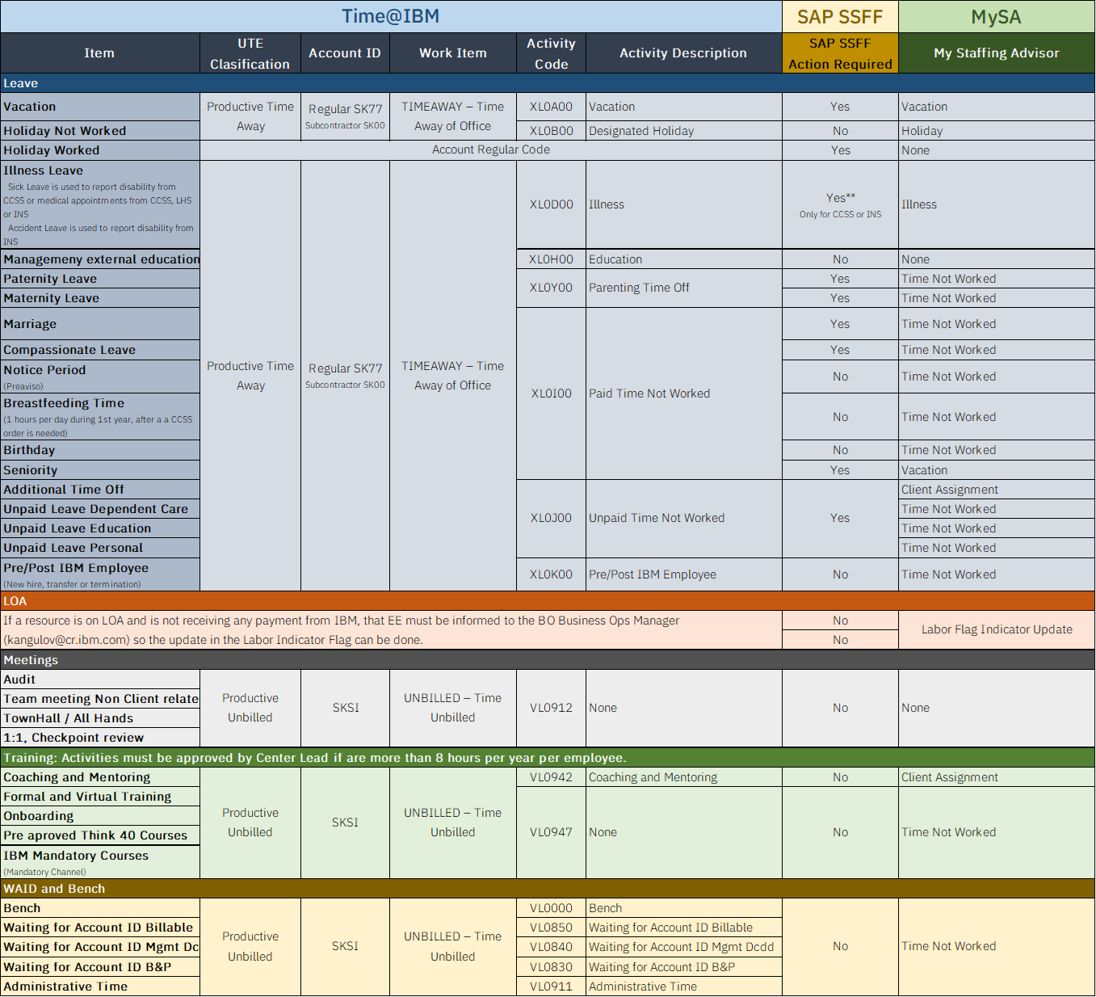

1. Vacaciones
Registrar en 3 herramientas: TIME + SAP + MySA. Documentación obligatoria: aprobación manager, backup confirmado, OOO activo (IBM y cliente).
Vacation time must be aligned with your Utilization Forecast, agreed with your manager(s) and approved in SAP SSFF. Remember: if you are taken a whole week (or maximum three continuous weeks) in Time@IBM you should submit in advance your claim.
Each account and each manager have internal documentation process, follow their instructions
Herramientas: TIME | SAP SF | MySA

TIME — Vacation (XL0A00)

- Ir a Time@IBM → seleccionar la semana de vacaciones
- De click en New Claim Item y escriba el Account: SK77
- En Work Item que debes seleccionar es el que dice TIME AWAY
- Y en Activity seleccione XL0A00 - Vacation.

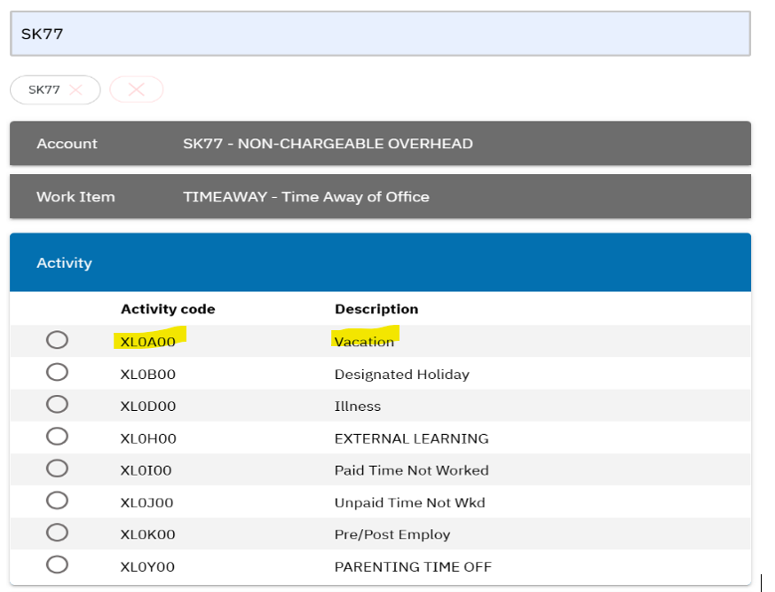

Nota:
- Verifique que el Total de la semana sume 40 horas: Se debe de restar las horas de vacaciones de las horas regulares.
*No sumara 40 horas si durante la semana se realizó Over Time ya que las horas de OT se sumaran a las 40 horas. (hacer referencia al proceso de Over Time)
- Submita el Time una vez que confirmes que la información agregada es la correcta

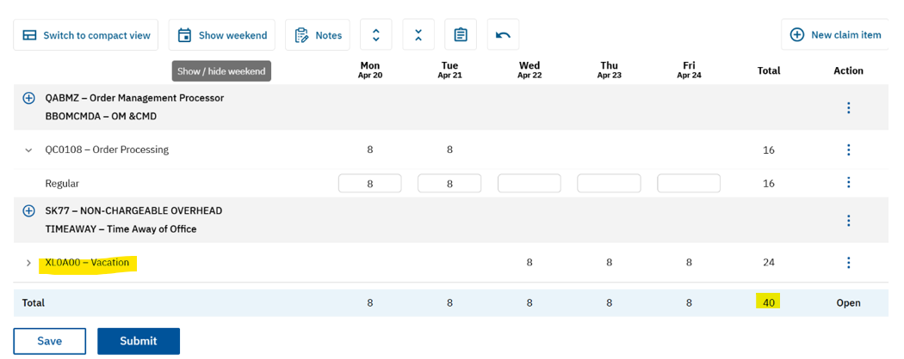

1.2 SAP SuccessFactors — Vacation Time Plan
• HR Zone → Solicitar tiempo libre → Absences → Create
• Time Type: Vacation Time Plan
• Start Date / End Date → Submit
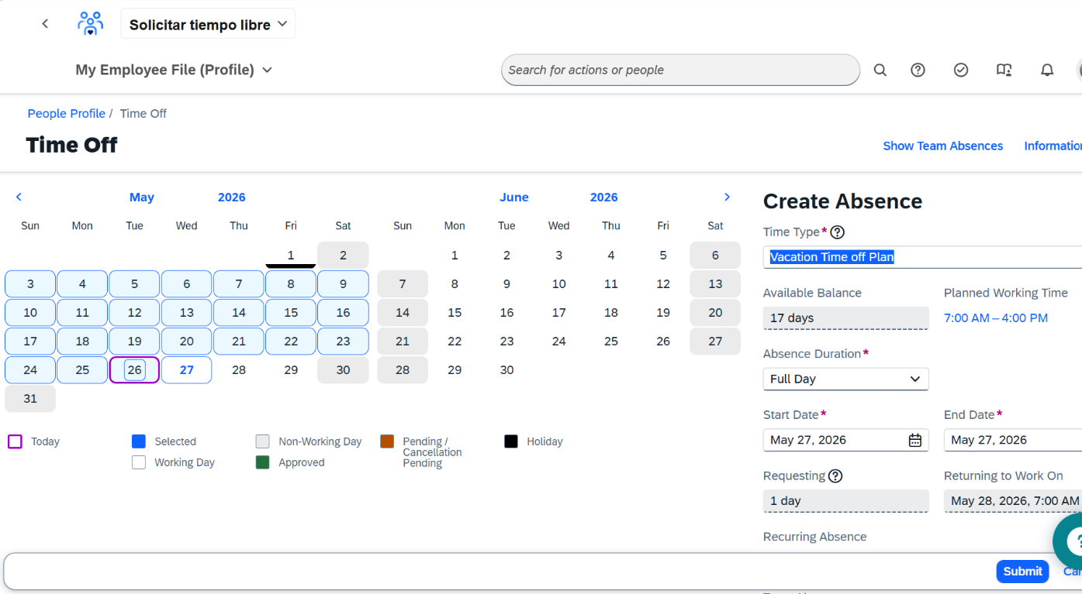

1.3 MySA — Non-Productive / Vacation
- Ir a My Hours Plan: https://w3.ibm.com/services/tools/mysa/app/#/AssignmentAndUtilization
- Add
• Assignment Type: Seleccionar Non-Productive → Category: Vacation
• Next → Start/End dates (días de vacaciones)
- Projected hours per week siempre dejarlo en 40 → Submit

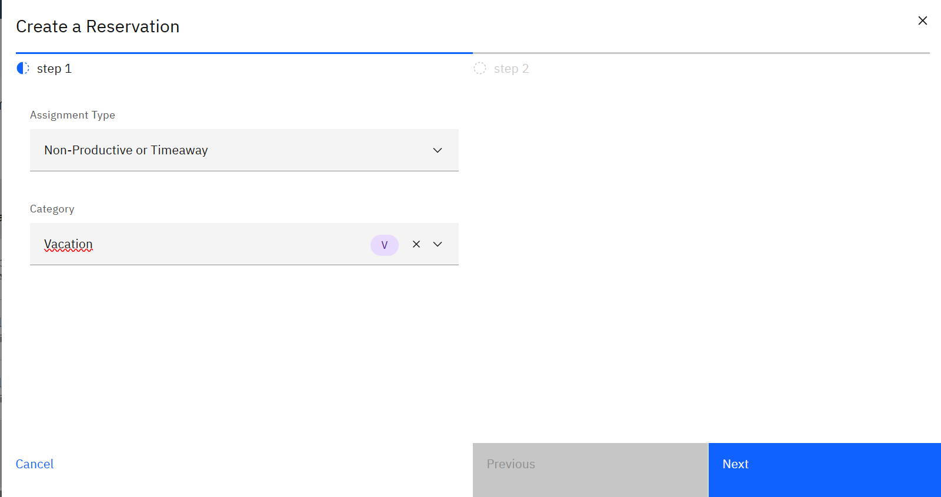
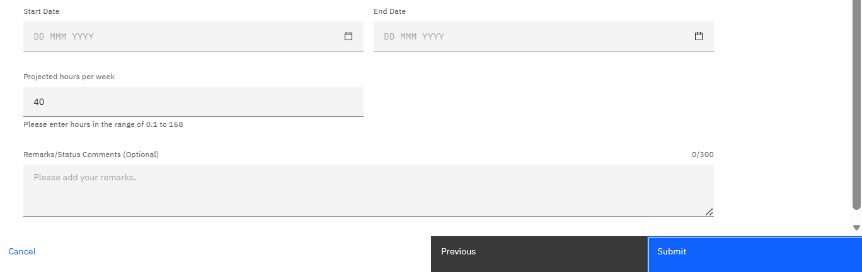

- Vas a notar que el total de las semanas se sumo las vacaciones. Asegurate que esas horas las restes a las horas regulares ya que las vacaciones + las horas regulares deben de dar un total de 40 horas

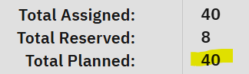

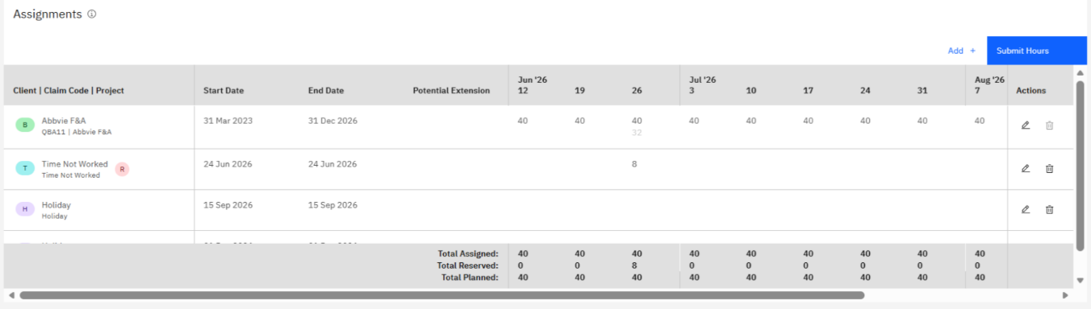

2. Cumpleaños
Registrar en 3 herramientas: TIME + MySA + LiveWork. SAP no requerido. Tomar dentro del mes de cumpleaños. No acumulable.
Herramientas: TIME | MySA |

2.1 TIME — Paid Time Not Worked (XL0I00)
• New Claim Item → Account: SK77 → Work Item: TIME AWAY → Activity: Paid Time Not Worked
• Total semana = 40h: restar las 8h de la línea regular
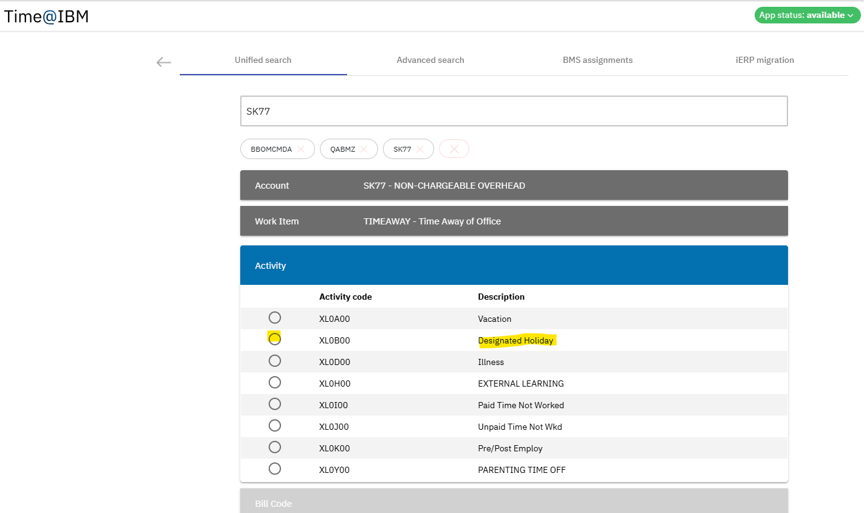
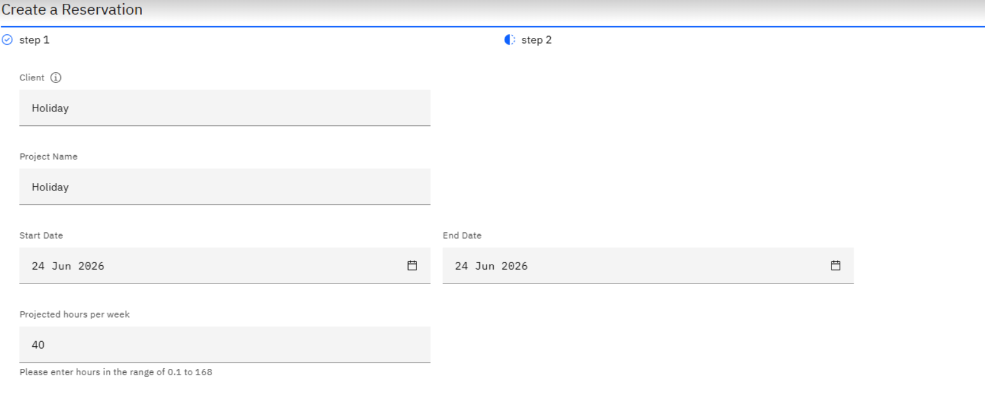
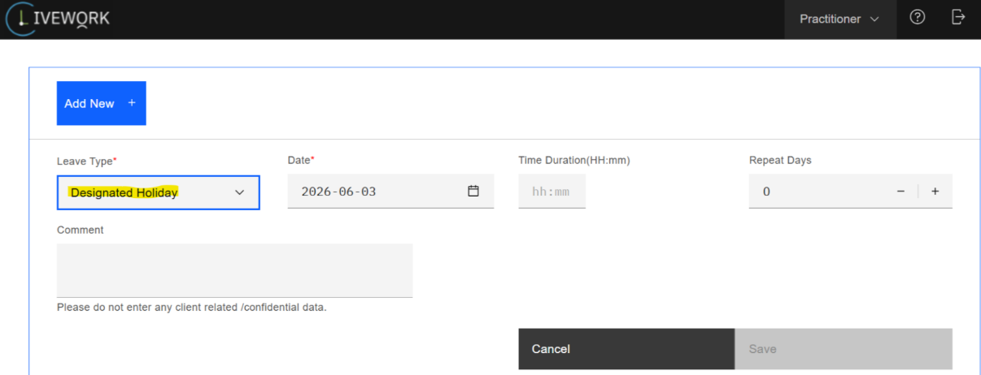

2.2 MySA — Non-Productive / Paid Time Not Worked
• My Hours Plan → Add+
• Assignment Type: Non-Productive → Category: Paid Time Not Worked
• Next → fechas → Submit
• Reducir línea principal para mantener total = 40h
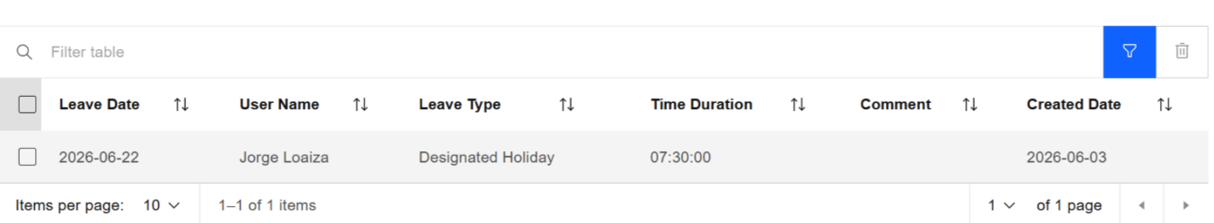
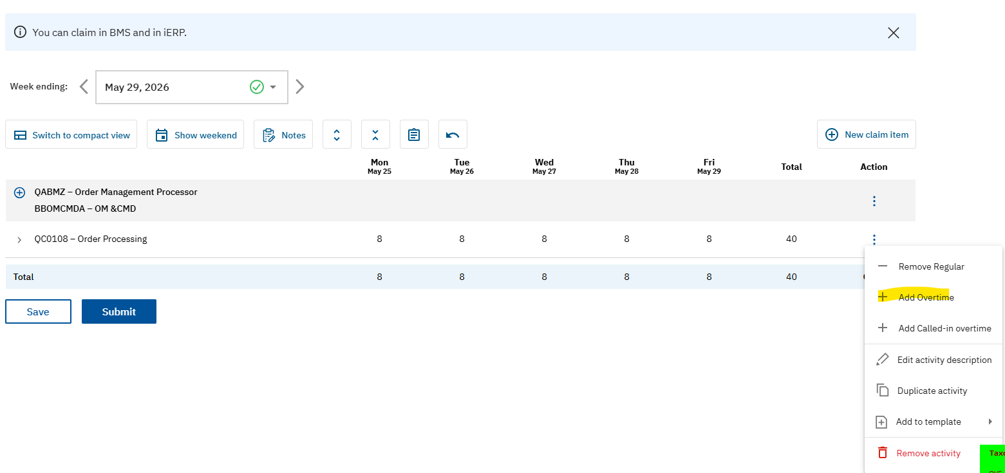

2.3 LiveWork — Vacation Leave (Cumpleaños)
• Exception leave → Leave management → Add new → Vacation Leave
• Guardar → evidencia para checklist
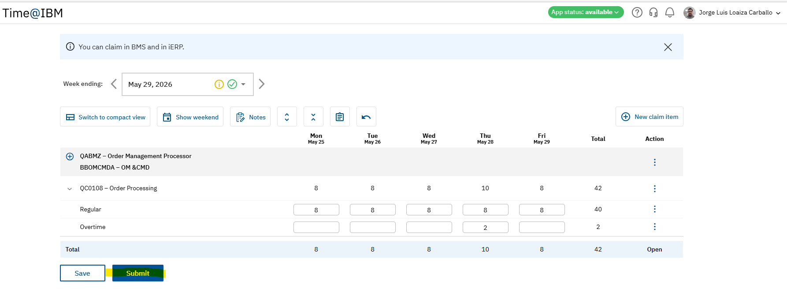
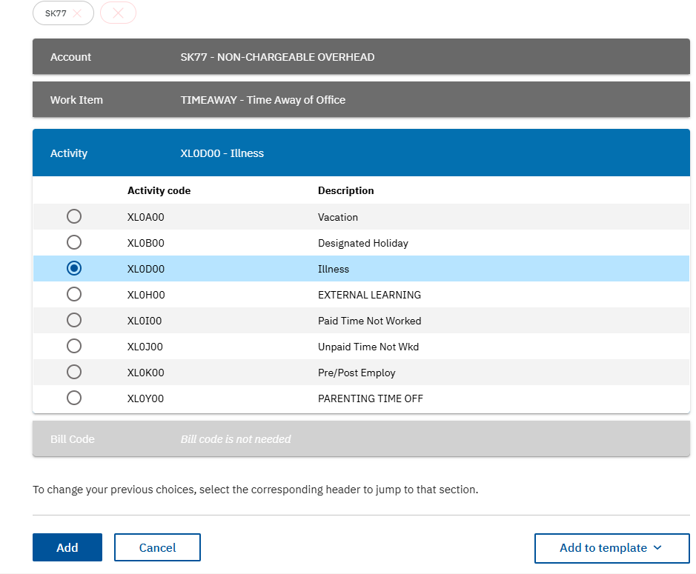

3. Feriado No Trabajado
Registrar en 3 herramientas: TIME + MySA + LiveWork. Completar con anticipación.
Herramientas: TIME | MySA | LiveWork

3.1 TIME — Designated Holiday (XL0B00)
• New Claim Item → Account: SK77 → Work Item: TIME AWAY → Activity: Designated Holiday
• Total semana = 40h: restar las 8h de la línea regular
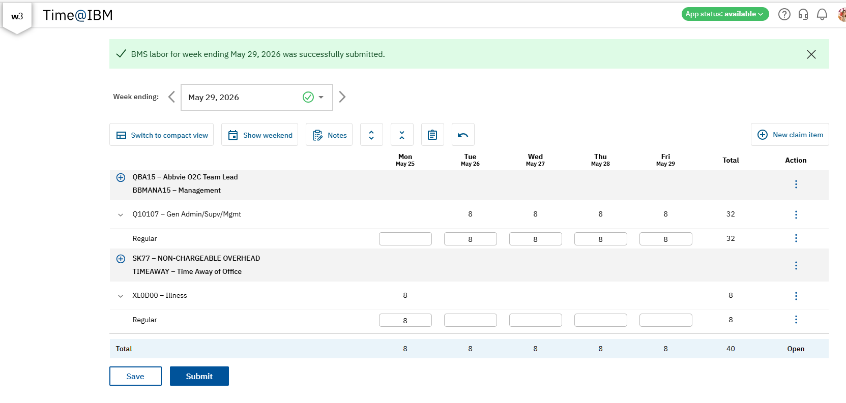

3.2 MySA — Non-Productive / Designated Holiday
• My Hours Plan → Add+ → Non-Productive → Designated Holiday
• Fechas → Submit. Reducir línea principal.
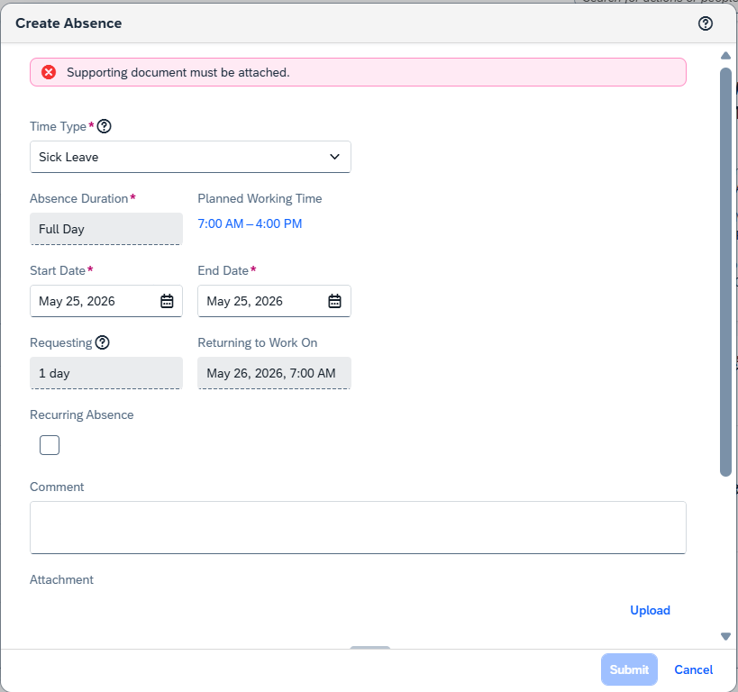

3.3 LiveWork — Designated Holiday
• Exception leave → Leave management → Add new → Designated Holiday
• Guardar → evidencia para checklist

4. Overtime (Horas Extra)
Registrar en 2 herramientas: TIME + SAP. Requiere aprobación previa del manager.
Herramientas: TIME | SAP SF
• TIME: en menú ⋮ → Add Overtime → restar esas horas de las horas regulares → Submit
• SAP: registrar por día, hora inicio DESPUÉS del horario regular (ej. schedule 7AM–4PM → OT desde 4:00 PM)
⚠️ Si se ingresa hora incorrecta en SAP, el sistema lo cuenta como hora regular y NO paga OT

5. Incapacidad / Sick Leave
Registrar en 2 herramientas: TIME + SAP. NO se registra en MySA.
Herramientas: TIME | SAP SF
• TIME: SK77 | TIMEAWAY | Illness (XL0D00). Total semana = 40h; restar horas de incapacidad de línea regular.
• SAP: HR Zone → Registre su tiempo → Absences → Create → Time Type: Sick Leave → fechas → adjuntar documento en Upload
⚠️ Siempre coordinar con manager para confirmar proceso según duración y tipo

6. LPA / Backclaim
Herramientas: LPA Tool
• El manager abre la tarea en LPA
• Ir a lpa.lpa-prod.wdc.app.cirrus.ibm.com con credenciales IBM
• Verificar qué herramienta tiene el error con la información del manager
• En 'To Add new entry Input Account Id / Work Item' → ingresar el Account ID correcto → reportar horas pendientes

7. Checklist de Ausencia
Para vacaciones, feriados y cumpleaños. Completar con capturas de pantalla y enviar al manager mínimo 1 hora antes de salir.

7.1 Evidencias requeridas
1. Aprobación — captura de aprobación del manager
2. OOO IBM y Cliente — captura de los mensajes de fuera de oficina
3. TIME — captura de la semana(s) en Time@IBM
4. SAP SuccessFactors — captura del registro aprobado (solo si aplica)
5. MySA — captura del forecast actualizado
6. LiveWork — captura del registro en LiveWork
7. Email backup — captura del correo de aprobación del backup con tareas pendientes
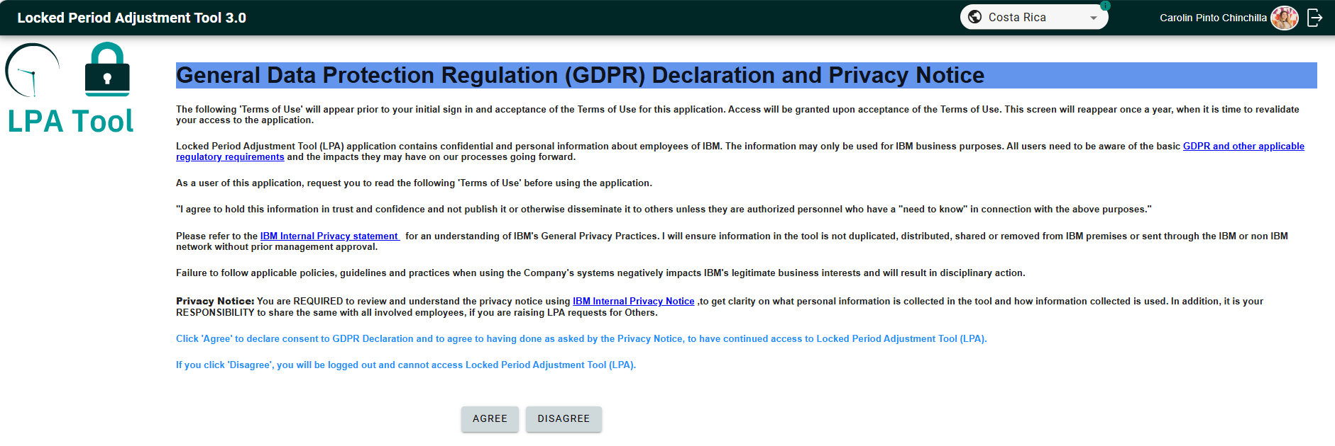
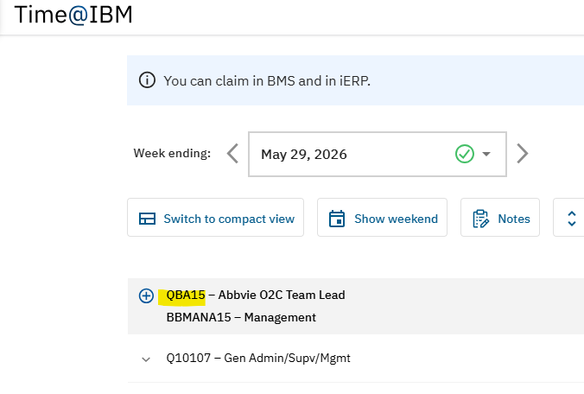
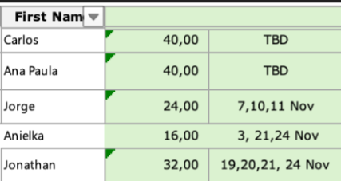
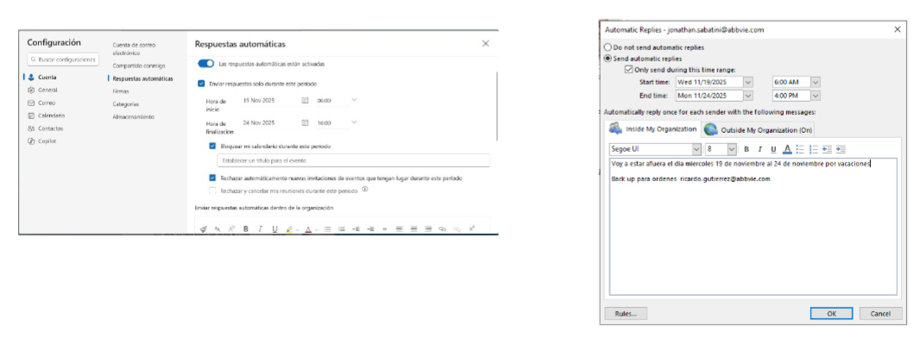
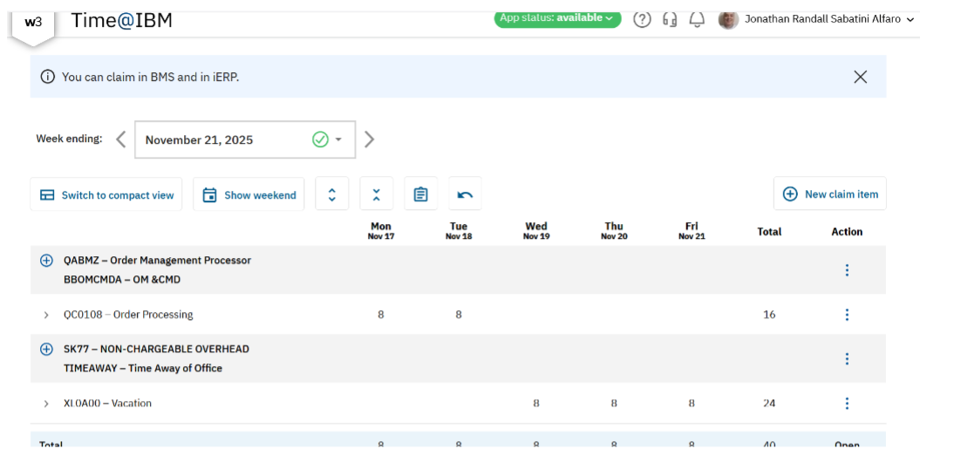
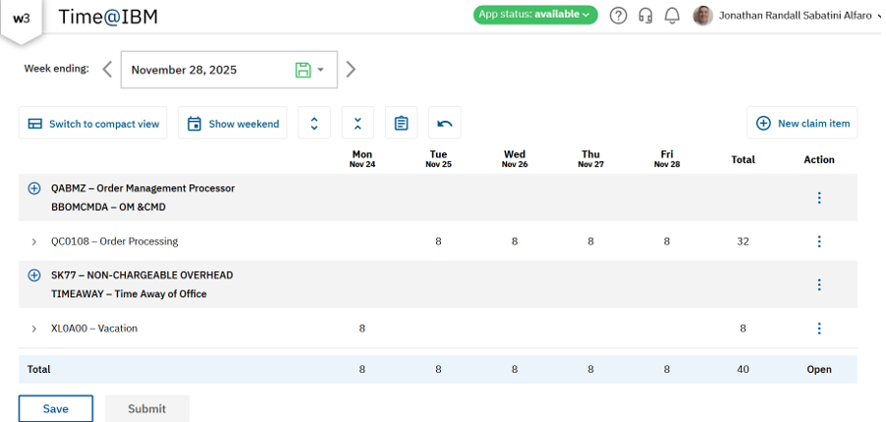
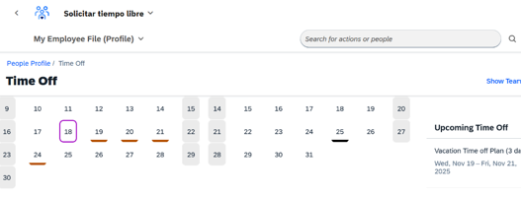
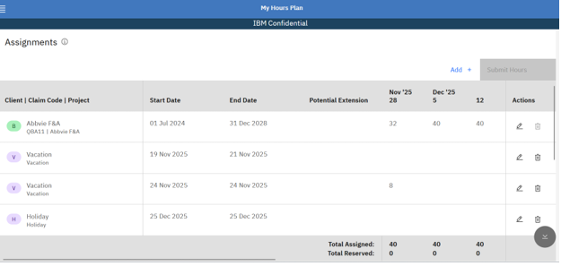
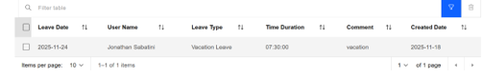
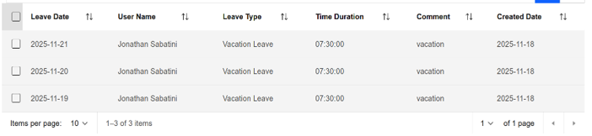
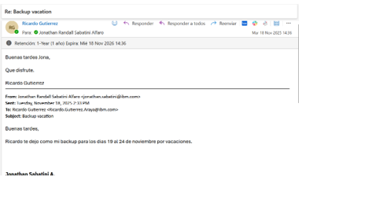
TRACE — Guía Visual ICA 2.0 · IBM Consulting Costa Rica · Made with IBM Bob

