Wendy Bronson
Assignment Module 2.3

EDR:
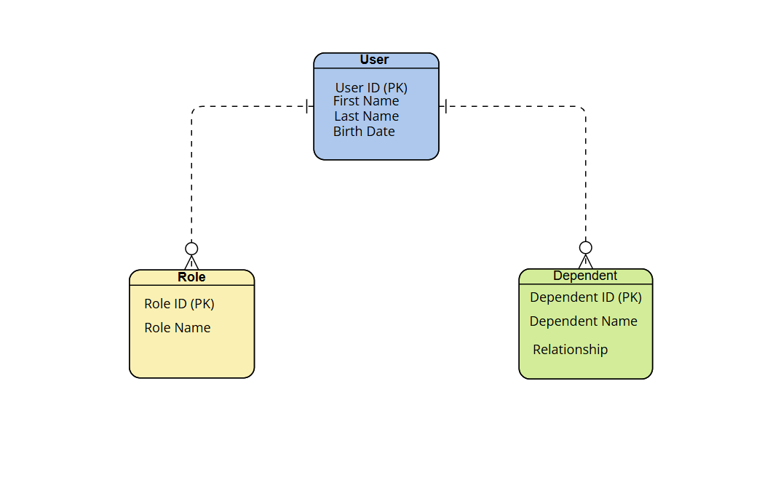
NoSQL Data Structure
