Group C
Wendy Bronson
Eric Sengvanhpheng
William Judd
Luis Cortez
Martha Guzman
July 30, 2026
Database Development and Use
Module 11.2 Milestone #3
Case Study: Bacchus Winery

Project Overview
For Milestone #3, Group C created three business reports using data from the Bacchus Winery database. Each report retrieves data from multiple tables and provides information that could help management make decisions about suppliers, wine sales, employee workloads, production, and inventory.

Report 1: Monthly Supplier Delivery Performance
This report summarizes supplier deliveries by year and month for each supplier. It displays the total number of deliveries, how many deliveries have been completed, how many are still pending, and the average number of days completed deliveries arrived early or late. This information helps Bacchus Winery monitor supplier performance, identify delivery trends, and recognize delays that could affect production scheduling and inventory planning. The report groups deliveries by supplier and month, allowing multiple deliveries within the same month to be summarized into a single management report instead of displaying each delivery separately.
A negative average indicates deliveries arrived early, zero indicates deliveries arrived on time, and a positive average indicates deliveries arrived late. A NULL value means there were no completed deliveries for that month, so an average could not be calculated.

Figure 1Monthly Supplier Delivery Performance Report
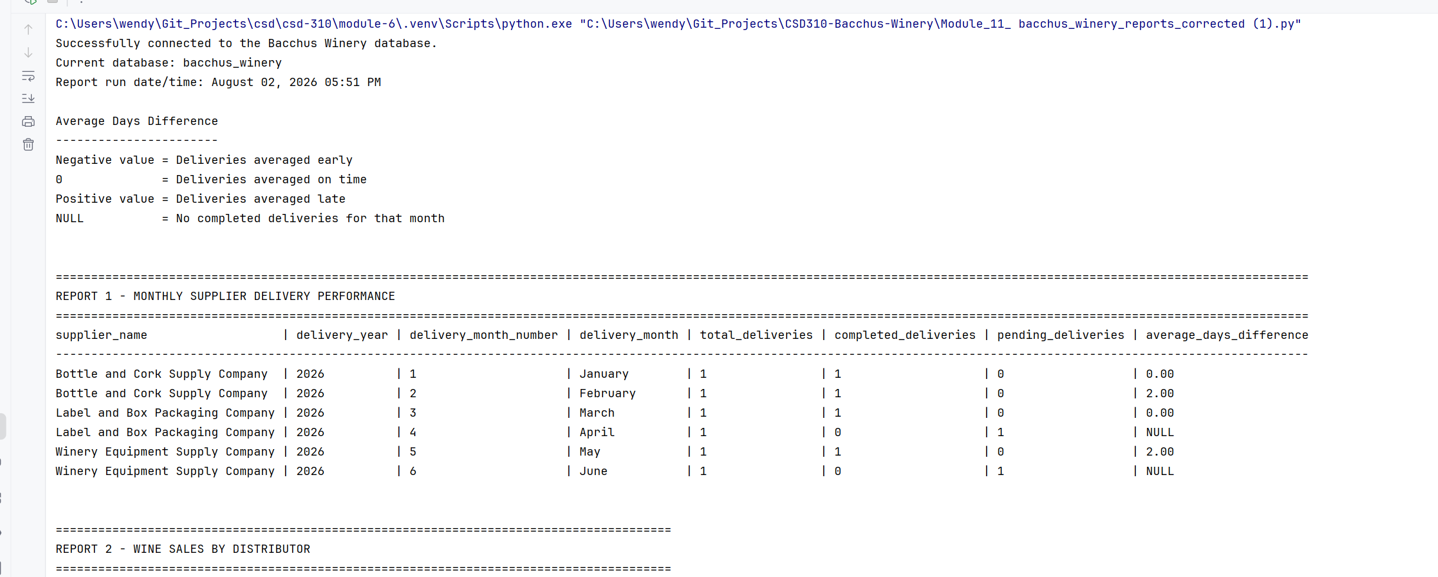

Report 2: Wine Sales by Distributor
This report shows the number of bottles ordered and the total sales amount for each wine and distributor. It allows management to see which wines are selling the best and which distributors are purchasing the most product. This information could help with production planning, inventory levels, and future sales efforts.

Figure 2 Wine Sales by Distributor Report
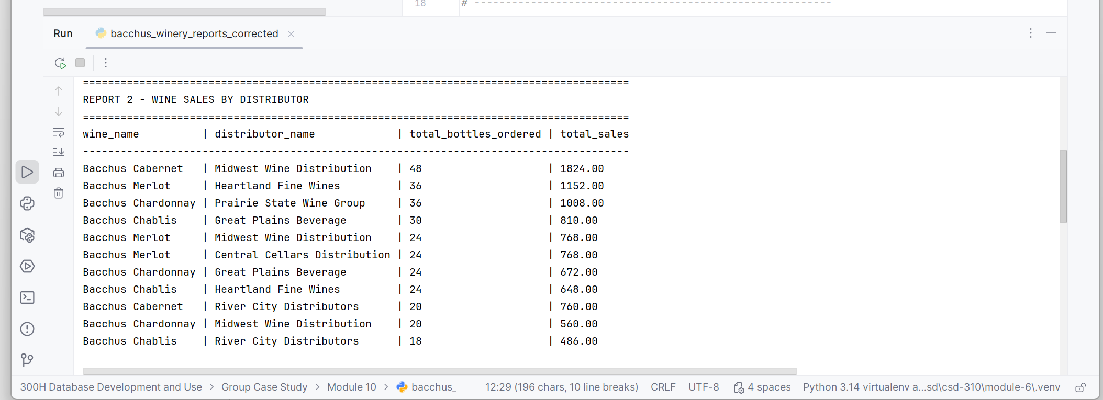

Report 3: Employee Hours for the Last Four Quarters
This report shows the total hours worked by each employee during the four most recent calendar quarters stored in the database. It gives management a way to compare employee workloads from quarter to quarter and identify possible staffing needs or changes in workload.
This report was updated to incorporate the instructor's feedback by displaying employee hours for the four most recent calendar quarters. This allows management to compare workloads across quarters and better identify staffing trends.
Figure 3 Employee Hours for the Last Four Quarters
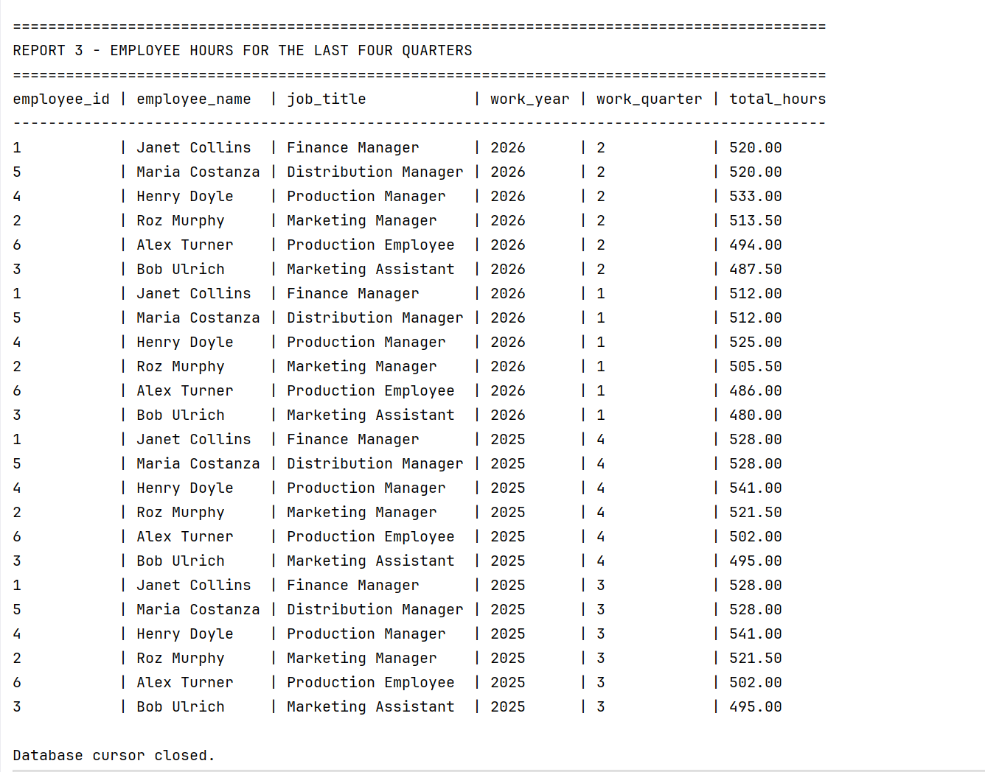

Revised Entity-Relationship Diagram
The revised ERD reflects the final structure of the Bacchus Winery database. It includes the tables, primary keys, foreign keys, and relationships used by the three business reports.
