Wendy Bronson
Assignment Module 2.3

ERD:
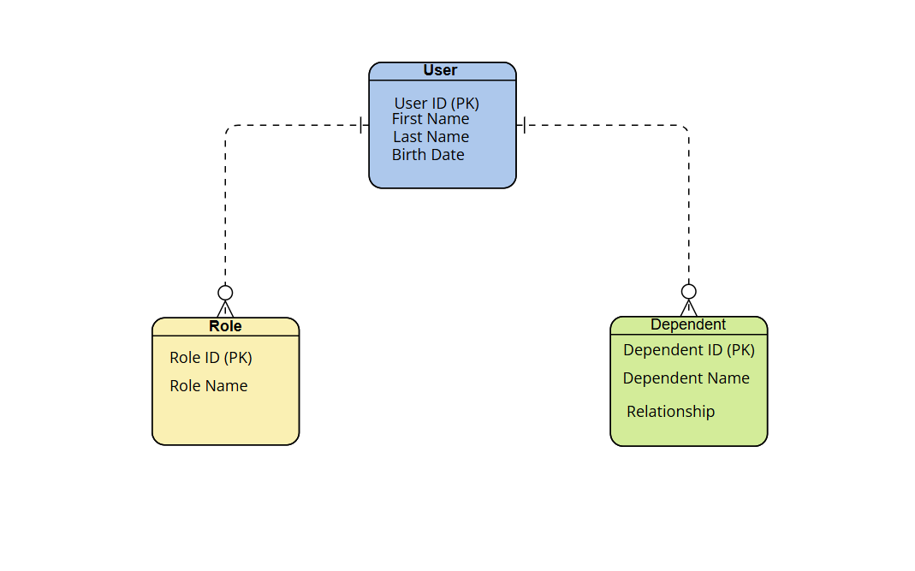
NoSQL Data Structure
