Wendy Bronson
Module 5.2 Assignment
06/27/2026

MySQL Command Line Screenshot:
Figure 1. SQL Script (db_init_2022.sql) Executed Successfully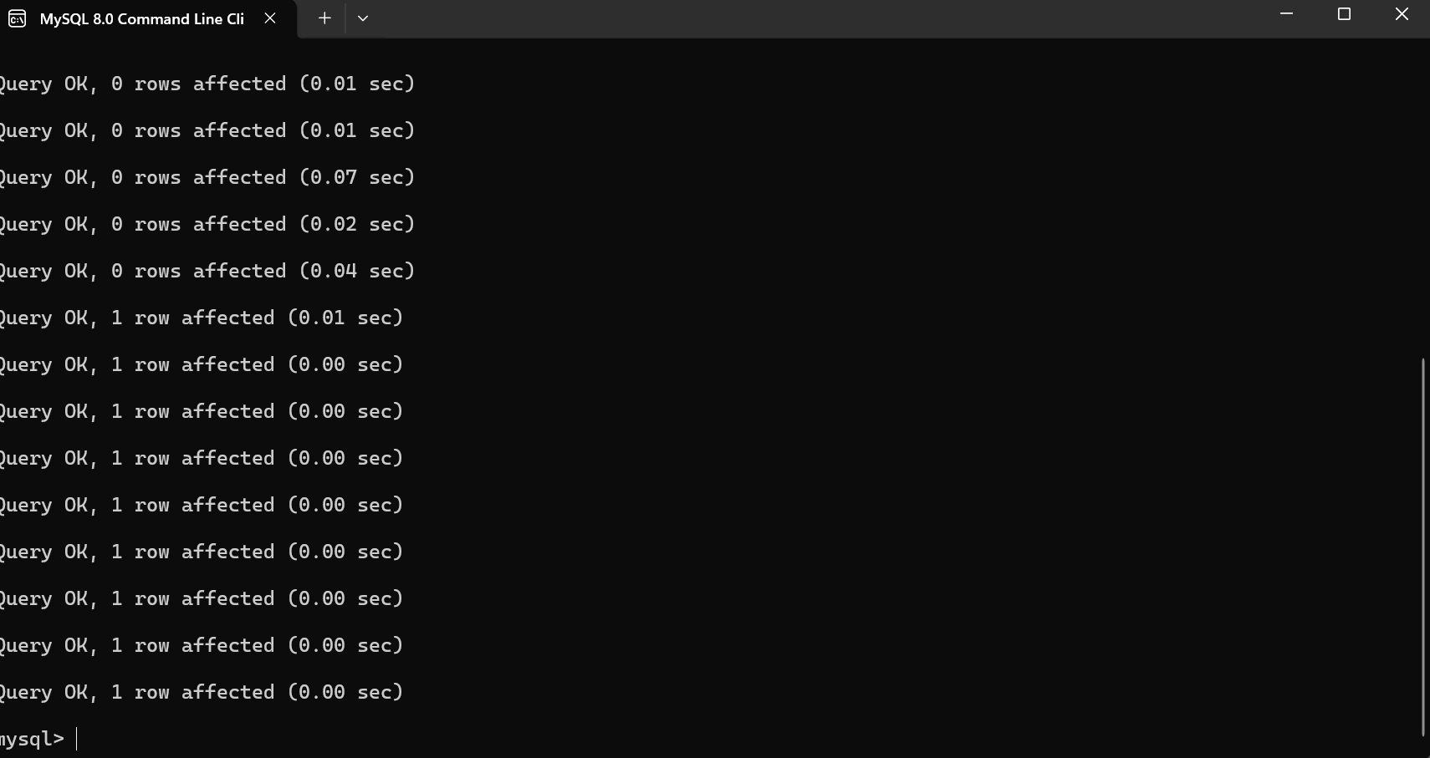
Figure 2. SHOW TABLES Output for the Movies Database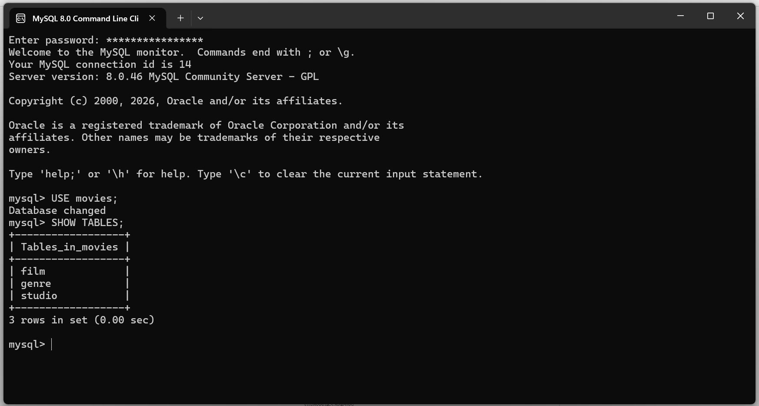
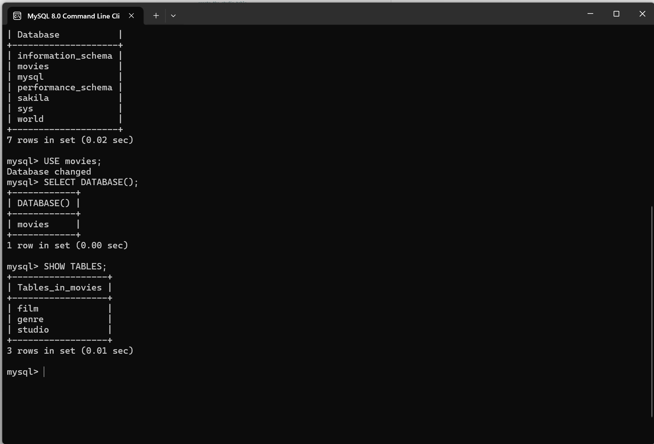
Figure 3. PyCharm Output Showing a Successful Connection to the Movies Database
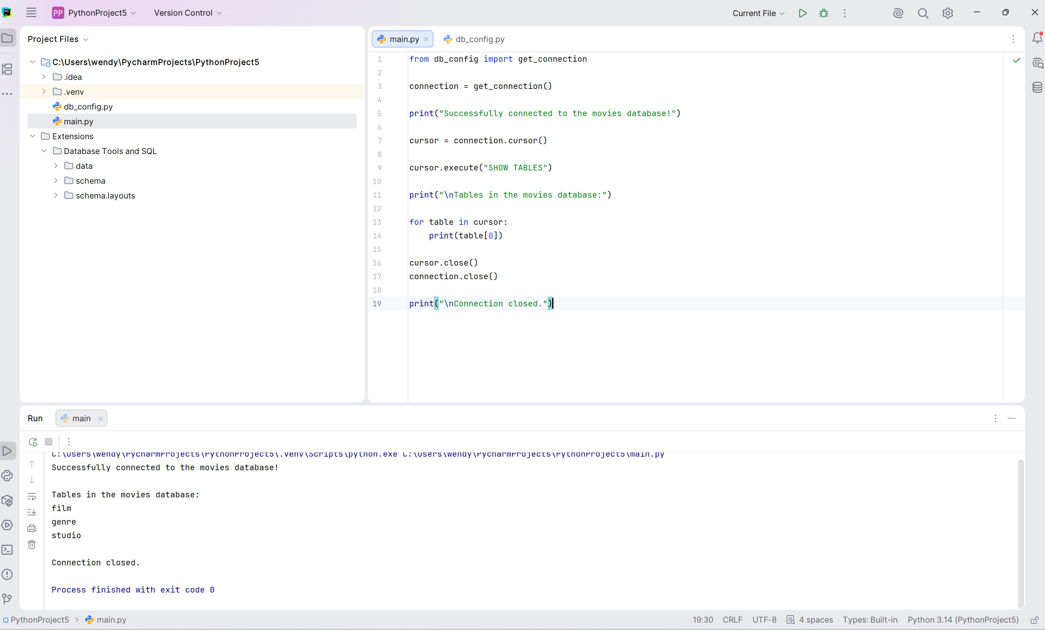

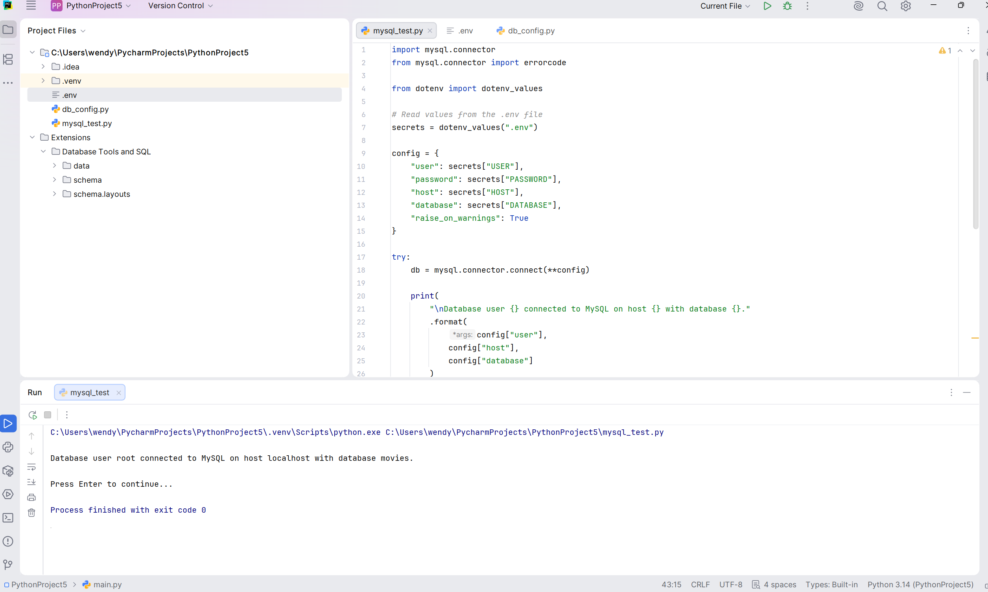

Git Repository: https://github.com/Wendybronson/csd-310.git

