06/10/2026

Wendy Bronson
Module 2.2 Debugging

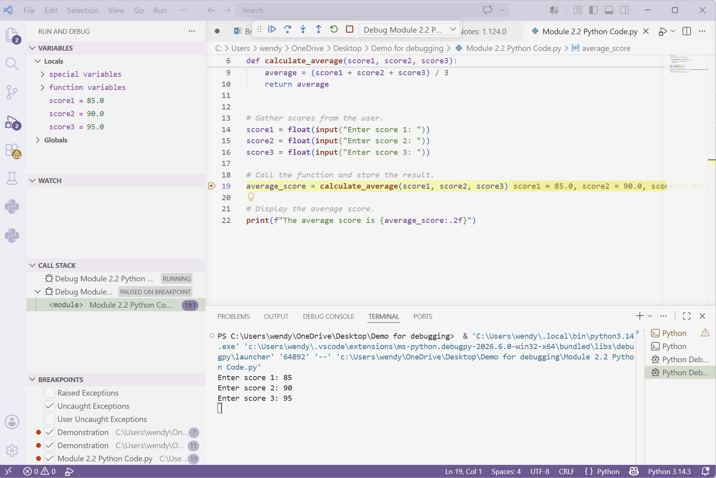
Figure 2. Stepped into the calculate average() function to observe the values passed into the function.
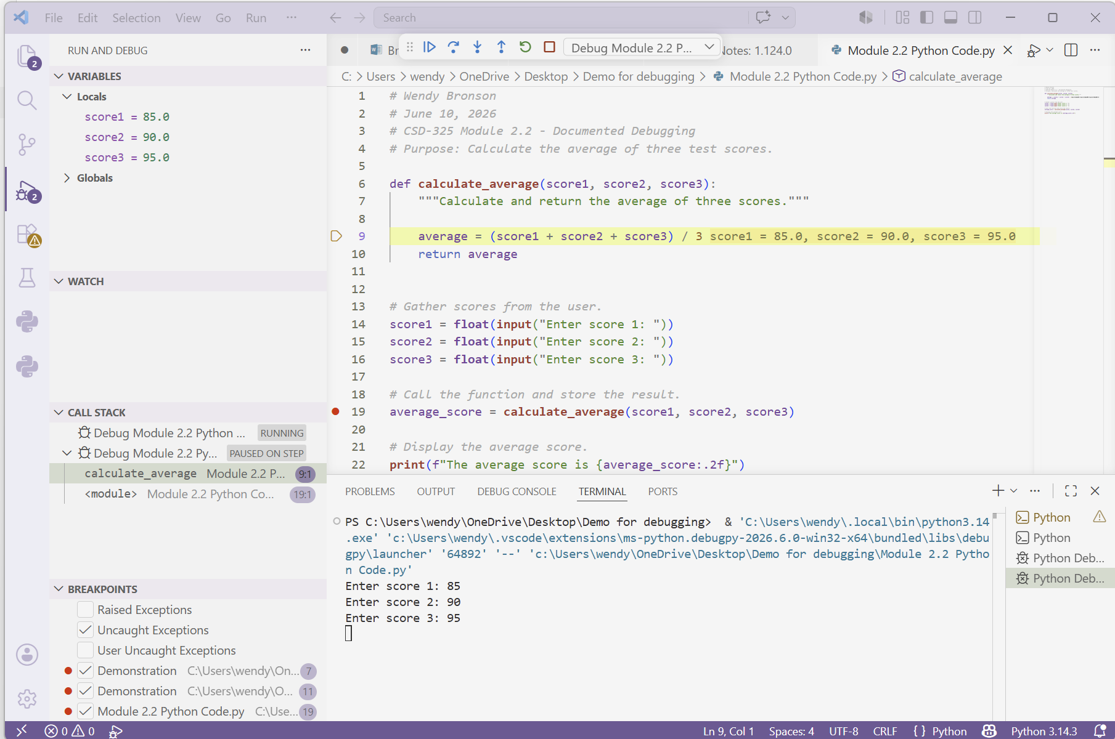
Figure 3. Step Over - The average value has been calculated and is ready to be returned to the main program.

