Figure 1.Module 4.2 – Original sitka_highs.py Flowchart
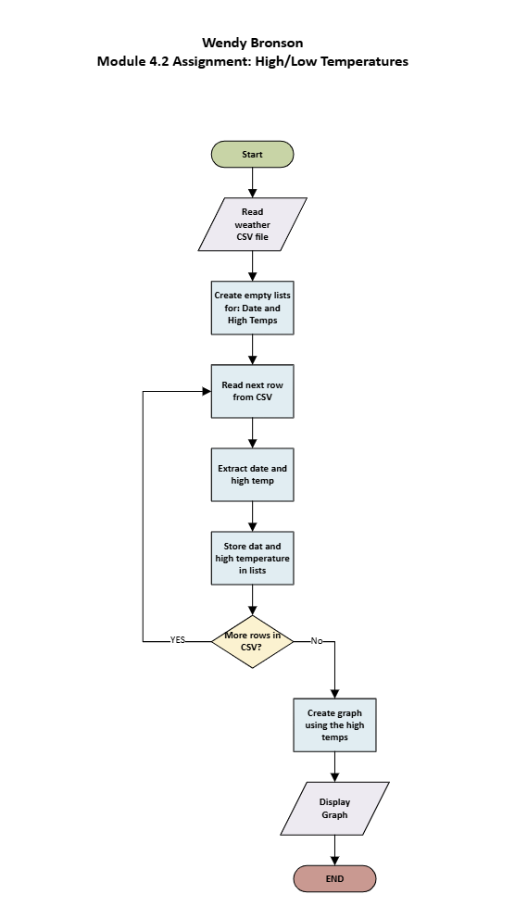

Figure 2 Module 4.2 – Revised sitka_high_low_.py Flowchart
