Wendy Bronson
Module 7.2 Assignment
Test Cases
CSD325-300H Advanced Python (2265-DD)
07/11/2026

- Function that accepts two parameters: a city name and a country name.
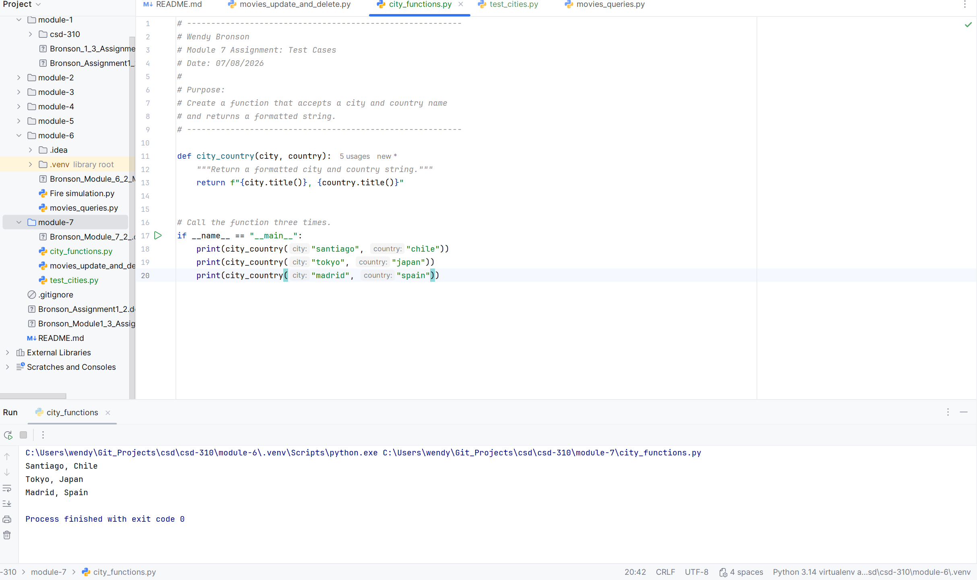
- Run test_cities.py, and make sure test_city_country() passes. When it passes, take a screenshot of the result.
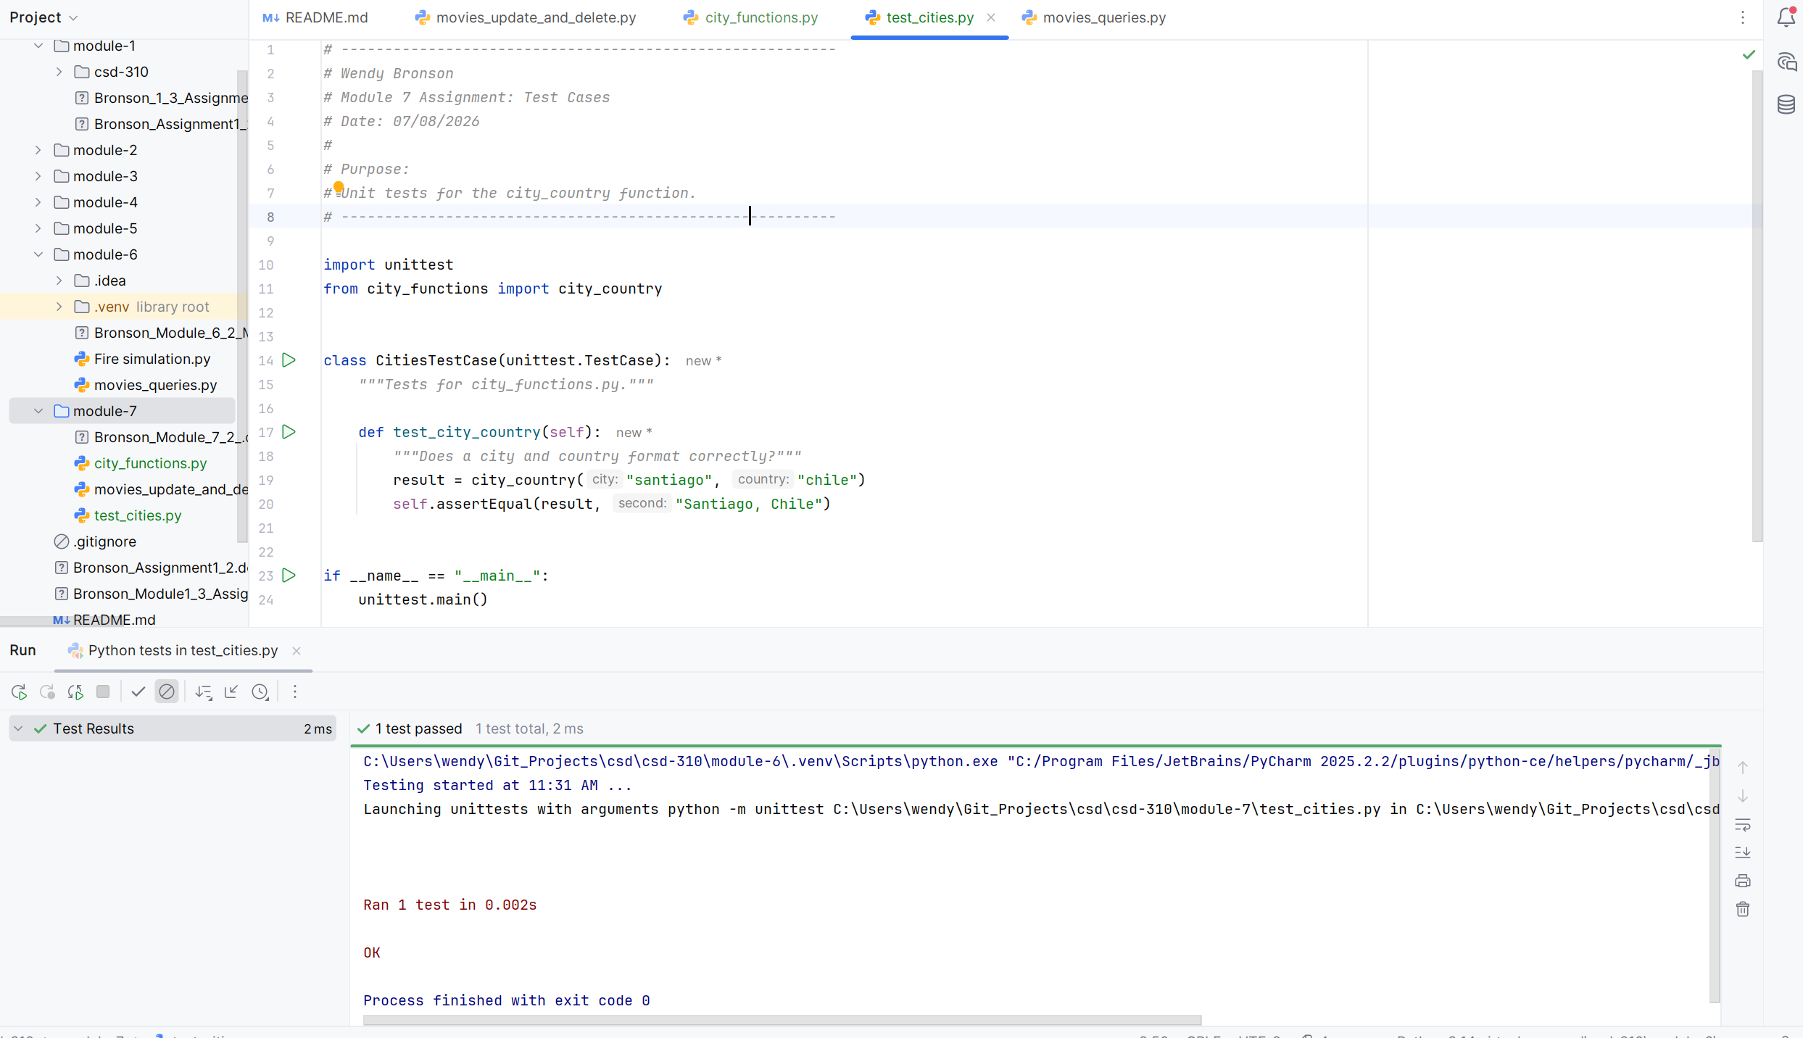
- Modify your city_country function in city_functions.py so it requires a third parameter, population. It should now return a single string of the form City, Country - population xxx, such as Santiago, Chile - population 5000000.
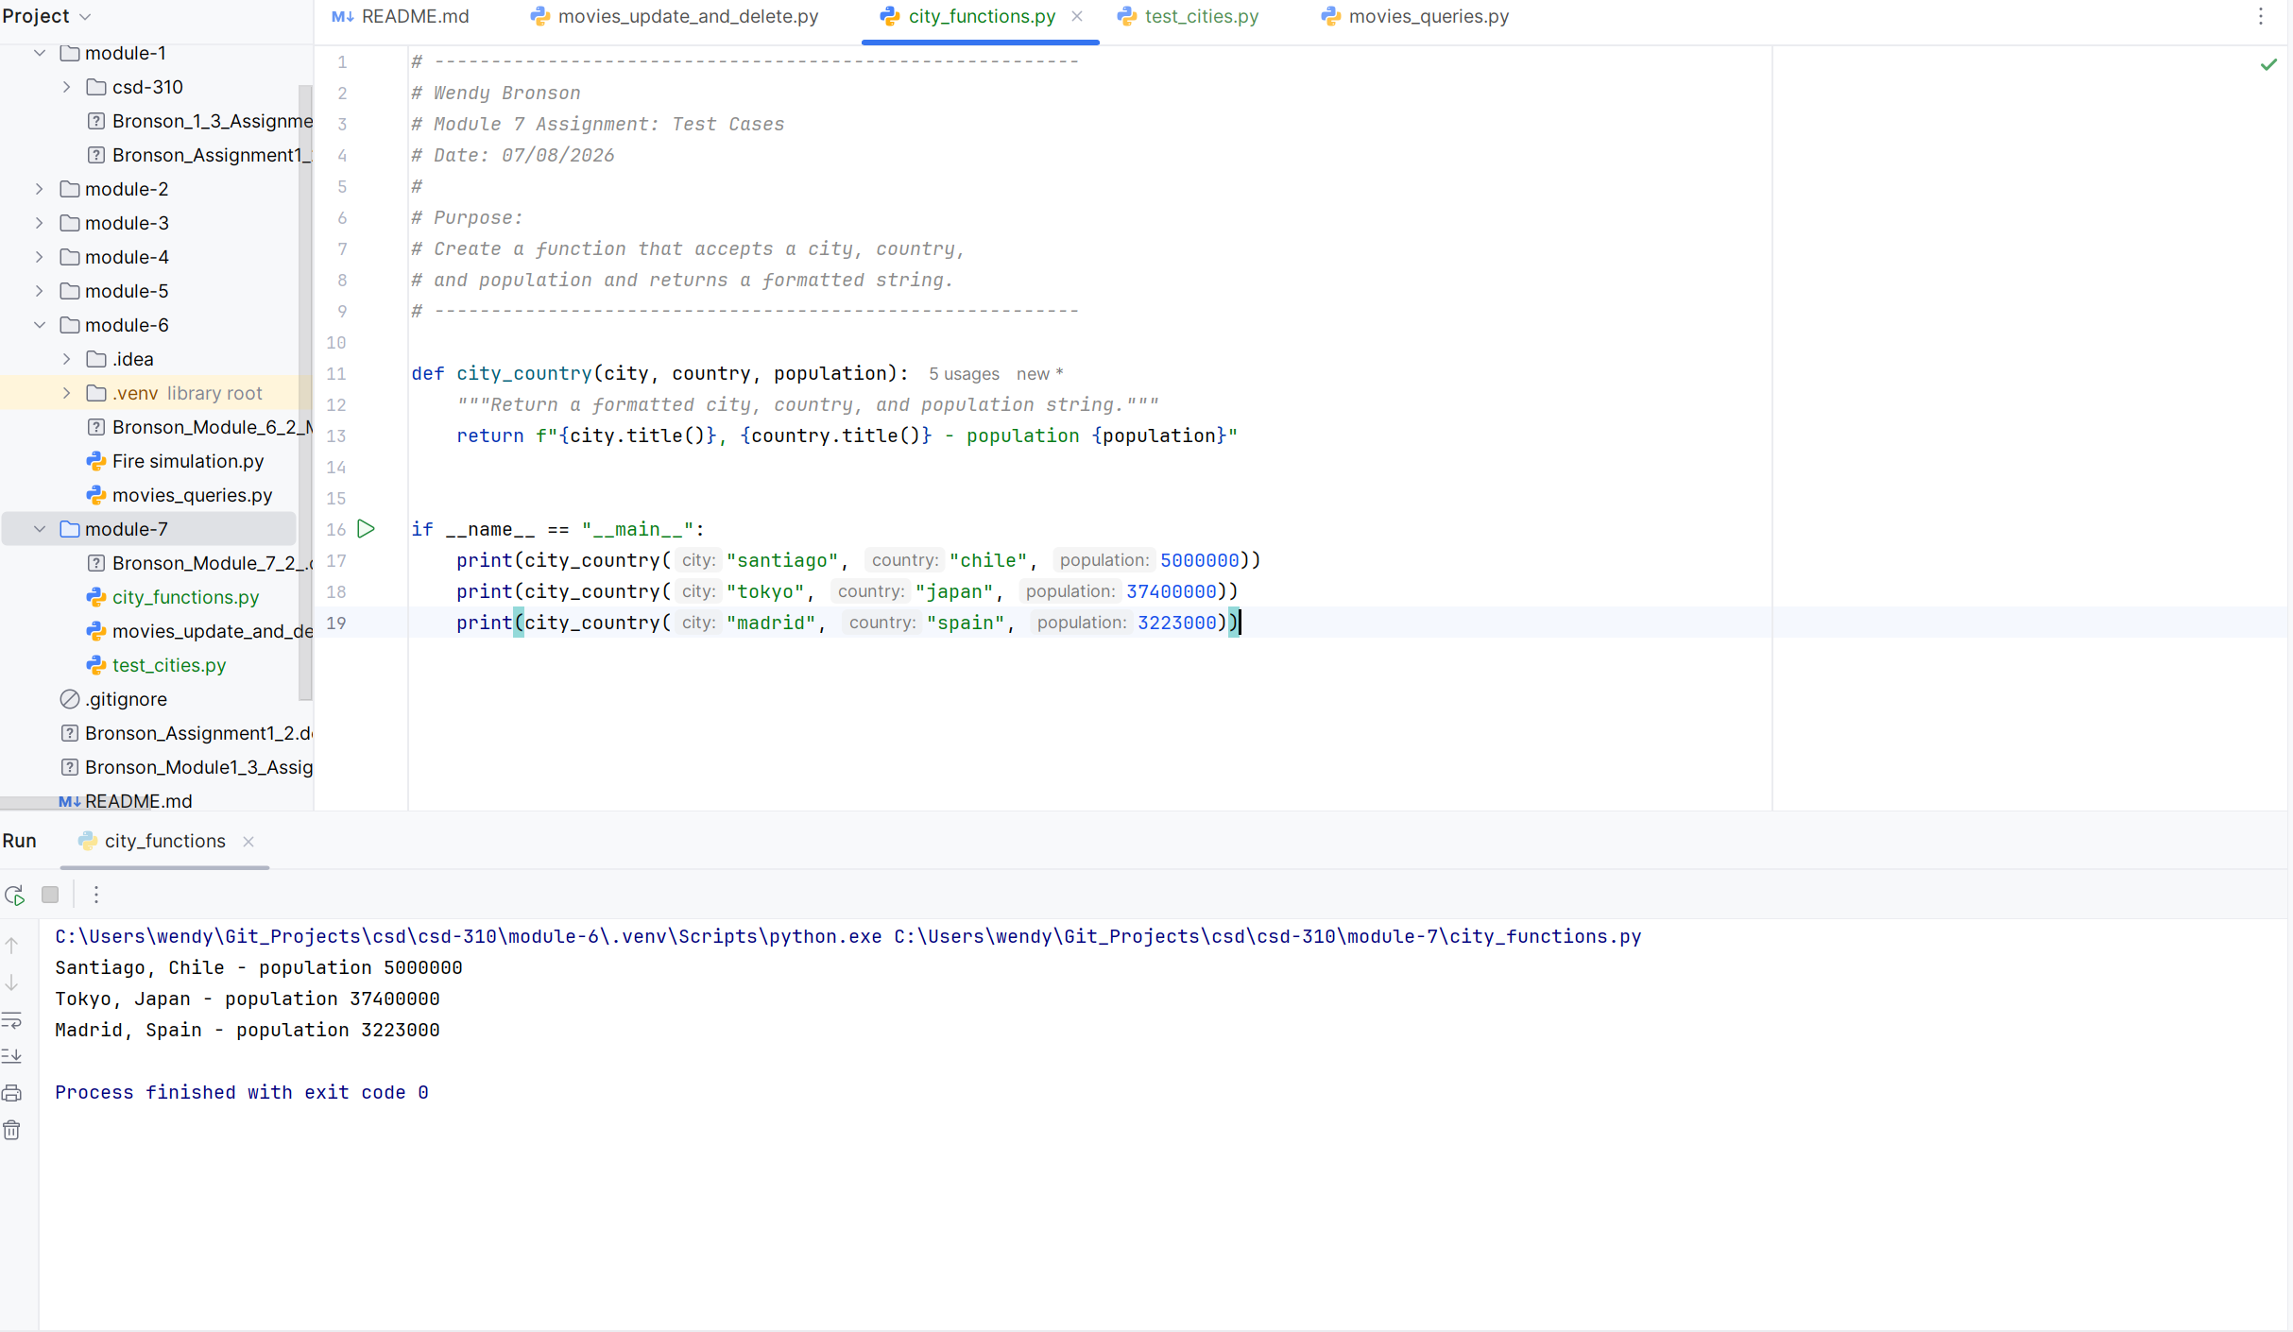
- Run test_cities.py again. It should fail. Take a screenshot of the result and paste into your Word document.
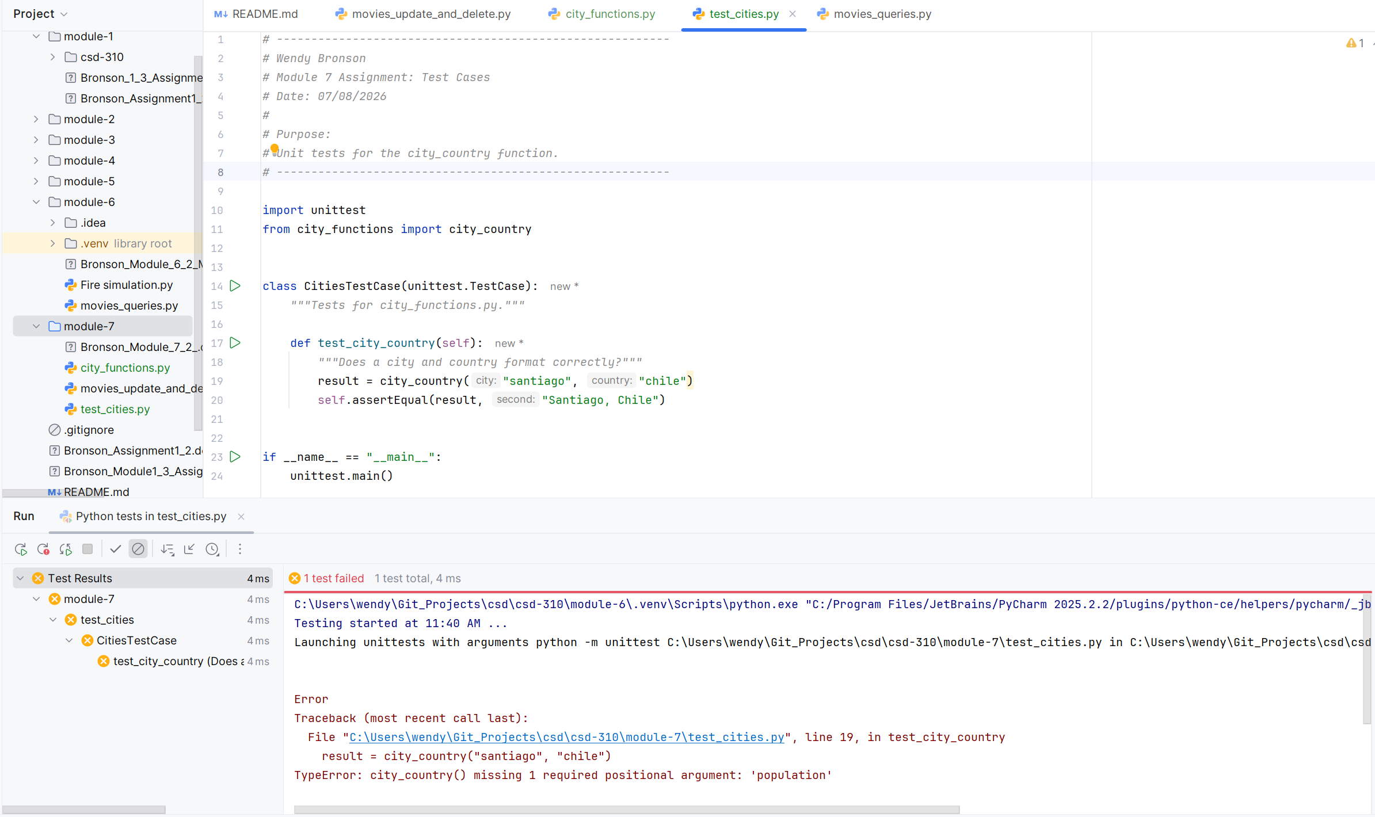
- Modify your city_country function in city_functions.py so that the population parameter is optional.
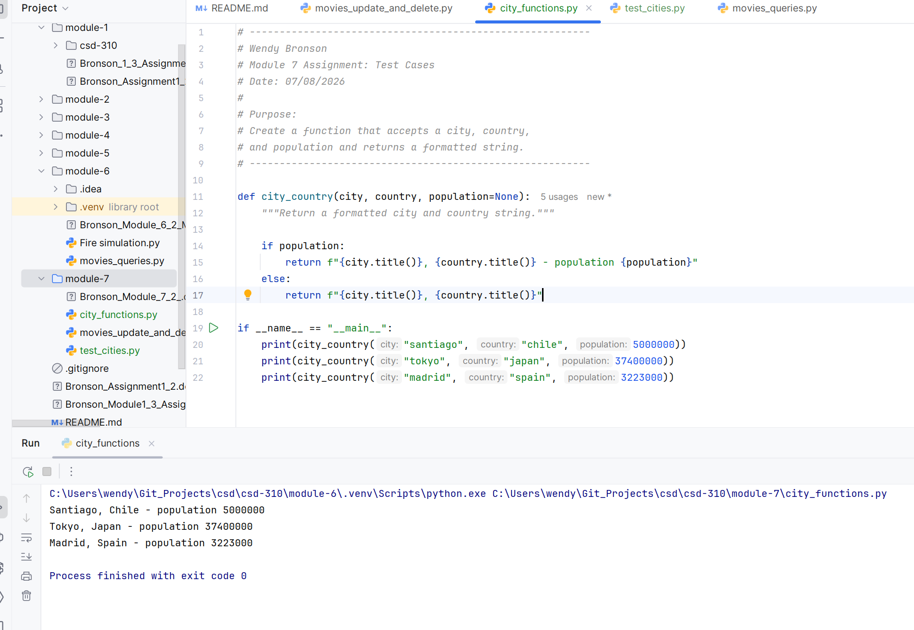
- Run test_cities.py again. It should pass.
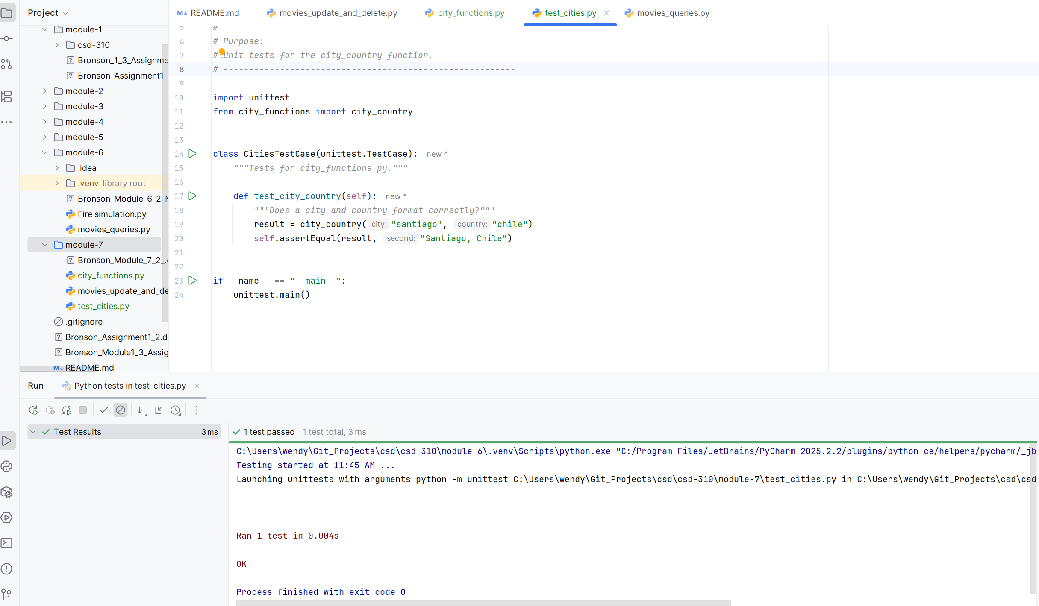
- Modify your city_country function in city_functions.py so it requires a fourth parameter, language. It should now return a single string of the form City, Country - population xxx, Language, such as Santiago, Chile - population 5000000, Spanish.
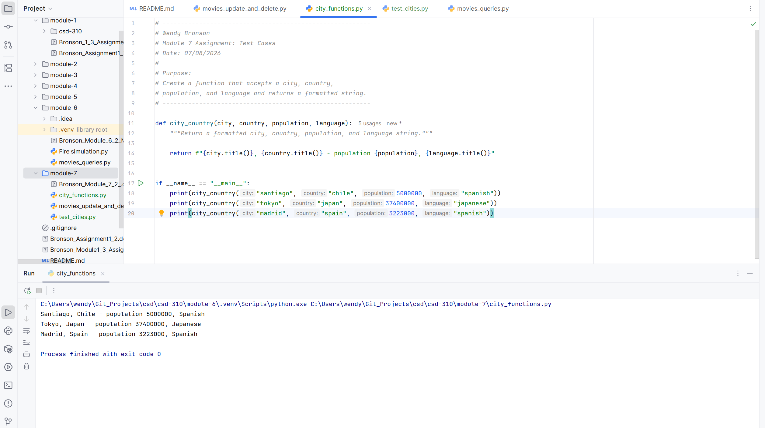
- Run test_cities.py again. It should fail.
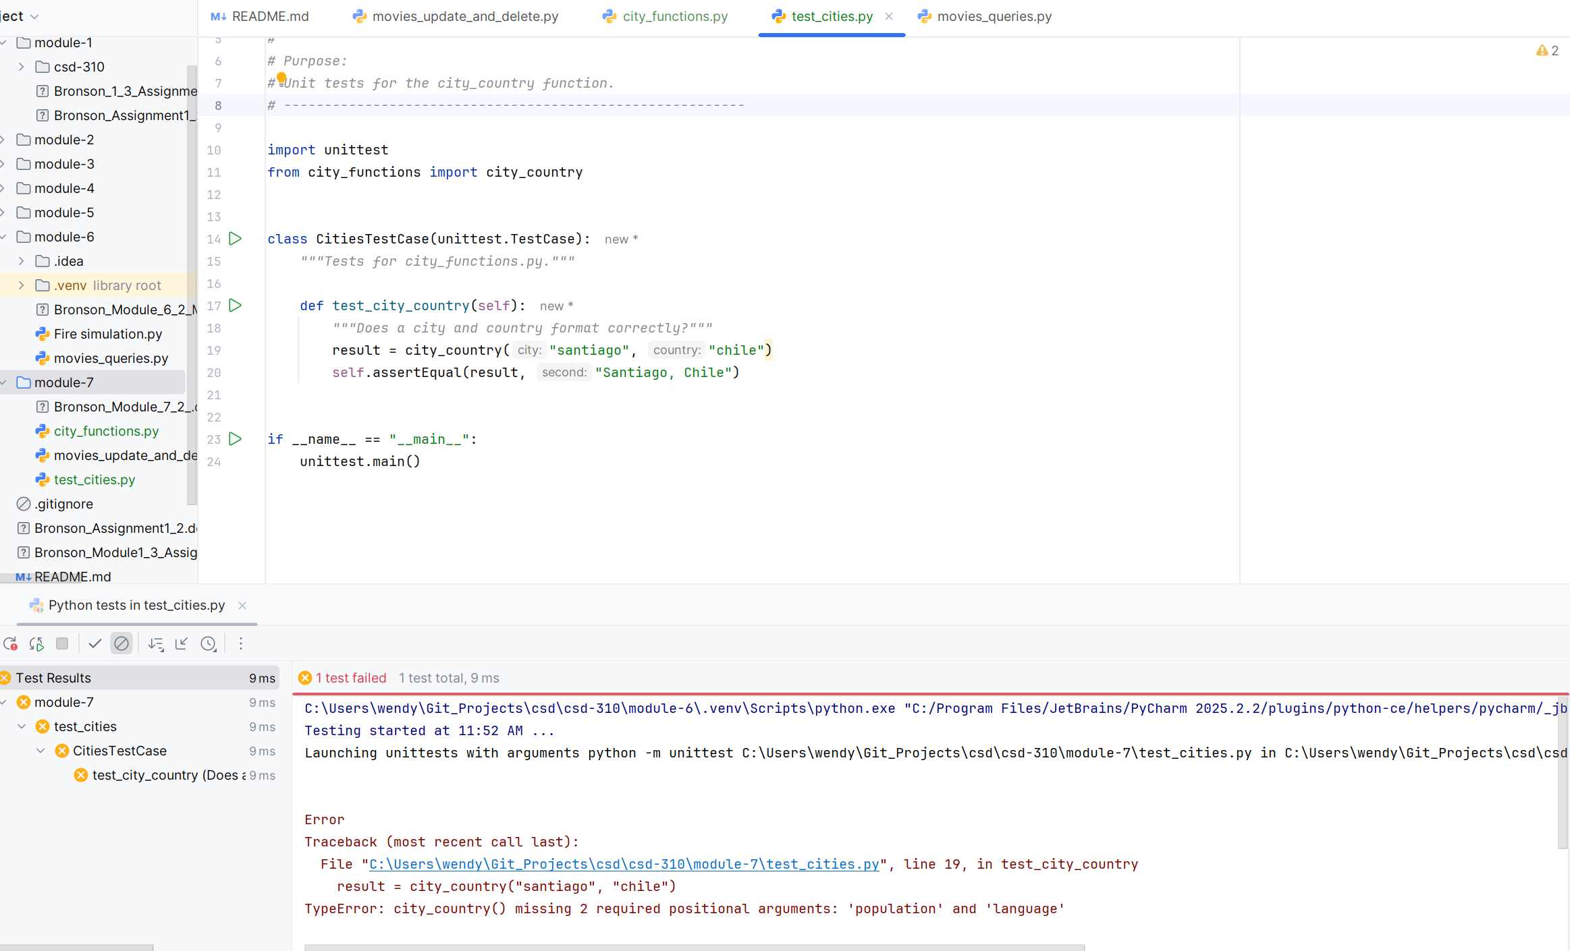
- Now modify your city_country function in city_functions.py so that the language argument is optional.
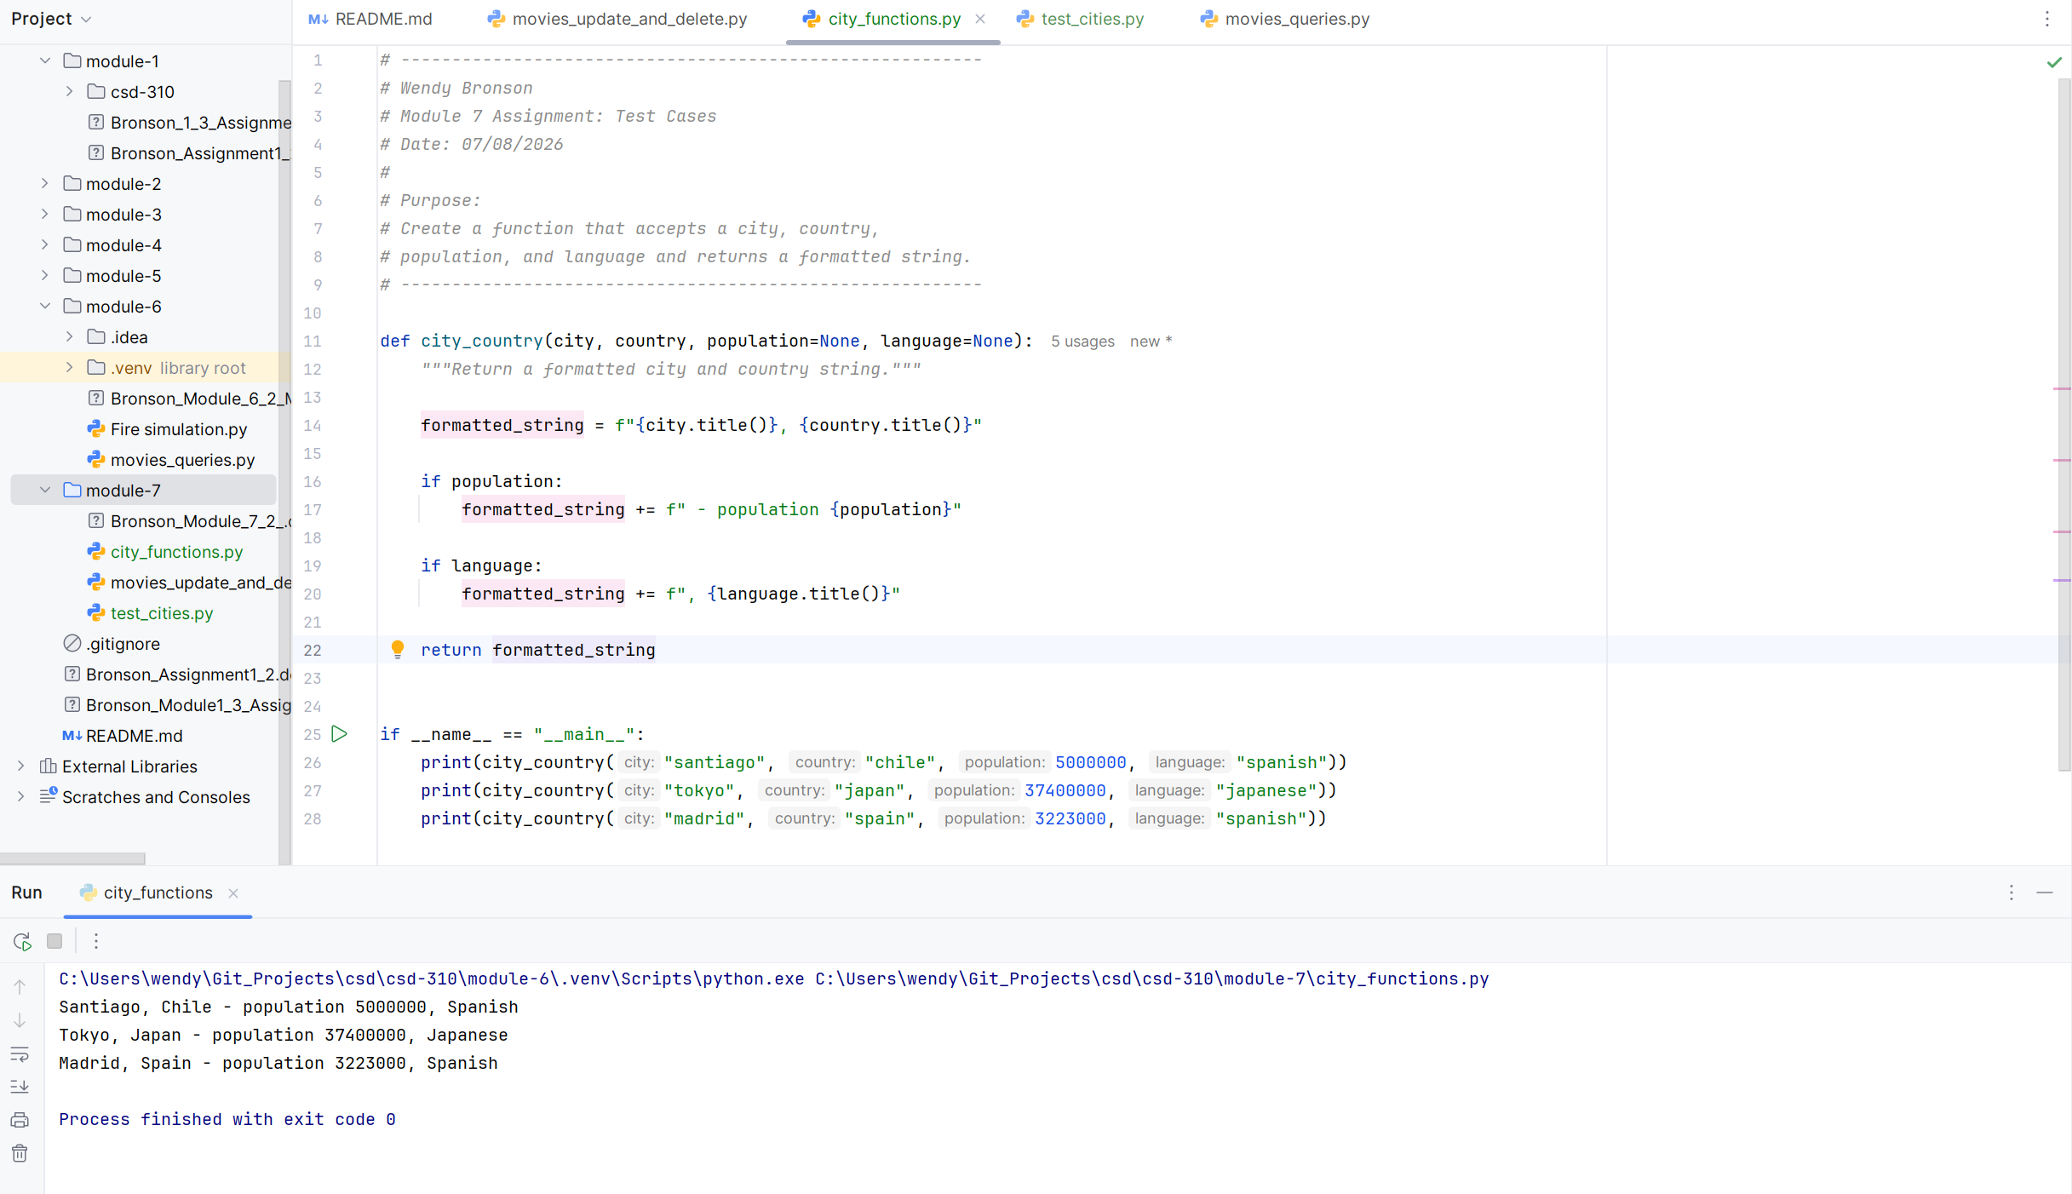
- Run test_cities.py again. It should pass.
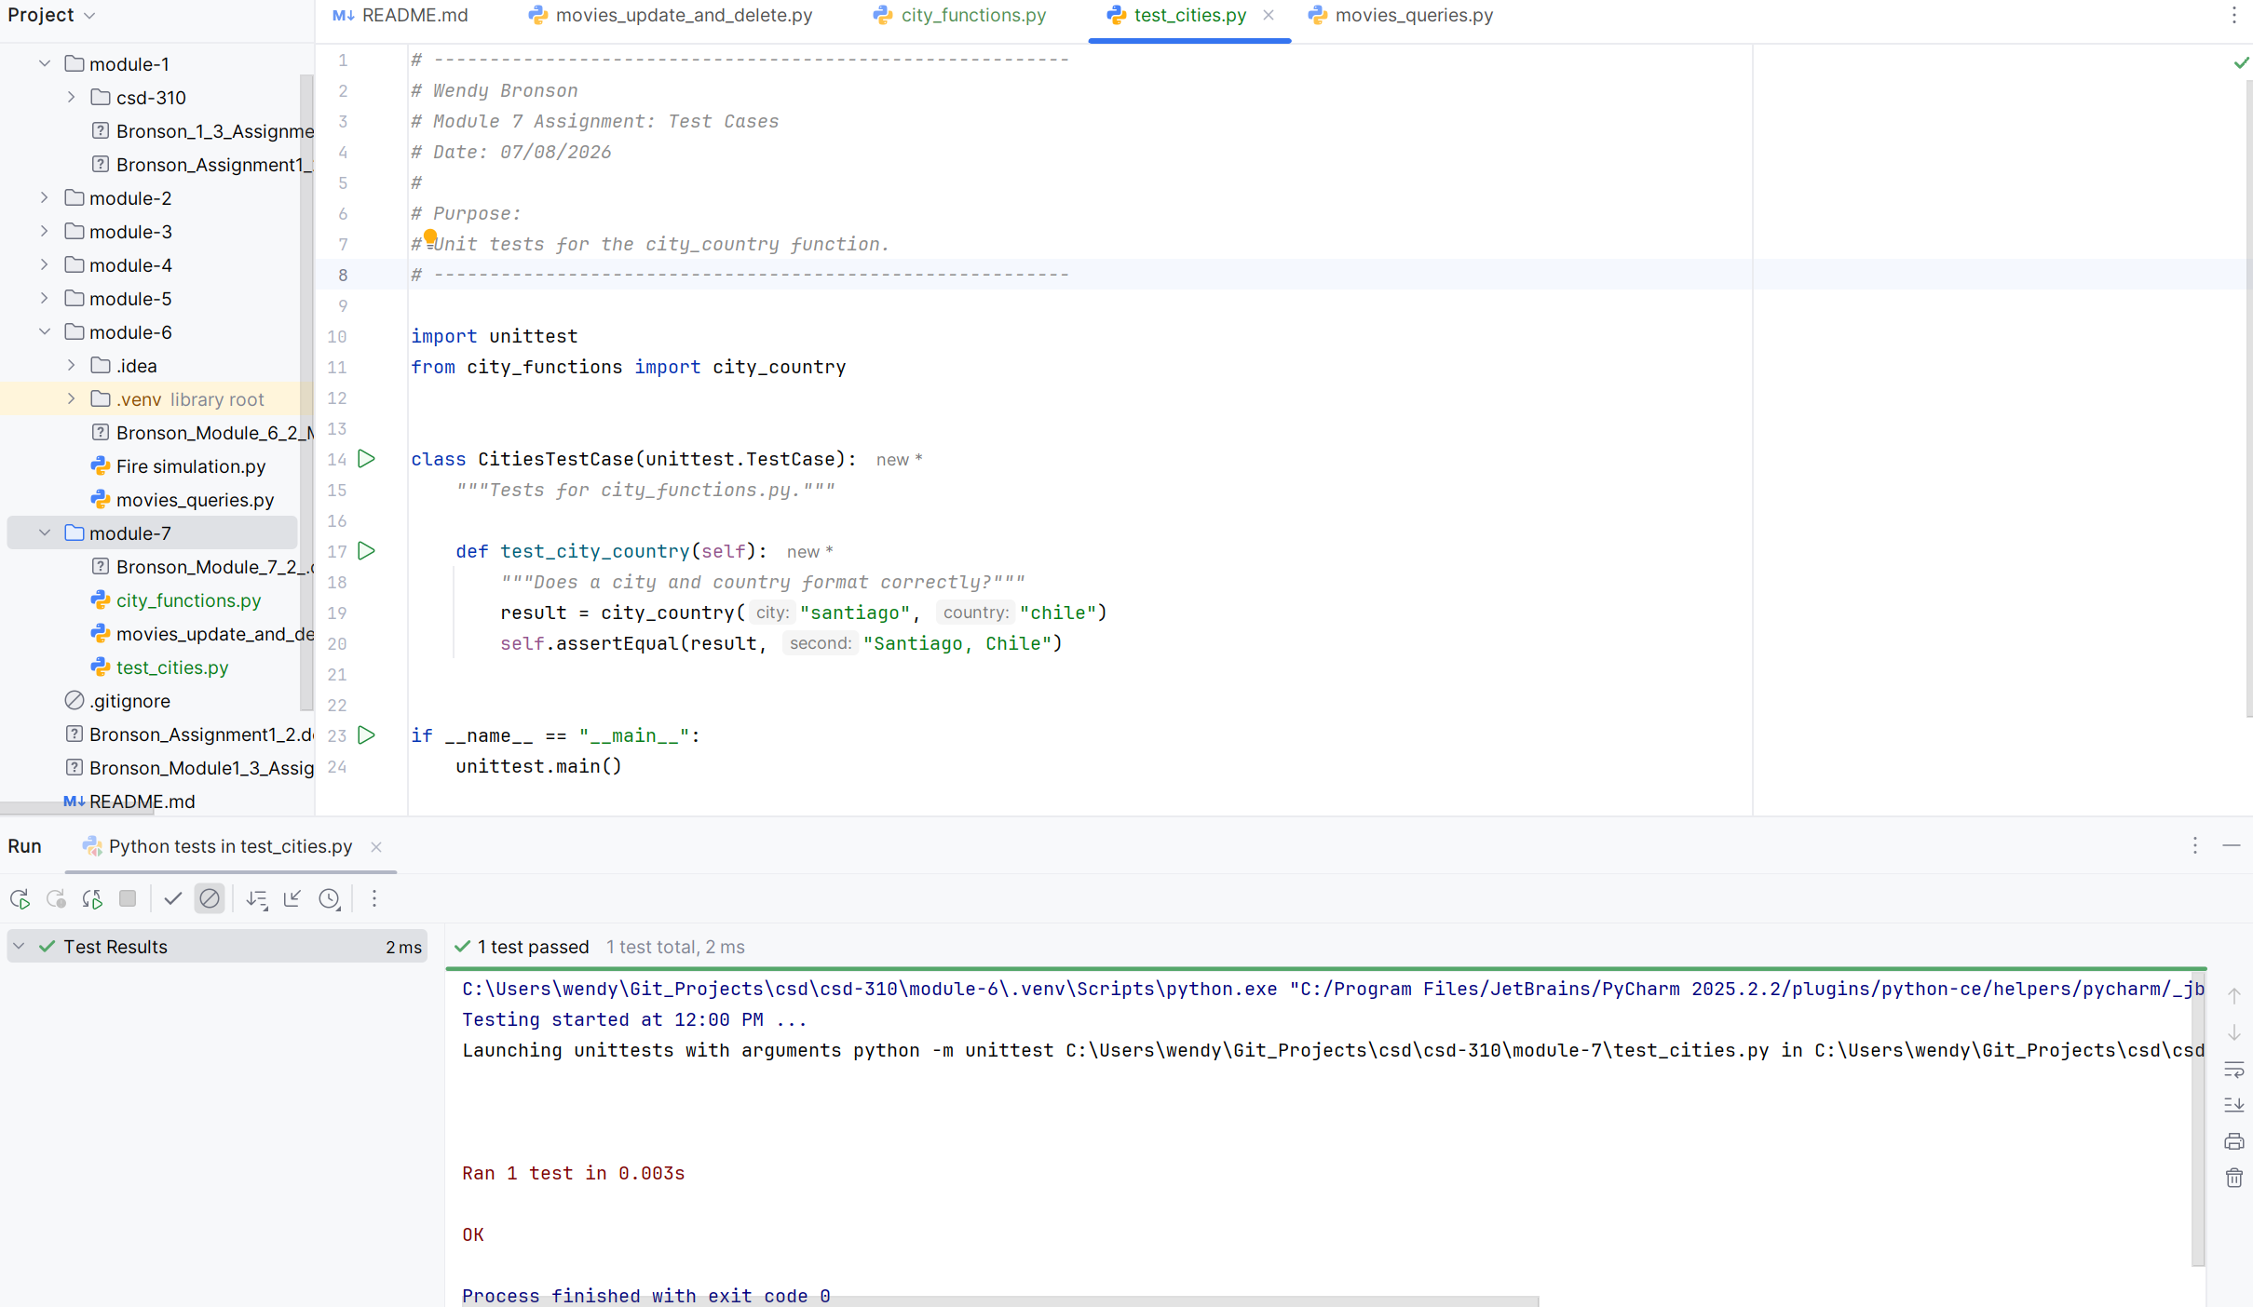
- Run city_functions.py. Call the function at least three times using a City, Country for one, City, Country, Population for the next and City, Country, Population, Language for the last.
