Wendy Bronson
Module 8.2 : JSON Practice
07/08/2026
CSD325-300H Advanced Python (2265-DD)

Output a notification that the JSON file was updated:
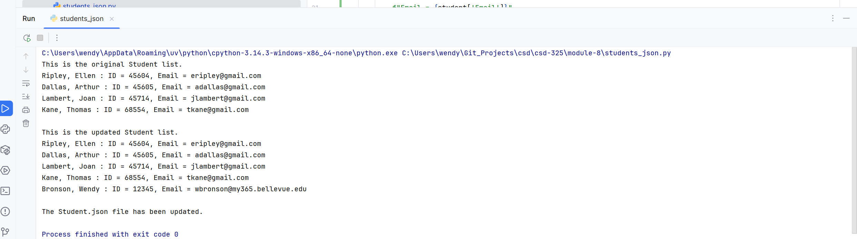

Notification that the student. Json file has changed:
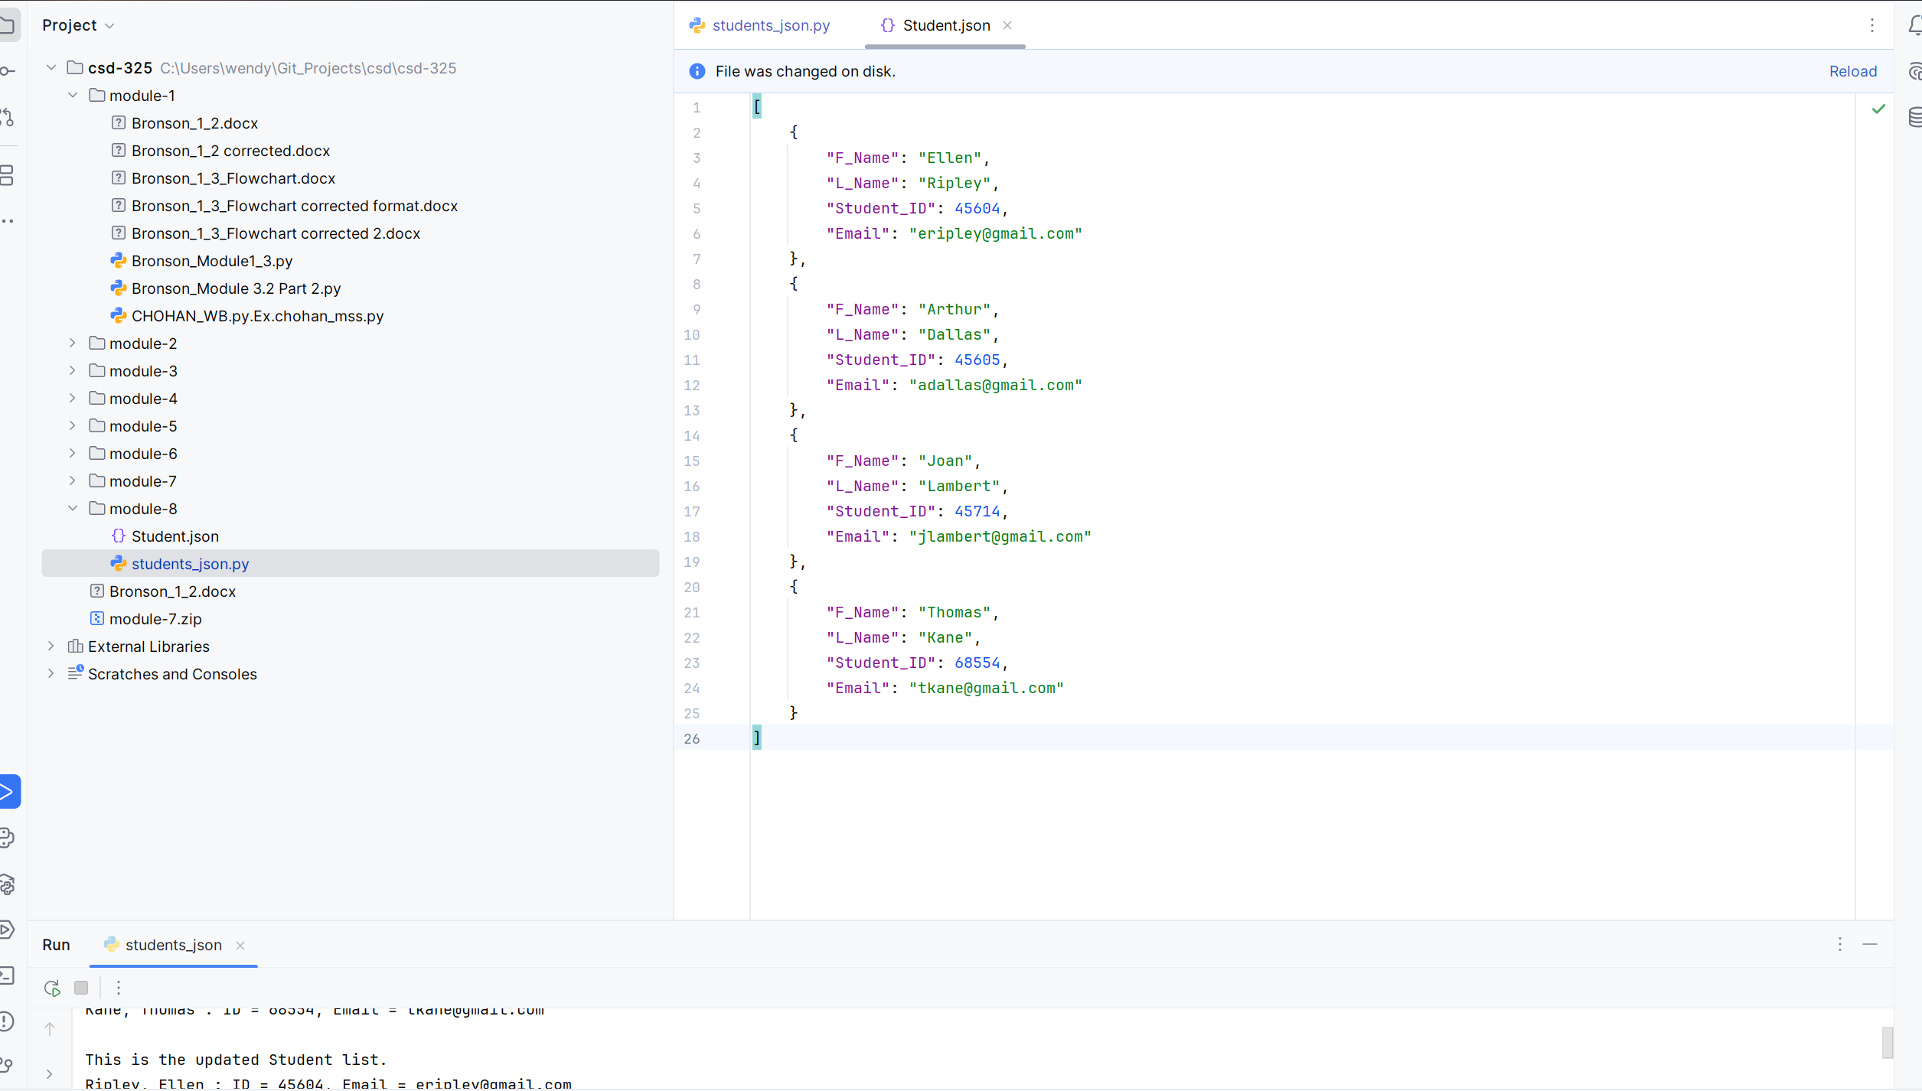
JSON file with updated names:
